# problem #2: pizza

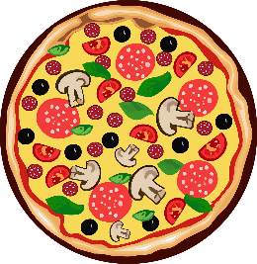Jane decided to host a party because she is a nice person. She wants to order pizza for the gang as per usual.

Unfortunately, she is not very good at math. That's why she asked you to help her to get the best value possible on her order. Is it better to get fewer but bigger pizzas? Or maybe they should go for more but smaller pizzas?

## task #1

## Write a program that asks for 4 pieces of information from the standard input:

## number of pizzas for the bigger type

## diameter of the bigger pizza (in cm)

## number of pizzas for the smaller type

## diameter of the smaller pizza (in cm)

Then, print the total area of both kinds of pizzas to the standard output.

an example run:

Std. Input:

number of bigger pizza(s) = 1

diameter of bigger pizza(s) (in cm) = 32

number of bigger pizza(s) = 2

diameter of smaller pizza(s) (in cm) = 24

Std. Output:

total area of bigger pizza(s): 804.25 cm2

total area of smaller pizza(s): 904.78 cm2

total area of smaller pizza(s): 904.78 cm2