
MarketLink
Project Report
TechWiz 2026 · End-to-End Web Solutions
Team Omniverse · Aptech Learning Centre, F.B. Area, Karachi

Contents
1
(If the contents list is empty, right-click it in Word and choose Update Field.)

Note for the team (please read before submitting). The SRS (section "Important Note Regarding AI Usage") does not allow documentation that is fully produced by an AI tool. This report is a draft that Claude Code (an AI coding assistant) prepared from the project's code, database and test runs so that the facts, tables and diagrams are correct. Before you submit it, read every section, rewrite the text in your own words, add your own design reasoning and team details, and keep "Claude Code (Anthropic)" in the list of AI tools you used (section 11). The report contains no source code, as the SRS asks.

1. Problem definition
Local farmers markets in Pakistani cities (for example the weekend markets in Clifton, DHA or F-9 Park) work only face to face. That causes the same problems every week:
- Customers do not know what is there before they go. They cannot see which farmers come on which day, what they have picked this week, the price, or whether it is already sold out.
- Farmers guess how much to bring. Without orders in advance they either bring too much (waste) or too little (lost sales), and they cannot tell regular customers that they will not come.
- Popular produce sells out early and people who arrive later leave with nothing.
- Nobody manages the markets online. There is no single place for market days and hours, the stall locations, trusted reviews or complaints.
MarketLink puts the farmers market online without changing how it works: farmers publish their weekly stock, prices and pickup windows; customers find markets and farmers on a map, reserve products with a pre-order for a pickup time slot, and pay the farmer in person at pickup. An administrator approves farmers, manages markets and categories, moderates content and reads platform reports.

1.1 Objectives
- Let customers browse markets, farmers and products by location, day, category and price, with a map and directions to the pickup point.
- Let customers pre-order against the farmer's real stock for a pickup slot, then track, modify or cancel the order before the farmer's cut-off time.
- Give farmers a simple dashboard for weekly stock (with a recurring template), pickup windows, pre-orders, sales insights and replies to reviews.
- Give the administrator control over users, markets, categories, content, announcements and reports.
- Work well on phones, in English and in Urdu, with secure, role-based access.

1.2 Scope
In scope | Out of scope (SRS 1.5)
Customer, farmer and admin areas with role-based access | Online payment (payment is made at pickup)
Markets, farmers, products, categories, cities | Delivery or courier logistics (pickup only)
Pre-orders with pickup slots and cut-off times | Checking farmer identity, licences or organic certificates
Reviews, ratings, favourites, restock reminders | Native mobile apps (the website is responsive instead)
Maps (OpenStreetMap), directions, notifications and e-mail
AI assistant (English, Urdu, Roman Urdu)

1.3 Users
User | What they do
Guest | Browses markets, farmers and products, uses the map and the assistant, can check out as a guest (an account is made and the password e-mailed)
Customer | Everything a guest can, plus a dashboard, order tracking, changes and cancellations, favourites, family sharing, reviews, restock reminders and notifications
Farmer | Registers a stall (approved by the admin), manages products, weekly stock, pickup windows, closed dates, pre-orders, sales insights and review replies
Administrator | Separate dashboard: farmers, customers, markets, cities, categories, products, reviews, moderation, announcements, the home page offer banner, messages, newsletter, FAQs, reports and farmer rankings

2. Design specifications

2.1 Architecture
MarketLink is a MERN application (MongoDB, Express, React, Node.js) with the multi-tier structure the SRS describes: the browser runs the React app, the Express server exposes a REST API and serves the built app, and MongoDB stores the data.
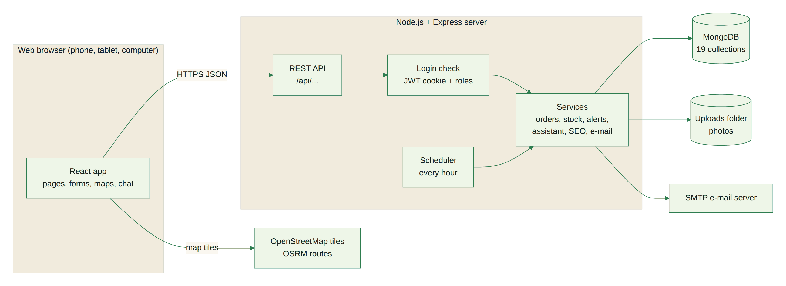
Figure 1 – System architecture
Layer | Technology | Notes
Presentation | React 19 (Vite), React Router 7, Bootstrap 5 with a custom theme, Bootstrap Icons, Recharts, DataTables, Leaflet maps, intl-tel-input | 77 routes (public, customer, farmer, admin); English and Urdu (right to left)
Application | Node.js 20+, Express 5 | 146 REST endpoints under /api, input checks on every request, rate limits on login, chat and AI features
Security | JWT in an httpOnly cookie, bcrypt password hashes, Helmet headers, CORS, role checks on every protected route | Customer, farmer and admin routes are separated on the server, not only hidden in the menu
Data | MongoDB with the Mongoose ODM | 19 collections with validation rules and indexes (section 4)
Services | Nodemailer (SMTP e-mail), an hourly scheduler, OpenStreetMap tiles and OSRM routes | Weekly stock template, low-stock alerts, "market open today" notices

2.2 Modules
Module | Main functions
Accounts | Register (customer, farmer wizard), one login page for every role, forgot / reset password, profile photo, family sharing
Markets and maps | Market list (opens on the markets open today), market page with the farmers there and whether each is at the market today, map of markets and stalls, driving route
Catalogue | Products with photos, categories, filters (price, category, market, day, rating, offers), grid or list view, search while typing, best sellers, product details with reviews
Pre-orders | Basket, checkout with a pickup date and slot per farmer, guest checkout, bookmarkable order page (/checkout/<order number>), modify and cancel before the cut-off
Farmer portal | Products and weekly stock template, inventory history, low-stock alerts, pickup windows, closed dates, "I cannot come today", orders (accept, decline, ready, complete), sales insights, review replies
Reviews | Verified reviews after pickup, "Did you receive your order?" question, farmer replies, moderation
Notifications | In-app and e-mail alerts for orders, restock reminders, new farmers, markets open today, announcements
Administration | Dashboard, users, markets, cities, categories, products, reviews, moderation queue, announcements, offer banner, messages by topic, newsletter, FAQs, reports, farmer rankings
AI assistant | Chat in English, Urdu and Roman Urdu: timings, top-rated farmers, best sellers, cheapest items, offers, farmer availability, order status and help

2.3 User interface design
- Look: one dark green (#173B2C) and one lime accent (#D4F06E) on a cream background, white cards and real photos (no illustrations); Fraunces for headings, Plus Jakarta Sans for text, Noto Nastaliq Urdu for Urdu.
- Home page: a full-width photo banner, then sections that take turns between dark green and light cream: categories, the offer banner, top picks, the video tour, top-rated farmers, markets and map, the farm-to-table story, an invitation for farmers and market organisers, customer reviews, why choose us and the FAQ.
- Phones: a bottom navigation bar on every page, dialogs open as bottom sheets, filters slide in from the side, tables turn into cards.
- Accessibility: keyboard access to every control, visible focus, alt text on every image, reduced motion respected where it matters, colour contrast checked.

2.4 Non-functional requirements
Requirement (SRS 1.7) | How it is met
Compatibility | Tested in Chromium; uses standard HTML, CSS and JavaScript supported by current Chrome, Edge, Firefox and Safari
Responsive design | Checked at 18 widths from 320 to 1920 px, no sideways scrolling (section 7 of the test report)
Security | Hashed passwords, httpOnly cookies, role checks on the server, rate limits, file-type checks on uploads
Performance | Server-side paging for tables, compressed responses, lazy-loaded pages, images sized for the screen (1024 px on phones, 1920 px on large screens)
Usability | Toast messages for every action, spinners on buttons while they work, clear empty states
Languages | English and Urdu on every public, customer and farmer page

3. Diagrams

3.1 Use cases
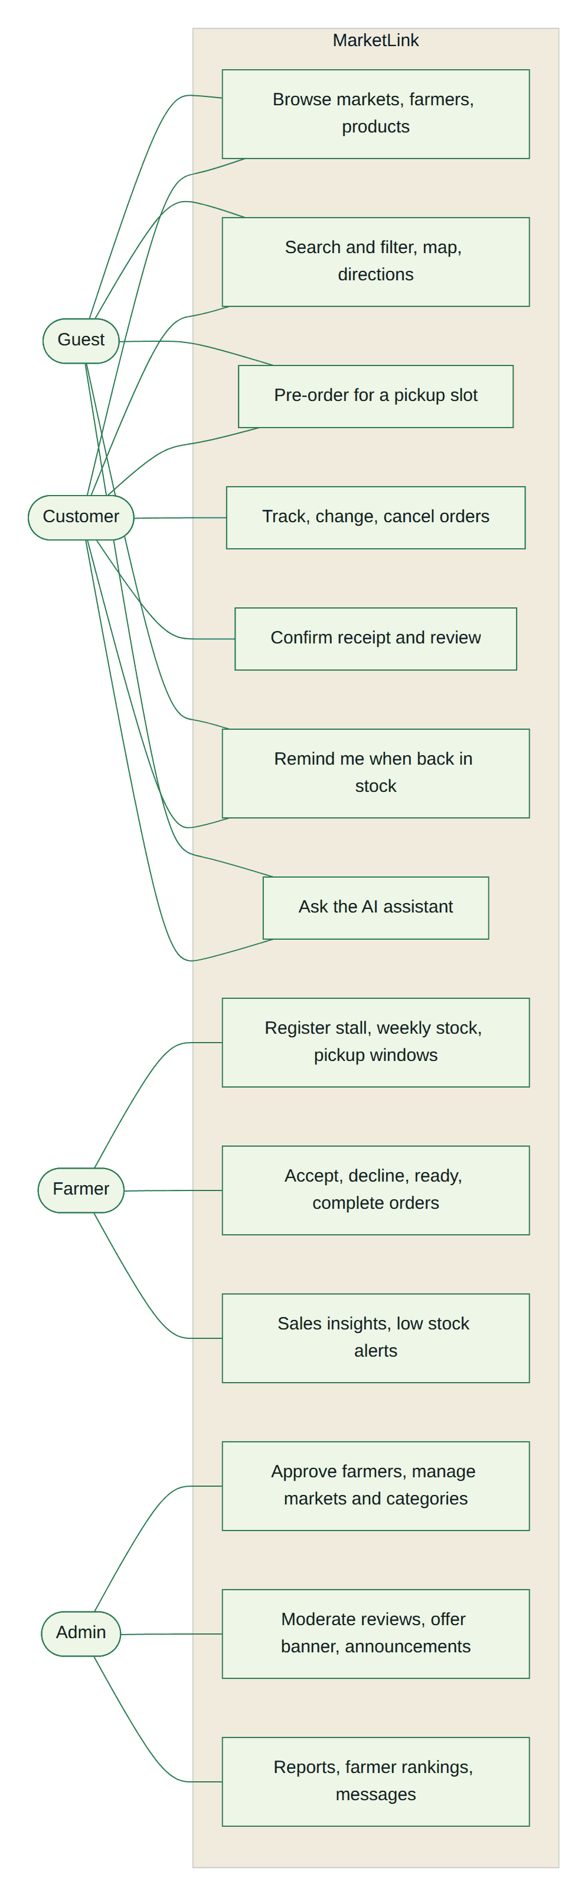
Figure 2 – Use cases by role

3.2 Data flow diagram – level 0 (context)
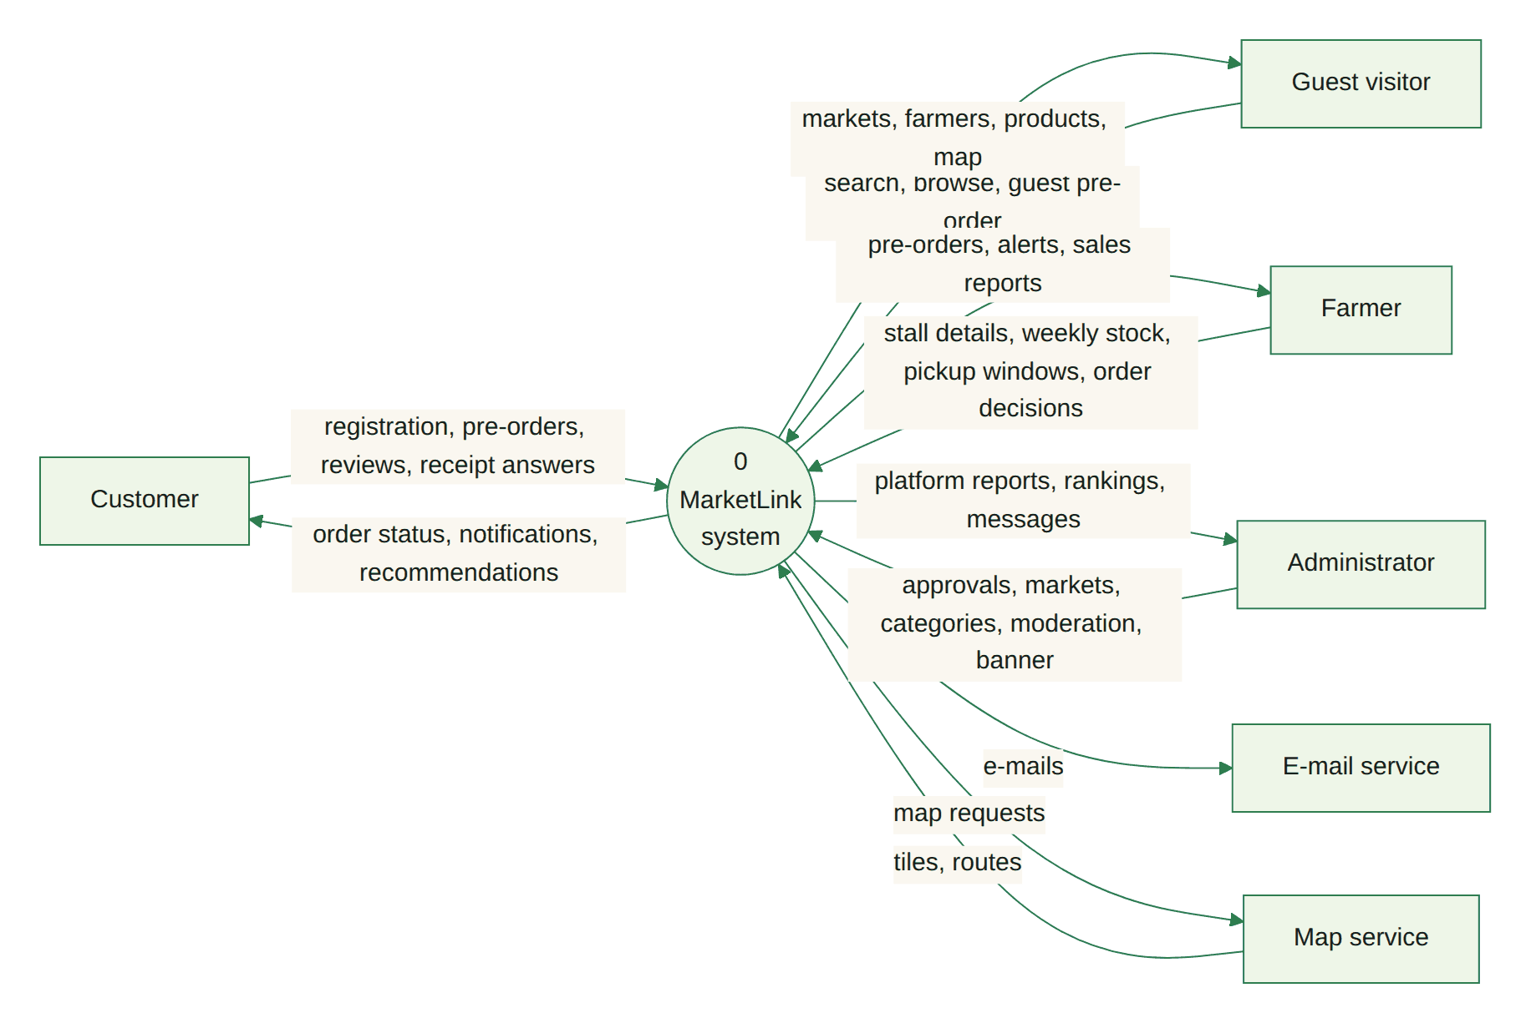
Figure 3 – Context diagram

3.3 Data flow diagram – level 1
The level-1 diagram is split in two to keep it readable.
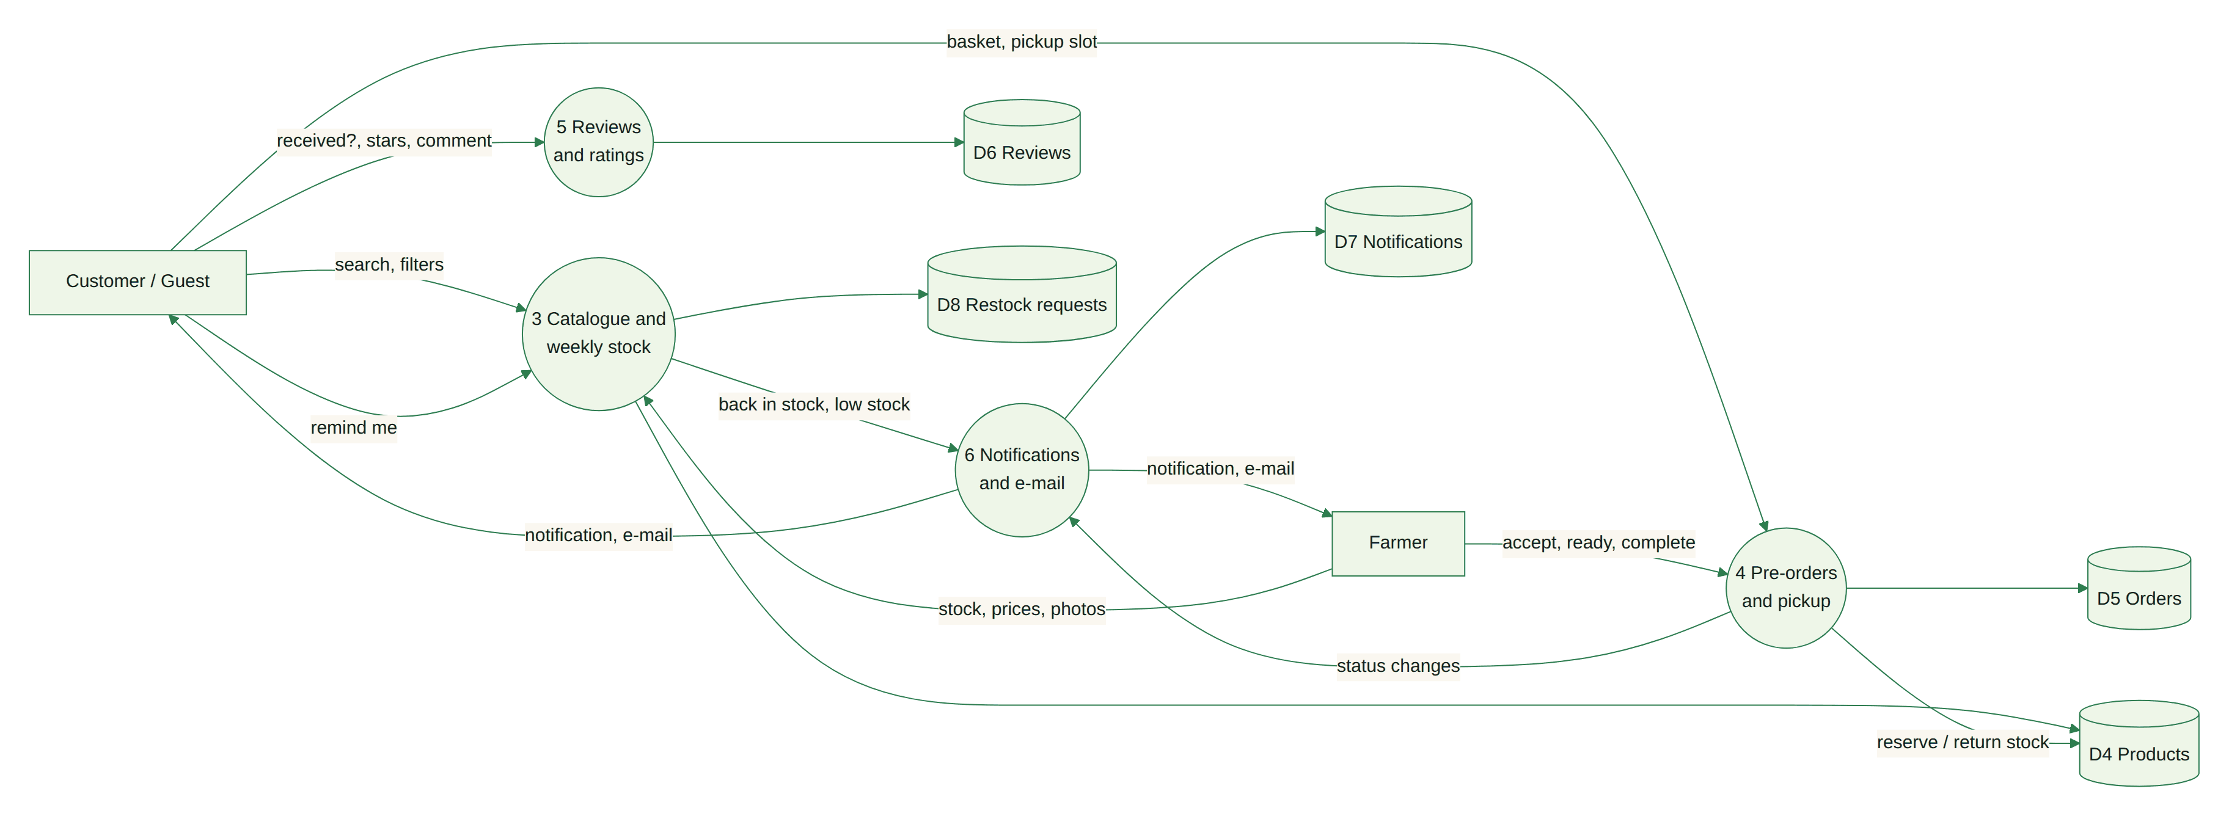
Figure 4 – DFD level 1: shopping, orders, reviews and notifications
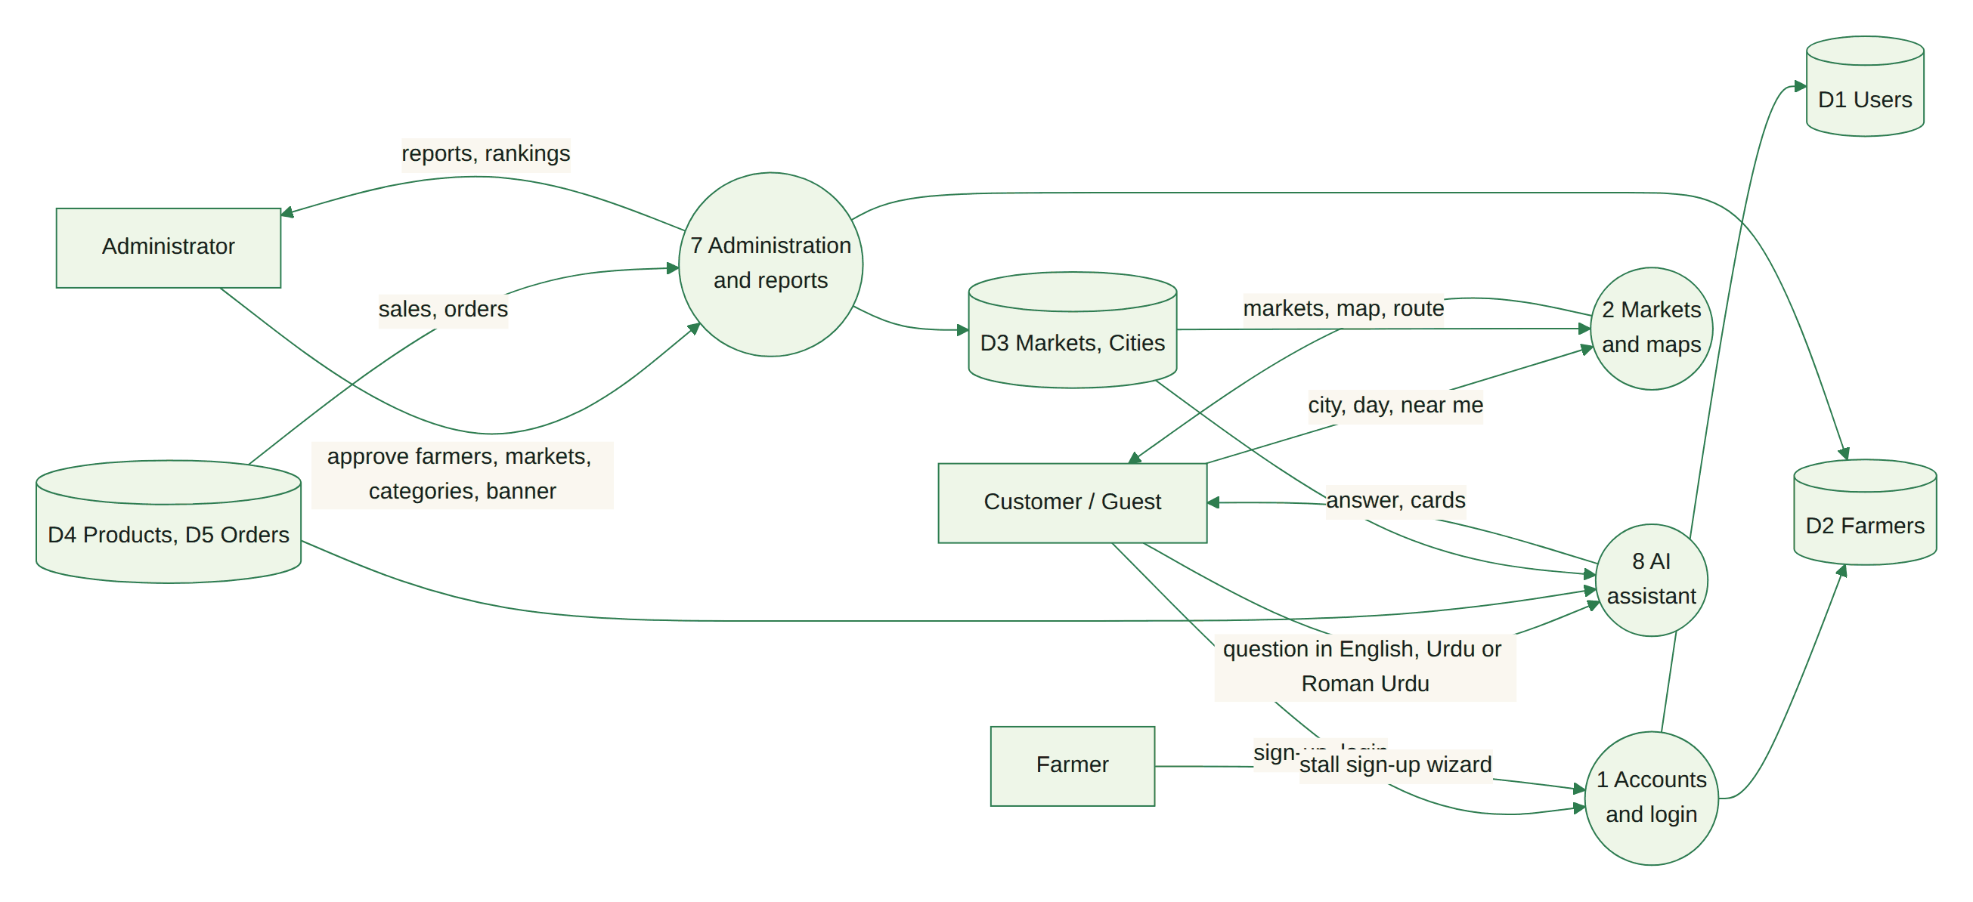
Figure 5 – DFD level 1: accounts, markets, administration and the assistant

3.4 Flowchart – customer pre-order
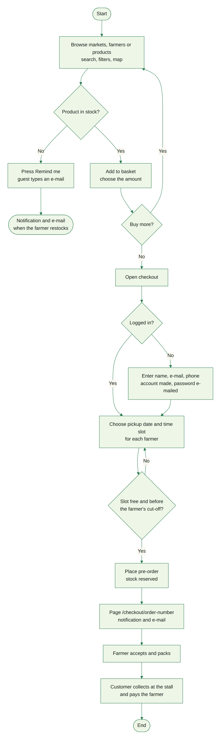
Figure 6 – Customer pre-order

3.5 Flowchart – farmer registration and approval
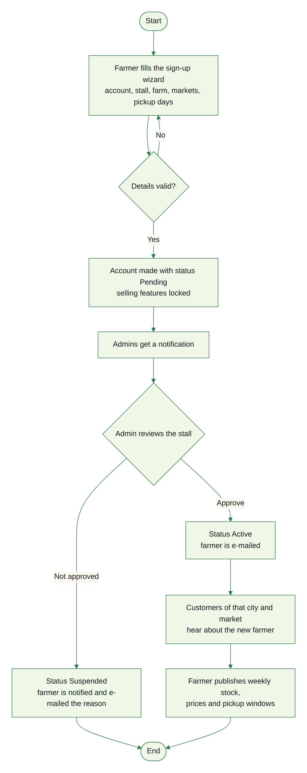
Figure 7 – Farmer registration and approval

3.6 Flowchart – farmer handles a pre-order
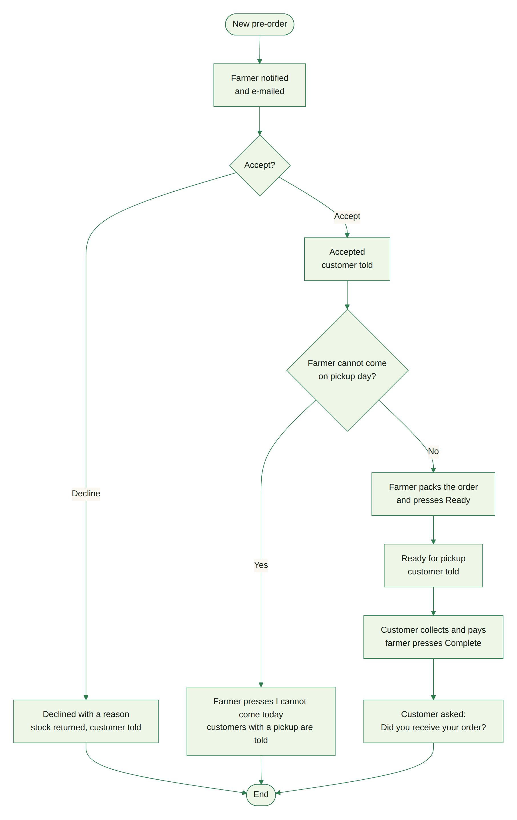
Figure 8 – Farmer order handling

3.7 Flowchart – receipt confirmation and review
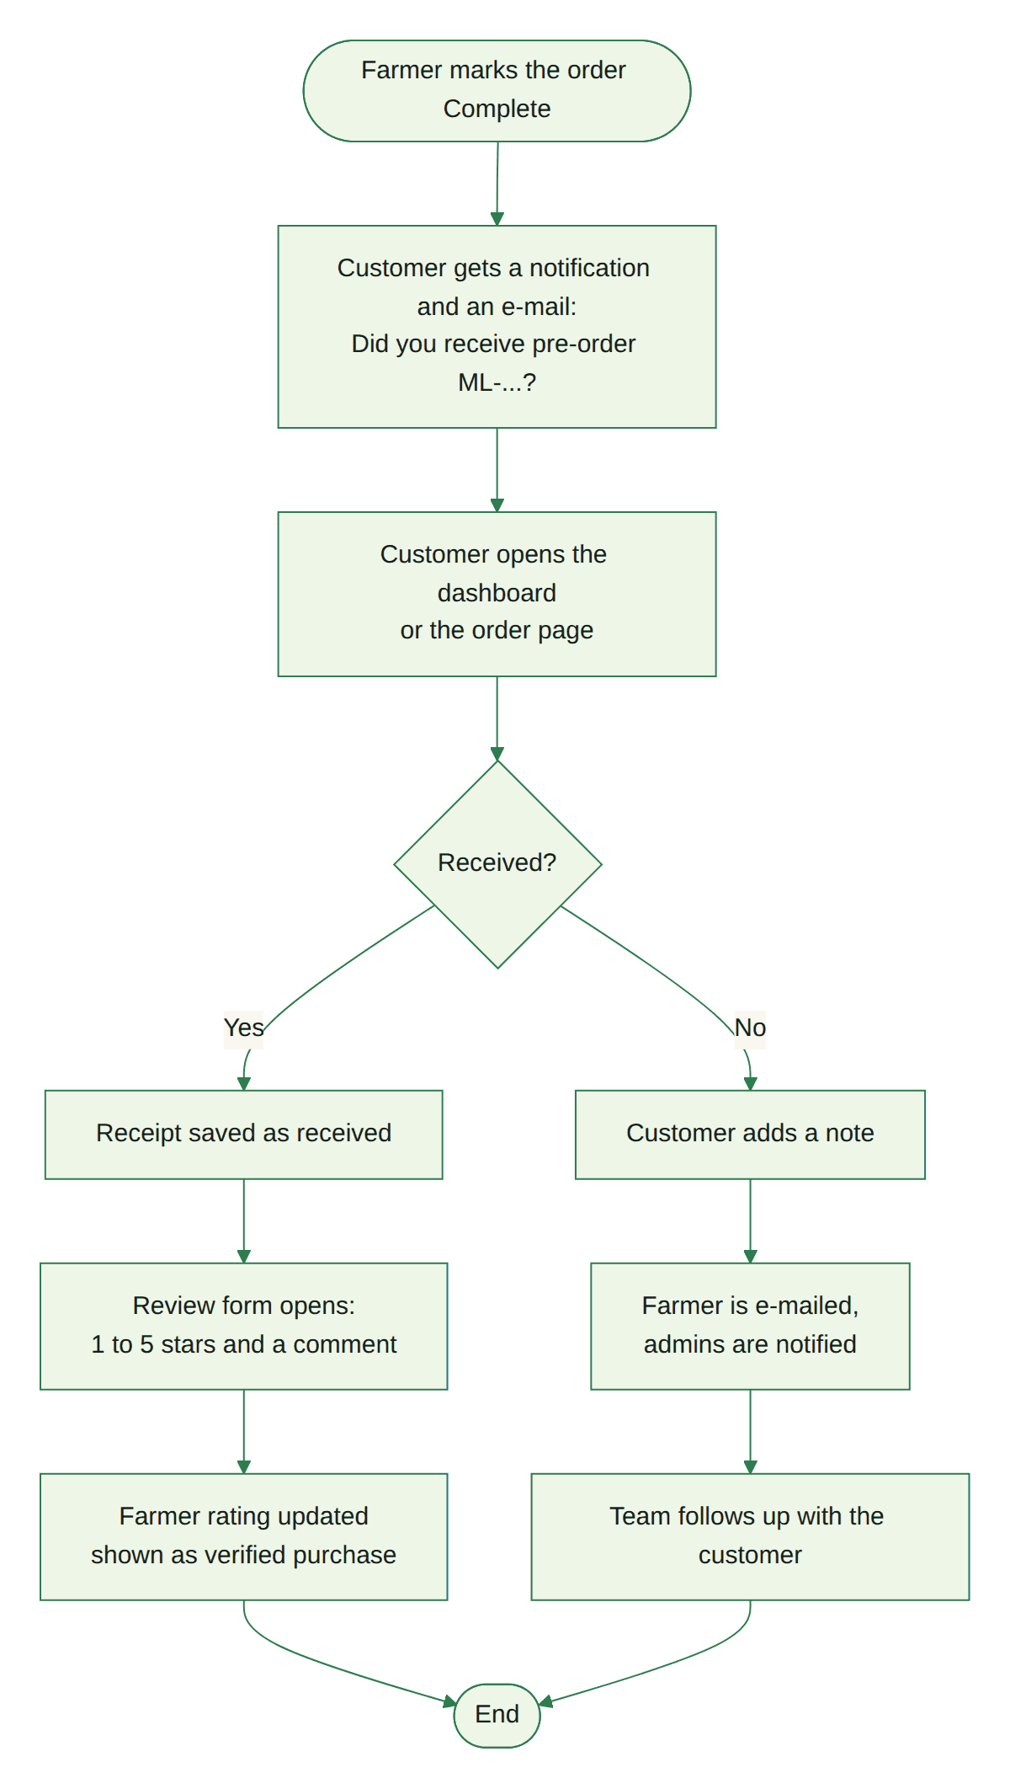
Figure 9 – Receipt confirmation and review

3.8 Flowchart – AI assistant
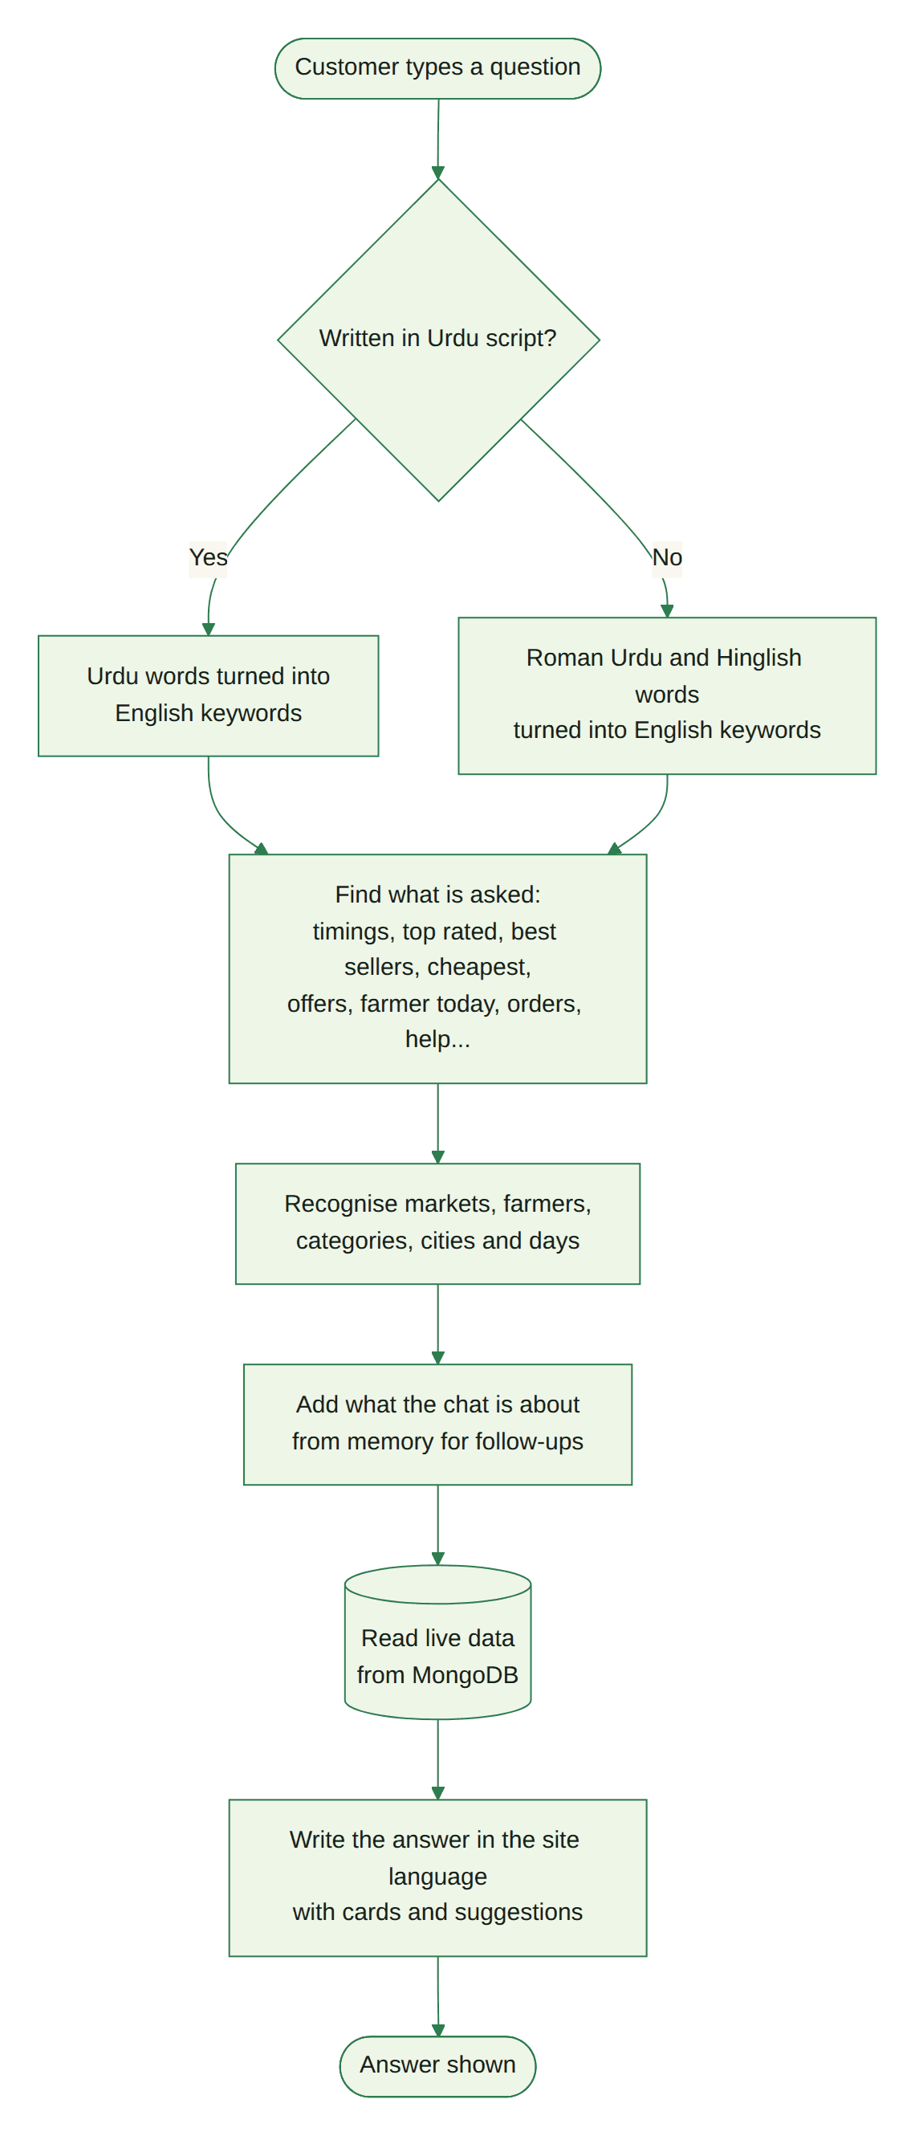
Figure 10 – How the assistant answers

3.9 Order states
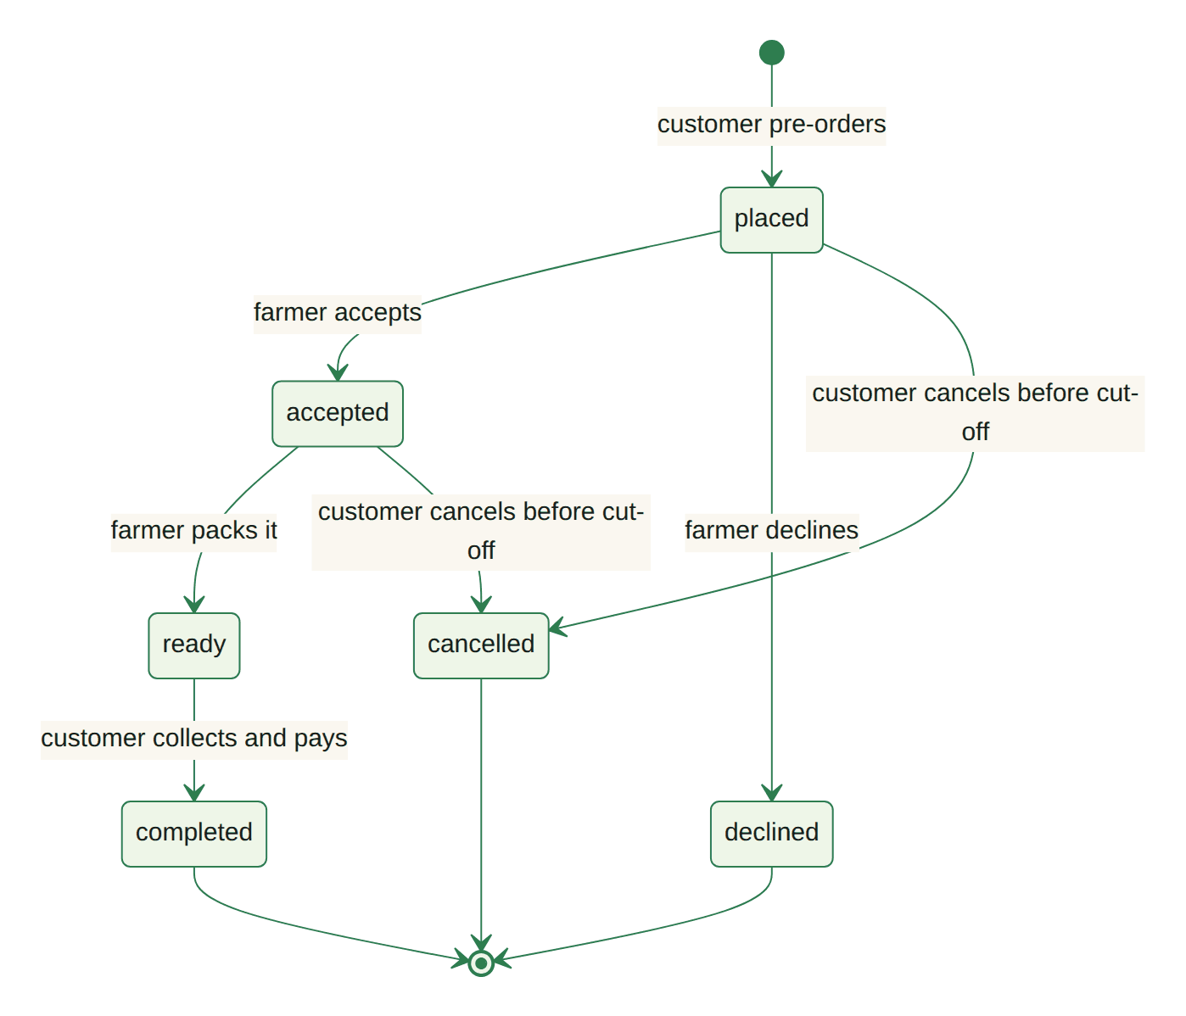
Figure 11 – Order status diagram

4. Database design
MongoDB stores the data in 19 collections. The main entities and their relations are shown below; the full list of fields follows. Relations are stored as references (ObjectId) except the order items and pickup windows, which are stored inside their order or farmer document.
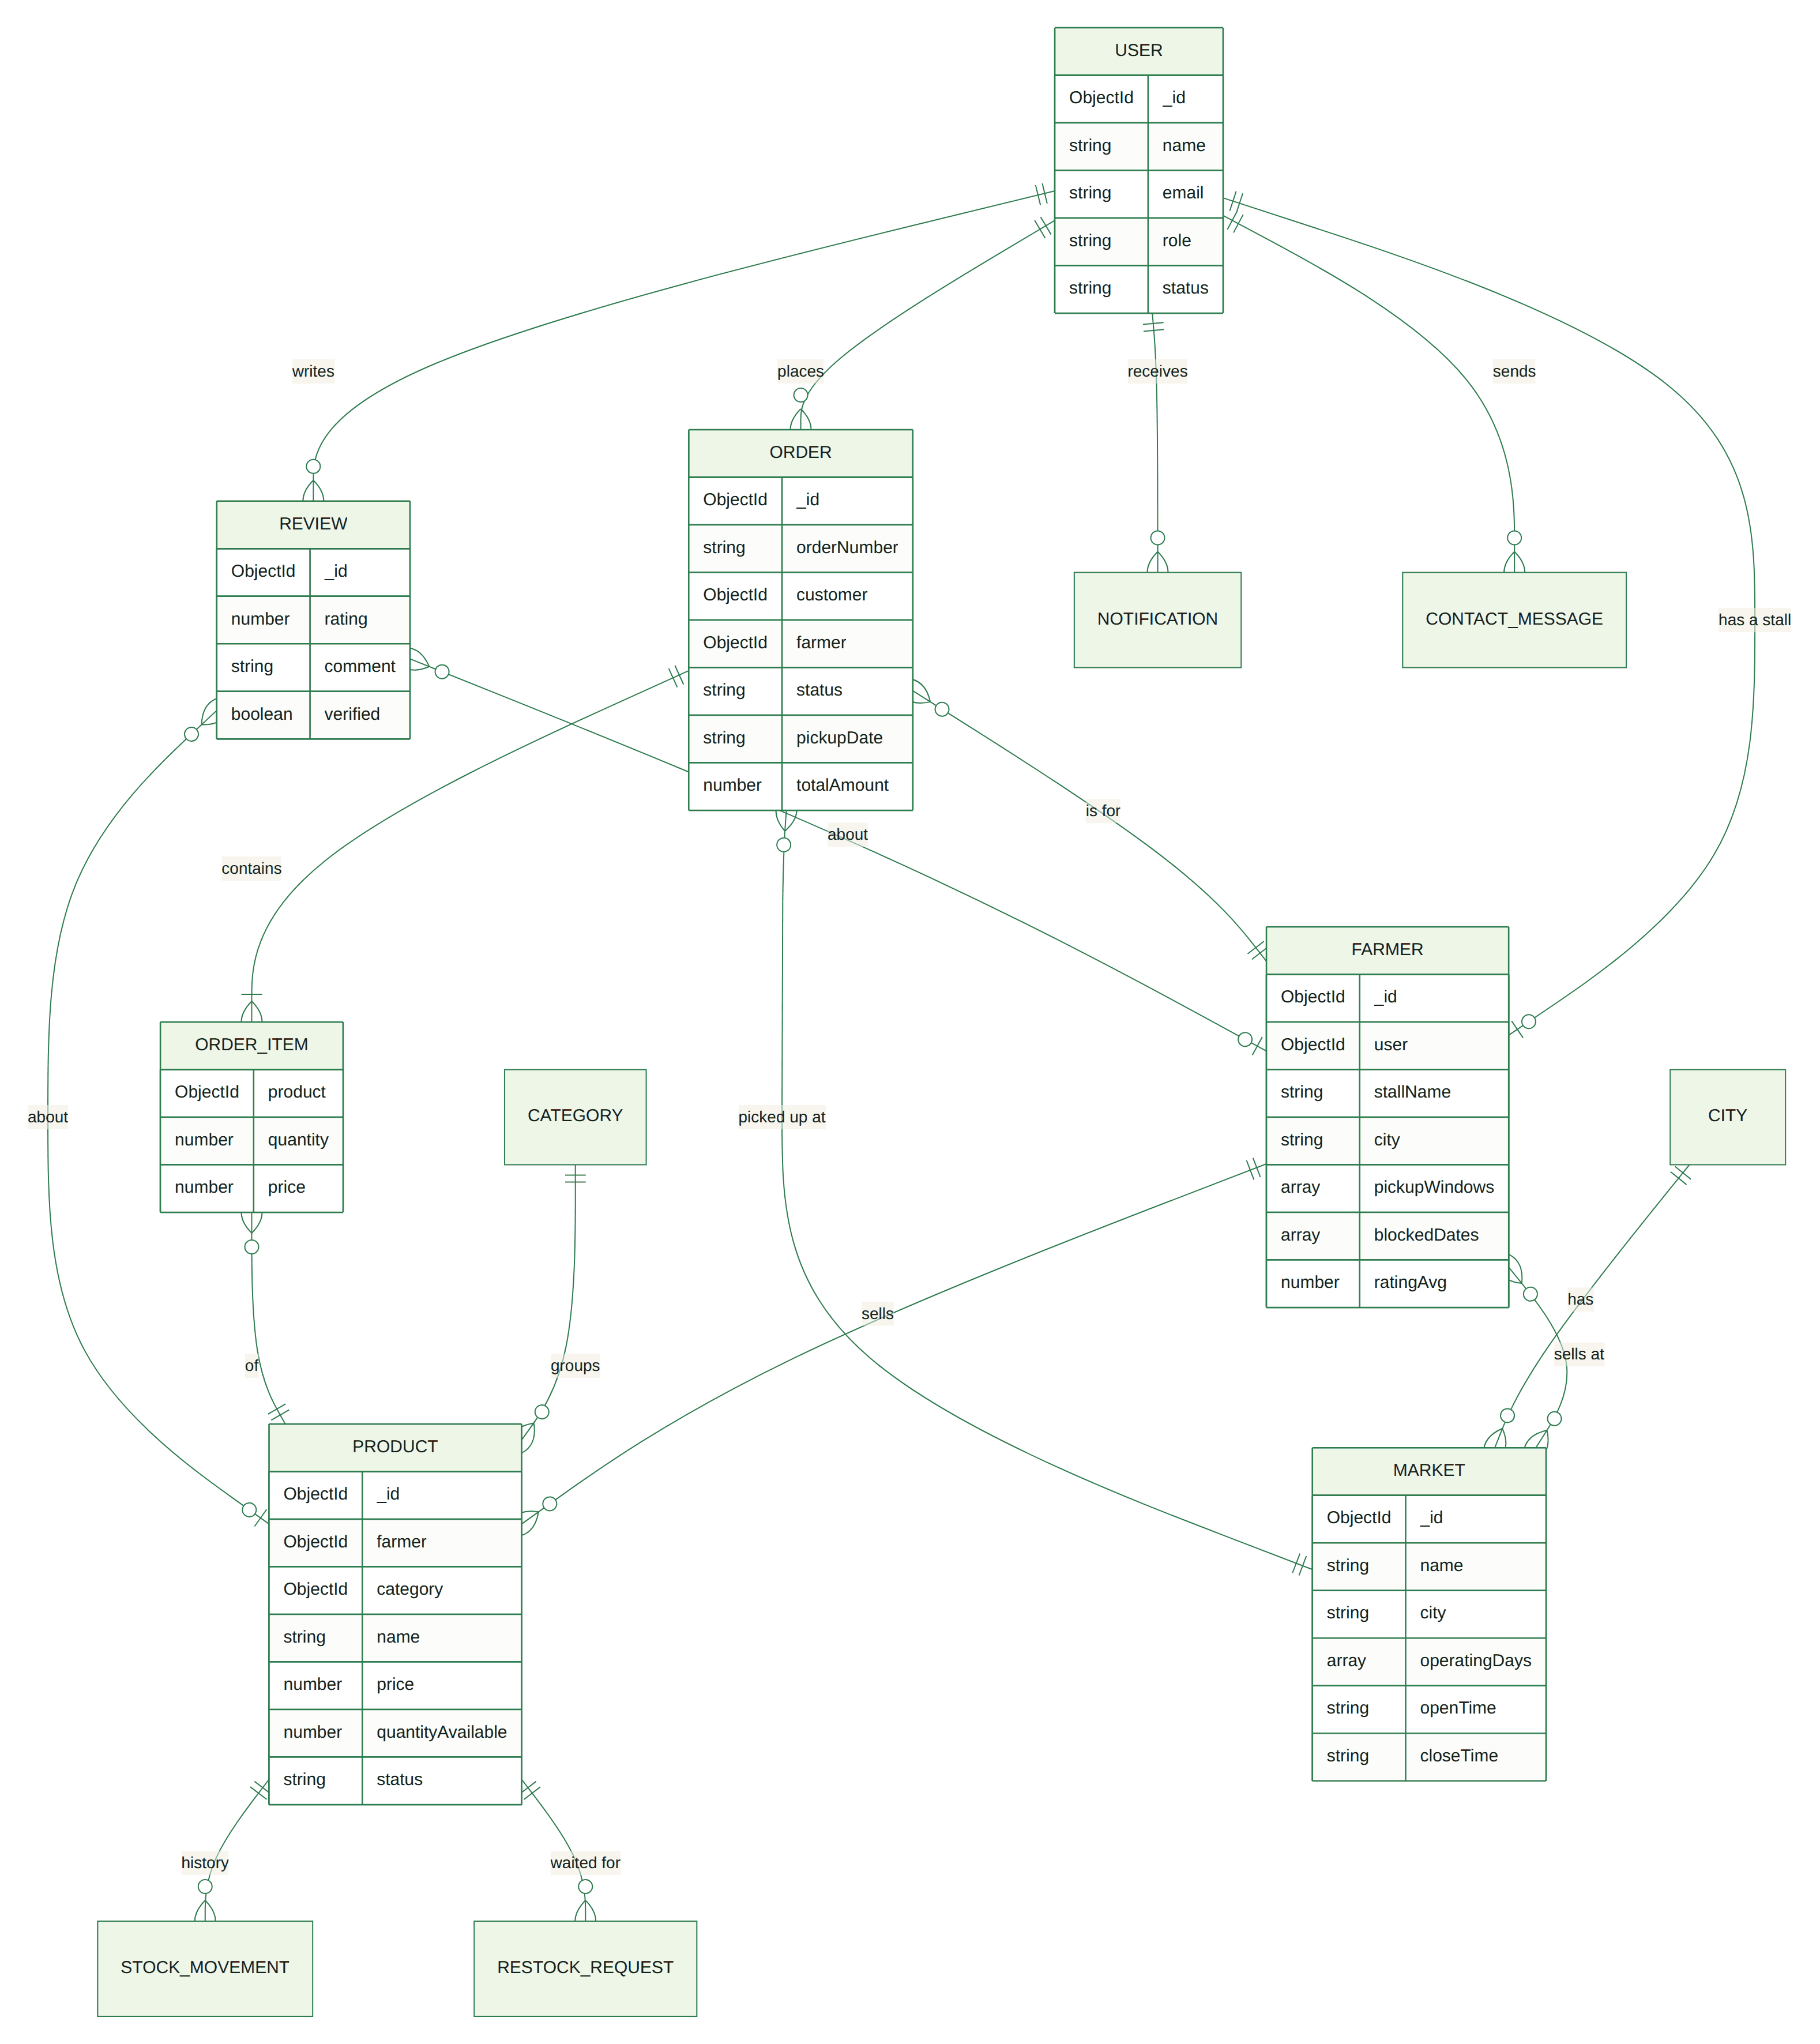
Figure 12 – Entity relationship diagram

4.1 Collections
Collection | Purpose
users | Every login: customers, farmers and administrators (role, status, favourites, family)
farmers | Stall profile of a farmer user: markets, days, pickup windows, closed dates, rating
markets | Farmers markets with address, days, hours and map position
cities | Master list of cities for markets and farmers
categories | Product categories (with Urdu name, photo and colour)
products | A farmer's product with price, unit, stock, status, photos and SEO fields
orders | Pre-orders with items, pickup slot, status history and receipt answer
reviews | Ratings and comments for farmers and products, with the farmer's reply
notifications | In-app messages for each user
stockmovements | History of every stock change (orders, restocks, template, corrections)
restockrequests | "Remind me when it is back" requests (customer or guest e-mail)
announcements | Platform notices, optionally for a season (months)
sitebanners | The home page offer banner the admin edits
contactmessages | Contact form messages with their topic
contentflags | Reports of inappropriate content for the moderation queue
faqs | Questions and answers (English and Urdu)
reports | Saved platform reports
subscribers | Newsletter subscribers
assistantchats | Saved chat history and memory of signed-in users

4.2 Fields of each collection
The tables below list every field with its type and the rules checked by the database layer.

Announcement (collection `announcements`)
Field | Type | Required | Rules / notes
title | String | Yes | max length 120
message | String | Yes | max length 1000
titleUr | String |  | max length 160
messageUr | String |  | max length 1200
audience | String |  | one of: all, customer, farmer; default "all"
months | Array<Number> |  | default []
link | String |  | max length 200
isActive | Boolean |  | default true
createdBy | ObjectId → User
_id | ObjectId | Yes | primary key
createdAt | Date |  | set automatically
updatedAt | Date |  | set automatically

AssistantChat (collection `assistantchats`)
Field | Type | Required | Rules / notes
user | ObjectId → User | Yes | unique
messages | Array of objects (from, text, cards, at)
memory.marketId | String
memory.marketName | String
memory.farmerId | String
memory.farmerName | String
memory.productId | String
memory.productName | String
memory.day | Number
memory.city | String
memory.name | String
memory.lastIntent | String
_id | ObjectId | Yes | primary key
createdAt | Date |  | set automatically
updatedAt | Date |  | set automatically

Indexes: user 1 (unique)

Category (collection `categories`)
Field | Type | Required | Rules / notes
name | String | Yes | unique; max length 60
nameUr | String |  | max length 60
slug | String | Yes | unique
description | String |  | max length 300
icon | String
image | String
color | String |  | default "#E6F4DA"
sortOrder | Number |  | default 0
isActive | Boolean |  | default true
_id | ObjectId | Yes | primary key
createdAt | Date |  | set automatically
updatedAt | Date |  | set automatically

Indexes: name 1 (unique); slug 1 (unique)

City (collection `cities`)
Field | Type | Required | Rules / notes
name | String | Yes | max length 60
slug | String | Yes
province | String |  | max length 60; default ""
latitude | Number |  | min -90; max 90
longitude | Number |  | min -180; max 180
isActive | Boolean |  | default true
sortOrder | Number |  | default 0
_id | ObjectId | Yes | primary key
createdAt | Date |  | set automatically
updatedAt | Date |  | set automatically

Indexes: name 1 (unique); slug 1 (unique)

ContactMessage (collection `contactmessages`)
Field | Type | Required | Rules / notes
name | String | Yes | max length 80
email | String | Yes | max length 120
subject | String |  | max length 150
topic | String |  | one of: market_request, market_complaint, farmer_complaint, order_help, selling, feedback, other
message | String | Yes | max length 2000
status | String |  | one of: new, read; default "new"
_id | ObjectId | Yes | primary key
createdAt | Date |  | set automatically
updatedAt | Date |  | set automatically

ContentFlag (collection `contentflags`)
Field | Type | Required | Rules / notes
targetType | String | Yes | one of: review, product, farmer
review | ObjectId → Review
product | ObjectId → Product
farmer | ObjectId → Farmer
reason | String | Yes | one of: spam, offensive, misleading, wrong_info, other, auto_language
note | String |  | max length 500
reporter | ObjectId → User
status | String |  | one of: open, resolved, dismissed; default "open"
action | String |  | one of: none, removed, restored, suspended; default "none"
resolutionNote | String |  | max length 300
resolvedBy | ObjectId → User
resolvedAt | Date
_id | ObjectId | Yes | primary key
createdAt | Date |  | set automatically
updatedAt | Date |  | set automatically

Indexes: status 1, createdAt -1; targetType 1, review 1, product 1, farmer 1

Faq (collection `faqs`)
Field | Type | Required | Rules / notes
question | String | Yes | max length 200
answer | String | Yes | max length 1500
questionUr | String |  | max length 300
answerUr | String |  | max length 2500
group | String |  | one of: shopping, pickup, farmers, account; default "shopping"
order | Number |  | default 0
showOnHome | Boolean |  | default false
isActive | Boolean |  | default true
_id | ObjectId | Yes | primary key
createdAt | Date |  | set automatically
updatedAt | Date |  | set automatically

Indexes: isActive 1, group 1, order 1

Farmer (collection `farmers`)
Field | Type | Required | Rules / notes
user | ObjectId → User | Yes | unique
stallName | String | Yes | max length 100
slug | String | Yes | unique
contactPerson | String | Yes
phone | String | Yes
email | String | Yes
address | String | Yes
city | String |  | default ""
bio | String |  | max length 1200
bioUr | String |  | max length 1500
tags | Array<String>
categories | Array<ObjectId → Category>
logo | String
coverImage | String
coverCredit.author | String
coverCredit.source | String
coverCredit.license | String
latitude | Number |  | min -90; max 90
longitude | Number |  | min -180; max 180
markets | Array<ObjectId → Market>
operatingDays | Array<Number>
pickupWindows | Array of objects (market, day, start, end)
slotMinutes | Number |  | min 10; max 240; default 30
slotCapacity | Number |  | min 1; max 100; default 6
orderCutoffHours | Number |  | min 0; max 168; default 12
blockedDates | Array<String>
autoApplyTemplate | Boolean |  | default true
templateLastAppliedWeek | String
isActive | Boolean |  | default false
ratingAvg | Number |  | default 0
ratingCount | Number |  | default 0
_id | ObjectId | Yes | primary key
createdAt | Date |  | set automatically
updatedAt | Date |  | set automatically

Indexes: user 1 (unique); slug 1 (unique); isActive 1; markets 1; operatingDays 1

Market (collection `markets`)
Field | Type | Required | Rules / notes
name | String | Yes | max length 100
slug | String | Yes | unique
description | String |  | max length 1000
descriptionUr | String |  | max length 1200
address | String | Yes
city | String |  | default ""
categories | Array<ObjectId → Category>
latitude | Number | Yes | min -90; max 90
longitude | Number | Yes | min -180; max 180
mapProvider | String |  | one of: openstreetmap, google; default "openstreetmap"
mapLink | String
operatingDays | Array<Number>
openTime | String |  | default "07:00"
closeTime | String |  | default "13:00"
image | String
imageCredit.author | String
imageCredit.source | String
imageCredit.license | String
isActive | Boolean |  | default true
liveNoticeDate | String
_id | ObjectId | Yes | primary key
createdAt | Date |  | set automatically
updatedAt | Date |  | set automatically

Indexes: slug 1 (unique); isActive 1, city 1; categories 1

Notification (collection `notifications`)
Field | Type | Required | Rules / notes
user | ObjectId → User | Yes
type | String |  | one of: order, restock, stock, announcement, review, account, moderation, system; default "system"
title | String | Yes
message | String | Yes
link | String
read | Boolean |  | default false
_id | ObjectId | Yes | primary key
createdAt | Date |  | set automatically
updatedAt | Date |  | set automatically

Indexes: user 1, read 1, createdAt -1

Order (collection `orders`)
Field | Type | Required | Rules / notes
orderNumber | String | Yes | unique
customer | ObjectId → User | Yes
farmer | ObjectId → Farmer | Yes
market | ObjectId → Market | Yes
items | Array of objects (product, name, nameUr, image, unit, price)
totalAmount | Number | Yes | min 0
pickupDate | String | Yes
pickupSlot.start | String | Yes
pickupSlot.end | String | Yes
pickupAt | Date | Yes
cutoffAt | Date | Yes
status | String |  | one of: placed, accepted, ready, completed, declined, cancelled; default "placed"
statusHistory | Array of objects (status, at, by, note)
customerNote | String |  | max length 500
placedBy | String |  | one of: customer, admin; default "customer"
farmerNote | String |  | max length 500
paymentMethod | String |  | default "pay_at_pickup"
completedAt | Date
receipt.status | String |  | one of: received, not_received
receipt.note | String |  | max length 500
receipt.at | Date
_id | ObjectId | Yes | primary key
createdAt | Date |  | set automatically
updatedAt | Date |  | set automatically

Indexes: orderNumber 1 (unique); customer 1, createdAt -1; farmer 1, status 1, pickupDate 1; market 1

Product (collection `products`)
Field | Type | Required | Rules / notes
farmer | ObjectId → Farmer | Yes
name | String | Yes | max length 100
nameUr | String |  | max length 100
slug | String
category | ObjectId → Category | Yes
price | Number | Yes | min 0
compareAtPrice | Number |  | min 0
unit | String |  | one of: kg, g, lb, dozen, piece, bunch, litre, pack, jar, loaf, box; default "kg"
quantityAvailable | Number |  | min 0; default 0
templateQuantity | Number |  | min 0; default 0
lowStockThreshold | Number |  | min 0; max 100000; default 5
lowStockAlertedAt | Date
soldOutAlertedAt | Date
description | String |  | max length 1500
descriptionUr | String |  | max length 1800
metaTitle | String |  | max length 70
metaDescription | String |  | max length 170
keywords | Array<String> |  | default []
aiSchema.summary | String |  | max length 300
aiSchema.season | String |  | max length 80
aiSchema.storage | String |  | max length 200
aiSchema.uses | String |  | max length 200
aiSchema.usesUr | String |  | max length 250
aiSchema.storageUr | String |  | max length 250
aiSchema.source | String |  | one of: claude, builtin, farmer
aiSchema.generatedAt | Date
image | String
gallery | Array of objects (url, credit.author, credit.source, credit.license)
imageCredit.author | String
imageCredit.source | String
imageCredit.license | String
status | String |  | one of: available, sold_out, unavailable; default "available"
isRemoved | Boolean |  | default false
removedReason | String
deletedByFarmer | Boolean |  | default false
markets | Array<ObjectId → Market>
days | Array<Number>
farmerActive | Boolean |  | default true
ratingAvg | Number |  | default 0
ratingCount | Number |  | default 0
totalSold | Number |  | default 0
_id | ObjectId | Yes | primary key
createdAt | Date |  | set automatically
updatedAt | Date |  | set automatically

Indexes: slug 1; farmer 1, isRemoved 1; category 1, price 1; markets 1; days 1; keywords 1

Report (collection `reports`)
Field | Type | Required | Rules / notes
generatedBy | ObjectId → User | Yes
reportType | String | Yes | one of: platform_overview, orders_summary, revenue_by_market, top_farmers, sales_by_category, customer_activity, inventory_status, city_overview, reviews_moderation
title | String
from | Date
to | Date
data | Mixed
_id | ObjectId | Yes | primary key
generatedAt | Date

RestockRequest (collection `restockrequests`)
Field | Type | Required | Rules / notes
product | ObjectId → Product | Yes
user | ObjectId → User
email | String | Yes | max length 120
_id | ObjectId | Yes | primary key
createdAt | Date |  | set automatically
updatedAt | Date |  | set automatically

Indexes: product 1, email 1 (unique)

Review (collection `reviews`)
Field | Type | Required | Rules / notes
type | String | Yes | one of: product, farmer
product | ObjectId → Product
farmer | ObjectId → Farmer | Yes
customer | ObjectId → User | Yes
order | ObjectId → Order
verified | Boolean |  | default false
rating | Number | Yes | min 1; max 5
comment | String |  | max length 1000
response.text | String |  | max length 1000
response.at | Date
isRemoved | Boolean |  | default false
removedReason | String
_id | ObjectId | Yes | primary key
createdAt | Date |  | set automatically
updatedAt | Date |  | set automatically

Indexes: product 1, isRemoved 1; farmer 1, isRemoved 1; customer 1, order 1

SiteBanner (collection `sitebanners`)
Field | Type | Required | Rules / notes
key | String | Yes | unique; max length 40
isActive | Boolean |  | default true
percent | Number |  | min 0; max 90; default 30
autoPercent | Boolean |  | default false
tag | String |  | max length 40
tagUr | String |  | max length 60
title | String |  | max length 90
titleUr | String |  | max length 120
text | String |  | max length 220
textUr | String |  | max length 300
buttonLabel | String |  | max length 30
buttonLabelUr | String |  | max length 40
link | String |  | max length 200
image | String
updatedBy | ObjectId → User
_id | ObjectId | Yes | primary key
createdAt | Date |  | set automatically
updatedAt | Date |  | set automatically

Indexes: key 1 (unique)

StockMovement (collection `stockmovements`)
Field | Type | Required | Rules / notes
farmer | ObjectId → Farmer | Yes
product | ObjectId → Product | Yes
productName | String | Yes
productNameUr | String
unit | String
change | Number | Yes
quantityAfter | Number | Yes | min 0
type | String | Yes | one of: initial, restock, adjustment, waste, stall_sale, correction, template, order_reserved, order_released, order_changed
reason | String |  | max length 200
order | ObjectId → Order
orderNumber | String
by | String |  | one of: farmer, customer, admin, system; default "system"
_id | ObjectId | Yes | primary key
createdAt | Date |  | set automatically
updatedAt | Date |  | set automatically

Indexes: farmer 1, createdAt -1; product 1, createdAt -1

Subscriber (collection `subscribers`)
Field | Type | Required | Rules / notes
email | String | Yes | max length 120
name | String |  | max length 80
source | String |  | one of: home, footer, checkout, admin; default "footer"
status | String |  | one of: subscribed, unsubscribed; default "subscribed"
token | String
unsubscribedAt | Date
_id | ObjectId | Yes | primary key
createdAt | Date |  | set automatically
updatedAt | Date |  | set automatically

Indexes: email 1 (unique); token 1

User (collection `users`)
Field | Type | Required | Rules / notes
name | String | Yes | max length 80
email | String | Yes | unique
password | String | Yes
role | String |  | one of: customer, farmer, admin; default "customer"
phone | String
address | String |  | max length 250
city | String |  | max length 60
status | String |  | one of: active, pending, suspended, inactive; default "active"
avatar | String
favoriteFarmers | Array<ObjectId → Farmer>
favoriteProducts | Array<ObjectId → Product>
savedMarkets | Array<ObjectId → Market>
household | ObjectId → User
lastLoginAt | Date
termsAcceptedAt | Date
termsVersion | String
resetPasswordHash | String
resetPasswordExpires | Date
_id | ObjectId | Yes | primary key
createdAt | Date |  | set automatically
updatedAt | Date |  | set automatically

Indexes: email 1 (unique); role 1, status 1

4.3 Database scripts
MongoDB does not use SQL, so the SRS's .sql files are replaced by:
- database/marketlink-schema.mongodb.js – creates the collections with their validation rules and indexes (run with mongosh).
- database/sample-data/ – the demo data as JSON files that can be imported with MongoDB Compass or mongoimport.
- npm run seed – fills a fresh database with the same demo data.

5. Test data used
The demo data is created by npm run seed and is the data used for every test in the test report.

Record counts after `npm run seed`
Data | Records | Details
Users | 21 | 1 administrator; 12 farmers (10 approved, 1 waiting for approval, 1 suspended); 8 customers (7 active, 1 deactivated)
Cities | 9 | Karachi, Lahore, Islamabad, Rawalpindi, Hyderabad, Faisalabad, Multan, Peshawar, Quetta
Markets | 8 | 6 in Karachi, 1 in Lahore, 1 in Islamabad (table below)
Categories | 8 | Vegetables, Fruits, Dairy & Eggs, Baked Goods, Herbs & Greens, Honey & Preserves, Grains & Pulses, Flowers & Plants
Products | 62 | 15 Fruits, 15 Vegetables, 7 Baked Goods, 6 Flowers & Plants, 6 Dairy & Eggs, 5 Honey & Preserves, 4 Herbs & Greens, 4 Grains & Pulses; 60 in stock, 2 sold out; 8 on offer; prices Rs 50 to Rs 3,200
Pre-orders | 435 | Pickup dates 1 August to 2 October 2026: 371 completed, 24 cancelled, 32 declined, and upcoming ones: 3 placed, 3 accepted, 2 ready
Reviews | 341 | 188 farmer reviews and 153 product reviews, most with a verified purchase; some with farmer replies
Stock movements | 81 | Restocks, weekly template runs, corrections and order reservations
Notifications | 11 | Order updates, alerts and announcements for the demo accounts
Announcements | 5 | Including seasonal notices shown only in their months
FAQs | 17 | English and Urdu, some shown on the home page
Content flags | 3 | Reports waiting in the moderation queue
Contact messages | 2 | Example messages for the admin inbox
Newsletter subscribers | 6
Saved reports | 1 | An example platform report

Markets
Market | City | Days | Hours
Clifton Seaview Farmers Market | Karachi | Sunday, Saturday | 07:00 to 13:00
DHA Phase 6 Weekend Market | Karachi | Sunday, Friday | 08:00 to 14:00
Gulshan Sunday Kisan Bazaar | Karachi | Sunday, Wednesday | 07:00 to 15:00
North Nazimabad Evening Green Market | Karachi | Wednesday, Saturday | 16:00 to 21:00
Bahadurabad Fresh Friday Market | Karachi | Tuesday, Friday | 16:00 to 21:00
Saddar Heritage Farmers Market | Karachi | Monday, Thursday, Saturday | 06:00 to 12:00
Model Town Kisan Market | Lahore | Sunday, Thursday | 07:00 to 13:00
F-9 Park Weekend Market | Islamabad | Sunday, Saturday | 08:00 to 14:00

Farmers
Stall | City | Status | Rating (reviews)
Malir Green Fields | Karachi | Approved | 4.55 (56)
Gadap Orchard Co. | Karachi | Approved | 4.29 (41)
Thatta Dairy Collective | Karachi | Approved | 4.28 (39)
Karachi Artisan Bakehouse | Karachi | Approved | 4.41 (39)
Hyderabad Herb Garden | Karachi | Approved | 4.25 (32)
Kirthar Honey & Preserves | Karachi | Approved | 4.41 (17)
Indus Grains & Pulses | Karachi | Approved | 4.49 (43)
Bloom & Bough Nursery | Karachi | Approved | 4.52 (25)
Ravi Organic Farm | Lahore | Approved | 4.25 (20)
Margalla Hills Farm | Islamabad | Approved | 4.36 (28)
Sunny Acres Poultry | Karachi | Waiting for approval | -
Old Town Goat Dairy | Karachi | Suspended | -

Example inputs used in the tests
Input | Values used
New accounts | Customer "New User" (new@x.com, +92 300 1234567, password Passw0rd); a sign-up without accepting the terms (noterms@x.com, refused); a farmer through the sign-up wizard; the browser test types the phone as +92 321 5551234 and checks it is saved as +923215551234
Invalid inputs | Empty required fields, wrong e-mail format, short password, phone with letters, price below zero, percent over 90, an outside web link
Pre-orders | 1 to 3 items from one or two farmers, the next free pickup slot, guest checkout with a new e-mail
Search words | mango, tomato, honey, "hon" (partial), Urdu and Roman Urdu words such as "tamatar"
Assistant questions | "which farmer is highly rated", "sab se acha kisan kaunsa hai?", "tamatar kahan milega", "sab se sasti sabzi", Urdu "سب سے اچھی ریٹنگ والا کسان کون ہے؟"

Special cases in the data, so every screen can be tried:
- A farmer waiting for approval (Sunny Acres Poultry) and a suspended farmer (Old Town Goat Dairy).
- A deactivated customer, and a family account (Omar Khan shares Ayesha Khan's household).
- Products on offer (a higher "before" price), sold-out and low-stock products.
- Pre-orders in every status, including upcoming ones for today and the coming days, and one completed pickup the demo customer has not yet confirmed (so "Did you receive your order?" can be tried).
- A closed date for Bloom & Bough Nursery next Friday, reviews with farmer replies, reported content in the moderation queue, seasonal announcements and newsletter subscribers.

6. Installation instructions
Requirements: Node.js 20 or newer, and MongoDB (MongoDB Community Server on the computer, or a free MongoDB Atlas cluster).
- Open a terminal in the MarketLink folder.
- Install everything: npm run install:all
- Copy server/.env.example to server/.env and set MONGO_URI (for example mongodb://127.0.0.1:27017/marketlink) and a long random JWT_SECRET.
- (Optional) Create the collections and indexes: run database/marketlink-schema.mongodb.js with mongosh.
- Load the demo data: npm run seed (this deletes existing MarketLink data).
- Start the app for development: npm run dev, then open http://localhost:5173
- Or build and run one server: npm run build and npm start, then open http://localhost:5000
E-mail: without SMTP settings the e-mails are printed in the server window. To send real e-mails, put the SMTP details (for example a Gmail address and app password) in server/.env and run npm run mail:test.
Urdu: press اردو in the top bar, or open any page with ?lang=ur.
Ready-to-run copy: the "Complete" zip already contains the built app and the server's packages, so only MongoDB, server/.env and npm run seed / npm start are needed (see HOW-TO-RUN.txt).

7. User credentials
All accounts are created by npm run seed. Everyone logs in on the same page, /login.
Role | E-mail | Password
Administrator | admin@marketlink.com | Admin@123
Farmer (approved) – Malir Green Fields | farmer@marketlink.com | Farmer@123
Farmer (waiting for approval) – Sunny Acres Poultry | pending.farmer@marketlink.com | Farmer@123
Farmer (suspended, cannot log in) – Old Town Goat Dairy | suspended.farmer@marketlink.com | Farmer@123
Other approved farmers | orchard@, dairy@, bakery@, herbs@, honey@, grains@, nursery@, lahore.farm@, islamabad.farm@ marketlink.com | Farmer@123
Customer – Ayesha Khan | customer@marketlink.com | Customer@123
Customer – Omar Khan (Ayesha's family member) | omar@marketlink.com | Customer@123
Other customers | bilal@, sara@, usman@, fatima@, hamza@ marketlink.com | Customer@123
Customer (deactivated, cannot log in) | inactive.customer@marketlink.com | Customer@123

8. SRS functional requirements and where to find them
SRS requirement | Where it is in MarketLink
Customer registration and login with name, contact number, e-mail and address | /register, /login; phone box with country flag
Favourite farmers and products | Heart buttons; Account → Favourites
Family account sharing (optional) | Account → Profile → Family
Browse markets by location and day, farmers at each market | /markets (open today first), market page with each farmer's status today
Farmer profile: stall, location, days, weekly stock | /farmers/<name>
Map with markers and directions | /map, market and farmer pages (OpenStreetMap, OSRM route, Google Maps link)
Categories and filters for price, category, market and day | /products filters, /categories
Product details: price, unit, quantity, farmer | /products/<name>
Basket and pre-order against stock, pickup date and slot | Basket, /checkout
Order status, cancel or modify before cut-off | Account → Orders → order page
Order history, reorder, favourites, restock alerts | Account → Orders, "Order again", Remind me
Preferred market and route-friendly pickup details | Account → Favourites → Saved markets, order page directions
AI assistant | Chat button on every page
Reviews and ratings after completion, visible before ordering | Receipt question, review form, product and farmer pages
Farmer registration details and profile (markets, days, windows, map pin) | /register/farmer wizard, Farmer → Profile, Pickup
Products: add, edit, view, delete; weekly template; sold out / unavailable | Farmer → Products, Inventory
Pre-orders: accept, decline, ready; cut-off and slots | Farmer → Orders, Pickup
Sales history, best sellers, total / pending orders, revenue | Farmer → Dashboard, Sales
Reply to reviews | Farmer → Reviews
Admin dashboard with platform totals | /admin
Approve or suspend farmers; activate or deactivate customers | Admin → Farmers, Customers
Manage markets with map position | Admin → Markets
Remove inappropriate listings or reviews | Admin → Moderation, Products, Reviews
Reports: orders, revenue by market, most active farmers | Admin → Reports, farmer rankings
Categories and announcements | Admin → Categories, Announcements (plus the offer banner)
Role-based access | Server checks the role on every protected request
Search, sort, filter with map results | Shop, farmers, markets, map pages
Responsive design | Every page, phone bottom bar
E-mail or in-app notifications | Bell menu, Notifications page, e-mails
About us, contact us with map | /about, /contact

9. Features added beyond the SRS
Urdu language with right-to-left layout; guest checkout; the "Did you receive your order?" check before reviews; restock reminders for guests and customers; "I cannot come today" for farmers and the live "at the market today" badge; notices when a market opens today or a new farmer joins; best sellers (top 5 / 10 / 20 per market); admin farmer rankings; an admin-edited offer banner; low-stock alerts and stock history; AI-written product descriptions; SEO (search-engine friendly pages, sitemap, structured data); contact topics (for example "Request a new market"); a newsletter; FAQs.

10. Assumptions
- Payment is made in person at pickup; there is no payment gateway (SRS 1.5).
- Pickup only; no delivery (SRS 1.5).
- Farmer identity and organic or food-safety claims are not verified; tags such as "Pesticide-free" are the farmer's own description (SRS 1.5).
- All markets use one time zone (Asia/Karachi by default) for pickup slots, cut-off times and "today".
- The e-mail address is the login name (the SRS example table's username).
- The project uses MongoDB, so the database is described with a mongosh script and JSON sample data instead of .sql files.
- OpenStreetMap is used instead of the paid Google Maps API; Google Maps links are offered for directions.
- Stock photos come from the Open Images Dataset under the CC BY 2.0 licence; their photographers are listed on the website's Photo credits page.

11. AI tools used (SRS requirement)
Tool | What it was used for
Claude Code (Anthropic) | Coding assistant during development, tests, and the first draft of this report and the test report
Canva | Logo design
EDSR super-resolution model (OpenCV) | Enlarging the 1024 px banner photos to 1920 px for large screens
(add any other tools your team used)

