# CI PIPELINE

1- Create CI pipeline for webapi build.
# Add the CI task related to the webapi build
Task-01: Add the task to build the image using th dockerfile:
Here we need to need to create the connection between ACR and pipeline and select the container repository.

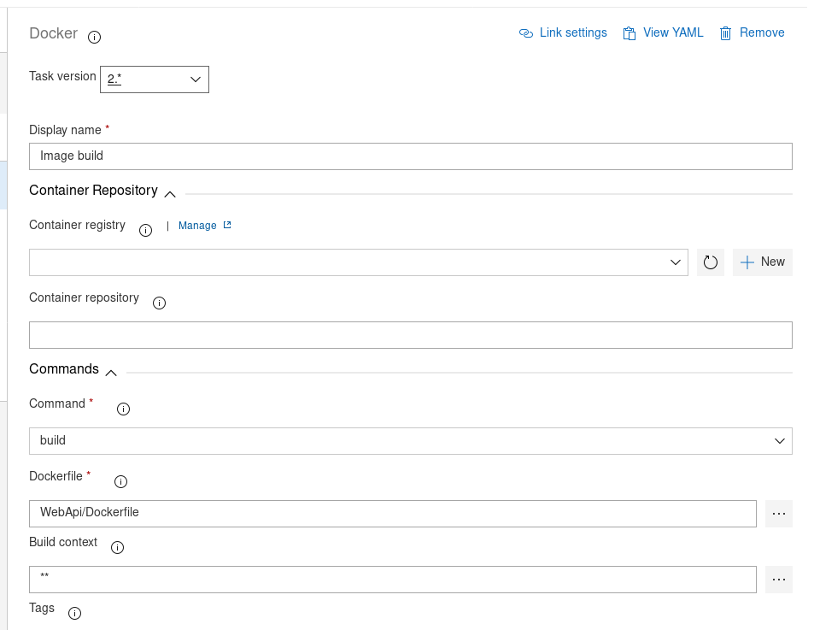

Task02: -Image push to ACR
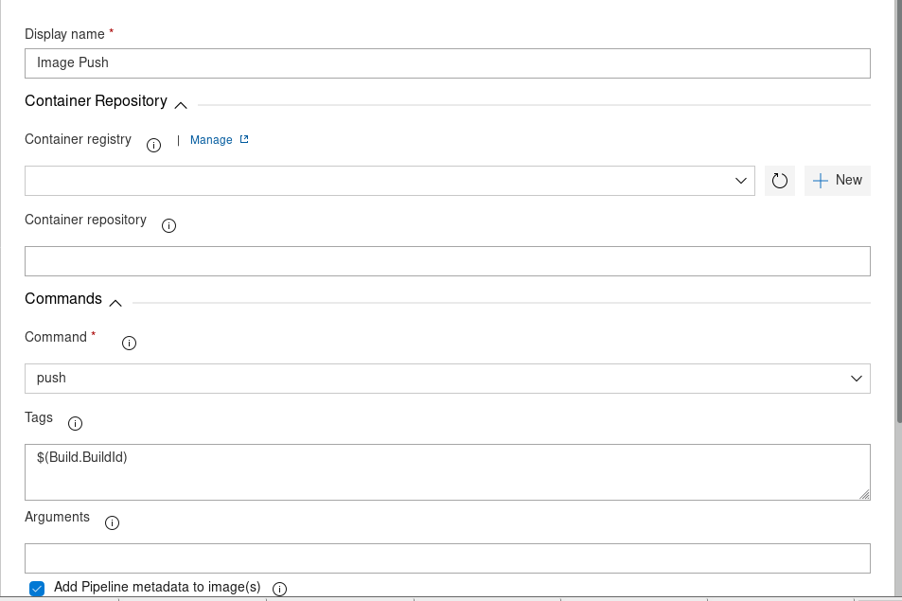

Task03:-Update the latest build image using the replacement token task.
Here latest build image will update in the deployment file “WebApi-Deployment.yaml” using the token prefix
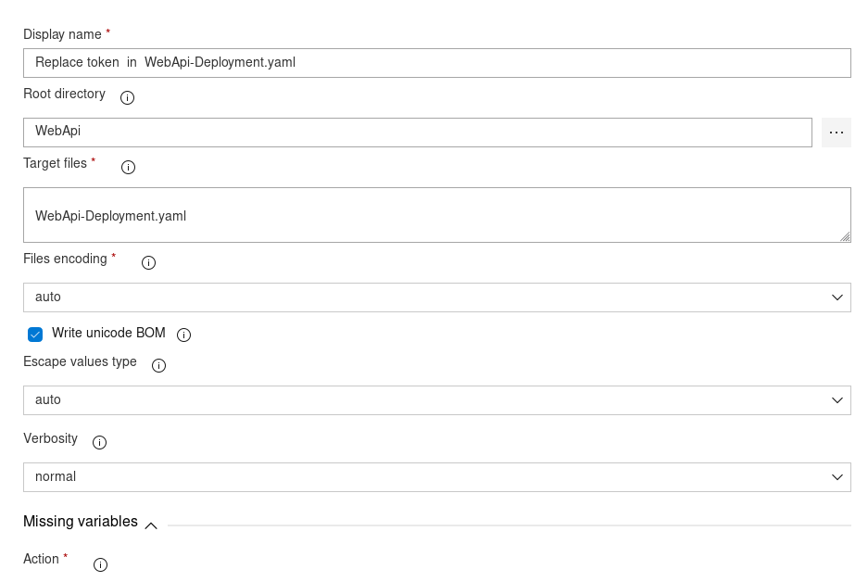
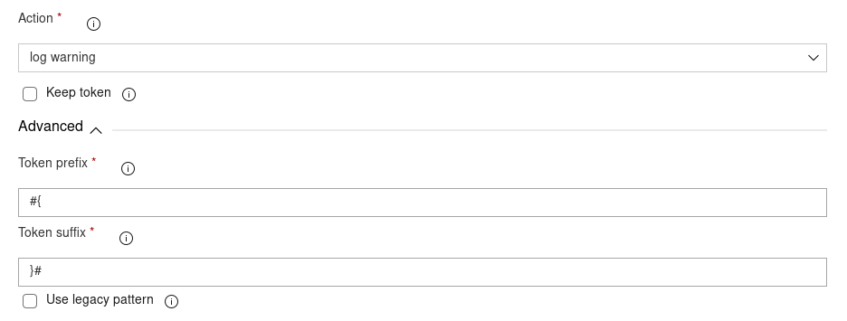

Task04: Copy the Artifacts:

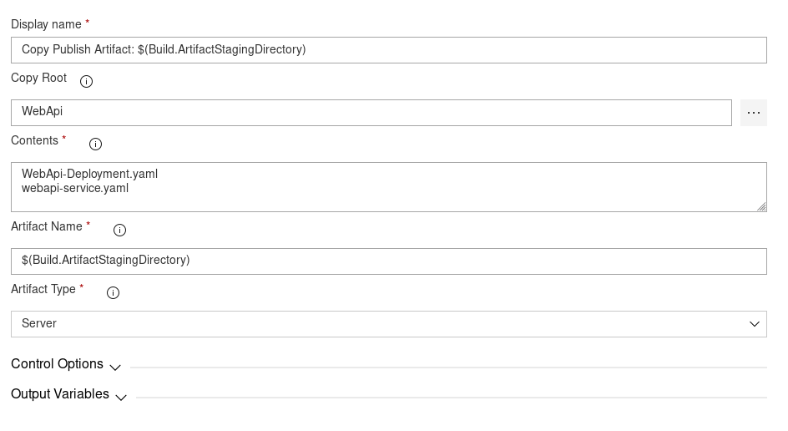

Task05: Publish the artifact for the release pipeline .

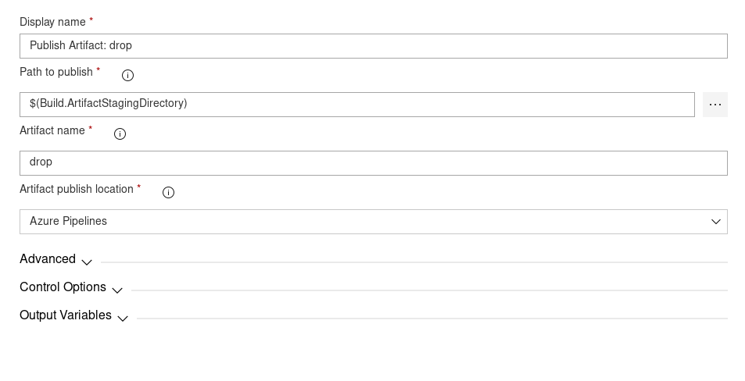
# Release Pipeline

Next Step we have to create the release pipeline using the CI artifact . In the release pipeline we have to select job as Deploy to Kubernetes.
Since we have to two definition file on is for the Deployment and other is for the Service.So, we have to create two task

Task01: One you add the task then we have to authenticate with the azure portal and need to specify in which name-space.
we want to deploy and we need to choose the command for the action so, here we will select “apply” and we will provide the
Deployment file location.
Task02 : Same thing we have to for the Service as well .Once you have done this then you are ready for the release .

