# 1-We will create a key vault, from the Azure portal, to store the VM password.
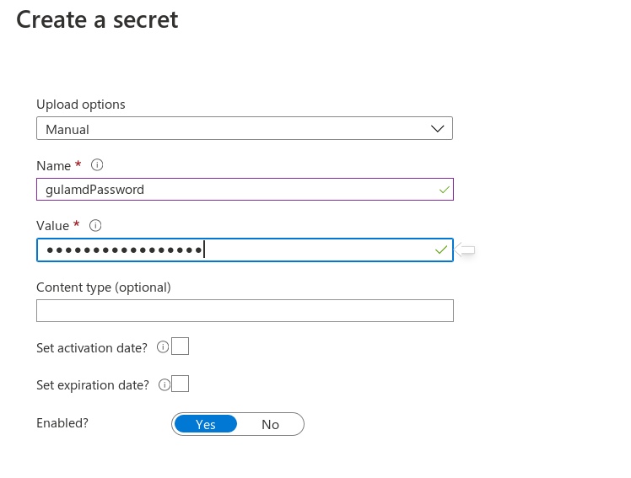
# 2-We will configure access policy for template deployment.

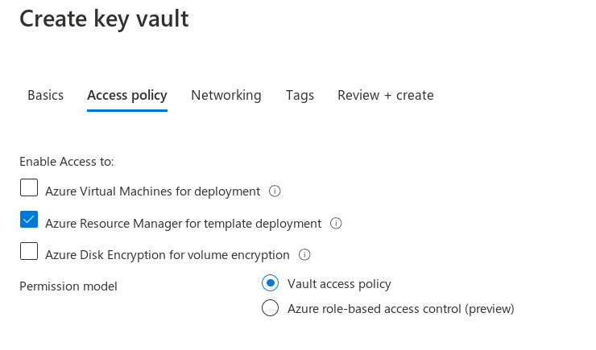
# 3-We will retrieve the password in ARM template using the Key vault resource ID .

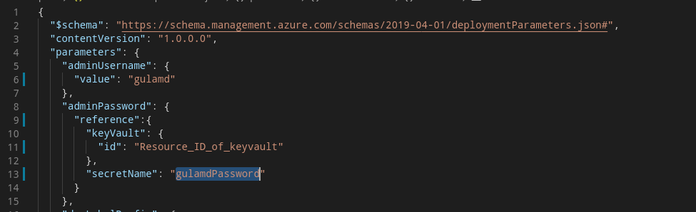

# 4- Push the code to the github registory for the use of azure devops pipeline.

# 5- Create the Organization in the Azure Devops Services.

# 6- Create the Project

# 7- Create CI Pipeline

a- Get the Source code from the Git repository

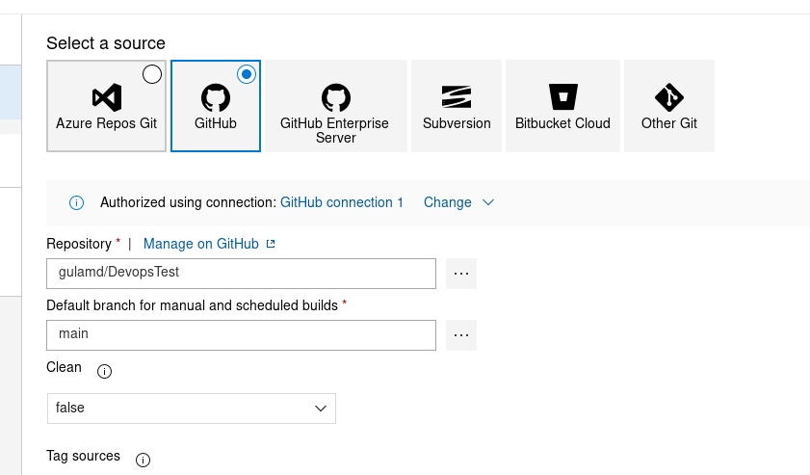
b- Add the task to Copy the *.json file.

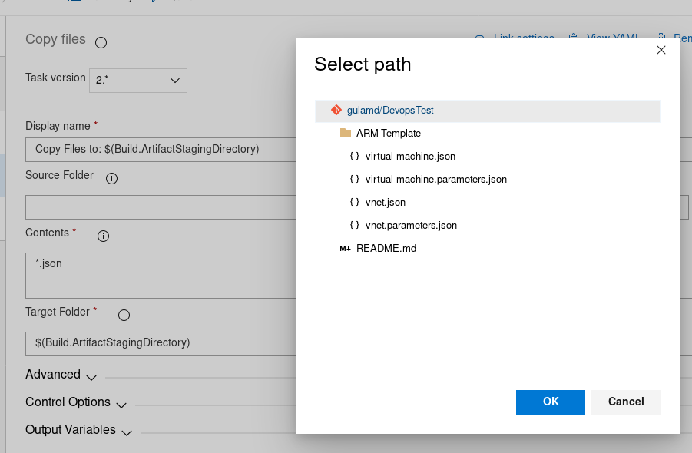

C-Add another task to publish the artifacts for the release pipeline.

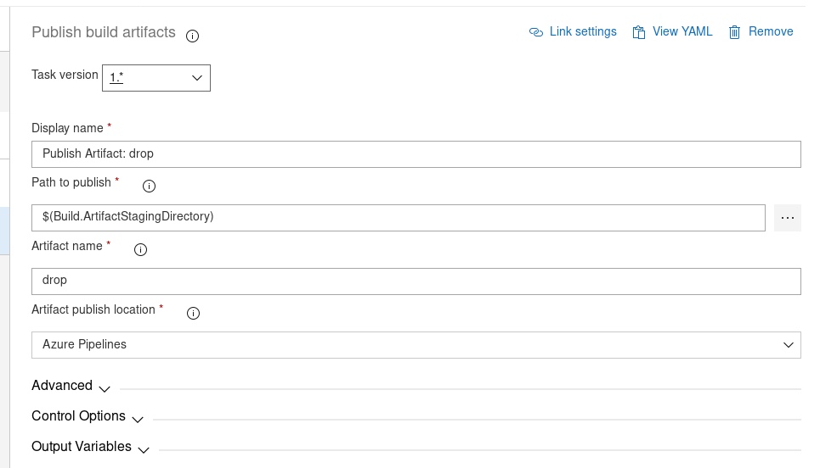

# 8-Next we need to run the CI pipeline to generate the artifacts.

# Create the Release pipeline .

a- Create task to deploy the Vnet
b- Create task to deploy the VM

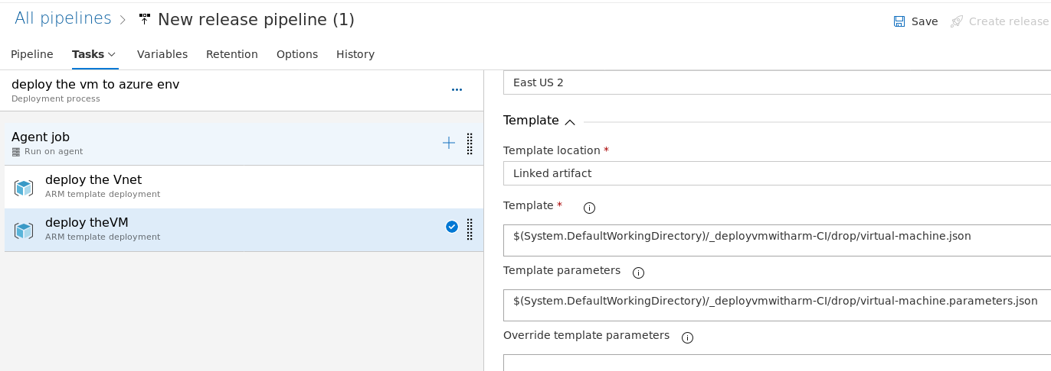

c- Here we need to integrate Azure key vault to pass the Admin Password because we did put the password in our script .

d- Create Variable group to integrate the azure key vault .

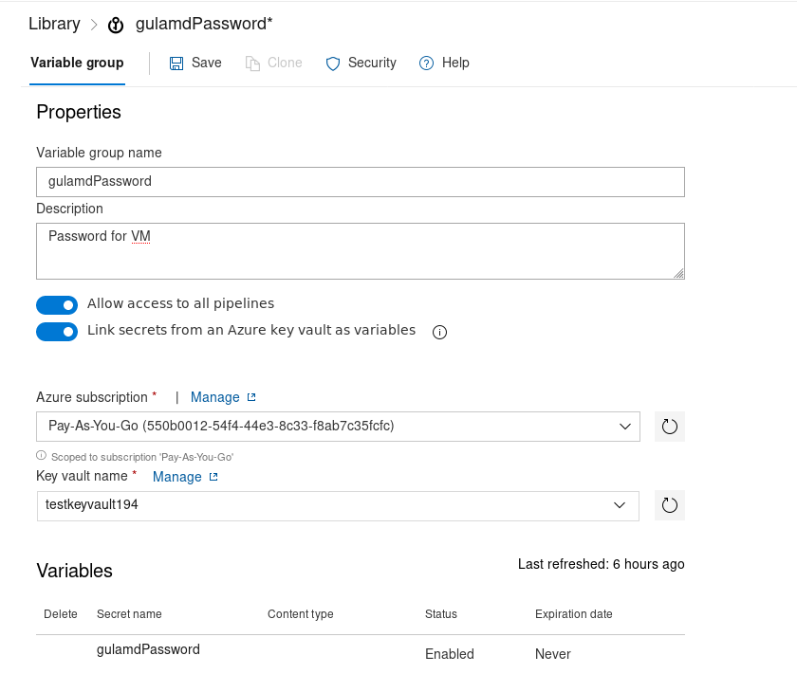

e- After this we need to pass the variable under the override template parameters.

