TECHNICAL PROJECT REPORT

# Title of Invention / Project:

RFID LOCK WITH ARDUINO

# Team Members / Inventors:

|  |  |  |  |  |  |
| --- | --- | --- | --- | --- | --- |
| **S.No.** | **Name** | **Department** | **Designation** | **Mobile** | **E-Mail** |
| 1. | Shaikh gulam jilani | cse | member | 8104355321 | gulamjilani61973@gmail.com |
| 2. | AAKASH KUMAR | CSE | LEADER | 7696146484 | aakashkumar160899@gmail.com |
| 3. | Isha limbu | cse | member | 8264610939 | ishalimbu001@gmail.com |
| 4. | Aman negi | cse | member | 9557926450 | amann931@gmail.com |
| 5. | Khushal Thakur | ECE | Mentor | 9646030764 | khushal.thakur@cumail.in |
| 6. | Anshul Sharma | ECE | Mentor | 9478697475 | anshulsharma.ece@cumail.in |
| 7. | Kiran Jot Singh | ECE | Mentor | 9463909689 | kiranjotsingh.ece@cumal.in |
| 8. | Divneet Singh Kapoor | ECE | Mentor | 9878422653 | divneet.ece@cumail.in |

Section – 1 (IPR Related)

# Brief Abstract (500 words):

* It is good looking suited for homes with good decor hassle free access to those whom you entrusted your lock password using card.
* It is cheap version of electronic lock we have used big arduino and rfid reader to read the genuine card and give access to people with right card it has buzzer which beeps accordingly.
* We have used bulky arduino Uno but we can use small microprocessors we can use Bluetooth for opening lock we can connect it with net and programme it send us information if someone was trying to access lock illegally we can use finger scanner to unlock the lock

# Existing state-of-the-art and Drawbacks in existing state-of-the-art

|  |  |  |
| --- | --- | --- |
| **S. No.** | **Existing state of art** | **Drawbacks in existing state of art** |
| 1 | BULKY | Not easy to install or it is not very much portable |
| 2 | RUNS ON MAIN POWER SUPPLY | IF power goes off u cannot open it manually |

# Novel/Additional modifications that you can propose to improve upon drawbacks

*(List down the features)*

* Rechargeable battery can be integrated
* We can use arduino nano

# Advantages

(*List down the advantages, if each feature is incorporated)*

* We can access lock if electricity goes off.
* It will reduce the size of lock .

# Block Diagram

(*Functional diagram depicting the flow of information in your system. Do not define exact components, only use generic terms. Must include modification*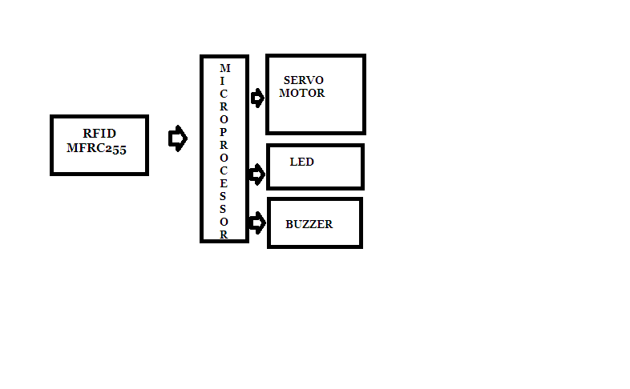

Section – 2 (Real Project)

# MateriaL 1 x RFID MFRC522 (SPI communication) 1 x servo-motor 9g 1 x BLUE LED 1 x YELLOW LED 2 x 220 Ohm reistor 1 x Buzzer 1 x Bread Board wires and cables to the connection

# Circuit Diagram

(*Fully functional circuit diagram with exact connections. Can use Fritzing/Proteus*)

# Steps of Circuit Completion

(*Bifurcate the circuit completion in steps, specify with photographs, leading to final project*)

## Step 1: Operation

**OPERATION:**

**ID TAG IS SPECIFIED IN CODE**

**When right tag is encountered blue led glows and buzzer beeps with sound accordingly.And the servo motor rotates showing opening of lock and after 10 seconds it rotates back showing locking of door.When right tag is not found buzzer beeps with error sound and yellow led glows indicating .Wrong tag.**

## Step 2: Stuff and Materials

[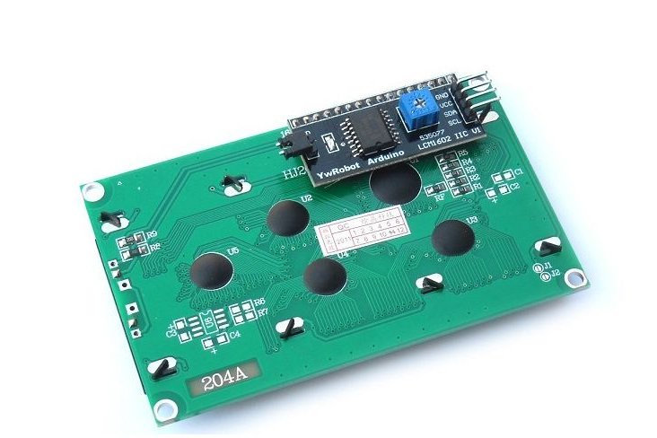](https://cdn.instructables.com/F84/YGC6/HHMI5AKV/F84YGC6HHMI5AKV.LARGE.jpg)[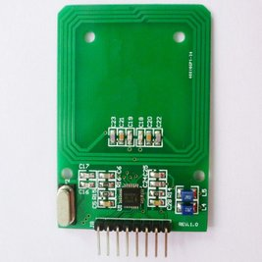](https://cdn.instructables.com/FLK/D1ZJ/HHMI5AKX/FLKD1ZJHHMI5AKX.LARGE.jpg)

[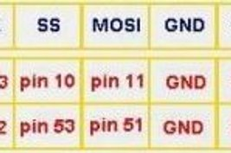](https://cdn.instructables.com/FSK/5HF6/HHMI5AKZ/FSK5HF6HHMI5AKZ.LARGE.jpg)

**STUFF and MATERIALS:**  
  
1 x Arduino uno  
1 x RFID MFRC522AN (SPI communication)  
1 x servo-motor 9g  
1 x green LED  
1 x red LED  
2 x 220 Ohm reistor  
1 x Buzzer  
1 x Bread Board  
wires and cables to the connection

## Step 3: Device Interconnections

[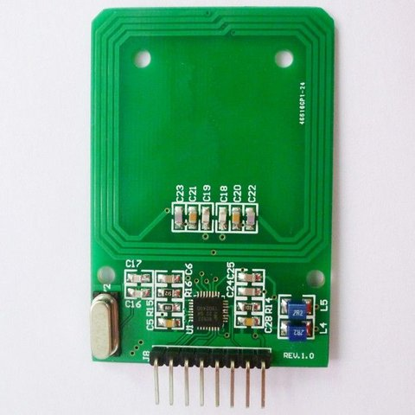](https://cdn.instructables.com/FVX/N7YV/HHMI5AM2/FVXN7YVHHMI5AM2.LARGE.jpg)

[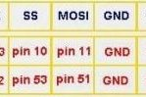](https://cdn.instructables.com/FK8/EDFC/HHMI5AM6/FK8EDFCHHMI5AM6.LARGE.jpg)

**INTERCONNECTIONS:**  
  
  
Interconnections from the RFID to the Arduino pins:  
Reset     > Pin 5  
SS           > Pin 10  
MOSI      > Pin 11  
MISO      > Pin 12  
SCK       > Pin 13  
Ground  > Ground  
3.3v        > 3.3v

## Step 4: The Whole Project Interconnections

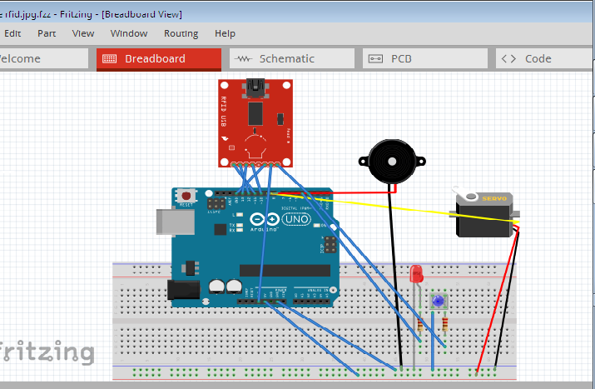

**The whole project:**  
  
 th eRFID is the MRFC522AN device.  
The Buzzer and the servo motor are general purpose devices.

## Step 5: Programming

[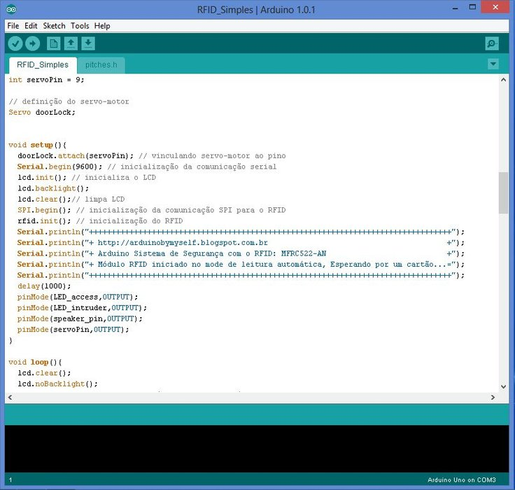](https://cdn.instructables.com/F4W/VXRP/HHMI5AN1/F4WVXRPHHMI5AN1.LARGE.jpg)

Below you have the Arduino's sketch, that should be placed in a folder with the same name of the file.  
  
In the next link you have the file "pitches.h" it is necessary to play the musical notes and the sounds, it must be in the same folder of the Arduino sketch.  
[L](https://docs.google.com/file/d/0B_YlEklLDDS7cmVDQmRpT29xRlE/edit?usp=sharing)ibraries:

[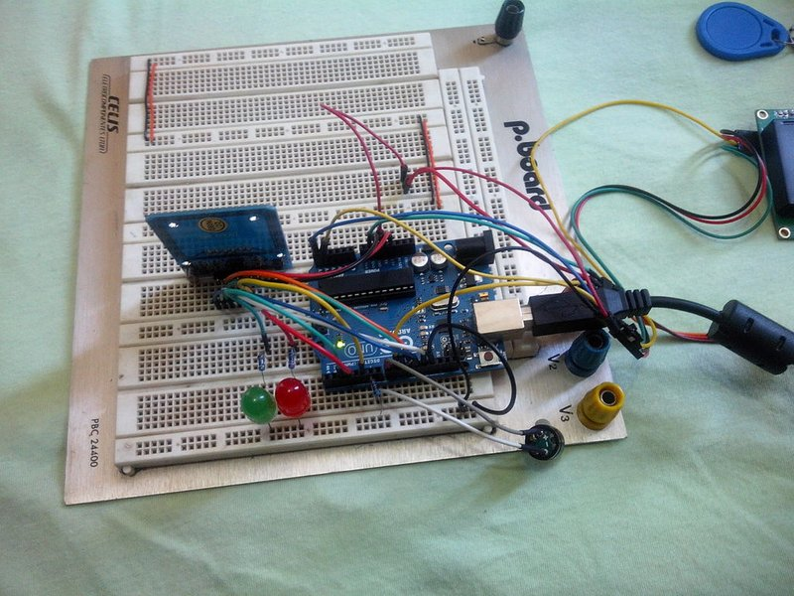](https://cdn.instructables.com/FCV/GTD3/HHMI5ANJ/FCVGTD3HHMI5ANJ.LARGE.jpg)

# Program Code

(*Link of your Github project*)