**REPORT**

**PubMed Research Paper Fetcher**

Project Structure

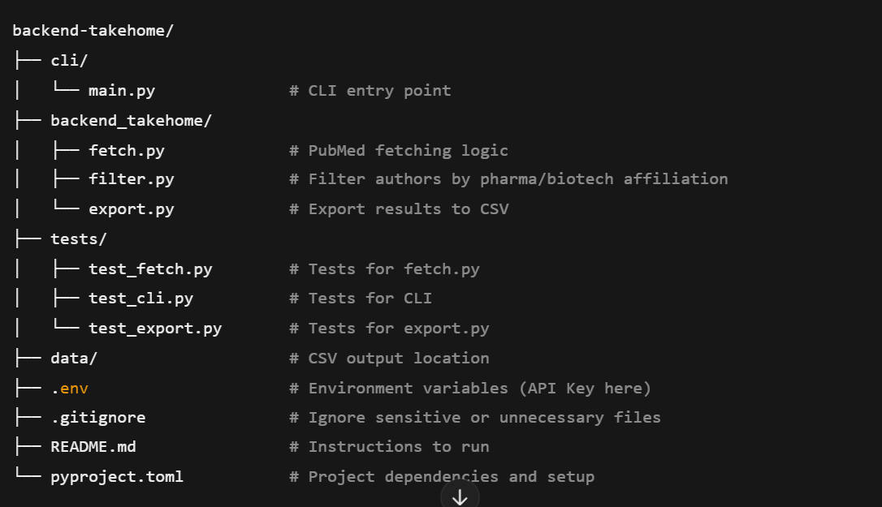

**Requirements Checklist**

Of course! Here's your checklist in simpler, easy-to-understand words, but keeping all your points intact:

**Checklist of Requirements**

### Where the Papers Come From

* Use the PubMed API to get papers ✅
* Allow full PubMed search features (all query options) ✅

### Output Format

* Give the results as a CSV file with these columns:
  + PubMed ID ✅
  + Title of the paper ✅
  + Date it was published ✅
  + Names of non-academic authors ✅
  + Company affiliations (if any) ✅
  + Email of the corresponding author ✅

### Features for the Command-line Tool

* Let the user pass the search query through the command line ✅
* Include these options:
  + -h or --help: Show help instructions ✅
  + -d or --debug: Show debug info while running ✅
  + -f or --file: Let the user choose the output filename ✅

### Code Setup and Environment

* **Version Control:**
  + Use Git for tracking changes ✅
  + Host the code on GitHub ✅
* **Dependencies and Setup:**
  + Use Poetry for managing dependencies and packaging ✅
  + Running poetry install should set up everything ✅
* **Execution:**
  + There should be an executable command called get-papers-list through Poetry ✅

### Documentation

* Add a README.md that explains:
  + How the code is structured ✅
  + How to install what’s needed and how to run the program ✅
  + What tools were used to build the program, with useful links ✅

### How the Project Will Be Evaluated

* **Functional:**
  + Does it do what the problem describes? ✅
  + Can it fetch and filter papers properly? ✅
* **Non-functional:**
  + Use type hints in Python throughout the code ✅
  + Efficient use of the API and data processing ✅
  + Code is easy to read, well-commented, and has clear docstrings ✅
  + Good code organization with separate, logical parts ✅
  + Solid error handling for bad queries, API issues, or missing info ✅

### Extra Credit!

* Split the project into:
  + A reusable module ✅
  + A command-line tool that uses the module ✅
* Publish the module to Test PyPI ✅