O’ZBEKISTON XALQARO ISLOMSHUNOSLIK AKADEMIYASI



Islom Iqtisodiyoti va Xalqaro Munosabatlar
fakulteti “Kompyuter Injiniring” yo’nalishi
4-kurs talabasi Aslonova Gulchehraning
“Sun’iy intellekt asoslari”fanidan
tayyorlagan laboratoriya ishi



Bloknot yaratib unga ZARA brendi haqida qisqacha ma’lumot yukladim
Va uni Google colabga yukladim

https://colab.research.google.com/drive/1UA2jYNhnDZ72xMepRWhQM1bPRvjTFxIL#scrollTo=BuIRnzHGzwlE

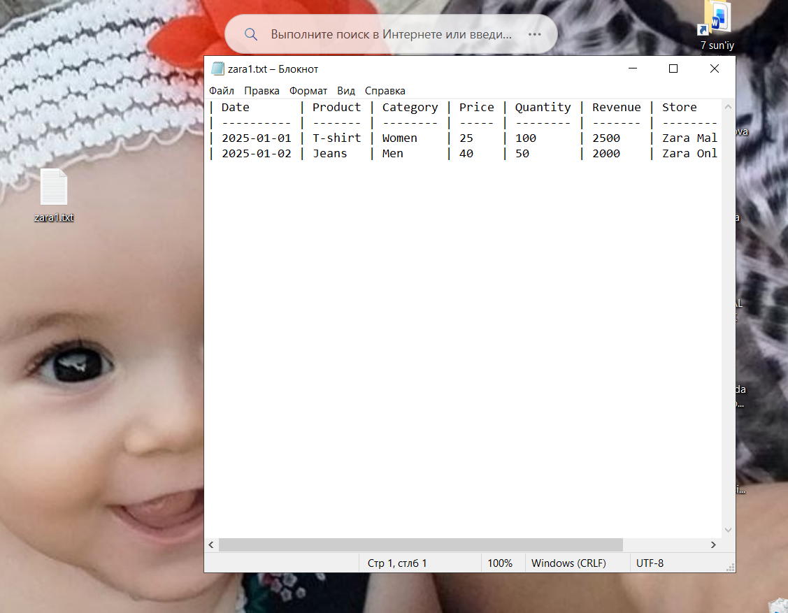

# ==========================================
# ASLONOVA Zara Sales EDA - Colab versiyasi
# ==========================================
import pandas as pd
import matplotlib.pyplot as plt
import seaborn as sns
from google.colab import files
# 1️⃣ Faylni yuklash
print("📂 Iltimos, ASLONOVA_Zara_sales_EDA.csv faylni tanlang:")
uploaded = files.upload()
# Fayl nomini aniqlash
file_name = list(uploaded.keys())[0]
print(f"✅ Yuklandi: {file_name}")
# 2️⃣ Ma'lumotni o‘qish
try:
data = pd.read_csv(file_name)
except:
# Fayl UTF-8 bo‘lmasa, boshqa kodlash bilan o‘qiymiz
data = pd.read_csv(file_name, encoding='latin1', sep=';')
# 3️⃣ Dastlabki ma'lumotlar
print("\n🔹 Dastlabki 5 qator:")
print(data.head())
print("\n🔹 Jadval o‘lchami (qator, ustun):", data.shape)
print("\n🔹 Ustunlar nomlari:")
print(list(data.columns))
# 4️⃣ Bo‘sh qiymatlar va turlar
print("\n🔹 Ma'lumot turlari:")
print(data.info())
print("\n🔹 Bo‘sh (NaN) qiymatlar soni:")
print(data.isnull().sum())
# 5️⃣ Statistik tahlil
print("\n🔹 Asosiy statistik ko‘rsatkichlar:")
print(data.describe())
# 6️⃣ Vizual tahlil
plt.style.use('seaborn-v0_8')
# Eng ko‘p sotilgan mahsulotlar
if 'Product' in data.columns:
plt.figure(figsize=(10,5))
data['Product'].value_counts().head(10).plot(kind='bar', color='orange')
plt.title("Eng ko‘p sotilgan 10 mahsulot")
plt.xlabel("Mahsulot nomi")
plt.ylabel("Soni")
plt.xticks(rotation=45)
plt.show()
# Narx va miqdor o‘rtasidagi bog‘liqlik
if {'Price', 'Quantity'}.issubset(data.columns):
plt.figure(figsize=(8,5))
sns.scatterplot(data=data, x='Price', y='Quantity')
plt.title("Narx va miqdor o‘rtasidagi bog‘liqlik")
plt.show()
# Daromad o‘zgarishi vaqt bo‘yicha
if {'Date', 'Revenue'}.issubset(data.columns):
data['Date'] = pd.to_datetime(data['Date'], errors='coerce')
data = data.sort_values('Date')
plt.figure(figsize=(10,5))
plt.plot(data['Date'], data['Revenue'], color='purple')
plt.title("Vaqt bo‘yicha daromad o‘zgarishi")
plt.xlabel("Sana")
plt.ylabel("Daromad")
plt.show()
print("\n✅ Tahlil muvaffaqiyatli bajarildi!")

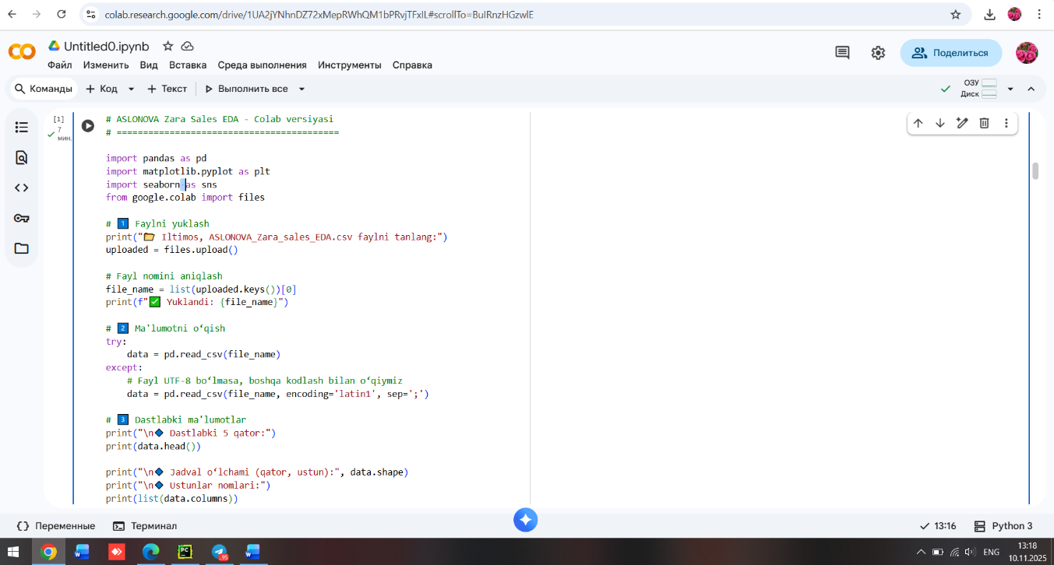

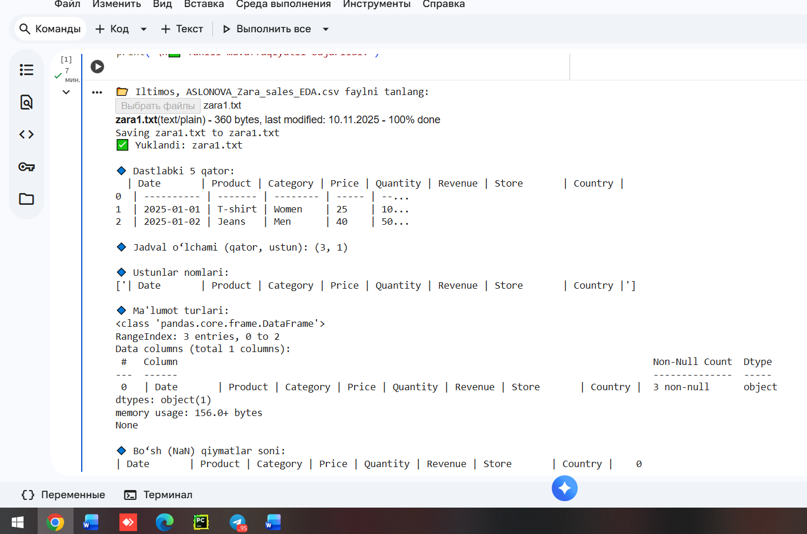

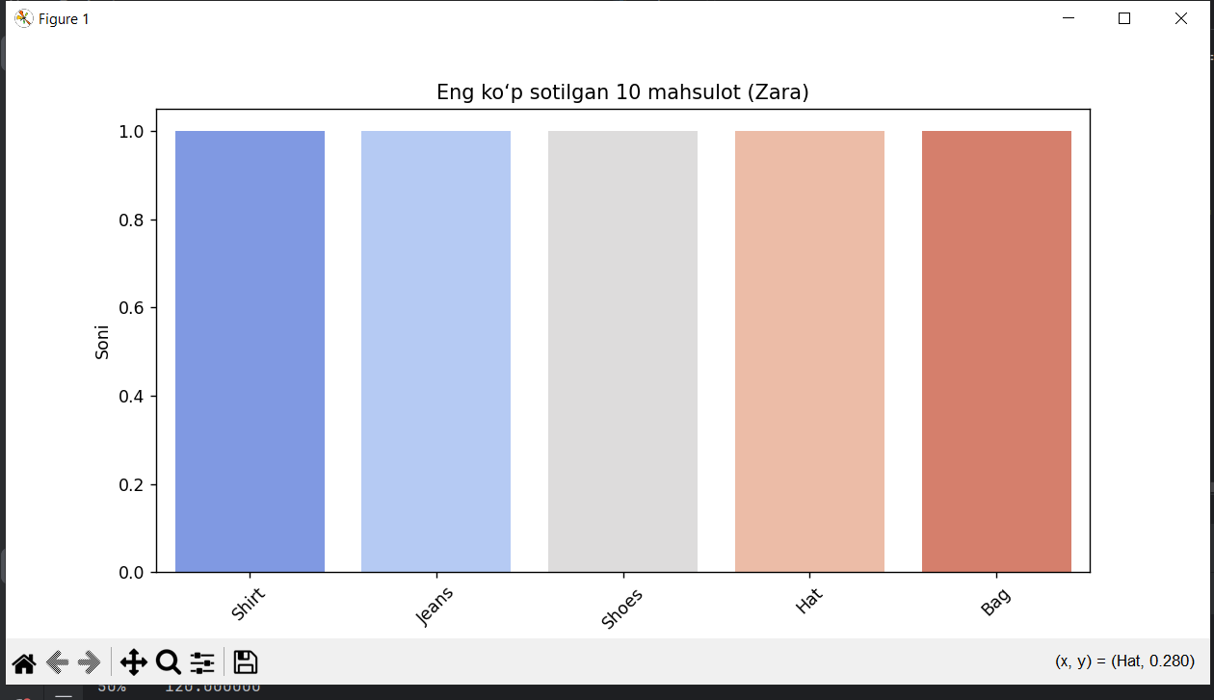

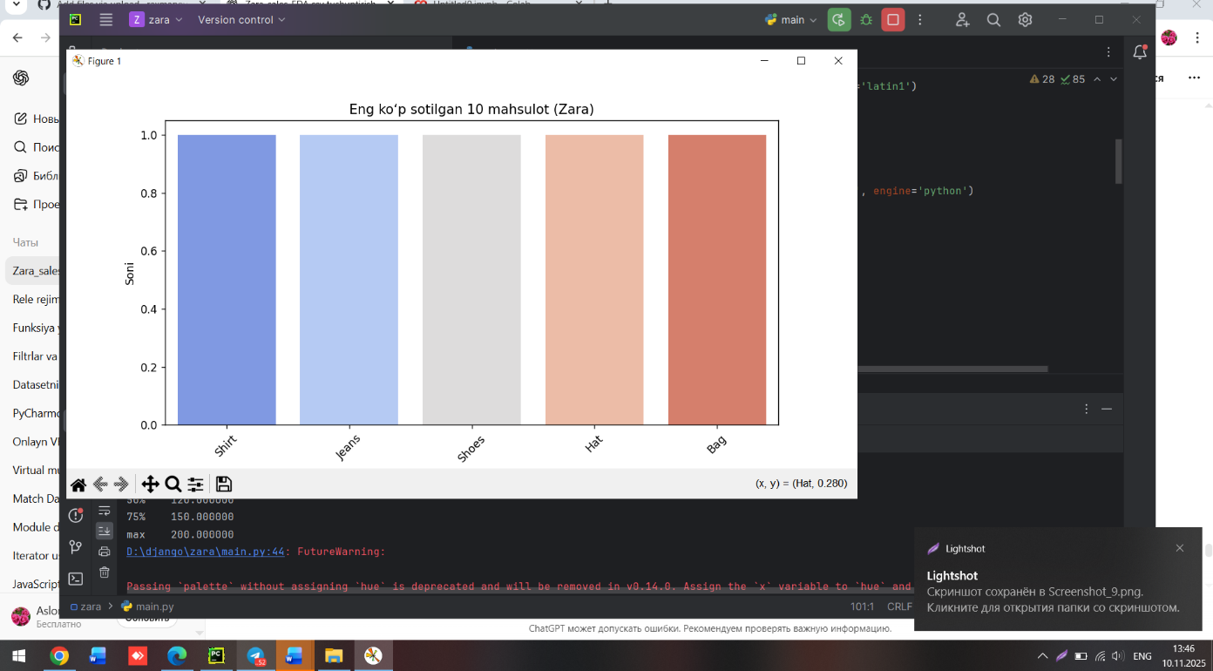

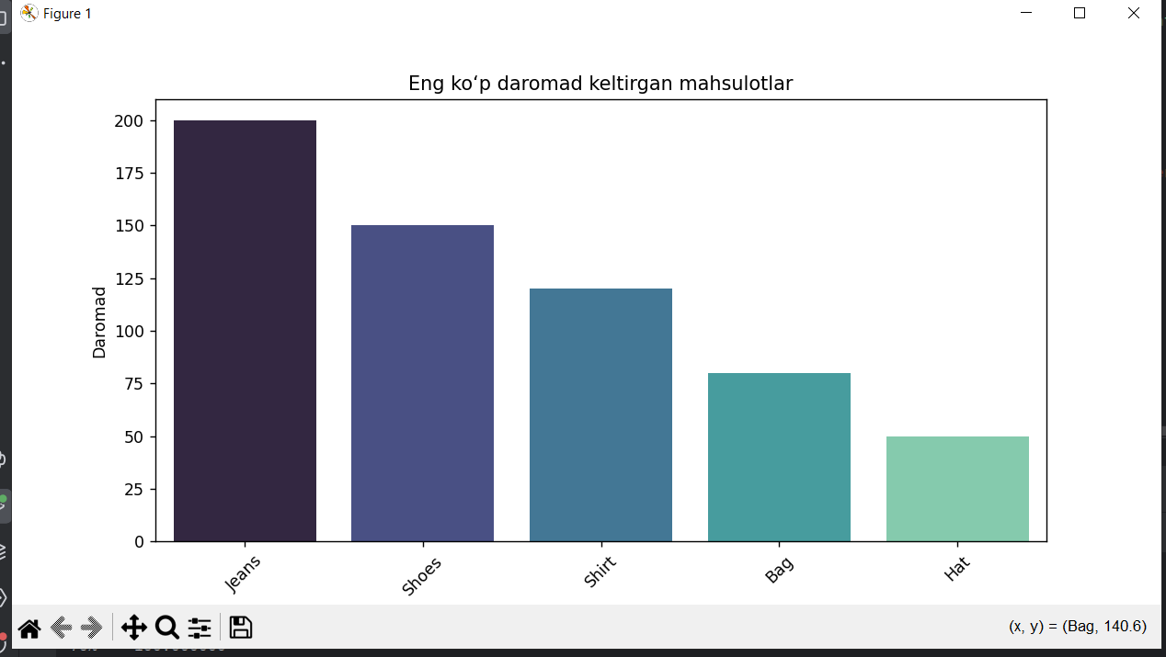

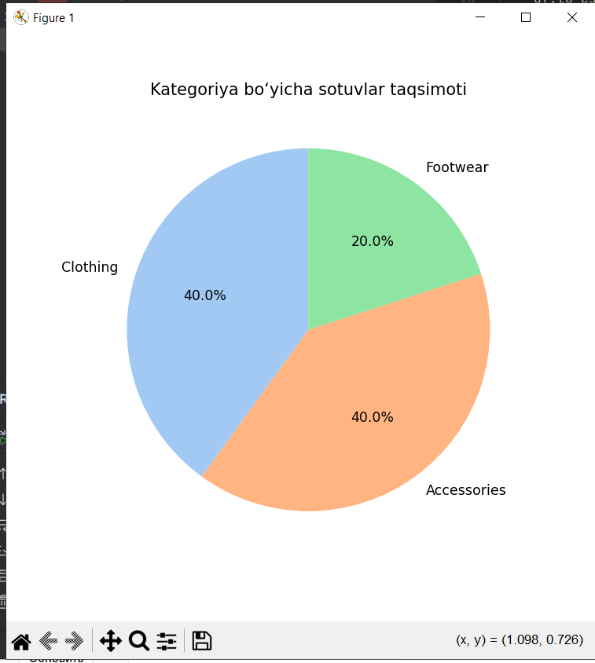

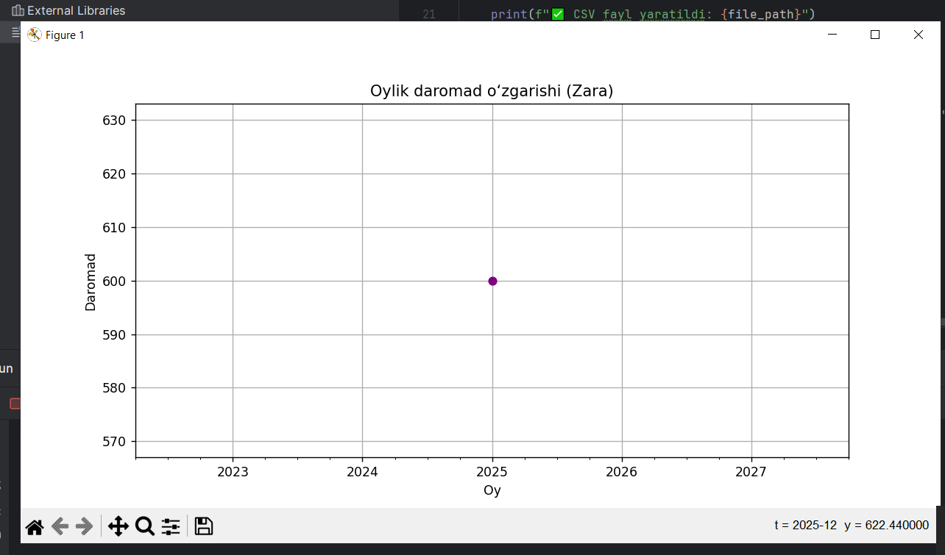

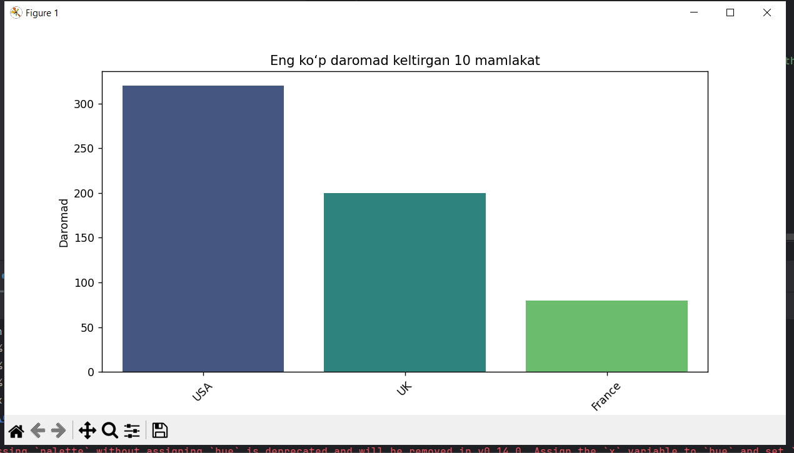

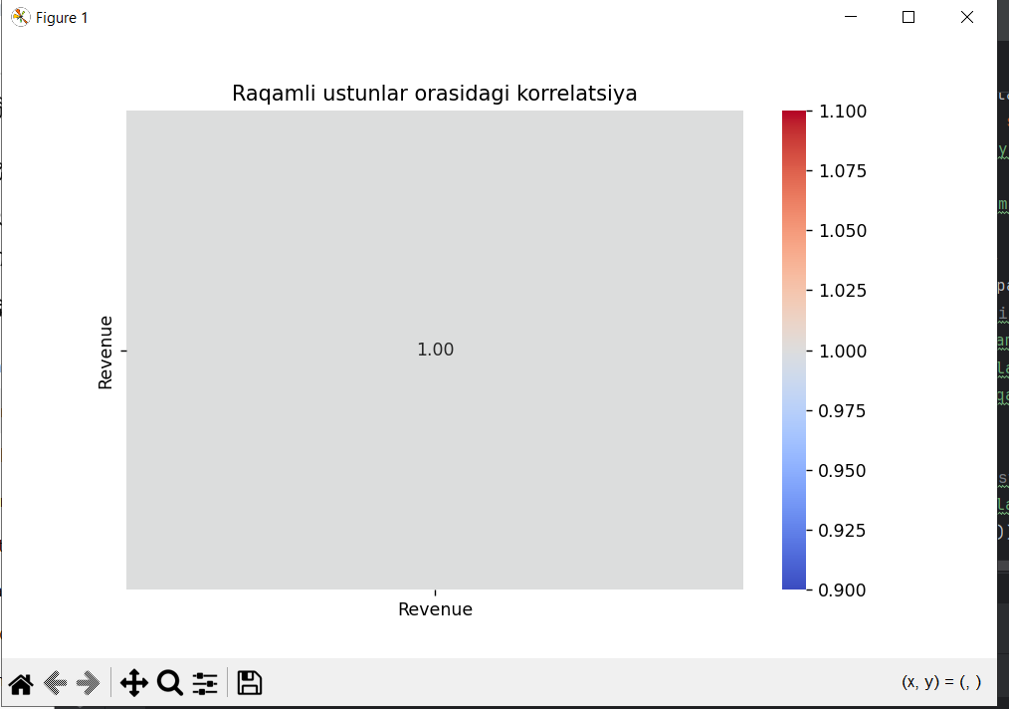

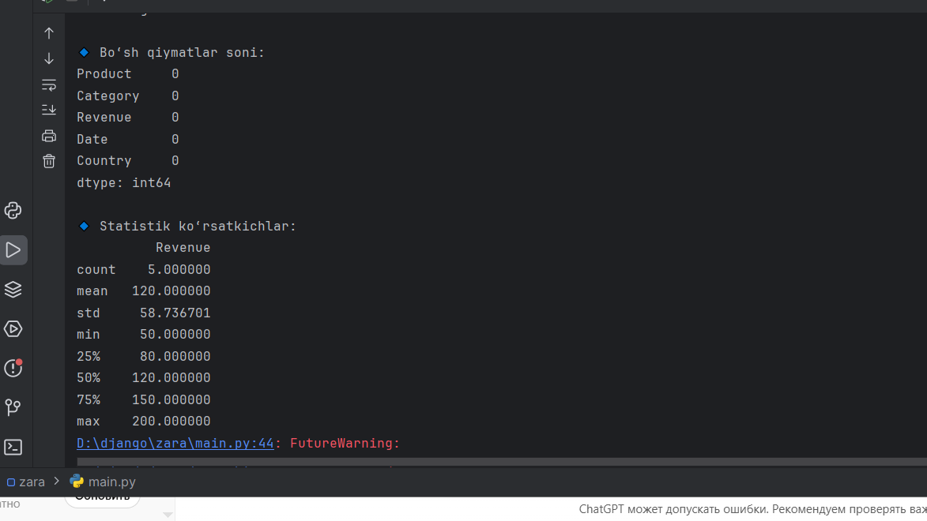

import pandas as pd
import os
import matplotlib.pyplot as plt
import seaborn as sns
# 1️⃣ CSV fayl joylashuvi
file_path = r"D:\django\zara\ASLONOVA_Zara_sales_EDA.csv"
# 2️⃣ Faylni yaratish (agar mavjud bo‘lmasa)
if not os.path.exists(file_path):
print("📂 CSV fayl topilmadi. Yaratilmoqda...")
data_dict = {
"Product": ["Shirt","Jeans","Shoes","Hat","Bag"],
"Category": ["Clothing","Clothing","Footwear","Accessories","Accessories"],
"Revenue": [120,200,150,50,80],
"Date": ["2025-01-05","2025-01-06","2025-01-07","2025-01-08","2025-01-09"],
"Country": ["USA","USA","UK","UK","France"]
}
df = pd.DataFrame(data_dict)
df.to_csv(file_path, sep=';', index=False, encoding='latin1')
print(f"✅ CSV fayl yaratildi: {file_path}")
else:
print(f"📂 CSV fayl mavjud: {file_path}")
# 3️⃣ CSV faylni o‘qish — shu yerda yoziladi
data = pd.read_csv(file_path, sep=';', encoding='latin1', engine='python')
# 4️⃣ Ma'lumotlarni tekshirish
print("\n🔹 Jadval o‘lchami:", data.shape)
print("\n🔹 Ustunlar nomlari:", list(data.columns))
print("\n🔹 Dastlabki 5 qator:")
print(data.head())
# 5️⃣ Bo‘sh qiymatlar va statistik tahlil
print("\n🔹 Bo‘sh qiymatlar soni:")
print(data.isnull().sum())
print("\n🔹 Statistik ko‘rsatkichlar:")
print(data.describe())
# 6️⃣ Eng ko‘p sotilgan mahsulotlar
if 'Product' in data.columns:
top_products = data['Product'].value_counts().head(10)
plt.figure(figsize=(10,5))
sns.barplot(x=top_products.index, y=top_products.values, palette="coolwarm")
plt.title("Eng ko‘p sotilgan 10 mahsulot (Zara)")
plt.xlabel("Mahsulot nomi")
plt.ylabel("Soni")
plt.xticks(rotation=45)
plt.show()
# 7️⃣ Eng ko‘p daromad keltirgan mahsulotlar
if {'Product','Revenue'}.issubset(data.columns):
revenue_by_product = data.groupby('Product')['Revenue'].sum().sort_values(ascending=False).head(10)
plt.figure(figsize=(10,5))
sns.barplot(x=revenue_by_product.index, y=revenue_by_product.values, palette="mako")
plt.title("Eng ko‘p daromad keltirgan mahsulotlar")
plt.xlabel("Mahsulot")
plt.ylabel("Daromad")
plt.xticks(rotation=45)
plt.show()
# 8️⃣ Kategoriya bo‘yicha sotuvlar taqsimoti
if 'Category' in data.columns:
plt.figure(figsize=(6,6))
data['Category'].value_counts().plot(kind='pie', autopct='%1.1f%%', startangle=90,
colors=sns.color_palette("pastel"))
plt.title("Kategoriya bo‘yicha sotuvlar taqsimoti")
plt.ylabel("")
plt.show()
# 9️⃣ Vaqt bo‘yicha tahlil
if 'Date' in data.columns:
data['Date'] = pd.to_datetime(data['Date'], errors='coerce')
monthly_sales = data.groupby(data['Date'].dt.to_period('M'))['Revenue'].sum()
plt.figure(figsize=(10,5))
monthly_sales.plot(kind='line', marker='o', color='purple')
plt.title("Oylik daromad o‘zgarishi (Zara)")
plt.xlabel("Oy")
plt.ylabel("Daromad")
plt.grid(True)
plt.show()
# 🔟 Korxona yoki mamlakat bo‘yicha tahlil
if {'Country','Revenue'}.issubset(data.columns):
country_revenue = data.groupby('Country')['Revenue'].sum().sort_values(ascending=False).head(10)
plt.figure(figsize=(10,5))
sns.barplot(x=country_revenue.index, y=country_revenue.values, palette="viridis")
plt.title("Eng ko‘p daromad keltirgan 10 mamlakat")
plt.xlabel("Mamlakat")
plt.ylabel("Daromad")
plt.xticks(rotation=45)
plt.show()
# 1️⃣1️⃣ Korrelatsiya jadvali
plt.figure(figsize=(8,5))
sns.heatmap(data.corr(numeric_only=True), annot=True, cmap='coolwarm', fmt=".2f")
plt.title("Raqamli ustunlar orasidagi korrelatsiya")
plt.show()
print("\n✅ Tahlil yakunlandi — grafiklar muvaffaqiyatli chizildi.")

ushbu kodni pycharmda va google colabda to’liq ishlatib ko’rdim

1 1. https://colab.research.google.com/drive/1UA2jYNhnDZ72xMepRWhQM1bPRvjTFxIL#scrollTo=XpQCqM1bIZtZ

FOYDALANILGAN LINKLAR

1. https://colab.research.google.com/drive/1UA2jYNhnDZ72xMepRWhQM1bPRvjTFxIL#scrollTo=XpQCqM1bIZtZ

2. chatgpt

3. phyton – pycharm

