

**Front-End UX Audit & Enhancement Proposal for Decibel HRMS**

**Department:** Human Resources

**Prepared by:** Gul-e-Fatima Faisal

**Date:** July, 2025.

**Table of Content**

Introduction -------------------------------------------------------------------------------1

Project Scope -----------------------------------------------------------------------------2

Objectives ---------------------------------------------------------------------------------3

Methodology ------------------------------------------------------------------------------4

Phase 1 -------------------------------------------------------------------------------------5

Phase 2 -------------------------------------------------------------------------------------6

Phase 3 -------------------------------------------------------------------------------------7

Interface Design Overview --------------------------------------------------------------8

Conclusion --------------------------------------------------------------------------------9

**Introduction**

This project aims to improve the user experience of ***Decibel HRMS (Human Resource Management System)*** by reviewing and enhancing its front-end functionality. The goal is to identify areas for improvement, redesign one module and provide recommendations for better usability and efficiency.

**Project Scope**

The project scope focuses on improving the user experience and front-end functionality of following modules of Decibel HRMS:

* Performance Management
* Recruitment
* Probation
* Workforce Administration
* Travel
* Leaves

**Objective**

The objective of this project is to improve the user experience (UX) and front-end functionality of Decibel HRMS by:

* Identifying the usability gaps.
* Suggesting front-end enhancements.
* Redesigning one module to show improvements.

**Methodology**

This project was done in three ways:

* **Review of Existing System:**

Evaluation of each module’s navigation clarity, information layout, colour consistency, mobile responsiveness, and loading speed.

* **Redesign of One Module:**

Complete redesign of the Performance Management module including:

* Improved layout
* Visual enhancements (icons, buttons)
* Simplified user interactions
* **Documentation of Findings:**

Compilation of screenshots (before and after), usability gaps, redesign mock-ups, and recommendations in a final report and presentation format.

**Phase 1 – Usability Review**

A detailed usability audit was conducted on all selected HR modules using the following evaluation parameters:

**Evaluation Criteria:**

* Navigation Clarity
* Information Layout
* Colour Consistency & Accessibility
* Mobile Responsiveness
* Speed & Loading

|  |  |  |  |  |  |
| --- | --- | --- | --- | --- | --- |
| **Module** | **Navigation Clarity** | **Info Layout** | **Colour Consistency** | **Mobile Responsiveness** | **Speed** |
| Performance Management | Confusing | Misaligned | Colour doesn’t match branding | Not responsive | Moderate |
| Recruitment | Confusing | Mixed details | Inconsistent colour scheme | Screen scrolls horizontally | Fast |
| Probation | Label loads late | Misaligned | Branding colours off | Not responsive | Moderate |
| Employment Form | Average | Overloaded | Colour usage is uneven | Not responsive | Slow |
| Workforce Admin | Mixed | Average | Colour don’t fit well | Not responsive | Moderate |
| Travel | Better than others | Basic | Colour palette feels off | Limited responsive | Slow |
| Leaves | Clear | Poor alignment | Colour scheme not uniformed | Basic mobile view | Fast |

**Phase 2: Redesign – Performance Management Module**

The ***Performance Management*** module was selected for redesign because it is used often and had the most complaints about usability.

**Main Problems Found:**

* Too many tabs made navigation confusing
* Colours were inconsistent across screens
* Didn’t work well on mobile devices
* Tasks needed required many clicks and page reloads
* Important information was not easy to find

**What Was Improved:**

* **Improved Navigation:** A simple sidebar with clear icons and labels
* **Clean Layout:** Information is grouped in cards and sections
* **Consistent Colours:** Used a proper colour theme across all screens
* **Mobile-friendly:** Fully responsive using CSS Grid and Flexbox
* **Modern UI:** New icons and clear action buttons.

**Before vs After Comparison:**

|  |  |  |
| --- | --- | --- |
| **Feature** | **Before (Old UI)** | **After (New UI)** |
| Navigation | Many tabs, confusing | Simple sidebar |
| Visual Style | Outdated look | Modern and clean design |
| Mobile Usability | Not mobile friendly | Fully responsive |
| Button Visibility | Hard to spot actions | Clear, bold action |
| Task Steps | 5-7 clicks | Only 2-3 clicks |

**Benefits for the HR Team:**

* Faster, smoother performance reviews
* Easier to use with less training
* Works well on mobile devices
* A more professional look builds employee trust

**Phase 3: Final Report Compilation**

All findings, evaluations, and designs were compiled into:

* Documentation (this report)
* Presentation Slide Deck (Canva)
* HTML/CSS Prototype (Performance Module)
* Google Form Feedback (if used) - [Attach summary or link]

**Included visuals:**

* Screenshots of existing UI
* Canva mock-ups of new UI
* Link to working HTML/CSS version

**Interface Design Overview**

In this section, you will see side-by-side screenshots of the old and new interfaces for key modules in the system. This helps to clearly show the changes and improvements made to the design and usability. The comparison gives a quick visual understanding of how the system has been updated to be more user-friendly and efficient across different areas.

(kia kia change kia ha uski summary likhni ha in short)

**Performance Management – Probation Initiation**

**Current Interface:**

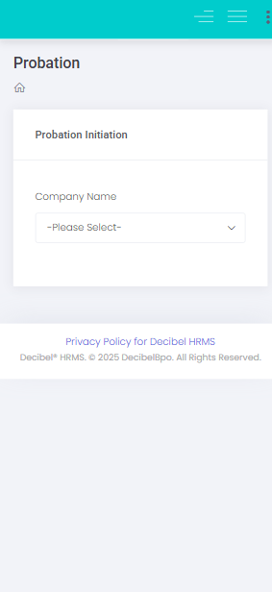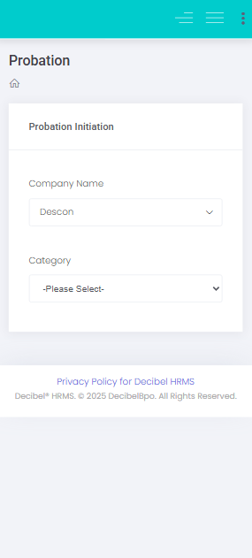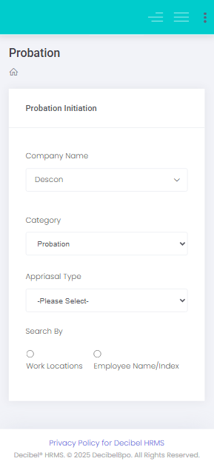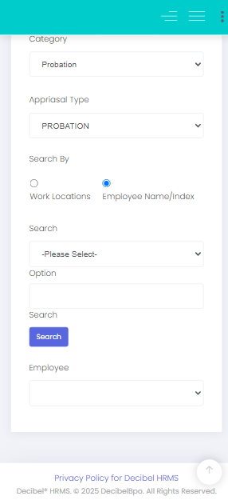

**New Interface:**

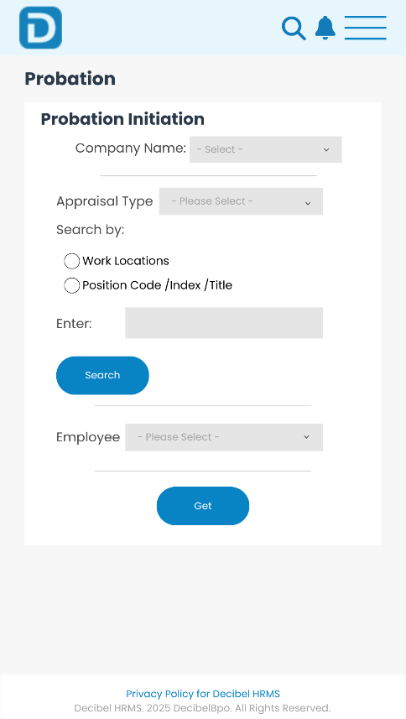

**Performance Management – Probation Reversal**

**Current Interface:**

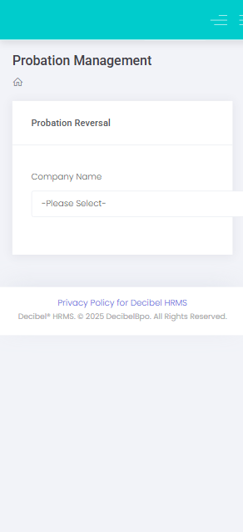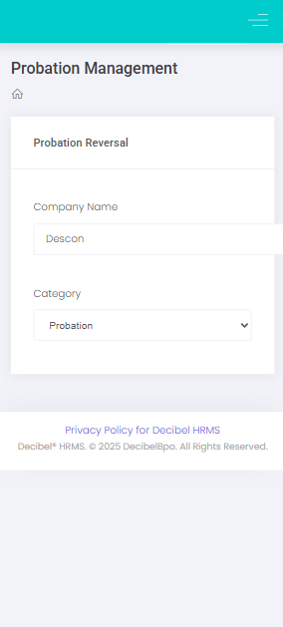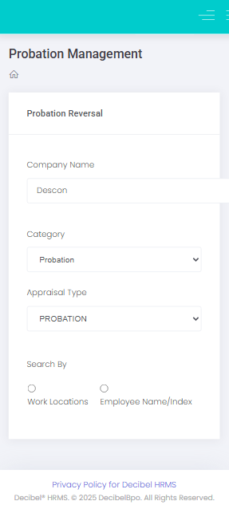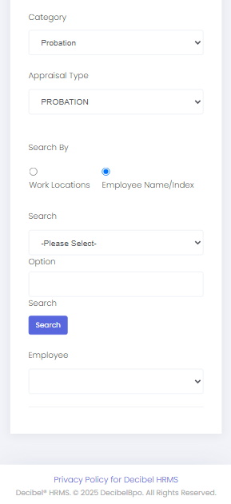

**New Interface:**

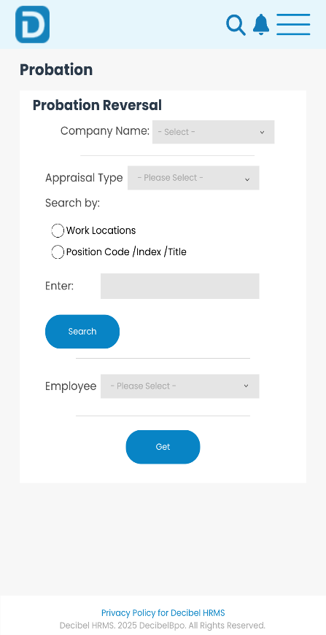

.

**Performance Management – Probation Deletion**

**Current Interface:**

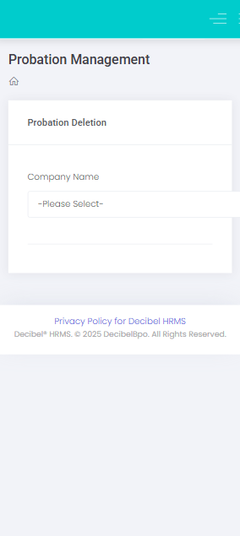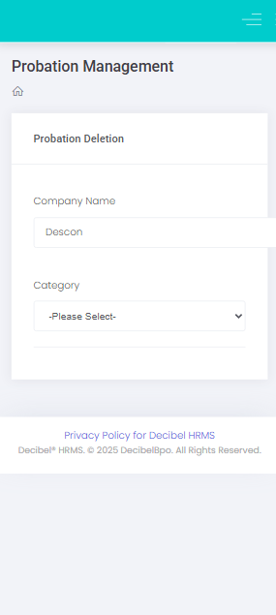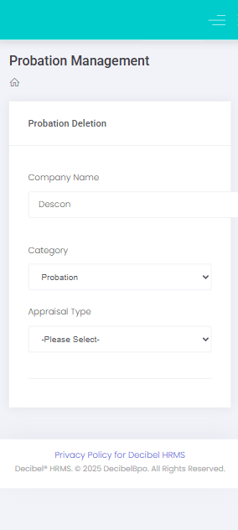

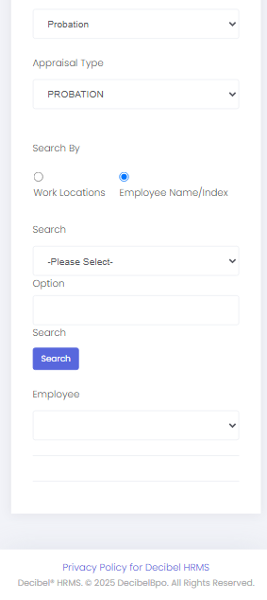

**New Interface:**

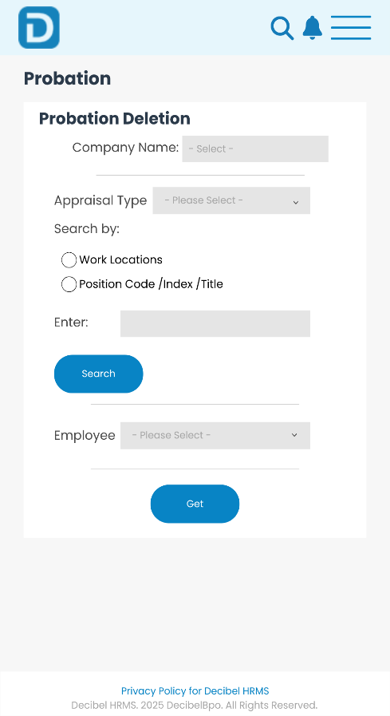

**Performance Management – Employee Wise Probation (TAT)**

**Current Interface:**

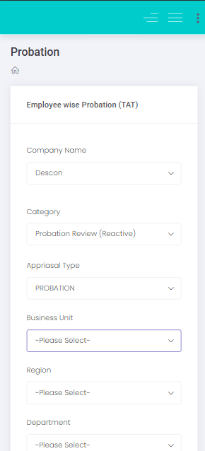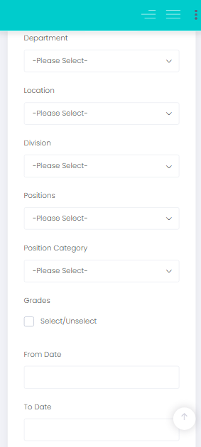

**New Interface:**

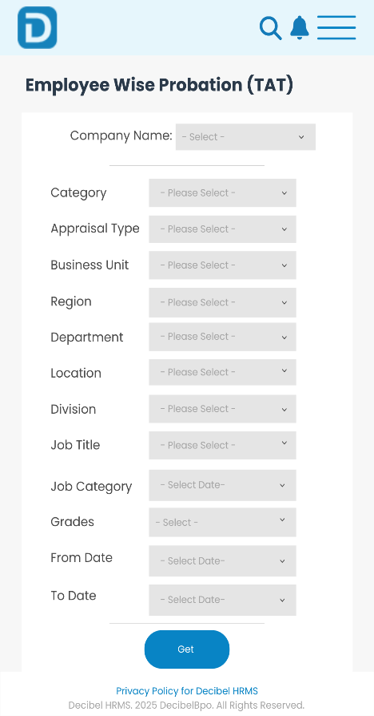

**Performance Management – Appraisal Initiation**

**Current Interface:**

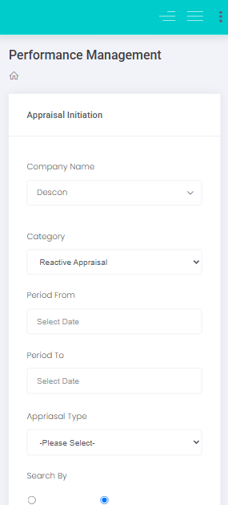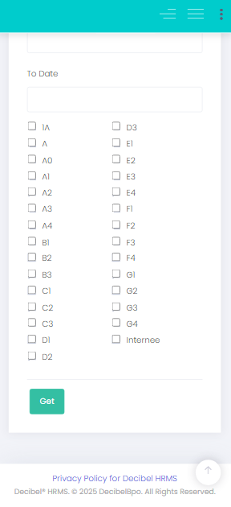

**New Interface:**

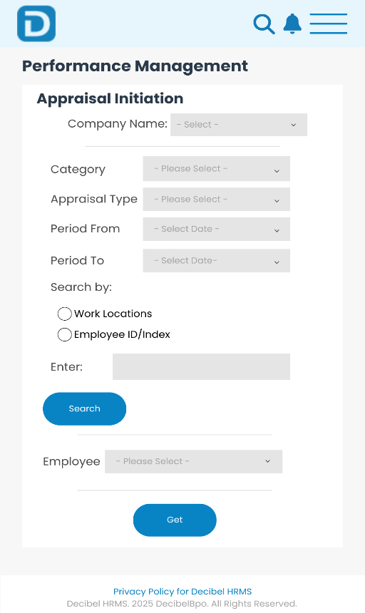

**Performance Management – Goal Deletion**

**Current Interface:**

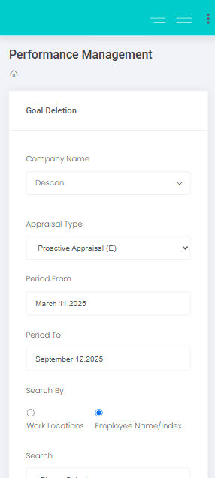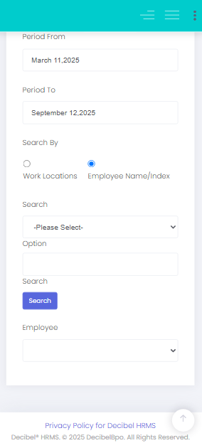

**New Interface:**

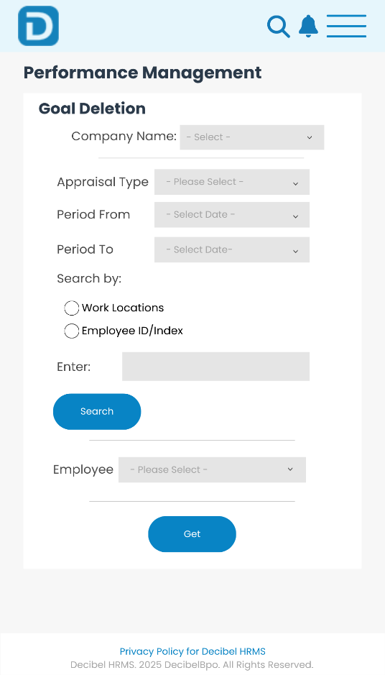

**Performance Management – Goal Reversal**

**Current Interface:**

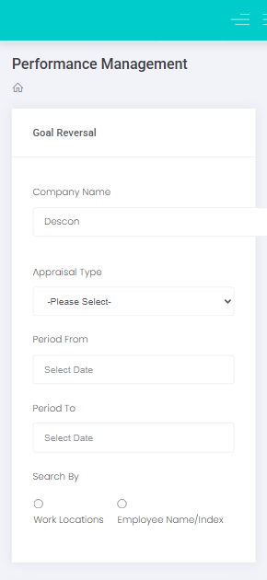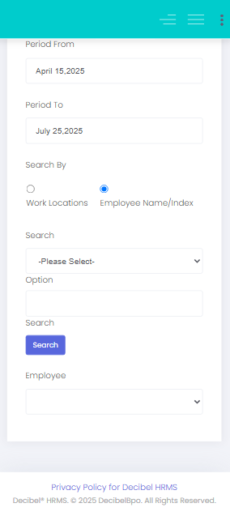

**New Interface:**

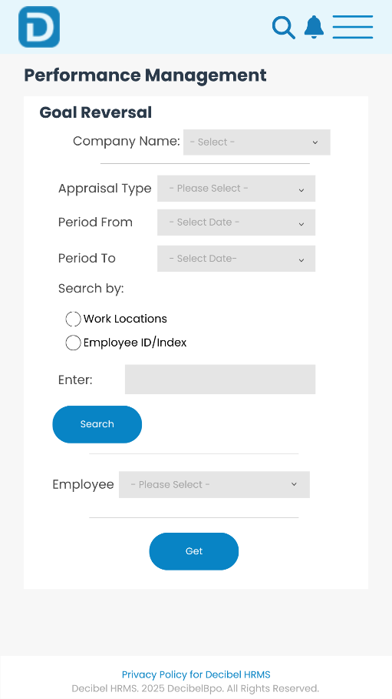

**Performance Management – Appraisal Type Mapping**

**Current Interface:**

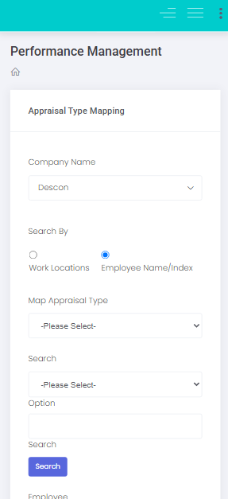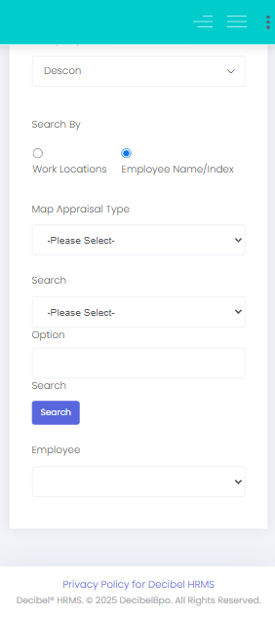

**New Interface:**

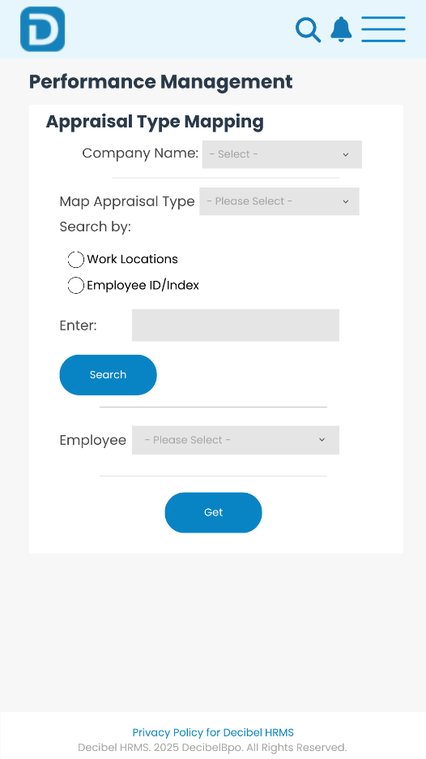

**Performance Management – Employee Evaluation Form**

**Current Interface:**

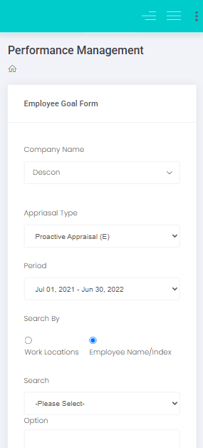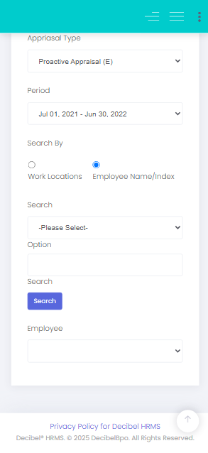

**New Interface:**

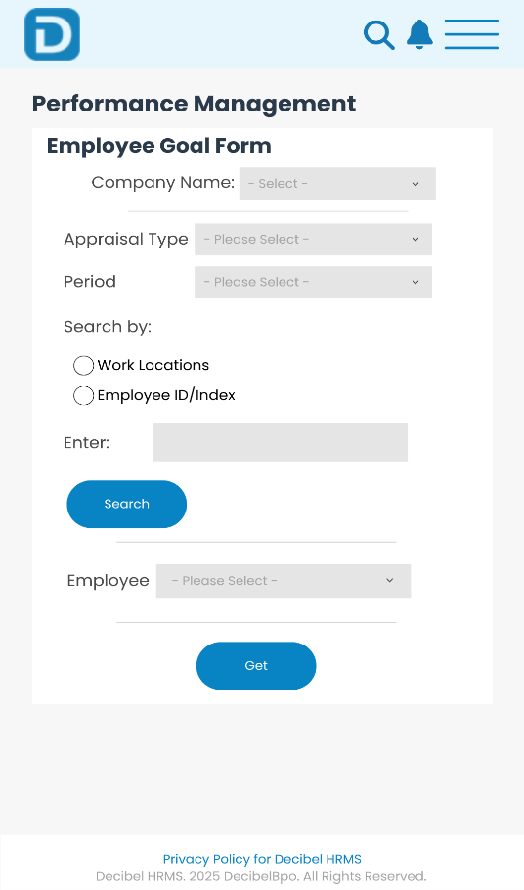

**Workforce Administration – Employee Data & Notifications**

**Current Interface:**



**New Interface:**

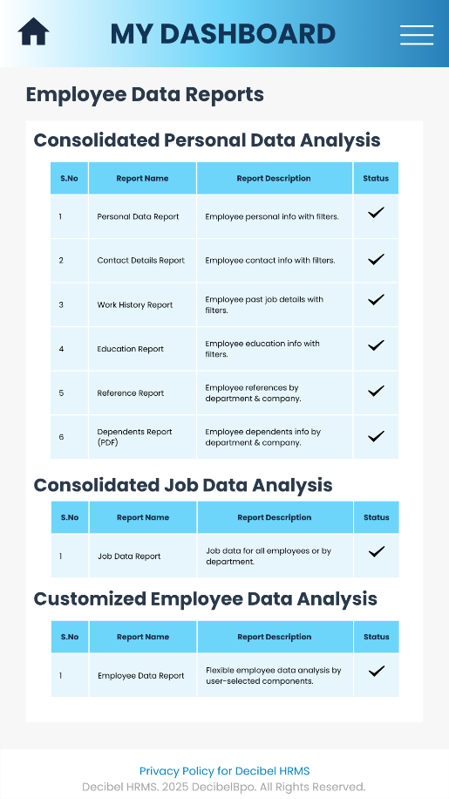 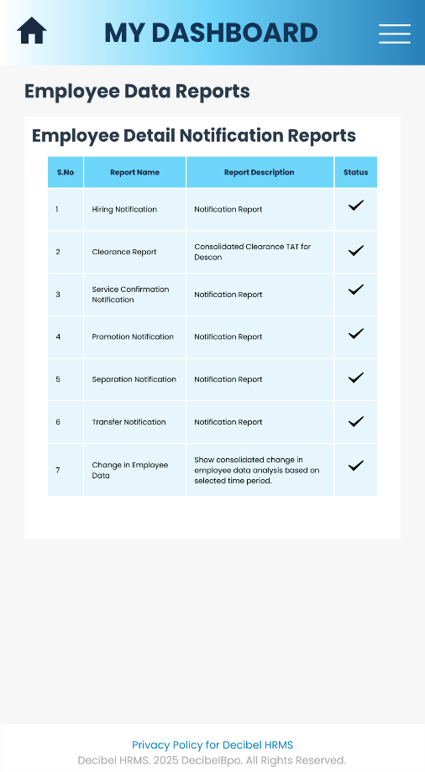

**Workforce Administration – Print Employee Data**

**Current Interface:**



**New Interface:**

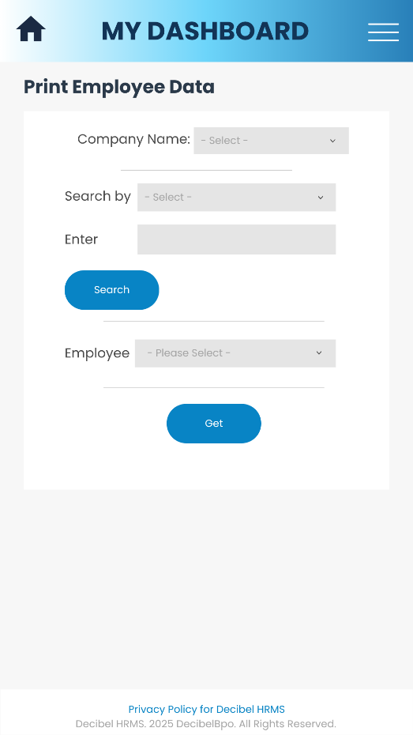

**Workforce Administration – Employee Letter**

**Current Interface:**

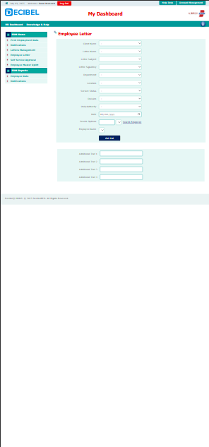

**New Interface:**

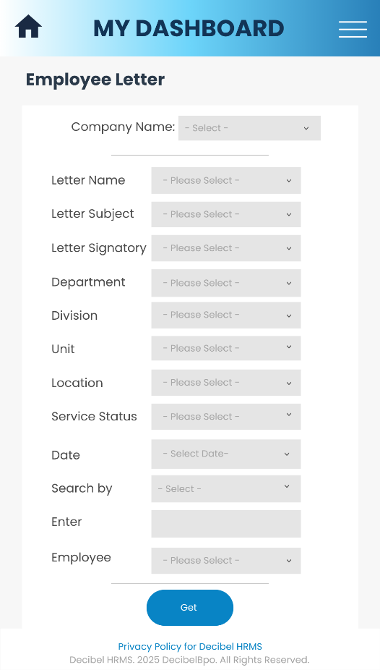

**Workforce Administration – Exit Interview Report**

**Current Interface:**

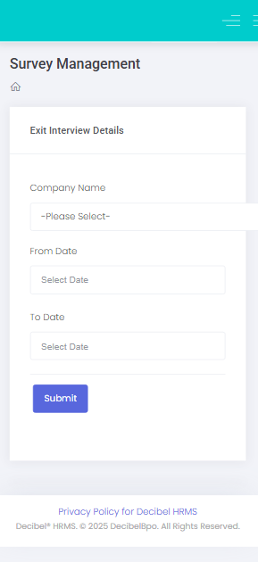

**New Interface:**

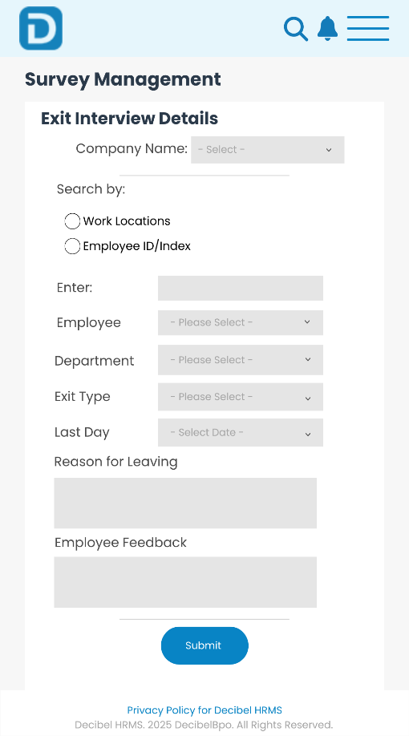

**Workforce Administration – Hiring Notifications**

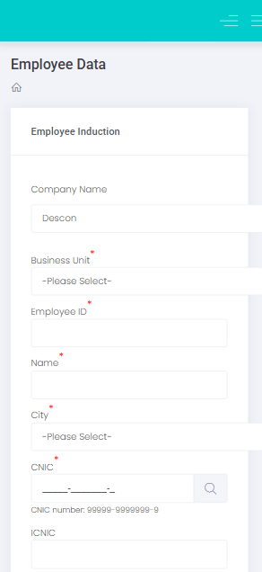**Current Interface:**

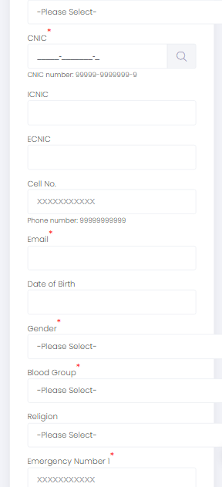 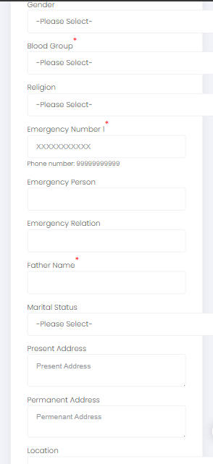

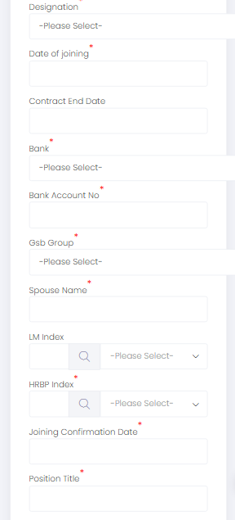 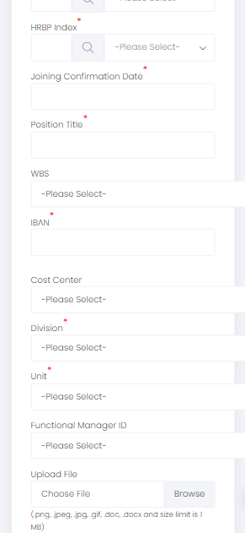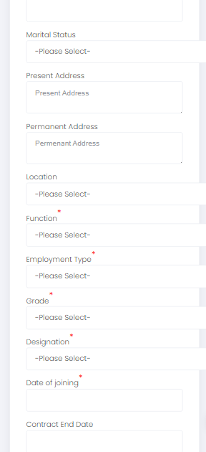

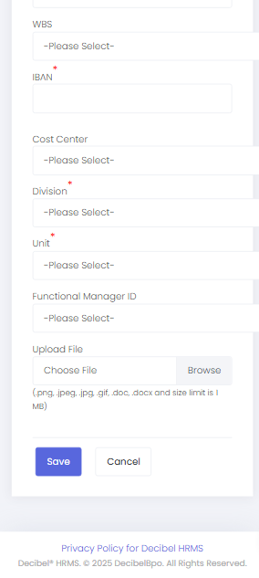

**New Interface:**

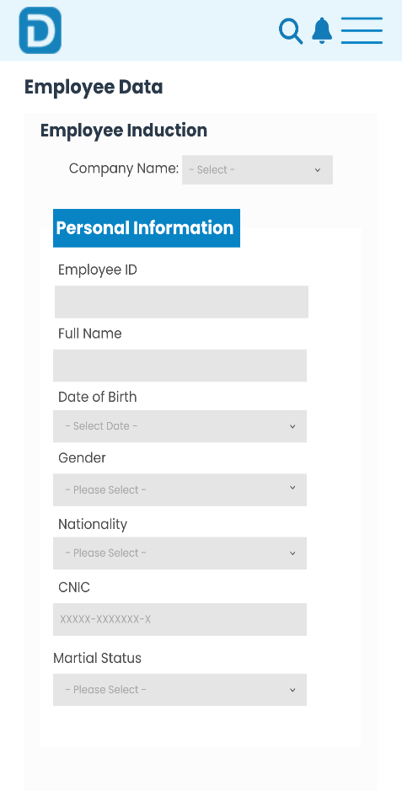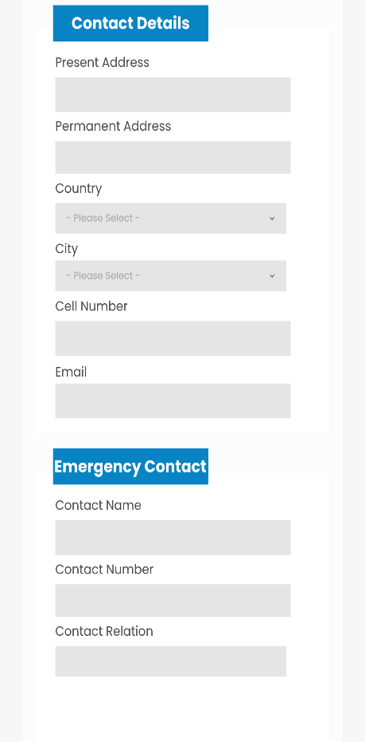

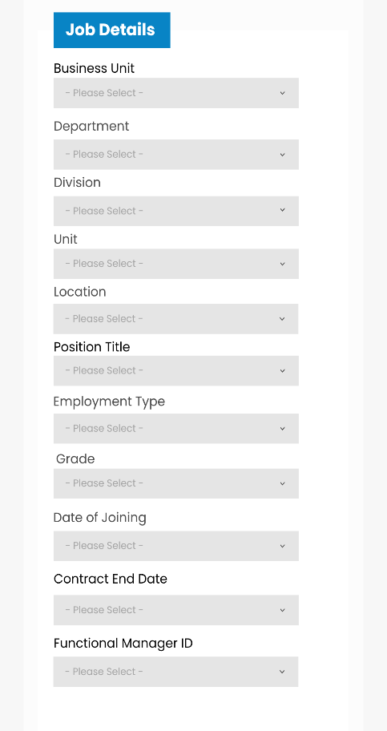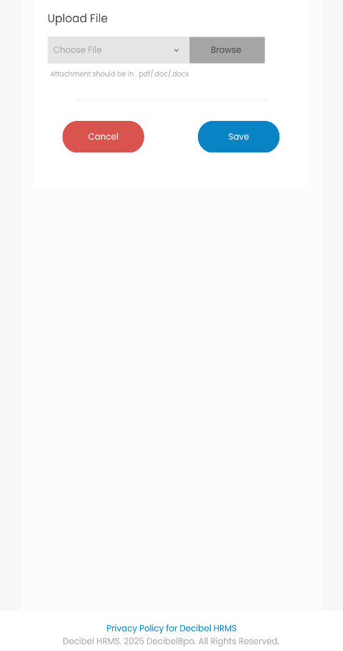

**Workforce Administration – Separation Notification**

**Current Interface:**

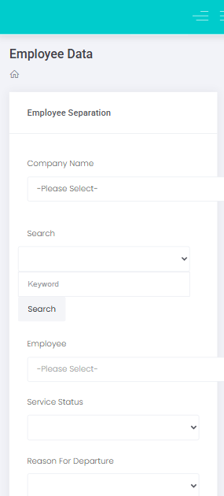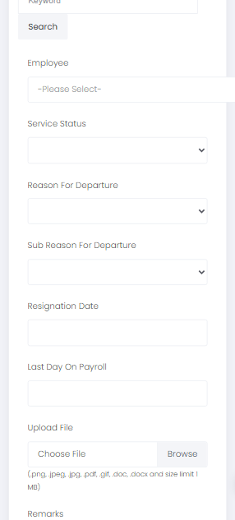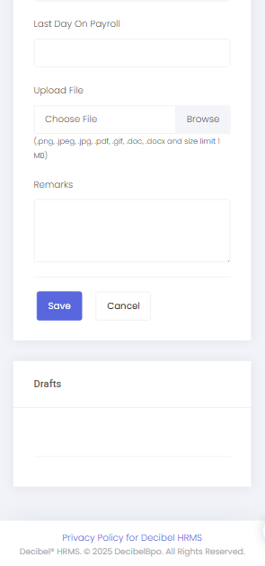

**New Interface:**

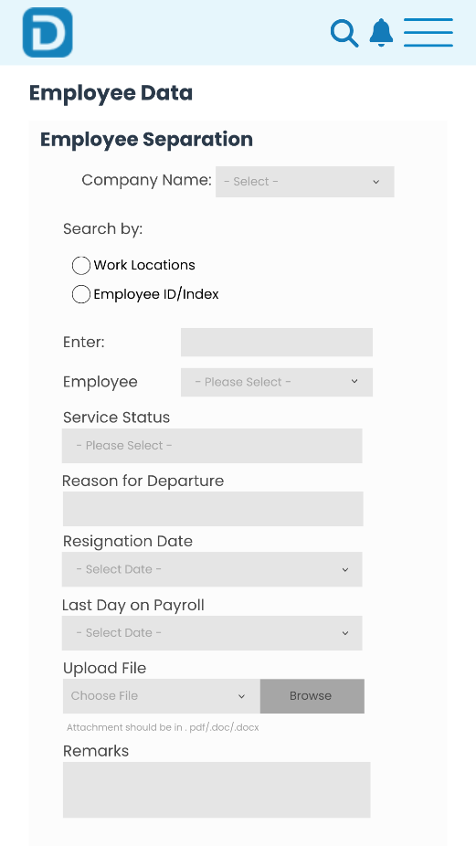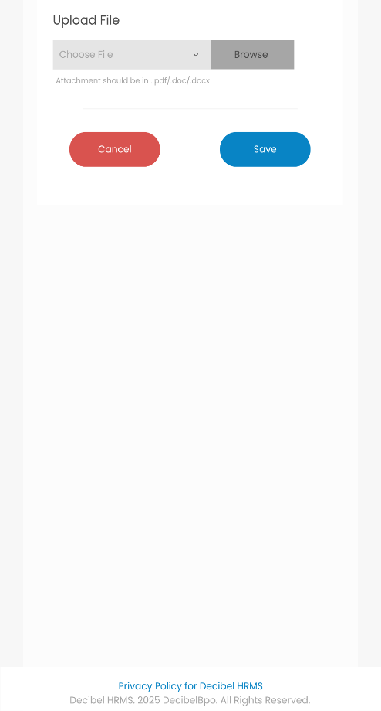

**Workforce Administration – Transfer Notification**

**Current Interface:**

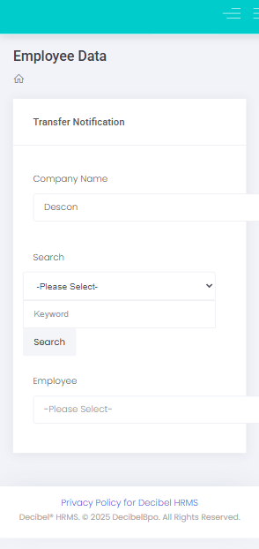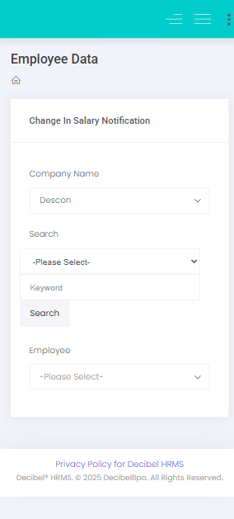

**New Interface:**

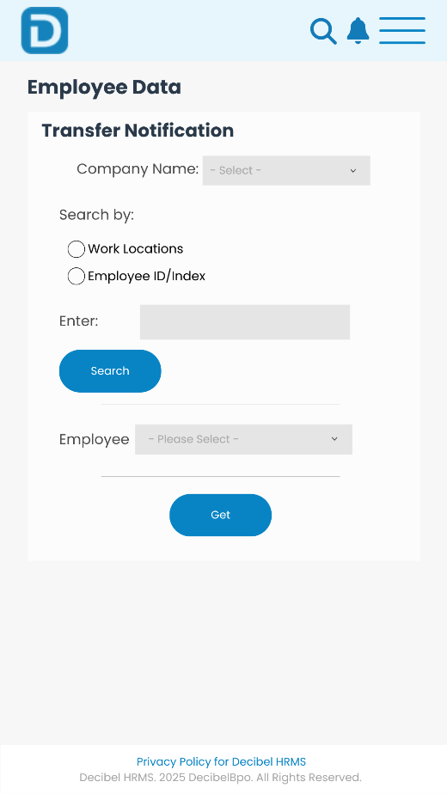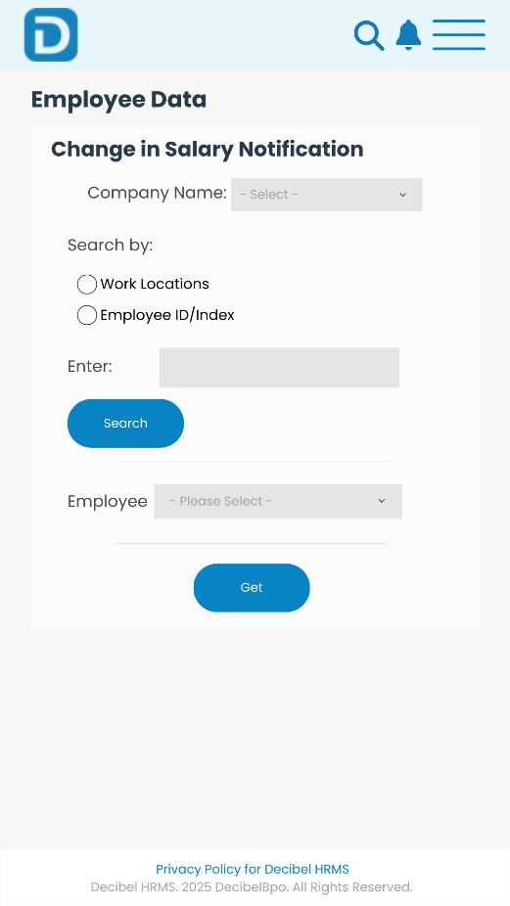

**Workforce Administration – Change in Salary Notification**

**Current Interface:**



**New Interface:**



**Workforce Administration – Initiate Clearance Process & Clearance View**

**Current Interface:**

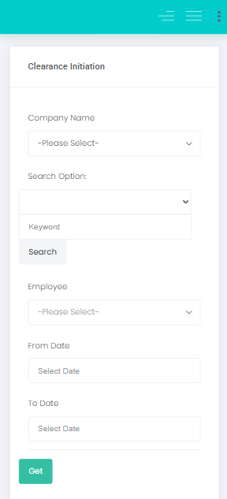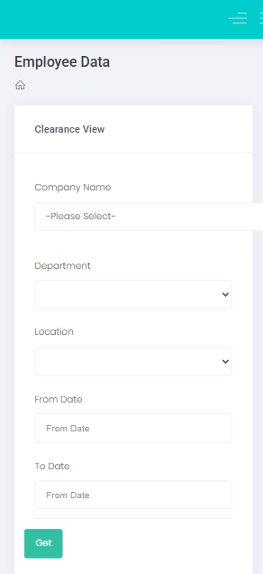

**New Interface:**

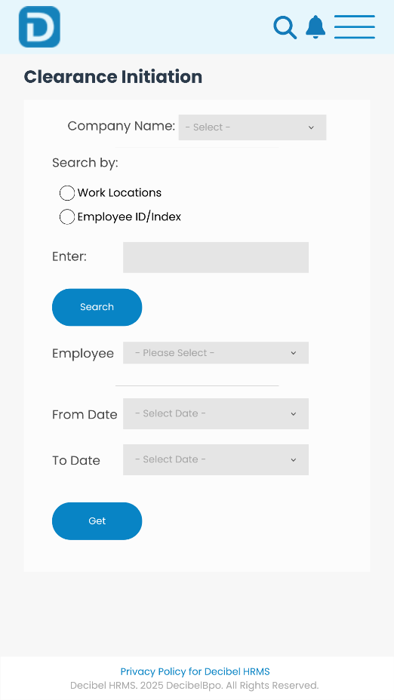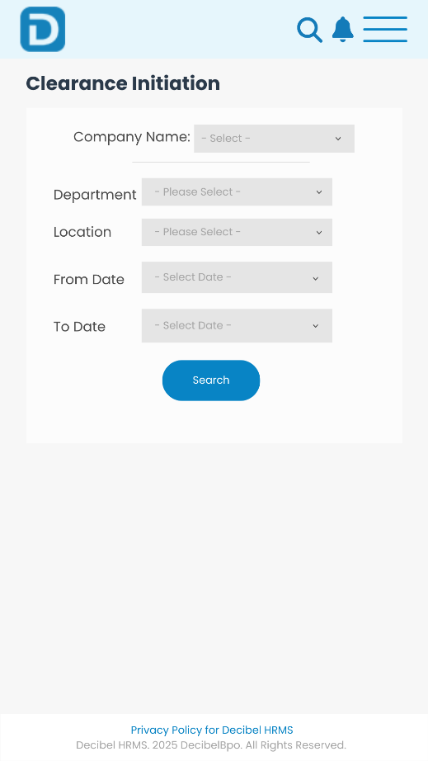

**Probation – Probation Initiation**

**Current Interface:**



**New Interface:**



**Probation – Probation Reversal**

**Current Interface:**



**New Interface:**



**Probation – Probation Deletion**

**Current Interface:**





**New Interface:**



**Probation – Employee Wise Probation (TAT)**

**Current Interface:**



**New Interface:**



**Probation – Appraisal Initiation**

**Current Interface:**



**New Interface:**



**Probation – Goal Deletion**

**Current Interface:**



**New Interface:**



**Probation – Goal Reversal**

**Current Interface:**



**New Interface:**



**Probation – Appraisal Type Mapping**

**Current Interface:**



**New Interface:**



**Probation – Employee Evaluation Form**

**Current Interface:**



**New Interface:**



**Travel – Travel Requisition**

**Current Interface:**

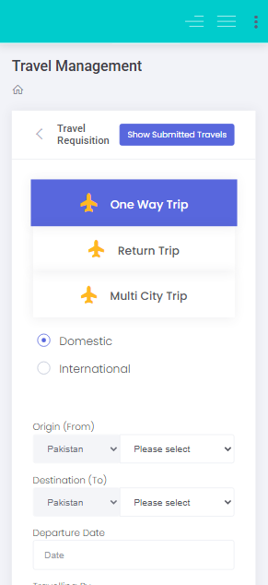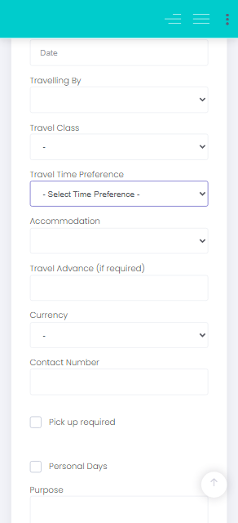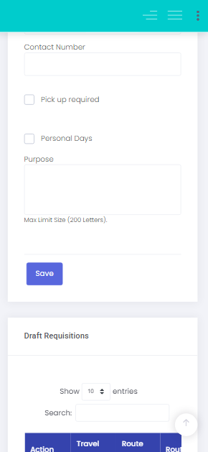

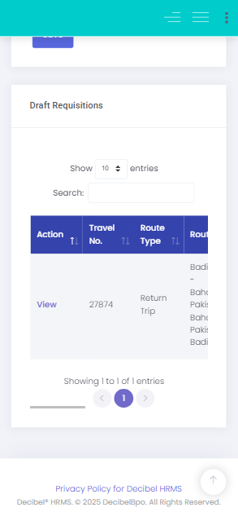

**New Interface:**

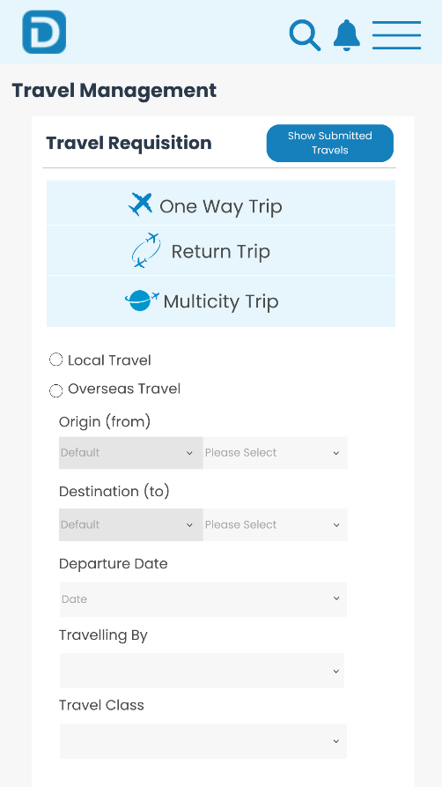

**Travel – Submitted Travel**

**Current Interface:**

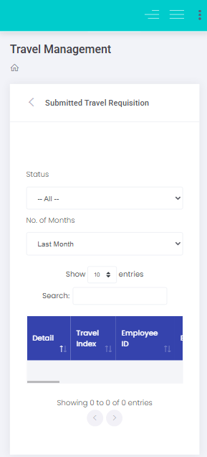

**New Interface:**

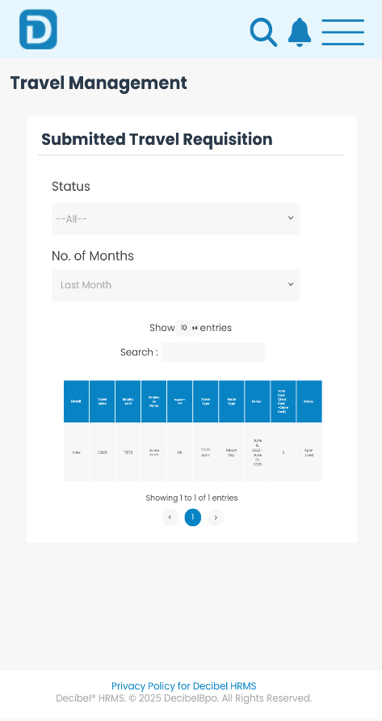

**Travel – Travel Expense**

**Current Interface:**

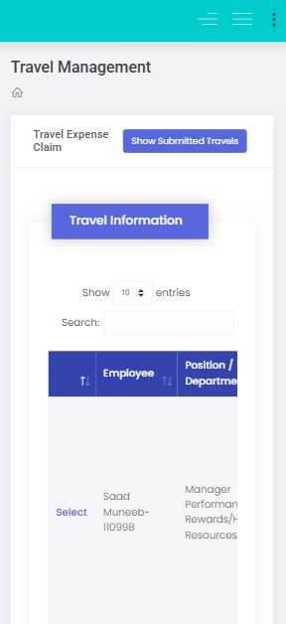

**New Interface:**

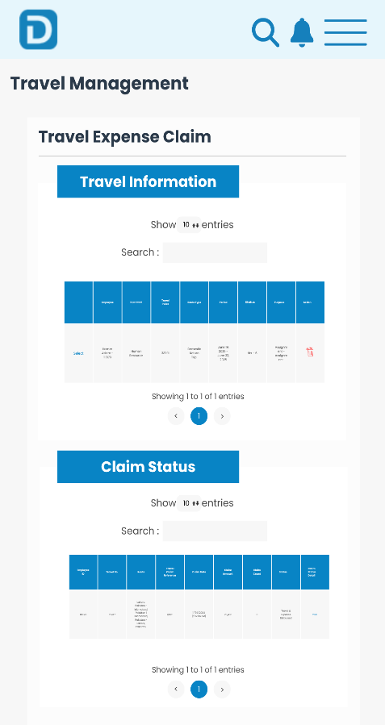

**Travel – Print Travel & Claim**

**Current Interface:**

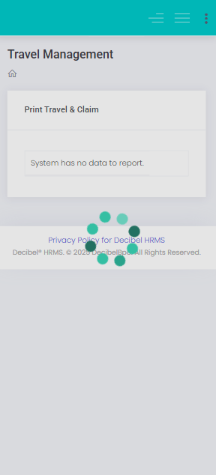

**New Interface:**

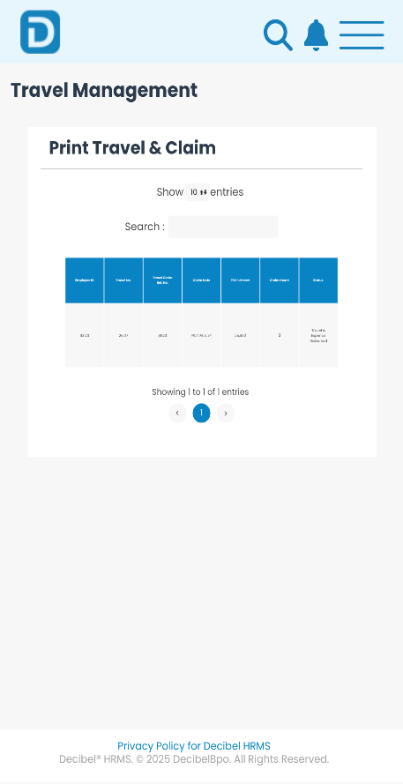

**Leaves – Submit Leaves**

**Current Interface:**

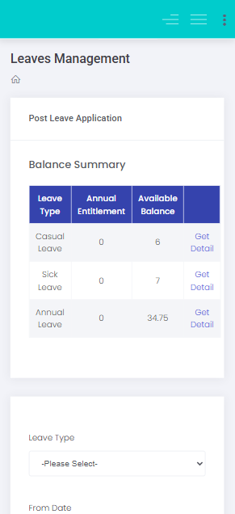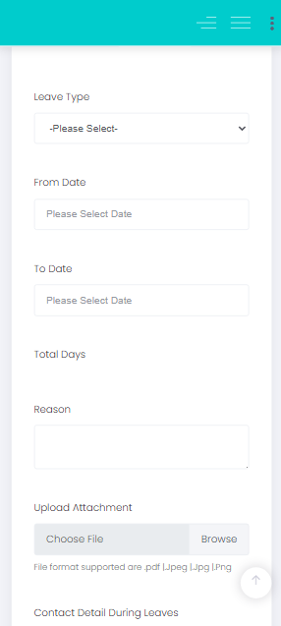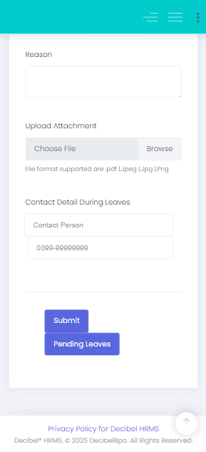

**New Interface:**

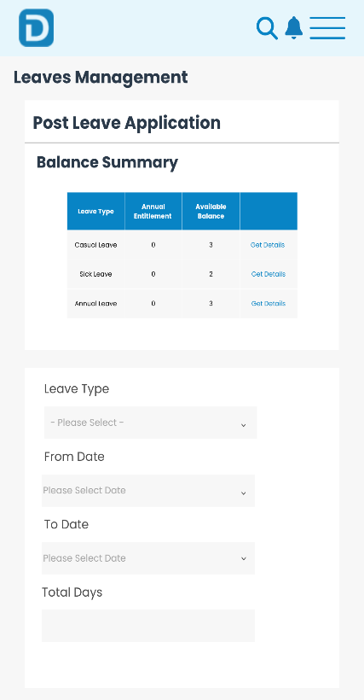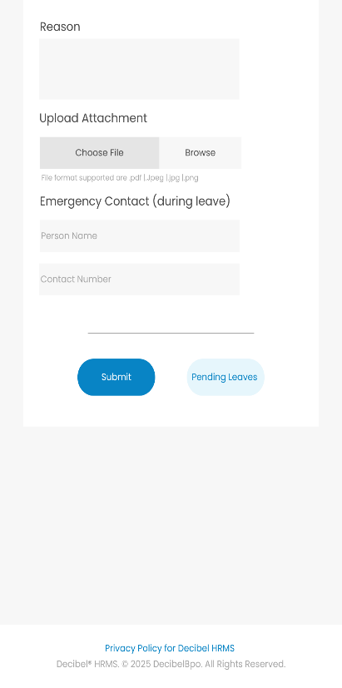

**Leave – Leave View**

**Current Interface:**

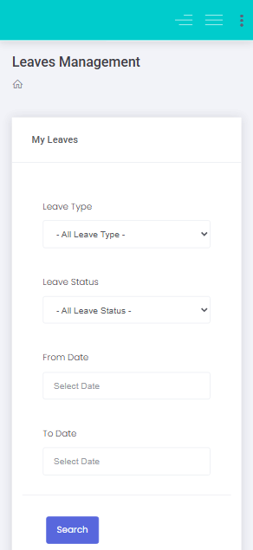

**New Interface:**

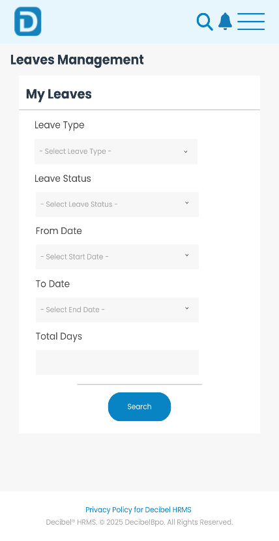

**Leave – Pending Leave Application**

**Current Interface:**

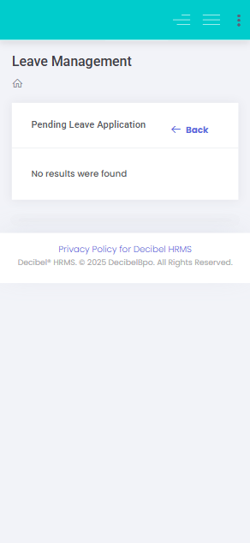

**New Interface:**

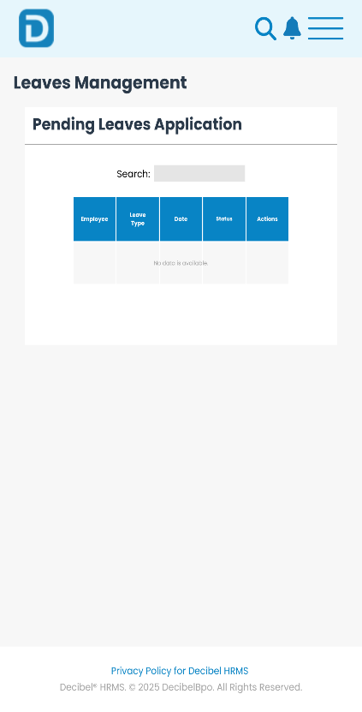

**Conclusion**

This project identified several usability issues across key modules of the ***Decibel HRMS***. A complete redesign of the ***Performance Management*** module demonstrated how strategic UI/UX improvements can lead to:

* Enhanced productivity
* Better user satisfaction
* Improved system efficiency