**Relax take-home finding Challenge:**

Shiva Bhattarai

The user engagement data and user data are imported in the jupyter notebook. I did the necessary feature engineering like changing into the DateTime format, resampling the data to obtain the number of login attempts in a week by different users. Next, I followed the given instructions to get the adaptive users, with more than three login attempts in a week. The adaptive user data frame was inner join with the user information data by the respective user_id. After the join, we drop columns with personal information like the name, email of the user.

Our ultimate goal is to find the factors that best predict the adoptive user. I followed the procedure of the feature_seleciton. I made the dummy variable for the object feature and used the standard scaling technique before using the PCA technique. It helps to obtain the factors that best predict the adoptive users.

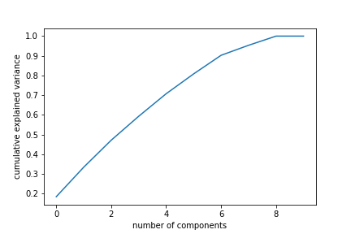

Here we can see the six components explain more than 80% variance. I also built the correlation table that shows the best features that form the principal components.