**Arbuscular Mycorrhizal Fungi and Plant Traits that Influence Root Colonization**

Students A and B

**Introduction**: The focus of this project as to assess the relationship between arbuscular mycorrhizal fungi and factors that affect fungal success of colonization of terrestrial plants and thus, survival. The data used for this project were obtained from the manuscript “An exotic invader drives the evolution of plant traits that determine mycorrhizal fungal diversity in a native competitor” [(1)](https://paperpile.com/c/UsS5ih/PoTC). The original question that the paper strived to answer was “How does *P. pumila*’s history of coexistence with *A. petiolata* affect the symbiotic AMF communities of populations of P. pumila?” In this study, *Pilea pumila* (Urticaceae), also known as Canadian Clearweed is the native species, while *Alliaria petiolata* (Brassicaceae), also known as Garlic Mustard, is an invasive species. The authors investigated the effects of invasive species colonization on arbuscular mycorrhizal fungi (AMF) colonization. Here, we chose to use the data from this paper to answer a different question: “Which plant traits have the greatest influence on the amount of arbuscular mycorrhizal fungi (AMF) species that colonizes a plant’s root system?” For this question, we hypothesized that Faith's phylogenetic diversity value would be a strong indicator of how many species of arbuscular mycorrhizal fungi are present in the *P. pumila* roots.

Arbuscular mycorrhizal fungi are soil microorganisms that form symbiotic relationships with most terrestrial plants [(2)](https://paperpile.com/c/UsS5ih/soJb). They are obligate biotrophs, meaning they cannot survive without a host. In the symbiotic relationship, AMF provide plants with nutrients and water as well as helping them become resistant to drought and disease and other toxic or harmful substances in exchange for carbohydrates and lipids [(3)](https://paperpile.com/c/UsS5ih/UOyn)(2). Researching these AMF and finding out what conditions or traits are optimal for successful colonization and growth could be useful in the agricultural industry. Introducing AMF to crops, especially those for food and production, would be beneficial as there are many types of diseases, both fungal and bacterial, that affect crop health and thus the yield. AMF could mitigate the common diseases that affect crops the most; it would serve as a kind of organic pesticide and fungicide. There are already some studies that show that AMF could prevent the growth of fungi (such as Fusarium Wilt) [(4)](https://paperpile.com/c/UsS5ih/vYiI) as well as weeds that compete with the plant for space and nutrients [(5)](https://paperpile.com/c/UsS5ih/Gl2F).

**Methods**: The data set from the paper included several spreadsheets in the same workbook containing data that they collected from several different iterations of their experiments. For our project, we focused solely on the data collected from the field in a single experiment. We tidied this data by fixing the column names to be “R friendly” (getting rid of spaces, giving detail about the information without being too verbose, etc.). The variables represented within the spreadsheet were the field experiment site, the source of the *P. Pumila* seeds, the number of years since the *A. petiolata* had infiltrated the native species, total fluorescence, initial seedling size in terms of how many leaves were present, the number of AMF species present on the plant, Faith’s phylogenetic diversity value, and the different species of AMF (indicated to be present by a 1, absent by a 0). There are 135 observations in the spreadsheet we utilized for this project.

Using the libraries tidyverse (6), ggplot2 (7), dplyr (8), and tibble (9), we wrote the R script (10) to analyze the relationship between the number of AMF species present and total fluorescence, initial seedling size, and Faith’s phylogenetic diversity. First, the libraries were imported, then the tidied data was imported as a csv file into R Studio. From there, we checked the distribution of the variables we chose to analyze. One of the variables showed a relatively normal distribution (Faith’s phylogenetic diversity), while the others did not (fluorescence, initial seedling size, and number of AMF species). We performed linear regression to analyze the relationship between the plant traits and the number of AMF species present.

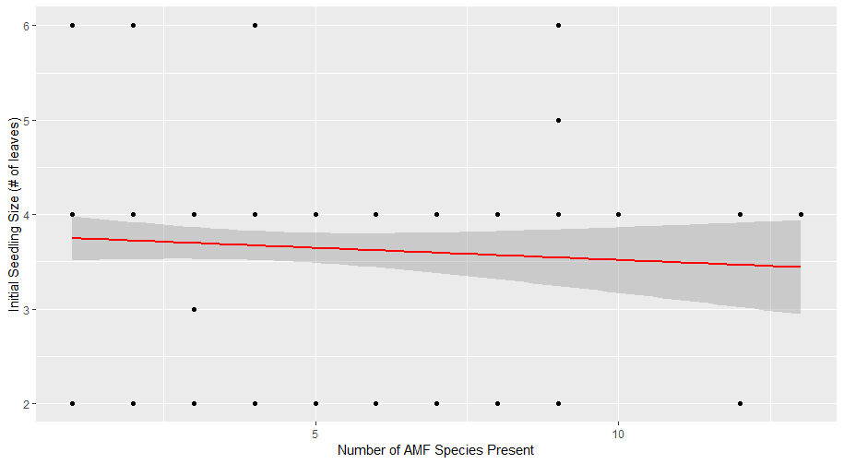

**Figure 1.** Relationship between initial seedling size and the number of AMF species present.

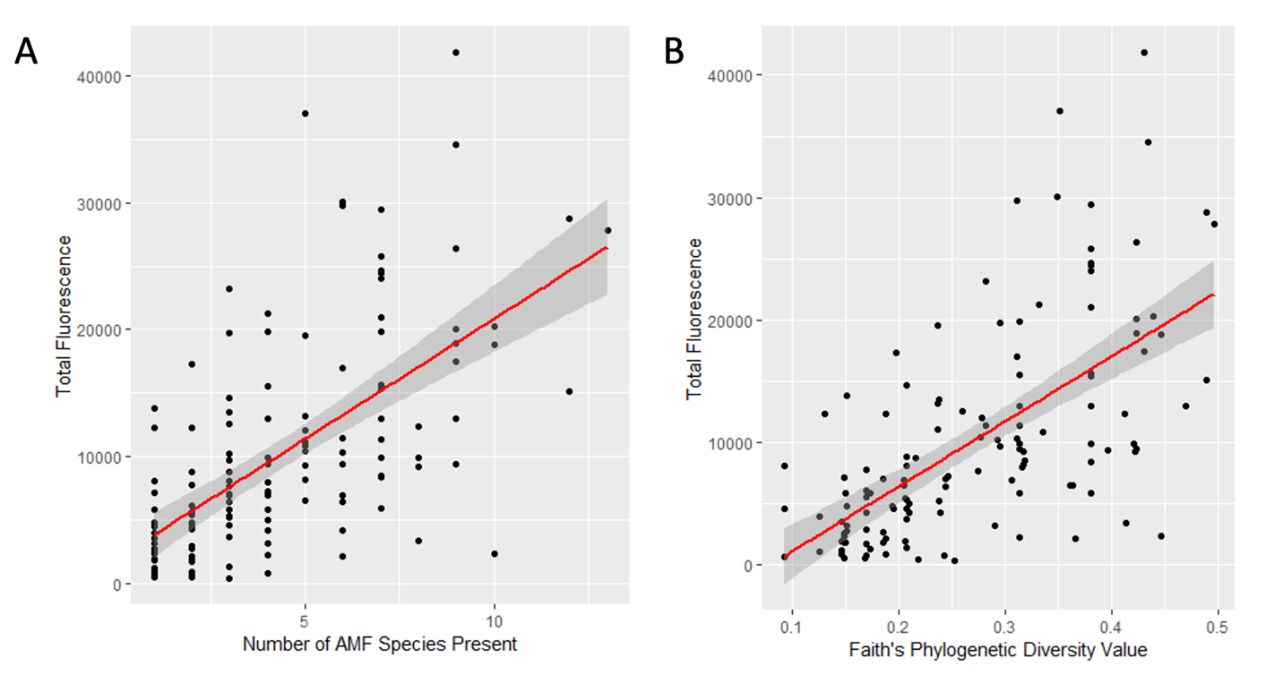

**Figure 2.** Relationship between (A) total fluorescence and number of AMF species and (B) Faith's Phylogenetic Diversity.

**Results**: Initial seedling size versus number of AMF species seemed to have no specific trend between the two. There is no visible order to the cluster of data points in Fig. 1. We found that the total fluorescence versus the number of AMF species seemed to have a positive correlation, but not a very strong one (Fig. 2A), whereas Faith’s phylogenetic diversity and the number of AMF species had the most positive correlation, with an R2 value of 0.8889 (Fig. 2B). Thus, the strongest indicator of how many AMF species will colonize a plant's roots is Faith's phylogenetic diversity value. This makes sense because a high number of AMF species present indicates high levels of AMF diversity in the root system, which corresponds with a high Faith's phylogenetic diversity value. So, our hypothesis held true. To account for the confoundedness of Faith’s phylogenetic diversity value and number of AMF species, we assessed the relationship between total fluorescence and Faith’s phylogenetic diversity. We found that the correlation is not as strong as it is between Faith’s phylogenetic diversity and the number of AMF species present, but because those variables are confounded, this graph of total fluorescence and Faith’s phylogenetic diversity value gives us the most accurate result in answering the question we posed at the beginning of this project.

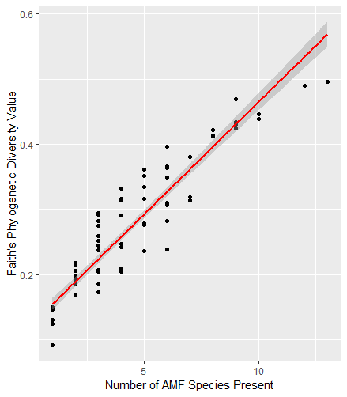

**Figure 1.** Relationship of Faith's PD to number of AMF species present.

**Discussion/Conclusion:** Overall, our hypothesis and prediction were supported by our analyses. Faith’s phylogenetic diversity value of a plant is the strongest indicator of its potential for arbuscular mycorrhizal fungi colonization.To extend this research, we propose that more plant traits than were present in this study should be looked at for more robust results. Some plant traits that could impact the success of AMF colonization are rate of respiration, leaf area, leaf morphology, plant carbon/nitrogen content, climate, and species; the optimal factors for the plants themselves will most likely also benefit the AMF. It is important to find what traits strongly indicate which plants will be more likely to have strong, diverse, AMF colonies because AMF presence is linked to greater plant resilience when faced with pathogens, drought, and other debilitating agents.

Further, the study should extend to other species and types of plants. As we mentioned before, there are many difficulties that farmers face with their crops. From fungi, bacteria, viruses, pests, drought, and more, crop management is essential. With this in mind, AMF should be applied to different kinds of crops to test the limits of its benefits. With each type of crop, the most common disease or fungi should be applied to test the resistance the AMF allows the plant from the afflicted infection. The findings from this research could be useful in sustainable farming practices, help cut down water use, and be an alternative to fungicide and pesticide use.

**Data:** Link to the Github repository: <https://github.com/uabryanblue/BE310_FALL2022_Project_Example>

**References**

1. [R. A. Lankau, R. N. Nodurft, An exotic invader drives the evolution of plant traits that determine mycorrhizal fungal diversity in a native competitor. *Mol. Ecol.* **22**, 5472–5485 (2013).](http://paperpile.com/b/UsS5ih/PoTC)

2. [Arbuscular mycorrhizal fungi: tiny friends with big impact (December 10, 2021).](http://paperpile.com/b/UsS5ih/soJb)

3. [M. Chen, M. Arato, L. Borghi, E. Nouri, D. Reinhardt, Beneficial Services of Arbuscular Mycorrhizal Fungi – From Ecology to Application. *Frontiers in Plant Science* **9** (2018).](http://paperpile.com/b/UsS5ih/UOyn)

4. [J.-L. Hu, *et al.*, Arbuscular Mycorrhizal Fungal Inoculation Enhances Suppression of Cucumber Fusarium Wilt in Greenhouse Soils. *Pedosphere* **20**, 586–593 (2010).](http://paperpile.com/b/UsS5ih/vYiI)

5. [R. S. L. Veiga, J. Jansa, E. Frossard, M. G. A. van der Heijden, Can arbuscular mycorrhizal fungi reduce the growth of agricultural weeds? *PLoS One* **6**, e27825 (2011).](http://paperpile.com/b/UsS5ih/Gl2F)

6. [H. Wickham, Easily Install and Load the “Tidyverse” [R package tidyverse version 1.3.1] (2021) (December 10, 2021).](http://paperpile.com/b/UsS5ih/FS3F)

7. [Create Elegant Data Visualisations Using the Grammar of Graphics [R package ggplot2 version 3.3.5] (2021) (December 10, 2021).](http://paperpile.com/b/UsS5ih/RxDj)

8. [A Grammar of Data Manipulation [R package dplyr version 1.0.7] (2021) (December 10, 2021).](http://paperpile.com/b/UsS5ih/tl5E)

9. [Simple Data Frames [R package tibble version 3.1.6] (2021) (December 10, 2021).](http://paperpile.com/b/UsS5ih/WHm0)

10. The R project for statistical computing *R*. Available at: https://www.R-project.org/ [Accessed December 11, 2021].