|  |
| --- |
| **PROJECT PLANNING & MANAGEMENT FORM**  **CMSE 322**  **PROJECT NO : 01**  **GROUP NO : 16**  **PROJECT NAME : Application Fostering Social Connections for Elderly Well-Being**  **PROJECT START DATE : 06.03.2024**  **PROJECT END DATE : 30.06.2024**  **SUPERVISOR : Nada KOLLAH**  **SEMESTER TERM : 2024 Spring Semester**  Project Type: Software Design & Development Project  Template updated: 20.11.2017 |

A.1. Preliminary Project Information

# A.1.1

|  |  |
| --- | --- |
| **Project No** | 01 |
| **Project Name** | Application Fostering Social Connections for Elderly Well-Being |
| **Start Date** | 06.03.2024 |
| **End Date** | 30.06.2024 |
| **Time** | 8 Weeks |

# A.1.2

|  |  |  |  |
| --- | --- | --- | --- |
| **Project Manager** | | | |
| **Name Surname** | Doğukan GÜLER | **ID No** | 17000166 |
| **Title/Role** |  | | |
| **Address** | Famagusta/TRNC | | |
| **Phone** | 05428765981 | | |
| **Email** | 17000166@emu.edu.tr | | |

A.2 Group Information

# A.2.1

|  |  |  |  |
| --- | --- | --- | --- |
| **Student 1** | | | |
| **Name Surname** | Hasan ODUNCUOĞLU | **ID No** | 17330170 |
| **Title/Role** |  | | |
| **Address** | Famagusta/TRNC | | |
| **Phone** | 05428725673 | | |
| **Email** | 17330170@emu.edu.tr | | |

|  |  |  |  |
| --- | --- | --- | --- |
| **Student 2** | | | |
| **Name Surname** | Aleyna YILMAZ | **ID No** | 21000166 |
| **Title/Role** |  | | |
| **Address** | Famagusta/TRNC | | |
| **Phone** | 05428891258 | | |
| **Email** | 21000166@emu.edu.tr | | |

# A.2.2

|  |
| --- |
| **List of Completed / Ongoing Projects of Team** |
| Student Feedback Review System  Real Estate Search Portal  Student Interaction Platform |

B.1 Introduction to Project

# B.1.1

|  |
| --- |
| **Summary of Project** |
| It was developed to reduce the social isolation of the elderly and increase their well-being. This project enables senior citizens to communicate with each other, interact and participate in social activities through mobile applications or web-based platforms. Thus, elderly people feel in a more active society and increase their social interactions. This project provides an effective solution to improve the well-being of older people and improve their quality of life. |

# B.1.2

|  |
| --- |
| **Key Words** |
| Elderly People  Welfare  Social Links  Mobile Technology  Community  Social Interaction  Social Support  Life Quality |

# B.1.3

|  |
| --- |
| **Aim of Project** |
| The aim of the project is to strengthen the social connections of older individuals through mobile applications or web-based platforms to reduce their social isolation and improve their well-being. |

# B.1.4

|  |
| --- |
| **Innovative Aspects/Contributions of Project** |
| The innovative aspects of the project are that it provides personalized support to seniors by strengthening their social connections through technology and improves their well-being by collaborating with healthcare professionals. |

# B.1.5

|  |
| --- |
| **Methods to be Applied** |
| **Market Research and Analysis:** Conducting detailed market research to understand the needs and preferences of the elderly.  **Technological Development:** Development of user-friendly mobile applications or web-based platforms for seniors.  **User Feedback:** Receiving feedback from elderly users during the project process and continuously improving the applications.  **Expert Collaboration:** Involving experts such as health professionals, psychologists and social workers in the project process.  **Community Engagement:** Implementing features such as events, chat rooms, and group activities to increase social interactions of older individuals. |

# B.1.6

|  |
| --- |
| **Economic and National Outcomes** |
| The economic effects of the project occur through a reduction in health expenditures and an increase in the general welfare of the society. |

B.2 Reason of Starting the Project, Methods and R&D Stages

# B.2.1

|  |
| --- |
| **1- Explain the reason of starting this project. (Max 500 charachter)** |
| The main aim of this project is to strengthen the social connections of older people and improve their well-being by using technology. An innovative approach has been adopted to meet basic needs such as access to technology, social interaction and participation in society. In this way, it is aimed for elderly individuals to live a healthier, happier and independent life. |

|  |
| --- |
| **2- Explain the purpose of this project.** |
| This project aims to provide innovative solutions through mobile applications or web-based platforms to strengthen the social connections of older individuals and improve their well-being. |

|  |
| --- |
| **3- Explain**   * **output of project** * **national / international standards if exist** * **the specific objectives of the project** * **success criterias** * **realistic constraints** |
| The outcome of the project will be a mobile application or web-based platform that will be used to strengthen the social connections of seniors. This project has the goal of meeting certain national or international standards. While the specific goals of the project include increasing the elderly's access to technology, reducing their social isolation and ensuring their greater integration into society, the success criteria are that users use the application frequently, increase social interactions and observe improvements in the welfare of the elderly. Realistic constraints may include financial limitations, technological deficiencies, and differences in the adaptation processes of older users to technology. |
| **4- Explain**   * **the methods to be applied during R&D activities** * **applications** * **technics and tools to be used** * **standards to be followed under the workflow** |
| **Which SOFTWARE PROCESS MODEL in below will you apply? Why? How? Explain.**  We chose the Agile methodology because the requirements of the project can constantly change, there is a need for a fast and flexible response, customer feedback plays an important role in project progress, and the team must constantly work collaboratively.  **Explain, Project Workflow:**   1. **Feasibility and Pre-research:**  Feasibility and preliminary research evaluates seniors' technology usage habits, social connection needs, and success factors of similar projects. This study helps determine the suitability of the project and its likelihood of success. 2. **System Design:**  The methodology to be used in the System design step will be the Common Application Design methodology because we plan to complete the project in constant interaction with the team members. These include Project Manager, System Designer and Database Designer. 3. **Software development:**  We plan to do the software development part of the project with teammates with the Agile approach. Agile methodology will provide flexibility, allowing us to focus on continuous customer feedback and achieve faster and more effective results in collaboration. 4. **Prototype implementation and testing work:**  During the project, Figma platform will be used when designing the user interface, and VScode will be used in the code writing and code testing phase. 5. **Maintenance:**  We will use code sharing platforms such as github to see all versions that are similar in subject to the project we will be doing. All services of the application and program will be monitored periodically. Thanks to the Agile model, in case of any problems or missing parts, the team will be able to solve the problems and release the new version after testing. |
| **5- Explain**   * **the contribution of national/international technological development if exist** * **starting a new research and development projects within or outside the team** * **launch new applications or research studies in different technology areas**   **With whom we can cooperate?**  **Expectations:**  **Published work:**  **Can your output be an input for other similar national/international projects?** |
| Stakeholders with whom we can collaborate include universities, research organizations, technology companies and healthcare providers. Expectations are to develop innovative technologies and introduce solutions to improve the well-being of the elderly. Published studies are important for sharing project results and increasing knowledge in the sector. Our project may be related to similar national or international projects, and the data and experiences obtained from these projects may contribute to our own outputs. |

B.3 Innovative and Unique Aspects

# B.3.1

|  |
| --- |
| **1- Describe**   * **differences** * **advantages** * **superiority**   **compared to other similar projects.** |
| The focus of our project is to improve the well-being of older people by strengthening their social connections. Our application, which has a flexible structure, offers personalized experiences according to users' needs and preferences. Our project, developed with a user-centered design approach, cares about user feedback and relies on this feedback during the development process. Our application, which can be used on both mobile devices and web-based platforms, offers wide access to elderly individuals and increases its user base. Our project aims to create a community by encouraging interaction between users and encourages the sharing of knowledge and experience among users. |

# B.4.1

|  |
| --- |
| **2- Who can contribute to this project in your team?** |
| • Project Manager  • System Designer  • Database Developer  • Interface Designer  • Lead Programmer |

C.1 Gantt Chart and Work Packages

# C.1.1 Gantt Chart

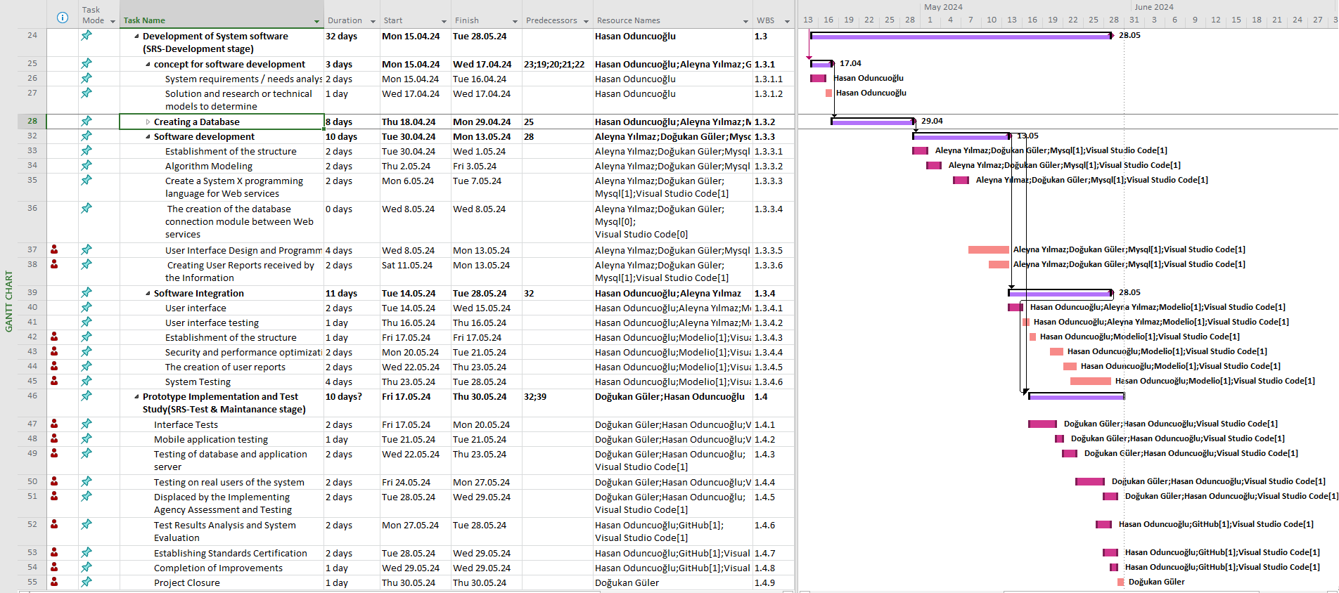



# C.1.2 List of Work Packages

|  |  |
| --- | --- |
| **Work Package No** | 1 |
| **Work Package Name** | **Project Feasibility and Pre-Research (Feasibility Analysis)** |
| **Start-End Date and Time** | **Wed 6.03.24** **Wed 13.03.24** |
| **Related Organizations** | - |

|  |
| --- |
| **1- List the activities of work packages.** |
| **1.1 Project Process and Economic Feasibility:**  **Project Start→ Analysis Phase→ Technical Research→ Financial Research→ Design Phase→ Development Phase→ Testing Phase**  **Economic Feasibility:**  Investment Costs; Hardware, software, staff salaries and marketing costs are calculated. Operating expenses; Server costs, maintenance, updates and staff salaries are taken into account. Revenue Estimates; Estimates are made regarding subscription fees, advertising revenues and donations. Profitability Analysis; The return period of the investment and the net present value are calculated.  **1.2 Technological Feasibility:**  Technology Selection; AI algorithms and visual analysis tools can also be used in the project. Applicability Research; The usability of the application by elderly individuals is tested. Data Security and Privacy; Security of user data is ensured. |
| **2- Describe the methods and parameters that will be used for work package.** |
| **Artificial Intelligence (AI) Algorithms;** Description: Artificial intelligence should provide personalized experiences by analyzing user behavior. For example, it should make activity recommendations based on the user's interests.  Parameters: Recommendation Algorithm, Emotion Recognition  **Visual Analysis Tools;** Description: Visual analytics should help users keep track of activities and other users in the virtual village.  Parameters: Face recognition, Event Tracking |
| **3- List the experiments, tests and analysis in the work package.** |
| How users use the application is observed. User feedback is collected.Tests how the application works under load. Response times and speed are analyzed. Data encryption and security are examined. It is verified that user data is protected against unauthorized access. |
| **4- List the output of work package and its success criterias.** |
| **Outputs:** An interactive virtual reality (VR) application that older individuals can use. User data security and privacy test reports.  **Success Criterias:** The application should be easily usable by older individuals. Users should be able to walk through the virtual village, participate in events, and communicate with other users.Data encryption and security should be examined. It must be verified that user data is protected against unauthorized access. |
| **5- Explain the relation of output with other work packages** |
| The development of the user application is carried out by the technical team. This output is associated with the design phase and development phase. Security test reports are prepared by the security team. Data security and confidentiality are ensured by the technical team. These outputs are associated with the security phase. |

|  |  |
| --- | --- |
| **Work Package No** | 2 |
| **Work Package Name** | **Based System Design Technology (Analysis & Design stage)** |
| **Start-End Date and Time** | **Thu 28.03.24** **Sat 13.04.24** |
| **Related Organizations** | - |

|  |
| --- |
| **1- List the activities of work packages.** |
| **System Analysis Activities:**  Interviews, surveys and observations are conducted to understand the needs of the users. Data flow diagrams, process diagrams and other models are created to understand the functioning of the system. The demands of the users and the requirements of the system are determined.  **System Design Activities:**  The components that make up the system (hardware, software, database, etc.) are defined. Database schemas are created. The user interface is designed. Server, network and security infrastructure is designed.  **Design System Activities:**  A catalog of reusable components is created. Design rules, color palette, typography and other style elements are determined. Components such as buttons, form fields, menus are designed. |
| **2- Describe the methods and parameters that will be used for work package.** |
| **System Analysis:** System analysis is the process of examining a system or business process, determining requirements and breaking the system into its components.  Parameters; Gathering and interpreting facts. Identifying problems. Setting goals.  **System Design:** System design is the process of planning a new business system or modifying an existing system by identifying components or modules to meet specific requirements.  Parameters; Identification of components or modules. Planning how to achieve the purpose of the system.  **Design Systems:** Design System is a special collection of components that are preferred for creating UX-based applications, have certain standards and can be reused at any time.  Parameters; Contains versatile and up-to-date UI elements.  Streamlining the workflow of designers and developers. |
| **3- List the experiments, tests and analysis in the work package.** |
| Users can easily understand the design. The interface is user-friendly. Testing of the prototype by users. Functionality and usability of the prototype. User feedback. The security and privacy of the design are tested.Data encryption and security. Verification that user data is protected. |
| **4- List the output of work package and its success criterias.** |
| **Outputs:** Users can easily understand the design.Functionality and usability of the prototype.Data encryption and security.  **Success Criterias:** The interface is user-friendly.Verification that user data is protected. |
| **5- Explain the relation of output with other work packages** |
| Usability tests and prototype tests are tests conducted with real users to verify how the design is perceived by users and its functionality.To verify that the design meets user needs and a successful product has been developed. |

|  |  |
| --- | --- |
| **Work Package No** | 3 |
| **Work Package Name** | **Development of System Software (Development Stage)** |
| **Start-End Date and Time** | **Mon 15.04.24** **Tue 28.05.24** |
| **Related Organizations** | - |

|  |
| --- |
| **1- List the activities of work packages.** |
| Coding (Development)  Testing |
| **2- Describe the methods and parameters that will be used for work package.** |
| Coding Method:  Description: This is the stage where the design is turned into code. Software modules are coded as required by the design.  Parameters:  Programming Language Selection , Code Quality  Testing Method:  Description: This is the stage carried out to verify the functionality, accuracy and performance of the software.  Parameters:  Test Scenarios  Error Detection and Correction |
| **3- List the experiments, tests and analysis in the work package.** |
| It must be determined which programming language will be used (for example, Python, Java, C#). Readability, maintainability and performance of the code should be taken into consideration. It should be determined which scenarios will be tested.The process of detecting and correcting errors should be managed. |
| **4- List the output of work package and its success criterias.** |
| **Outputs:** Coded Software Modules: Coded software modules as required by the design. Tested Software: The functionality, accuracy and performance of the coded software has been tested. **Success Criteria:** Code Quality: Readability, maintainability and performance of the code. Test Results: Identifying and correcting errors according to the test results of the software. |
| **5- Explain the relation of output with other work packages** |
| Coding (Development) Outputs and Their Relationship: This output can be considered as the coded version of the requirements in the design phase. Testing Outputs and Relationship: This output can be considered as the testing of the functionality and accuracy of the design. |

|  |  |
| --- | --- |
| **Work Package No** | 4 |
| **Work Package Name** | **Prototype Implementation and Test Study and Maintenance (Test & Maintenance stage)** |
| **Start-End Date and Time** | **Fri 17.05.24** **Thu 30.05.24** |
| **Related Organizations** | - |

|  |
| --- |
| **1- List the activities of work packages.** |
| Prototype Application and Testing Activities  Maintenance Activities |
| **2- Describe the methods and parameters that will be used for work package.** |
| Prototype Application Method:  Description: This is the phase of developing and testing the prototype.  Parameters:  Prototype Development Method , Test Scenarios  Maintenance Parameters:  Description: This is the phase of using the software in a live environment and troubleshooting problems.  Parameters:  Error Correction Time |
| **3- List the experiments, tests and analysis in the work package.** |
| How the prototype will be developed should be determined (e.g. rapid prototyping, evolutionary prototyping). It should be determined which scenarios will be tested on the prototype. It should be determined how long it will take to solve the problems. Update Frequency; It should be planned how often the software will be updated. |
| **4- List the output of work package and its success criterias.** |
| **Outputs:** Prototype Application: A prototyped version of the design.  Test Results: Tested version of the prototype and user feedback.  **Success Criteria:** Prototype Quality: The functionality, usability, and accuracy of the prototype.  Maintenance Continuity: Continuous updating of the prototype and troubleshooting. |
| **5- Explain the relation of output with other work packages** |
| Prototype Application and Testing Outputs and Their Relationship: This output can be considered as the coded and tested version of the requirements in the design phase.  Maintenance Outputs and Relationship: This output is important to ensure the continued functionality and accuracy of the software. |

# C.1.3 List of Milestones (should be matched in the Gantt chart)

|  |  |  |
| --- | --- | --- |
|  | **Description of Output** | **Expected Time Interval** |
| 1 | Project Feasiibility and Pre-Research | **Wed 6.03.24** **Wed 27.03.24** |
| 2 | Technological Feasibility | **Thu 14.03.24** **Wed 27.03.24** |
| 3 | System Design technology (SRS-design stage) | **Thu 28.03.24** **Sat 13.04.24** |
| 4 | concept for software development | **Mon 15.04.24** **Wed 17.04.24** |
| 5 | Creating a Database | **Thu 18.04.24** **Mon 29.04.24** |
| 6 | Software development | **Tue 30.04.24** **Mon 13.05.24** |
| 7 | Software Integration | **Tue 14.05.24** **Tue 28.05.24** |

# C.1.4 List of Risks

|  |  |  |  |
| --- | --- | --- | --- |
| **Risk** | **Probability** | **Effects** | **Your Strategy** |
| The time required to develop the software is underestimated. | High | Serious | It is necessary to implement strategies such as detailed planning, regular communication, risk management and flexibility. |
| Software tools cannot work together in an integrated way. | High | Tolerable | To ensure integration between software tools, a strategy should be followed using standard data formats and integrating with compatible APIs. |
| Customers fail to understand the impact of requirements changes. | Moderate | Tolerable | It is important to communicate regularly and clearly explain the impact of changes on project objectives. |
| The rate of defect repair is underestimated. | Moderate | Tolerable | Replace potentially defective components with more reliable bought-in components. |
| The size of the software is underestimated. | High | Serious | Investigate buying sw components;  Investigate use of a program generator. |
| Code generated by code generation tools is inefficient. | Moderate | Insignificant |  |
| Key staff are ill at critical times in the project. | Moderate | Serious | Reorganize team so that there is more overlap of work and people therefore understand each other’s jobs. |
| The database used in the system cannot process as many transactions per second as expected. | Moderate | Serious | Investigate the possibility of buying a higher-performance database. |

C.2 Project Management and Organization

# C.2.1 Project Team

|  |  |  |  |  |  |  |
| --- | --- | --- | --- | --- | --- | --- |
| **Personnel Name** | **Title** | **ID** | **Education Status** | **Graduation Date** | **Date of Starting Work** | **Idea Owner** |
| Hasan Oduncuoglu | User Interface Designer/Tester | 17330170 | Undergraduate | 2025 | 07/03/2024 | Yes |
| Aleyna Yılmaz | Project Manager/Data Base Team Leader/Data Base Developer | 21000166 | Undergraduate | 2025 | 07/03/2024 | Yes |
| Doğukan Güler | Programmer/ Analyst | 17000252 | Undergraduate | 2025 | 07/03/2024 | Yes |

# C.2.2 Organization Scheme (an example is given below!)

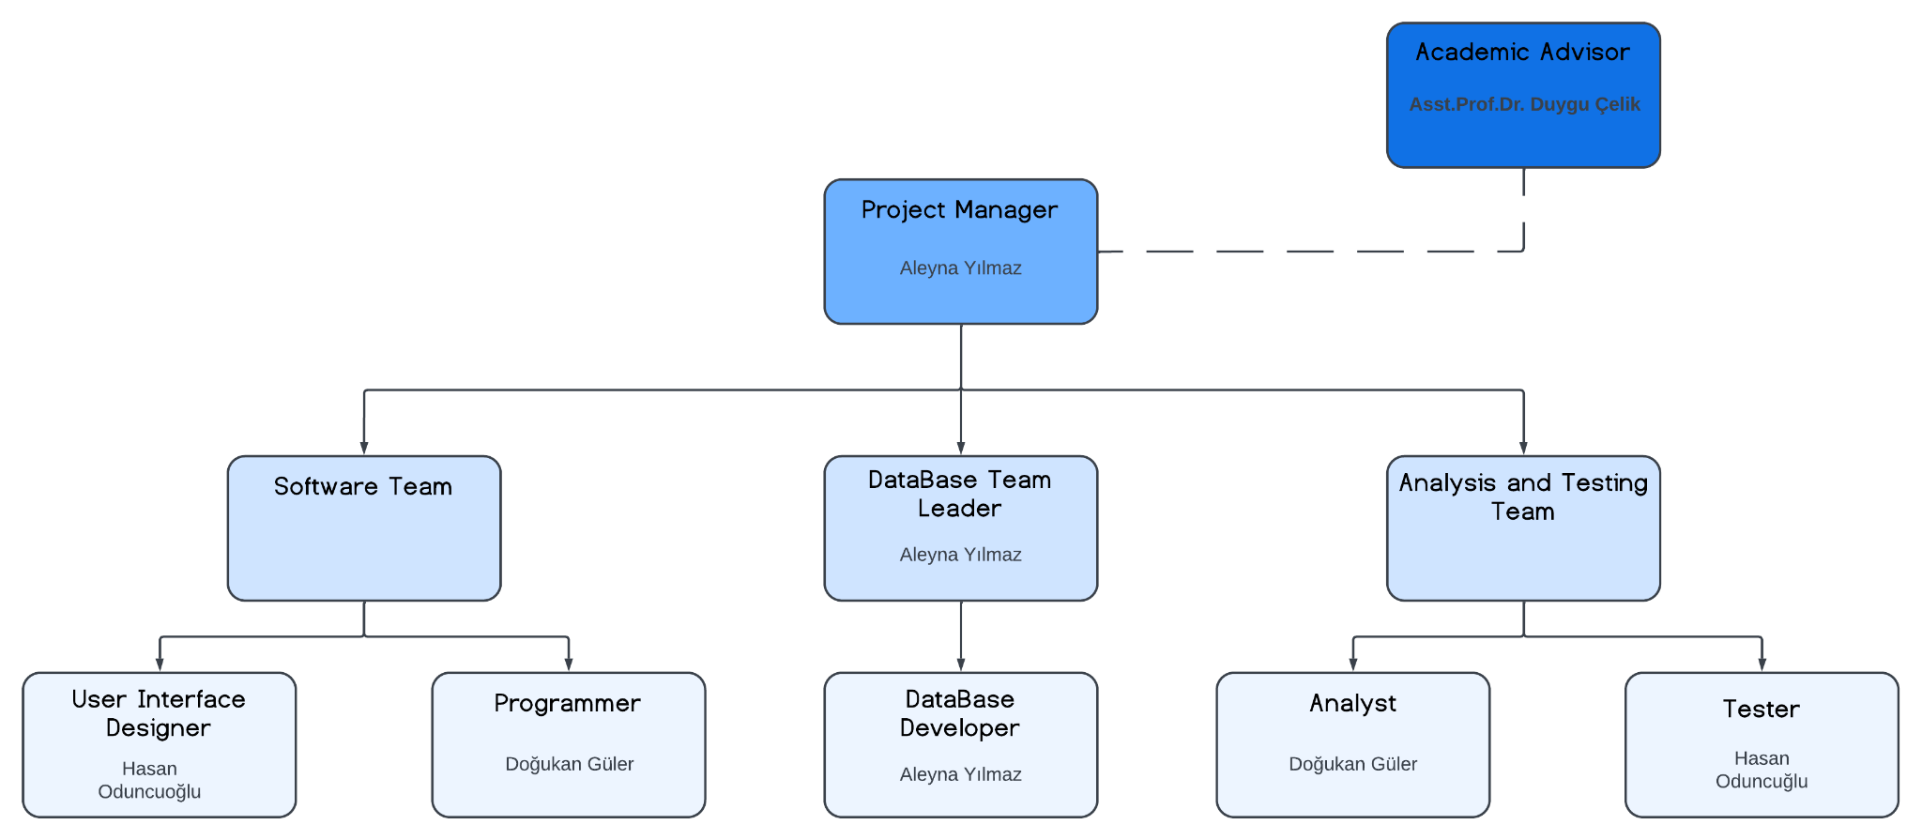

D.1 Economic Forecasts

|  |
| --- |
| **1- Evaluate the commercialization potential of project outcomes. List possible risks here?** |
| Application Fostering Social Connections for Elderly Well-Being attempts to create an Android application that promotes social ties for the well-being of the elderly not only addresses a crucial societal issue, but also provides a ground-breaking approach to combat loneliness among seniors. By harnessing technology to build a user-friendly virtual social environment accessible via tablets and mobile phones, the initiative has the potential to transform the well-being of seniors across the world. However, among this potential comes a landscape characterized with problems, such as user adoption barriers, technical complications, privacy issues, and intense market competition. However, the deep influence on mental health, as well as the pressing global demand for such solutions, highlight this endeavour's new marketing potential. Application Fostering Social Connections for Elderly Well-Being, with its strategic foresight, unwavering commitment to user-centric design, and diligent attention to privacy and security, can navigate these risks and position its application as an example of hope, changing the lives of millions while creating a unique place in the competitive market for social connectivity solutions. |

|  |  |
| --- | --- |
| **2- List your expectations to your team which are come by your project** | |
| Time-to-market (month): | August 2024 |
| The expected increase in sales revenue (%): | 8% |
| The expected increase in market share (%): | 8% |
| Time to start to gain: | June 2026 |

D.2 National Outcomes

|  |
| --- |
| **1- Specify the output that may be subject to patent, utility model and industrial design registration in the project.** |
| Given the scope of the project, multiple components may be subject to various forms of intellectual property protection. Unique features and abilities aimed at building social relationships for the elderly's well-being may be patentable. These could be algorithms or processes built into the application that enable meaningful interactions between users. Furthermore, while utility model and industrial design registration may not directly apply to software projects, characteristics such as user interface design or certain visual elements of the application may be eligible for industrial design protection. Application Fostering Social Connections for Elderly Well-Being should contact legal specialists in order to successfully identify and protect any intellectual property assets born from this initiative. |
| **2- Explain the potential of project and its outputs that may have an effect on social life, education, health and etc.** |
| The program directly addresses the common issue of loneliness among people aged 60 and up by developing an original Android application that allows for virtual social relationships through avatars. In a period of challenges caused by circumstances like loss and the COVID-19 pandemic, this technology solution offers a lifeline by allowing for meaningful contacts and friendships. The project represents a beacon of hope in addressing greater worldwide challenges raised by the World Health Organization, as evidenced by research demonstrating the transformative impact of technology on mental health, notably in reducing loneliness. Application Fostering Social Connections for Elderly Well-Being' project alleviates current challenges while also setting the path for a better, more connected future for the elderly, thereby improving their overall quality of life. |
| **3- Explain the positive and negative effects of project outputs for environment and human being.** |
| Application Fostering Social Connections for Elderly Well-Being plan to develop a user-friendly software for elderly social interaction in Northern Cyprus is like reaching out a warm hand to individuals who are feeling separated and lonely. It's encouraging to see technology being used for such a worthy cause, potentially delivering joy and friendship to people who need it the most. However, we should use caution, realizing that, while technology can be a great tool for good, it also presents its own set of difficulties. We must guarantee that the software does not mistakenly further isolate users or build a reliance on virtual interactions over real-world connections. Finally, it is about striking a balance between using technology to improve people's lives and remaining pinned in the real human relationships that truly support the soul. |

(M013) Instrument / Equipment / Software / RELEASE PURCHASES

|  |  |  |  |  |  |  |  |  |  |  |  |
| --- | --- | --- | --- | --- | --- | --- | --- | --- | --- | --- | --- |
| **Project Name** | |  | | | | | | | | | |
| **Line no** | **Instrument / Equipment / Software / Publication Name** | | **No. of Item** | **Capacity** | **Technical specification** | **Purpose of Project Activities** | **Post-Project Place of Use / Purpose** | | **Unit Price (USD)** | **Unit Price (TL)** | **Total Amount (TL)** |
| **R & D** | **Production** |
| **1** | **Laptop** | | **4** | **-** | **512gb minimum with 100gb unused space and Core i5/i7 quad-core 2.2GHz or faster** | **Involved in every task of the project** | **Yes** | **Yes** | **1,200** | **40,000** | **160,000** |
| **2** | **Internet Connection** | | **1** | **-** | **Min. 20Mbps** | **Connection** | **Yes** | **Yes** | **275** | **8,900** | **8,900** |
| **3** | **MS Project** | | **1** | **-** | **Project Management Software** | **Planning** | **Yes** |  | **30** | **1,000** | **1,000** |
| **4** | **Office 365** | | **1** | **-** | **Collection of office-related applications** | **Management** | **Yes** |  | **100** | **3,300** | **3,300** |
| **5** | **Modelio** | | **1** | **-** | **Tools for drawing diagrams** | **UML Diagrams** | **Yes** |  | **-** | **-** | **-** |
| **6** | **MySQL** | | **1** | **-** | **Tools for creating database** | **Database Operations** |  | **Yes** | **4,280** | **140,000** | **140,000** |
|  |  | |  |  |  |  |  |  |  | **TOTAL** | **313,200 TL** |

(M030) Quarterly Estimated Cost Form (TL)

|  |  |  |  |  |
| --- | --- | --- | --- | --- |
| **Project Name :** | | | | |
| **Cost Item** | **2024** | | **TOTAL**  **(TL)** | **TOTAL COST RATE OF CONTENTS (%)** |
| **I** | **II** |
| **Personnel** | 30,000 | 30,000 | 60,000 | 26 |
| **Travel** | 10,000 | 10,000 | 20,000 | 9 |
| **Instrument / Equipment / Software / Publications** | 10,000 | 10,000 | 20,000 | 9 |
| **Domestic Works Made By R & D and Testing Institutions** | 25,000 | 25,000 | 50,000 | 21 |
| **International Works Made By R & D and Testing Institutions** | - | - | - | - |
| **Domestic Services Procurement** | 12,000 | 12,000 | 24,000 | 11 |
| **Overseas Service Procurement** | - | - | - |  |
| **Material** | 30,000 | 30,000 | 60,000 | 24 |
| **TOTAL COST** | 117,000 | 117,000 | 234,000 | 100 |
| **CUMULATIVE COST** |  |  |  | 100 |
| **IN THE PROJECT TOTAL MAN-MONTH** | | | 234,000 | |

APPENDIX

|  |  |  |  |
| --- | --- | --- | --- |
|  | Task Name | Duration | Dependences |
|  | Project Initiation | 1 day |  |
|  | Economic feasibility analysis | 1 day | A |
|  | Analysis of similar products | 1 day | B |
|  | Market research | 1 day | C |
|  | Identification of the requirements and cost analysis of relevant sectors | 1 day | C |
|  | Analysis of Workflow | 1 day | D;E |
|  | Output technical and technological requirements analysis | 1 day | F |
|  | Determine the technological resources will be needed in the project | 1 day | G |
|  | Literature and patent research | 1 day | H |
|  | Examination of similar national and international projects made by applied technology | 1 day | I |
|  | Conceptual design | 2 days | J |
|  | Potential research approaches and methods | 1 day | J |
|  | Software requirements analysis | 3 days | K;L |
|  | Determining the System Parameters | 1 day | M |
|  | Design of System | 5 days | N |
|  | Selection of the device to be used | 2 days | N |
|  | Material and Supplier Selection | 2 days | N |
|  | Evaluation of System Design and Revisions | 2 days | N |
|  | Concept for software development | 3 days | O;P;Q;R |
|  | Creating a Database | 8 days | S |
|  | Software development | 10 days | T |
|  | Software Integration | 11 days | V;T |
|  | Prototype Implementation and Test Study(SRS-Test & Maintanance stage) | 10 days? | U;V |
|  | Project Closure | 1 day | W |

|  |  |  |  |  |  |  |  |  |
| --- | --- | --- | --- | --- | --- | --- | --- | --- |
| Task ID | Task Name | Minimum Duration | Average Duration | Maximum Duration | **Expected Time** | **Variance** | **Standart Deviation** | Dependency (Predicate) |
|  | Project Initiation | 0.5 day | 1 day | 2 days | **1.08 days** | **0.0625** | **0.25** |  |
|  | Economic feasibility analysis | 0.5 day | 1 day | 2 days | **1.08 days** | **0.0625** | **0.25** | A |
|  | Analysis of similar products | 0.5 day | 1 day | 2 days | **1.08 days** | **0.0625** | **0.25** | B |
|  | Market research | 0.5 day | 1 day | 2 days | **1.08 days** | **0.0625** | **0.25** | C |
|  | Identification of the requirements and cost analysis of relevant sectors | 0.5 day | 1 day | 2 days | **1.08 days** | **0.0625** | **0.25** | C |
|  | Analysis of Workflow | 0.5 day | 1 day | 2 days | **1.08 days** | **0.0625** | **0.25** | D;E |
|  | Output technical and technological requirements analysis | 0.5 day | 1 day | 2 days | **1.08 days** | **0.0625** | **0.25** | F |
|  | Determine the technological resources will be needed in the project | 0.5 day | 1 day | 2 days | **1.08 days** | **0.0625** | **0.25** | G |
|  | Literature and patent research | 0.5 day | 1 day | 2 days | **1.08 days** | **0.0625** | **0.25** | H |
|  | Examination of similar national and international projects made by applied technology | 0.5 day | 1 day | 2 days | **1.08 days** | **0.0625** | **0.25** | I |
|  | Conceptual design | 1 day | 2 days | 3 days | **2 days** | **0.1089** | **0.33** | J |
|  | Potential research approaches and methods | 0.5 day | 1 day | 2 days | **1.08 days** | **0.0625** | **0.25** | J |
|  | Software requirements analysis | 1 day | 3 days | 5 days | **3 days** | **0.4489** | **0.67** | K;L |
|  | Determining the System Parameters | 0.5 day | 1 day | 2 days | **1.08 days** | **0.0625** | **0.25** | M |
|  | Design of System | 3 days | 5 days | 7 days | **5 days** | **0.4489** | **0.67** | N |
|  | Selection of the device to be used | 1 days | 2 days | 3 days | **2 days** | **0.1089** | **0.33** | N |
|  | Material and Supplier Selection | 1 day | 2 days | 3 days | **2 days** | **0.1089** | **0.33** | N |
|  | Evaluation of System Design and Revisions | 1 day | 2 days | 3 days | **2 days** | **0.1089** | **0.33** | N |
|  | Concept for software development | 2 days | 3 days | 4 days | **3 days** | **0.1089** | **0.33** | O;P;Q;R |
|  | Creating a Database | 6 days | 8 days | 10 days | **8 days** | **0.4489** | **0.67** | S |
|  | Software development | 8 days | 10 days | 12 days | **10 days** | **0.4489** | **0.67** | T |
|  | Software Integration | 9 days | 11 days | 13 days | **11 days** | **0.4489** | **0.67** | V;T |
|  | Prototype Implementation and Test Study(SRS-Test & Maintanance stage) | 9 days | 10 days | 11 days | **10 days** | **0.1089** | **0.33** | U;V |
|  | Project Closure | 0.5 days | 1 day | 2 days | 1.08 days | 0.0625 | 0.67 | W |

|  |  |  |  |  |
| --- | --- | --- | --- | --- |
|  | **Paths** | **Total Expected Time For Each Path** | **Variance Of Each Path** | **Standart Deviation Of Each Path** |
|  | A B C D F G H I J K M N O S T U W X | 53,8 days | 1,0912 | 1,044605 |
|  | A B C E F G H I J K M N O S T U W X | 53,8 days | 1,0912 | 1,044605 |
|  | A B C D F G H I J L M N O S T U W X | 52,88 days | 1,0446 | 1,022056 |
|  | A B C E F G H I J L M N O S T U W X | 52,88 days | 1,0446 | 1,022056 |
|  | A B C D F G H I J K M N P S T U W X | 50,8 days | 1,0912 | 1,044605 |
|  | A B C E F G H I J K M N P S T U W X | 50,8 days | 1,0912 | 1,044605 |
|  | A B C D F G H I J L M N P S T U W X | 49,88 days | 1,0446 | 1,022056 |
|  | A B C E F G H I J L M N P S T U W X | 49,88 days | 1,0446 | 1,022056 |
|  | A B C D F G H I J K M N Q S T U W X | 50,8 days | 1,0912 | 1,044605 |
|  | A B C E F G H I J K M N Q S T U W X | 50,8 days | 1,0912 | 1,044605 |
|  | A B C D F G H I J L M N Q S T U W X | 49,88 days | 1,0446 | 1,022056 |
|  | A B C E F G H I J L M N Q S T U W X | 49,88 days | 1,0446 | 1,022056 |
|  | A B C D F G H I J K M N R S T U W X | 50,8 days | 1,0912 | 1,044605 |
|  | A B C E F G H I J K M N R S T U W X | 50,8 days | 1,0912 | 1,044605 |
|  | A B C D F G H I J L M N R S T U W X | 49,88 days | 1,0446 | 1,022056 |
|  | A B C E F G H I J L M N R S T U W X | 49,88 days | 1,0446 | 1,022056 |
|  | **A B C D F G H I J K M N O S T V W X** | **54,8 days** | **1,0912** | **1,044605** |
|  | **A B C E F G H I J K M N O S T V W X** | **54,8 days** | **1,0912** | **1,044605** |
|  | A B C D F G H I J L M N O S T V W X | 53,88 days | 1,0446 | 1,022056 |
|  | A B C E F G H I J L M N O S T V W X | 53,88 days | 1,0446 | 1,022056 |
|  | A B C D F G H I J K M N P S T V W X | 51,8 days | 1,0912 | 1,044605 |
|  | A B C E F G H I J K M N P S T V W X | 51,8 days | 1,0912 | 1,044605 |
|  | A B C D F G H I J L M N P S T V W X | 50,88 days | 1,0446 | 1,022056 |
|  | A B C E F G H I J L M N P S T V W X | 50,88 days | 1,0446 | 1,022056 |
|  | A B C D F G H I J K M N Q S T V W X | 51,8 days | 1,0912 | 1,044605 |
|  | A B C E F G H I J K M N Q S T V W X | 51,8 days | 1,0912 | 1,044605 |
|  | A B C D F G H I J L M N Q S T V W X | 50,88 days | 1,0446 | 1,022056 |
|  | A B C E F G H I J L M N Q S T V W X | 50,88 days | 1,0446 | 1,022056 |
|  | A B C D F G H I J K M N R S T V W X | 51,8 days | 1,0912 | 1,044605 |
|  | A B C E F G H I J K M N R S T V W X | 51,8 days | 1,0912 | 1,044605 |
|  | A B C D F G H I J L M N R S T V W X | 50,88 days | 1,0446 | 1,022056 |
|  | A B C E F G H I J L M N R S T V W X | 50,88 days | 1,0446 | 1,022056 |

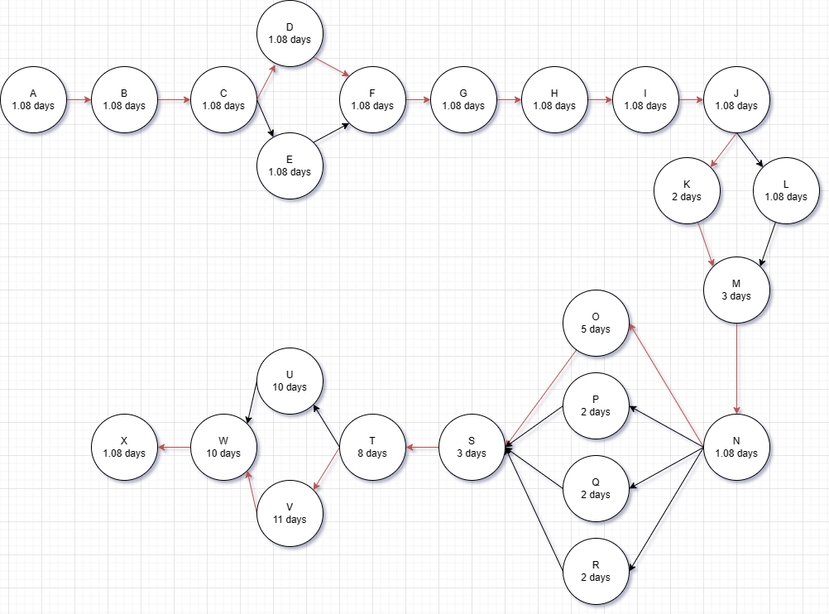**Network Diagram (Indicating the Critical Path With Red Lines)**

**CPM (Critical Path Management) Analysis By Using PERT (Defining Paths)**

The first one with **bold** font is our critical path having days. The calculation of the first path is shown, other paths are calculated in the similar way by checking the table values in PERT Calculation Section.

**PERT CALCULATION**

Expected time calculated using expected duration values.

Variance calculated by variance values of each process.

Standart deviation calculated by taking square root of variance.

You can also see all other possible paths.

The longest path “**A B C D F G H I J K M N O S T V W X”** indicated in bold color which has **54,8 days** days is our critical path

Formulas :

Expected Time: (min. duration +4*avg. duration +max. duration)/6

Variance: ${\left({\left(max.duration−min.duration\right)}/6\right)}^{2}$

Derivation: $\sqrt{variance}$

**Crashing Approach**

**Z= (**specified time – expected time) **/** path standart deviation

For each path in critical path management section we will calculate the z value :

Assume : We an order came saying that the project should be completed within 55 days instead of 62 days ( Reduction of 1 week ).

|  |  |  |  |  |  |
| --- | --- | --- | --- | --- | --- |
|  | **Expected Time Of The Path** | **Specified Time** | **Standart Deviation Of The Path** | **Z value** | **Probability Of Finishing %** |
|  | 53,8 | 62 | 1,044605 | 7,8498 | **78** |
|  | 53,8 | 62 | 1,044605 | 7,8498 | **78** |
|  | 52,88 | 62 | 1,022056 | 8,9231 | 81 |
|  | 52,88 | 62 | 1,022056 | 8,9231 | 81 |
|  | 50,8 | 62 | 1,044605 | 10,7212 | 99 |
|  | 50,8 | 62 | 1,044605 | 10,7212 | 99 |
|  | 49,88 | 62 | 1,022056 | 11,8584 | 98 |
|  | 49,88 | 62 | 1,022056 | 11,8584 | 98 |
|  | 50,8 | 62 | 1,044605 | 10,7217 | 99 |
|  | 50,8 | 62 | 1,044605 | 10,7217 | 99 |
|  | 49,88 | 62 | 1,022056 | 11,8584 | 98 |
|  | 49,88 | 62 | 1,022056 | 11,8584 | 98 |
|  | 50,8 | 62 | 1,044605 | 10,7212 | 99 |
|  | 50,8 | 62 | 1,044605 | 10,7212 | 99 |
|  | 49,88 | 62 | 1,022056 | 11,8584 | 98 |
|  | 49,88 | 62 | 1,022056 | 11,8584 | 98 |
|  | **54,8** | 62 | **1,044605** | 6,8925 | 75 |
|  | **54,8** | 62 | **1,044605** | 6,8925 | 75 |
|  | 53,88 | 62 | 1,022056 | 7,9447 | 79 |
|  | 53,88 | 62 | 1,022056 | 7,9447 | 79 |
|  | 51,8 | 62 | 1,044605 | 9,7644 | 83 |
|  | 51,8 | 62 | 1,044605 | 9,7644 | 83 |
|  | 50,88 | 62 | 1,022056 | 10,88 | 99 |
|  | 50,88 | 62 | 1,022056 | 10,88 | 99 |
|  | 51,8 | 62 | 1,044605 | 9,7644 | 83 |
|  | 51,8 | 62 | 1,044605 | 9,7644 | 83 |
|  | 50,88 | 62 | 1,022056 | 10,88 | 99 |
|  | 50,88 | 62 | 1,022056 | 10,88 | 99 |
|  | 51,8 | 62 | 1,044605 | 9,7644 | 83 |
|  | 51,8 | 62 | 1,044605 | 9,7644 | 83 |
|  | 50,88 | 62 | 1,022056 | 10,88 | 99 |
|  | 50,88 | 62 | 1,022056 | 10,88 | 99 |