Software Requirements Specification
for
Application Fostering Social Connections for Elderly Well-being
Version 1.0 approved
Prepared by ALEYNA YILMAZ 21000166
DOĞUKAN GÜLER 17000252
HASAN ODUNCUOĞLU 17330170
Eastern Mediterranean University
30/04/2024
Table of Contents
Table of Contents ii
Revision History ii
1. Introduction 1
1.1 Purpose 1
1.2 Document Conventions 1
1.3 Intended Audience and Reading Suggestions 1
1.4 Product Scope 1
1.5 References 1
2. Overall Description 2
2.1 Product Perspective 2
2.2 Product Functions 2
2.3 User Classes and Characteristics 2
2.4 Operating Environment 2
2.5 Design and Implementation Constraints 2
2.6 User Documentation 2
2.7 Assumptions and Dependencies 3
3. External Interface Requirements 3
3.1 User Interfaces 3
3.2 Hardware Interfaces 3
3.3 Software Interfaces 3
3.4 Communications Interfaces 3
4. System Features 4
4.1 System Feature 1 4
4.2 System Feature 2 (and so on) 4
5. Other Nonfunctional Requirements 4
5.1 Performance Requirements 4
5.2 Safety Requirements 5
5.3 Security Requirements 5
5.4 Software Quality Attributes 5
5.5 Business Rules 5
6. Other Requirements 5
Appendix A: Glossary 5
Appendix B: Analysis Models 5
Appendix C: To Be Determined List 6

Revision History
Name | Date | Reason For Changes | Version

Introduction

Purpose

The main and primary goal is to develop an accessible digital platform which will help and assist elderly people in Northern Cyprus in terms of loneliness and social isolation, helping elderly people to live happier, healthier, increase their quality of life and core connected lives.

Document Conventions
This document conforms to the IEEE standard for Software Requirements Specification. The document implements the MLA format. Bold face and indentation is used to emphasize sections and sub-section headings of the project. The remainder of the document will be written using the standard font, Arial.

Intended Audience and Reading Suggestions
This document is to be read by the project manager, development team, testers, documenters and also the clients. The SRS has been arranged in order of priority. The audience mentioned are to become intimately familiar with the SRS so that they can make progress with the product with little or no errors.

Product Scope

The aim of this undertaking is to produce an Android app that will be easy to use and will be accessible on tablets and mobile phones. The program will have the purpose to create a virtual social environment that will pay attention to the needs of senior users in Northern Cyprus. The characteristics of will consist of avatar-based interaction, fascinating exercises for betterment of cognitive and mental health, easy navigation, language options as English and Turkish and strong security and privacy measures. Usability testing and community engagement will become key parts of the development process that will guide to make sure the outcome is inclusive and effective. The movement would be directed towards reducing the loneliness of older adults, 60 and over in Northern Cyprus and developing the full potential of the meaningful relationships among them.

References
The references used.
E-Store Structural Model
E-Store Behavioural Model
E-Store NFR Model
Vision Draft 5

Overall Description

Product Perspective
In addition to this, it will serve a channel for elderly patients to talk to physicians and nurses in different departments, based on their issues and problems. There could be physician and nurse buttons for appointment scheduling, talking to patients, and offering general advice. The app will enable elderly to learn about various health indicators and also give you fitness and health advice too. It is also planned that the program will include interactive chats and games. Man’s success depends on factors like the usability of the interface, features that help the brain and inclusivity. The work was designed to target senior citizens over the age of 60 living in Northern Cyprus to lessen the feelings of social isolation and loneliness and instead build social relationships and a sense of belonging. What is more, the program has aimed at inclusive service, giving users the simplicity of access and usage regardless of their technical skills or level. The application will allow to accommodate the language variety of the user community, and therefore, it will provide bilingual options in both Turkish and English. This project will be aimed at minimizing the mental health risks involved with loneliness that include depression, anxiety, and cognitive problems. Technology will be employed to assist people in interacting with each other, and hence elderly people will live healthier and more social life in Northern Cyprus.

Product Functions
The application will provide users with the following functions, based on the user class:

o Create an account
o Manage your account
o Delete account
o Login/logout
o Ask for help
o Search for doctor and nurse
o View homepage
o Search for an individual doctor or nurse
o Remind pill
o Select games
o Exercise and health advice
o Open chat
o Open chat groups
o adding additional information (e.g. descriptions, images)
o receives advise from doctor or nurse

User Classes and Characteristics
Elderly person: The elderly person (user) interface is less technical than the administrator (doctor, nurse and admin) interface. Adjustments made affect the user’s account exclusively. Elderly people can navigate the chat, play games, request consultation form doctor or nurse, etc.

Doctor and Nurses: This interface is a bit more complex than the user (elderly person). Doctor or nurse can provide advice on health metrics.

Admin: Admin has the most complicated interface out of all users of the system. Since admin can edit all the background information necessary for the application to function properly.

Operating Environment
The system requires the following software and hardware platform to run optimally;

Operating System: Android 8

Design and Implementation Constraints
Operating System Limitations: The minimum operating system requirement is Android 8.

User Documentation
The application will come with a hands-on tutorial for first-time users, being guided through the functions of the systems. A help guide will also be available to clear out queries for later reference.

Assumptions and Dependencies
The project is hugely dependent on the compatibility of the operating system.

External Interface Requirements

User Interfaces
The program interface should be easy-to-use for elderly people who may not be familiar with digital technology. Components for UI should be well labelled and easy to operate on. Customize font sizes, color contrasts, and other visual features for people with seeing difficulties of various degree.

Hardware Interfaces
The system is supported by Android 8, RAM of 1 GB memory is needed. Also, there should be Wi-Fi and 4G connection.

Software Interfaces
The Application Fostering Social Connections for Elderly Well-being is compatible with Android 8 and above. It will use a RDBMS (Relational Database Management System), for easy usability, to maintain, control and update data into the database easily.

Communications Interfaces
Simple Mail Transfer Protocol (SMTP) will be implemented to send verification codes, notifications etc. to the customers’ emails. A security protocol will be implemented to provide security for all monetary transactions. A secure internet connection links the user to the database.

System Features

System Feature 1
<Don’t really say “System Feature 1.” State the feature name in just a few words.>
4.1.1 Description and Priority
These features cover the scope of basic features that the application will provide for the elderly people user class. It describes the actions they will be able to perform within their individual personal frame of their accounts. These are the basic features that every elderly people user is meant to have. They are of very high priority and describe the standard user-system interaction features.
4.1.2 Stimulus/Response Sequences
Some of the functions in this category are triggered automatically by the default settings of the system. Others are in response to user command.
4.1.3 Functional Requirements
REQ-1: New users shall be able to register.
REQ-2: Returning users shall be able to login.
REQ-3: Logged in users shall be able to logout.
REQ-4: Elderly people shall be able to change their password
REQ-5: Elderly people shall be able to edit/manage their profile
REQ-6: Elderly people shall be able to adjust the language settings of their account
REQ-7: The system shall notify users in case of invalid data fields

Other Nonfunctional Requirements

Performance Requirements
Applications should be responsive, which is by performing low latency to the user interaction.
Ensure time for page loading and action execution of function to boost user experience.

Safety Requirements
Encrypt all the user data and conversations in order to avoid unapproved access by third parties.
Employing stricter authentication and permission procedures for identity authentication and limiting the access to sensitive features will be one measure.
Security audits and upgrades are to be implemented as a regular process in order to deal with the potential weaknesses.

Security Requirements
Encrypt all the user data and conversations in order to avoid unapproved access by third parties.
Employing stricter authentication and permission procedures for identity authentication and limiting the access to sensitive features will be one measure.
Security audits and upgrades are to be implemented as a regular process in order to deal with the potential weaknesses.

Software Quality Attributes
Usability:
•The system should include a questions page for user’s to ask questions or complaints about the application
•The system should have a frequently answered questions page to tackle major frequent issues that user’s might have with using the application.
•The system should have a well formed, easy to use graphical user interface
•The system should be user friendly
•The system must be easy to learn for both novices and users with experience from similar systems
•The system must be efficient for the frequent user
•The system must be easy to remember for the casual user
•The user must understand what the system does
•The user must feel satisfied with the system

Supportability:
•The system should be easy to maintain.
• In order for the system to be easy to maintain it is done with an objected oriented language, which is easy to maintain.
•Maintenance of the system should be cost efficient
•Maintenance of the system should be less frequent
•The system should easily adapt to changes made
•The system should be able to detect the location of the user

Business Rules
Not applicable

Other Requirements
Compliance Requirements
The app should meet all the legal requirements and regulations as well as the industry standards including GDPR, accessibility requirements, and healthcare requirements.

Backup and Recovery
Routine data backup not to lose it during the system crashes or disasters.
Enact data recovery methods to restore app and user data in the case of the system crash.

Support and Maintenance
The development team must ensure that they are there for the users with ongoing support, addressing any questions, bugs, and system changes.
Users should be allowed to forward their technical problems or use instructions for use of the application to a support desk or a customer support staff.

Training and Onboarding
Make training material and supporting tools available to users to enable them to understand how the program can be used effectively.
Onboarding procedures, which should be designed to assist new users during the sign-up and setup process with ease.

Performance Monitoring
Develop tools and techniques to do in-time checkups of the application performance.
Establish and monitor KPIs to ensure optimal execution and provide basis for development.

Feedback and Improvement
Implement mechanisms of feedback to evaluate user satisfaction and propose implications to the areas that need improvement.
Be in the habit of weighing the feedback and adjusting future applications in the right direction.

Data Ownership and Portability
Users should be the ones to control their data and have the freedom to export the data to a transferable format.
Transparent policies and procedures should be designed for the data domain, including ownership, usage, and transferability.

Integration with Existing Systems
The application should be able to interact correctly with the organization's existing systems, as well as the infrastructure.
Proven APIs and integration points make the integration of the third-party services possible without any complications.

Disaster Recovery and Business Continuity
Seek ways and provision for business continuity during disasters and system failures.
Have a redundancy and failover mechanisms to make sure that the system will be operational and will be able to access data whenever there is a breakdown.

Environmental Considerations
Install redundancy and failover mechanisms so that the system can be operational even during downtime, and the data is constantly available.
The user interface should be oriented toward the environment by limiting power consumption and reducing the footprint of the carbon.
Appendix A: Glossary
API Application Programming Interface
COVID-19 Coronavirus Disease 2019
GDPR General Data Protection Regulation
UI User Interface
UX User Experience
WHO World Health Organization
Appendix B: Analysis Models
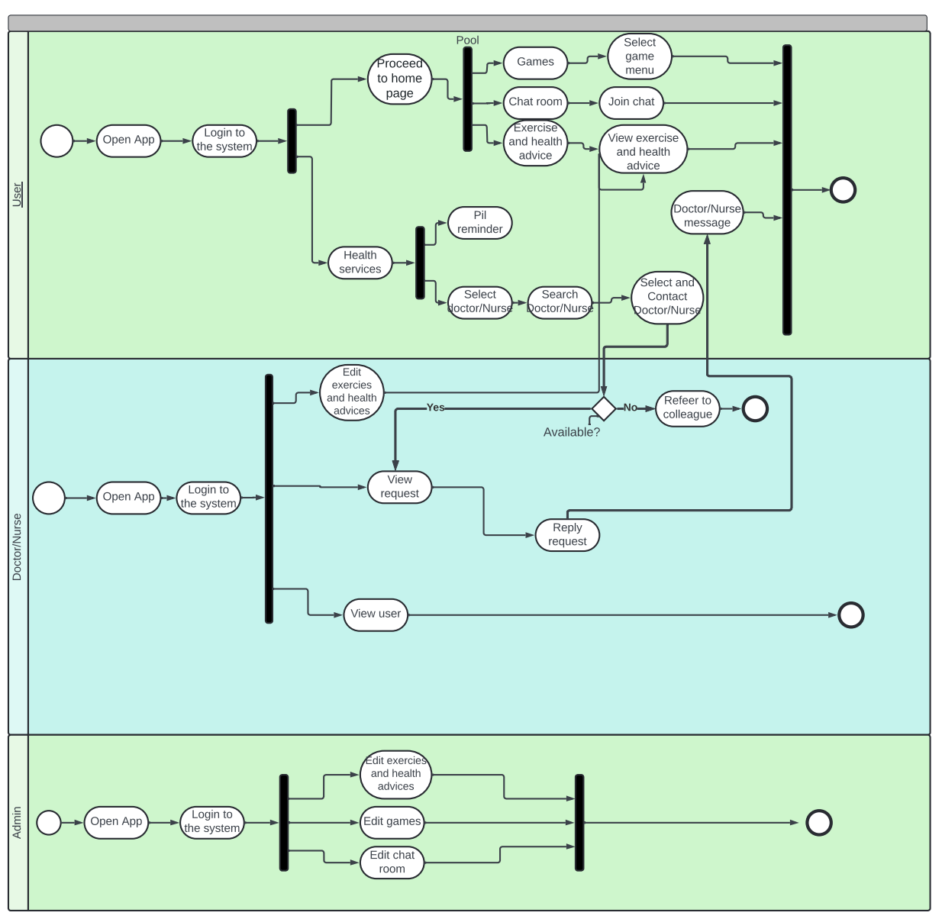

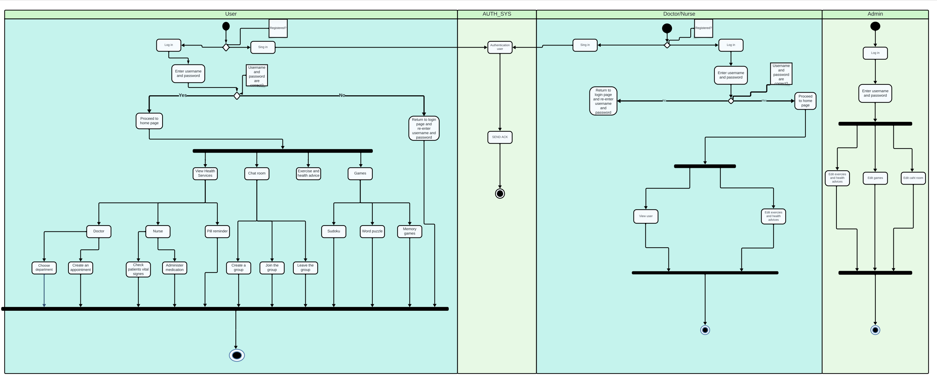

Appendix C: To Be Determined List
Not applicable

