**3. INTRODUCTION**

**Purpose**

Real estate search portal is a website designed to facilitate transactions such as real estate search, purchase, sale, rental and evaluation. This portal allows users to view, compare and query properties available in local or international markets. Additionally, the portal also provides users with additional services such as mortgage calculators, moving services, interior design solutions, legal advice and market trends.

**System Scope**

The system scope includes a description of the functions and features that the portal offers. System scope is determined by the portal's goals, audiences, requirements, constraints, and assumptions. The system scope also determines the success criteria and performance measures of the portal.

**Operating Environment**

The operating environment refers to the hardware, software, network and security components on which the portal runs. The operating environment provides the resources and infrastructure necessary to ensure that the portal operates in an efficient, secure and user-friendly manner. The operating environment may vary during the development, testing, deployment and maintenance phases of the portal.

**Design and Implementation Constraints**

Design and implementation constraints are factors that affect the development and operation of the portal. Design and implementation constraints ensure that the portal complies with technical, business, legal and ethical standards. Design and implementation constraints determine the portal's architecture, interface, data model, code quality, security protocols, compliance requirements, and testing strategies.

**5. OVERALL DESCRIPTION**

**SYSTEM ARCHITECTURE**

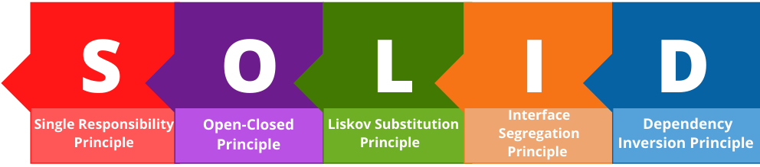

**Single Responsibility Principle:** This principle says that each class or module should have only one responsibility. This way, the code is easier to read, test and modify. For example, for the real estate search portal, different classes or modules can be created for different functions such as searching, listing, comparing, adding to favourites, saving, sharing and communicating. These classes or modules interact with each other as needed, but do not interfere with each other's business.

**Open-Closed Principle:** This principle states that software components should be closed to change but open to extension. This way, the code becomes more stable, secure and compatible. For example, for real estate search portal, if one wants to change the search criteria or the way it displays results, existing classes or modules are not changed, but new classes or modules are added. These new classes or modules are derived from or compatible with existing classes or modules.

**Liskov Substitution Principle:** This principle states that subclasses of a class can be used in place of its superclass. This way, the code is more consistent, logical and reliable. For example, for the real estate search portal, the property type is residence, workplace, land, etc. Different subclasses can be created, such as These subclasses can be used as a property type instead of the parent property class. These subclasses inherit the properties and behaviours of the superclass, but may also define their own properties and behaviours.

**Interface Decomposition Principle:** This principle says that a class or module should not implement interfaces it does not need. This way, the code becomes simpler, clearer and more flexible. For example, for the real estate search portal, different interfaces can be created for different functions such as searching, listing, comparing, adding to favourites, saving, sharing and communicating. These interfaces are implemented as needed by classes or modules, but unnecessary interfaces are not implemented.

**Dependency Inversion Principle:** This principle says that software components should depend on abstractions but not on details. This way, the code is more independent, modular and amenable to change. For example, for the real estate search portal, different classes or modules can be created for different functions such as searching, listing, comparing, adding to favourites, saving, sharing and communicating. These classes or modules interact with each other through abstract interfaces or classes, but they do not depend on each other's details.

**USE CASES**

Use cases for a real estate search portal may include the following scenarios:

**Use case 1:** The user enters the portal's website, enters the desired location, property type, price range, number of rooms, square meters and other criteria in the search box, clicks the search button, the portal lists the properties suitable for the user, the user examines the list, compares the properties he likes, adds to the favourites adds, saves, shares or contacts advertisers.

**Use case 2:** The user downloads the portal's mobile application, opens the application, activates the location service, views properties near him, marks properties on the map, reads property details, watches property photos or videos, sees property reviews or ratings, sends a message to the advertiser if he likes the property, or calls.

**Use case 3:** The user enters the portal's website, selects moving services from the menu, enters the location to be moved, the date to be moved, the type of property to be moved to, the size of the property to be moved to and other information on the moving services page, the portal lists the moving companies suitable for the user, the user examines the list, the moving location he likes is He compares the companies, gets a quote, sees their comments or scores, and makes an agreement with the moving company.

**Use case 4:** The user enters the portal's website, selects the interior design solutions from the menu, enters the desired property type, property size, design style, budget and other information on the interior design solutions page, the portal lists the interior designers suitable for the user, the user examines the list, selects the interior he likes compares designers, sees their portfolios, comments or ratings, and contacts the interior designer.

**Use case 5**: The user enters the portal's website, selects legal consultancy services from the menu, enters the desired property type, property size, purchase-sale agreement, title deed transactions and other information on the legal consultancy services page, the portal lists the legal advisors suitable for the user, the user examines the list, compares the legal advisors he/she likes, sees their comments or scores, and contacts the legal advisor.

**Use case 6:** The user enters the portal's website, selects market trends from the menu, enters the desired location, property type, time period and other information on the market trends page, the portal shows the user relevant market trends, the user examines market trends, property prices, supply-demand It sees the balance, return on investment, competitive situation and other factors, and makes decisions based on market trends.

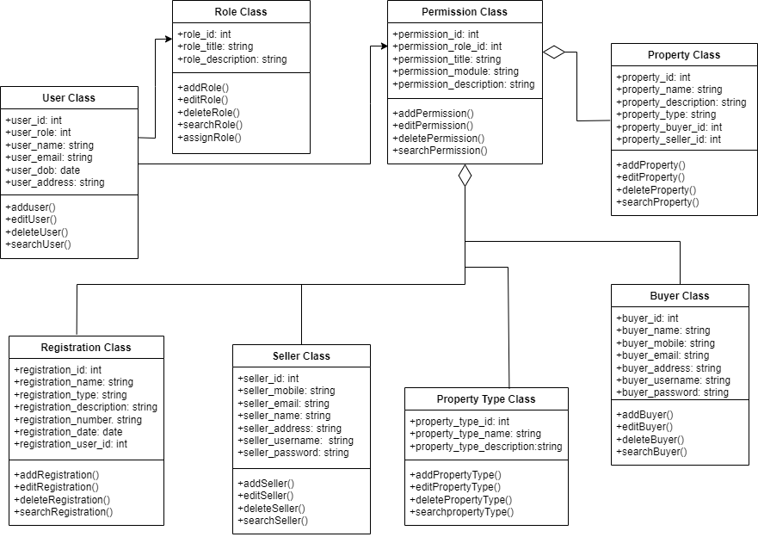**CLASS DIAGRAM**

**Modular Hierarchy Diagram**

