

Term Project
CMSE 353

Software Requirement Analysis and Specification

Team Members
Doğukan GÜLER 17000252
Aleyna YILMAZ 21000166

Group No: 01

Team Number: 12

Project Name: Secure Teams-Like System

Supervisor: Prof.Dr. Alexander Chefranov

Lab Supervisor: Research Assistant Nada KOLLAH

Semester Term: 2023 Fall
2) Outline

- Cover Page..........................................................................................................1
- Outline.................................................................................................................2
- Problem Definition..............................................................................................3
- Description of work breakdown and task distribution between team members...........................................................................................................3-4
- Description of algorithm for solving your problem.........................................4-5
- Description of database structure designed.........................................................5
- Description of tools you used for implementation of your problem and the details of their installation and preparation for usage......................................5-6
- Description of the developed program.............................................................6-9
- User guide.........................................................................................................10
- Description of conducted tests and their results with screenshots of the runs...............................................................................................................12-14
- Conclusion.........................................................................................................15
- Referances.........................................................................................................16
- Appendices with the most important code explained in the main part........17-20

3) Problem Definition
The problem definition for this project is to develop a Secure Teams-Like System (STLS). This system should have three types of users: Students, Teachers, and a System Administrator.

The System Administrator is responsible for adding new users to the system and managing their privileges. Teachers can create groups (teams) of students, assign students and teachers to these teams, and create channels within the teams for communication. All information in the system is stored in a DES-encrypted format, with secret keys created and updated periodically by the System Administrator.

Users should be able to view the teams they are assigned to or have created, and communicate with others via chat. The user interface of the STLS should resemble that of Teams. The solution should be implemented as a software application, and it should be tested to ensure its correctness. A report detailing the assignment should also be prepared.

4) Description of work breakdown and task distribution between team members

Work breakdown
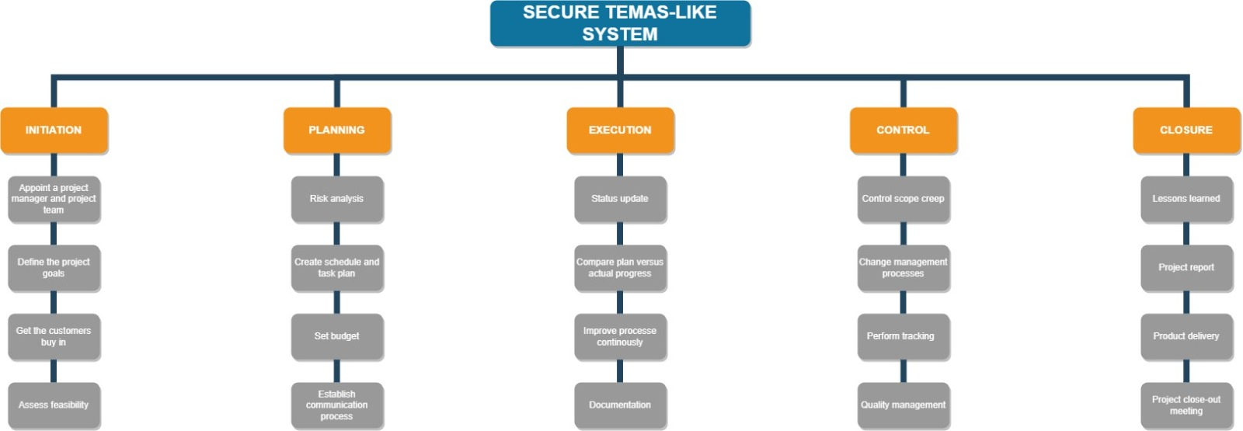

Work Distribution
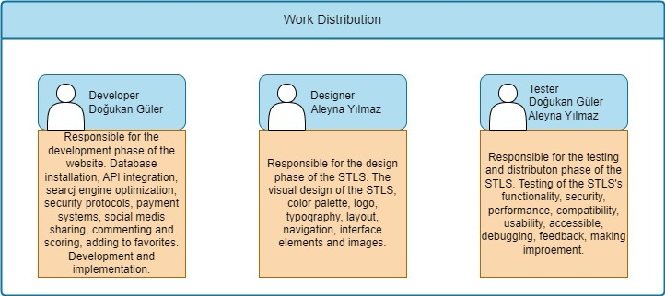

5) Description of algorithm for solving your problem

Problem: Developing a course management system application. This app should enable students and teachers to register for courses and message. Additionally, the application must be connected to the MySQL database and store and process data.

Algorithm: The following steps to develop the application:
Step 1: Analyzing and designing the application's requirements. In this step, it is necessary to determine what features the application will have, what data it will use, what interfaces it will offer and what functions it will perform. Additionally, the application must be modeled as classes, objects, properties, methods, and relationships in accordance with the object-oriented programming paradigm.

Step 2: Writing the codes of the application. In this step, it is necessary to write codes in Java language in accordance with the design of the application. The codes are grouped into three packages named pl, ui and util. The pl package contains the necessary classes to connect with the database and manipulate data. The ui package contains the necessary classes to create and control the application's interfaces. The util package contains the necessary classes to implement the application's helper functions. The codes were written and debugged in Visual Studio Code.

Step 3: Testing the application. In this step, it is necessary to test whether the application's codes work correctly, whether it meets the application's requirements, and the performance of the application. Testing can be done both manually and automatically. Test results can be used to evaluate the quality and reliability of the application.

6) Description of database structure designed
This program defines a class called baglanti, which is used to establish a connection to a MySQL database. The class has four public fields: url, root, sifre, and baglanti. The url field contains the connection string for the database, which specifies the protocol (jdbc:mysql), the host name (localhost), the port number (3306), and the database name (pl). The root and sifre fields contain the username and password for accessing the database. The baglanti field is a constructor that initializes the other fields with default values.

The program does not use the baglanti class directly, but it may be used by other classes that need to connect to the database. To use this program, you need to have a MySQL server running on your local machine, and you need to have access to it using your root and sifre credentials. You also need to have a MySQL driver installed on your machine, such as MySQL Connector/J or MySQL Connector/C. These drivers allow Java applications to communicate with MySQL databases using JDBC.

7) Description of tools you used for implementation of your problem and the details of their installation and preparation for usage

Java Swing: Java's graphical user interface (GUI) library. This library provides various components and tools to design your application's interface. For example, you can use components such as windows, menus, buttons, labels, images. Java Swing is an extension of the AWT library included in the java.awt package. Java Swing provides various components such as window, label, button, list, menu. To create a GUI with Java Swing, you first need to create a Frame object and add the components you want to it.

MySQL: It is a database management system. This system provides a platform to store and query your application's data. For example, you can create tables such as courses, students, courses and associate them. It stores data in tables and processes it with SQL queries. To use MySQL, you must first download and install the MySQL Installer package. You then need to add the required driver file for the database connection to your project. You can do this from the libraries section in your IDE or by using a package manager such as Maven.

JDBC: Abbreviation for Java Database Connectivity. This technology enables data transfer between Java and MySQL or any other database. For example, you can read or write data from the database with JDBC queries. It is a library used to connect to databases and perform data operations with Java. JDBC API consists of classes included in the java.sql package. For database interaction with JDBC, you need to follow five steps: register the driver class, establish a database connection, send the SQL query, get the results, and close the connection.

8) Description of the developed program
loginForm.java: This file contains a class that creates and controls the application's login form. This file contains codes that define and place the username and password fields, the login button, the registration link, and error messages.

The most important place in this file may be the actionPerformed() method, which runs when the login button is clicked. This method compares the information entered by the user with the database and performs verification. If the username and password are correct, it redirects to the home page of the application. If it is wrong, it shows error message. This method is a place to ensure the security and functionality of the application.
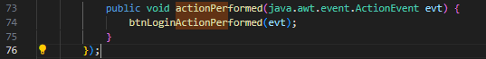
Another important place in the loginForm.java file is the mouseClicked() method of the registerLabel object. This method works when the user clicks on the registration link. This method directs the user to the registration form. In this form, one needs to enter information such as username, password, email and role. This method is a place to ensure the usability and functionality of the application.
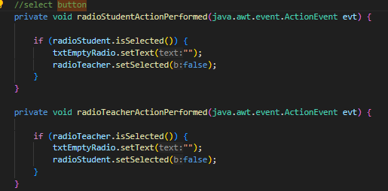

Another important place in the loginForm.java file is the initComponents() method. This method is a place to create and set the components of the application's login form. This method defines the username and password fields, the login button, the registration link, and error messages. It also determines the sizes, colors, fonts and positions of these components. This method is a place to provide the design and appearance of the application's interface.
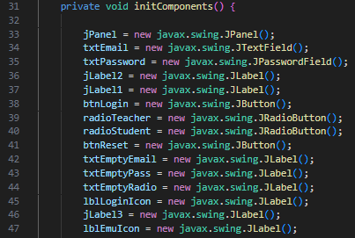

Student.java-Teacher.java: These files contain classes that indicate that the application uses the object-oriented programming paradigm. These classes represent the basic components of the application, such as student and teacher. These files contain codes that define the properties, behaviors and relationships of these classes.

Constructor methods in the student.java file: These methods are used to create objects of the Student class. These methods identify student characteristics such as first name, last name, email, password, role, and courses. These methods are important for storing and processing the application's data.
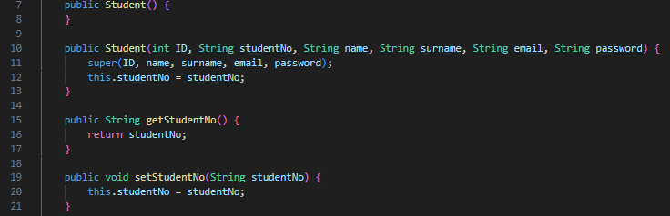
Constructor methods in the teacher.java file: These methods are used to create objects of the Teacher class. These methods define the teacher's characteristics such as first name, last name, email, password, role, courses and messages. These methods are important for storing and processing the application's data.
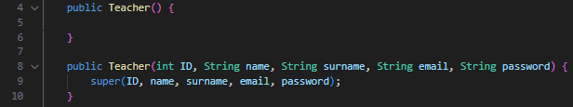
Getter and setter methods in student.java and teacher.java files: These methods are used to access and change the properties of Student and Teacher classes. These methods are important to update and protect the application's data.

baglanti.java: public String url=“jdbc:mysql://localhost:3306/pl”;: This line defines a String variable named url and assigns a value to it. This variable is defined with the public keyword. This means that this variable is also accessible from other classes. The value of this variable is a JDBC connection address used to connect to the MySQL database. This address contains the protocol, location, port, and name of the database.
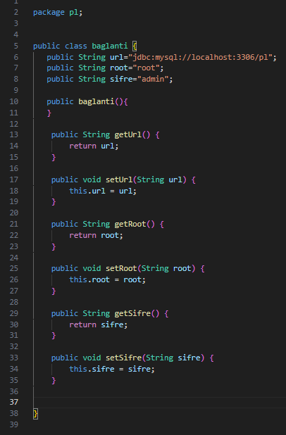

Desdatabase.java: This part is used to install the JDBC library. JDBC is a standard for interacting with databases in Java1. Loading the JDBC library allows us to use the necessary classes and methods to connect to the database and send queries.
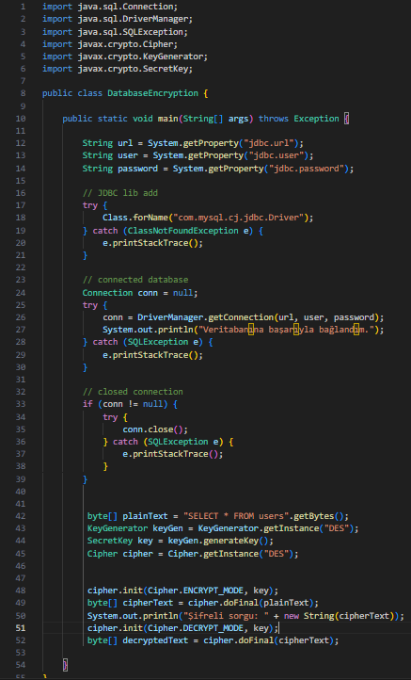
We call the Class.forName (“com.mysql.cj.jdbc.Driver”) method to load the JDBC library. This method loads that class into memory using the class name we provide. This class contains the JDBC driver required to connect to the MySQL database. When the driver class is loaded, it registers itself in the DriverManager class. DriverManager class helps us select the appropriate driver to connect to the database2.

9) User guide

Download and install the application: You can download the source codes of the application here. After downloading this file, you can open the project using a Java IDE (e.g. Eclipse, NetBeans, VsCode). To run the application, select the Main.java file and issue the Run command. To install the application, you can convert the project to a JAR file or make it an executable. You can use the features of your IDE for these operations.

For Students
Log in or register to the application: When you run the application, the login form appears. In this form, you can log in by filling in the username and password fields. If you have not registered before, you can go to the registration form by clicking the registration link in the lower right corner of the form. In the registration form, you need to enter information such as username, password, email and role (student or teacher). After entering the information, you can complete the registration process by clicking the register button.

Use the features of the application: When you log in to the application, you will see different features depending on your role. If you are logged in as a student, you can use the following features:

Register for courses: On the home page, you can see the list of courses you can register for. To register for a course, click on the name of the course and click the register button in the window that opens. The courses you are enrolled in appear in the menu on the left side of the home page.

Message: By clicking the messages button in the upper right corner of the home page, you can see the list of people you can message. This list includes teachers and students in the courses you are enrolled in. To send a message to a person, click on the person's name and write a message in the window that opens and click the send button. You can also view incoming messages in the same way.

Exit the application: You can exit the application by clicking the log out button in the upper right corner of the home page. This does not close the application, it just ends your session. To completely close the application, you can click the close button in the upper right corner of the window.
For Teachers
Create a course: You can create a new course by clicking the create course button on the home page. In the course creation form, you need to enter information such as the course name, description, category, and image. After entering the information, you can create your course by clicking the create course button. Courses you create appear in the menu on the left side of the home page.

Add a course: When you click on a course you've created, you can see a list of the course's courses. To add a new course, click the add course button and enter information such as the name and description of the course in the window that opens. After entering the information, you can add your course by clicking the add course button.

Select students: When you click on a course you created, you can see a list of students who want to enroll in the course. To accept or reject a student for a course, click the approve or reject button next to the student's name. Students you accept into the course appear in the course students tab.

Message: By clicking the messages button in the upper right corner of the home page, you can see the list of people you can message. This list includes teachers and students in the courses you are enrolled in. To send a message to a person, click on the person's name and write a message in the window that opens and click the send button. You can also view incoming messages in the same way.

Exit the application: You can exit the application by clicking the log out button in the upper right corner of the home page. This does not close the application, it just ends your session. To completely close the application, you can click the close button in the upper right corner of the window.

10) Description of conducted tests and their results with screenshots of the runs

Login Page

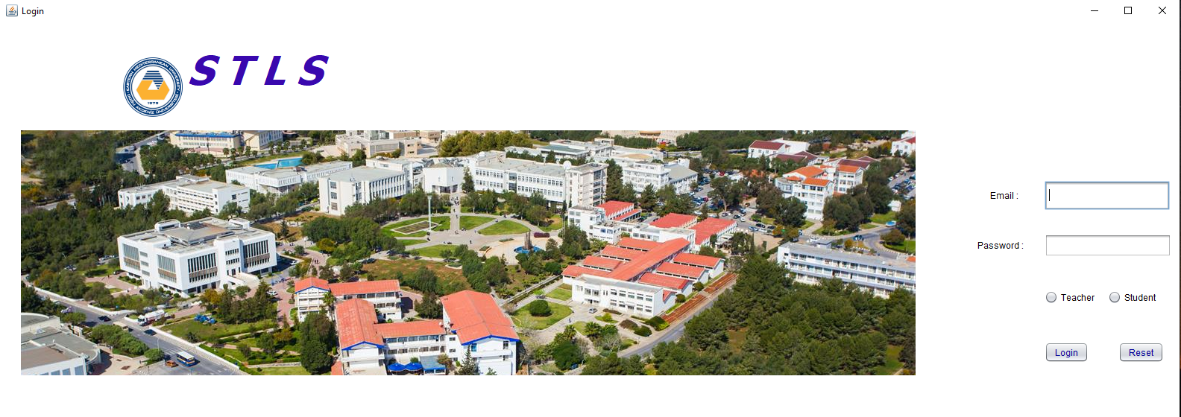
TeacherMainPage
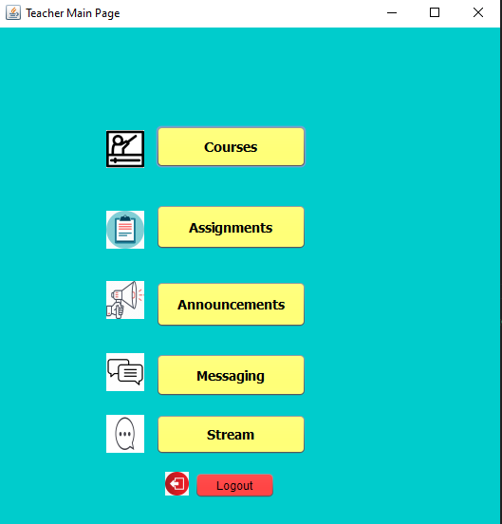

Teachers Course Page
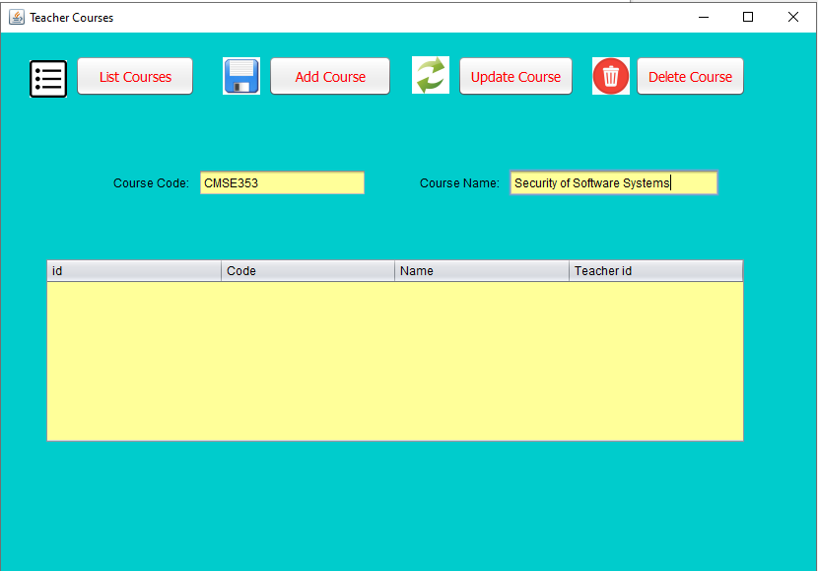

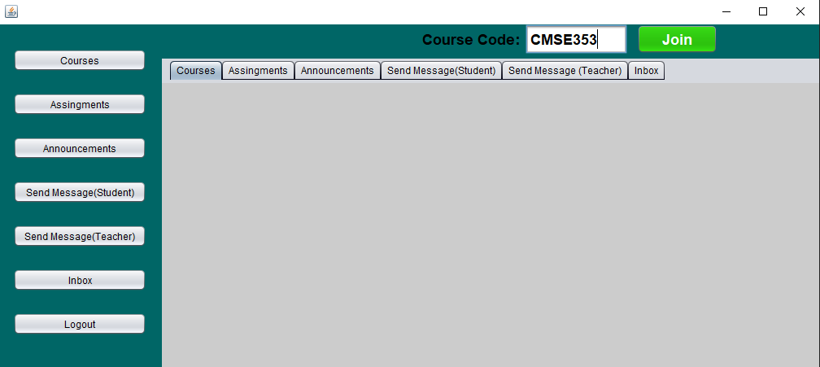
Student Course Page
Message Page

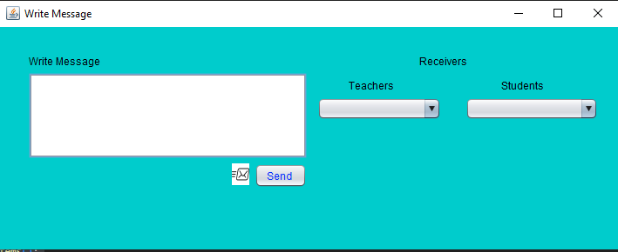

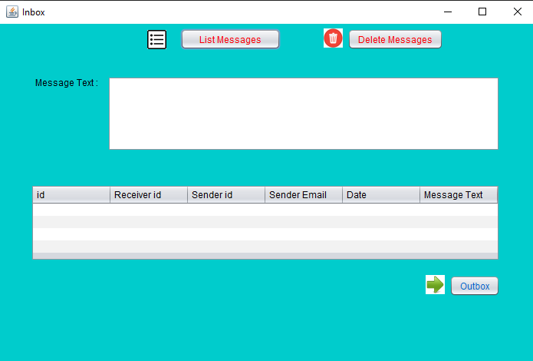

11) Conclusion
In this project, a course management system application was developed with the Java programming language. This application was designed and coded in accordance with the object-oriented programming paradigm. The application consists of classes grouped in three packages named pl, ui and util. The pl package contains the necessary classes to connect with the database and process data. The ui package contains the necessary classes to create and control the application's interfaces. The util package contains the necessary classes to implement the application's helper functions. The application offers graphical user interfaces with the Java Swing library. The application connects with the MySQL database and stores and processes data.

The application allows students and teachers to register for courses and send messages. The application offers different features according to student and teacher roles. Students can enroll in courses and send messages. Teachers can create courses, add lessons, select students and send messages.

To develop the application, first the requirements of the application were analyzed and designed. Then, the application codes were written and tested. To run and install the application, Java platform and MySQL database were used.

In this project, the basic features of the Java programming language, syntax, data types, variables, operators, control statements, loops, arrays, methods, classes, objects, inheritance, polymorphism, abstract classes, interfaces, inner classes, exceptions, collections, file operations, Swing library, JDBC library and MySQL database were used.

12) Referances
- https://www.learnupon.com/blog/what-is-an-lms/#:~:text=An%20LMS%2C%20or%20learning%20management,offering%20different%20features%20and%20capabilities.
- https://github.com/bojanzdelar/learning-management-system-shared-library
- https://www.geeksforgeeks.org/java-program-to-store-a-student-information-in-a-file-using-awt/?ref=gcse
- https://copyassignment.com/student-management-system-project-in-java/
https://itsourcecode.com/free-projects/php-project/learning-management-system-project-in-php-with-source-code/
- https://www.youtube.com/watch?v=KKIeRXwZ-Sw
- https://www.geeksforgeeks.org/crud-operations-in-student-management-system-in-java/
- https://code-projects.org/simple-student-management-in-java-with-source-code/
- https://www.geeksforgeeks.org/data-encryption-standard-des-set-1/?ref=gcse
- https://www.geeksforgeeks.org/crud-operations-in-student-management-system-in-java/?ref=header_search
- https://bilgisayarkavramlari.com/2008/03/13/des-veri-sifreleme-standardi-data-encryption-standard/
- https://www.youtube.com/watch?v=KgSa2AQt6ic
- https://github.com/ThalKod/discord-clone/blob/master/middleware/index.js
- https://www.youtube.com/watch?v=hIc_9Wbn704
- https://www.youtube.com/watch?v=XffVSIFRv3A
- https://www.youtube.com/watch?v=gFVZ2h1Usks
- https://ngonyoku.medium.com/jdbc-how-to-connect-java-to-mysql-database-c7dc06dcb28c
- https://ngonyoku.medium.com/jdbc-how-to-connect-java-to-mysql-database-c7dc06dcb28c
- https://github.com/topics/course-management-system
- https://itsourcecode.com/free-projects/java-projects/course-management-system-project-in-java-with-source-code/
- https://cloud.google.com/architecture/scalable-and-resilient-apps

13) Appendices with the most important code explained in the main part: item 8

Admin:

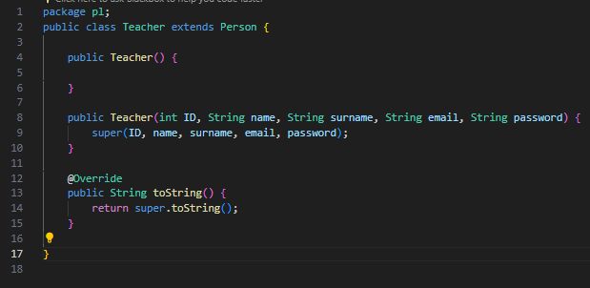
Teacher:
Teacher.java
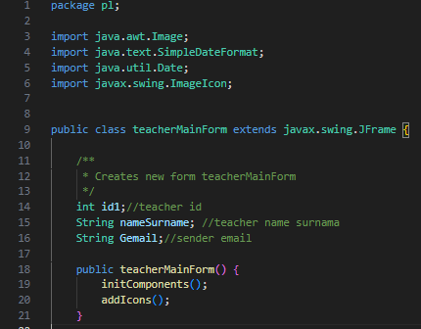

teacherMainForm.java

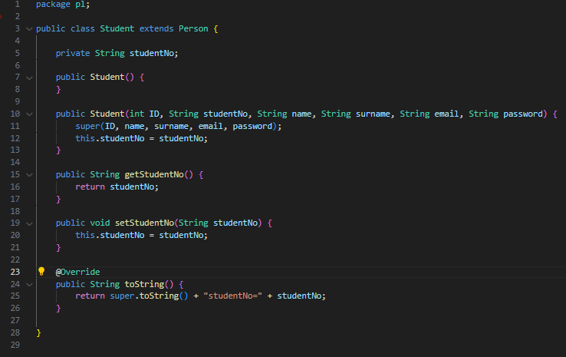
Student:
Student.java

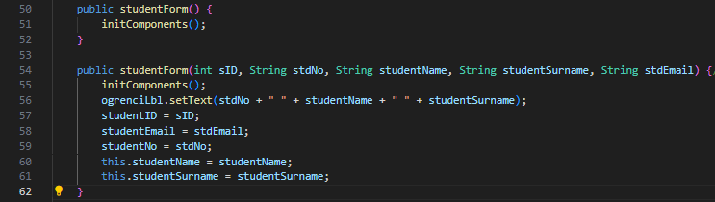
studentForm.java

DES Database.java

