

INTERNATIONAL UNIVERSITY OF SARAJEVO

**Bus Seat Booking System**

Software Requirements Specification

25/04/2016

Group 1:

-Ibrahim Guler 1010319

-Ozgur Altınkaya

-Yousef aly 130303008

-Emad Obaidat 992441

-Abdullah Alrez 992450

Contents

1. Introduction 3

1.1 Purpose 3

1.2 Scope 3

1.3 Glossary 4

1.4 References 4

1.5 Overview 5

2. General Description 5

2.1 Product Perspective 6

2.2 Product Functions 6

2.3 Assumptions and Dependencies 6

3. System Requirements Specification 7

3.1 Functional Requirements 7

3.2 Non-Functional Requirements 8

3.2.1 Performance 8

3.2.2 Reliability 8

3.2.3 Availability 8

3.2.4 Portability 9

3.3 Hardware & OS Requirements 9

3.4 Database Requirements 9

4. System Evolution 10

# Introduction

In today’s world,the innovation of technology has made huge impact and solutions in our lives such as reservation or booking bus tickets in advance at home.Planning a travel is just a click away .There are tons of existing features that has made easier for customers who can reserve seat or book bus ticket from any place in the world as long as they are connected to internet. .Thousands of people use this days so that they can arrive their destinations safe and sound within a short period of time. The road transportation is not only safest means of transportation today but also bus tickets are usually cheaper than most transportations so customers tend to travel to other state, countries using road transportation and arrive their destinations. Therefore, this bus seat reservation system is to help thousands of people ,that uses road transportations on a daily basis to travel from one place to another.

## 1.1 Purpose

The main purpose of this software is to reduce the complexity involved in the bus reservation process and make it convenient for the customers to book the seats as when they require such that they can utilize this software to make reservations, modify reservations or cancel a particular reservation

1.2 Scope

The name of the software is “BUS RESERVATION SYSTEM”.This software provides options for viewing different buses available with different timings for a particular date and provides customers with the facility to book a ticket, modify or cancel a particular reservation but it does not provide the customers with details of cost of the ticket and it does not allow the customer to modify a particular part of his reservation and he/she can modify all his details.

This project allows the user to book bus ticket online. User can check the availability of seats in bus on particular date and time. This system has an effective graphical user interface which enables user to check the availability of seats. The seats which are already booked will be shown in red color. User can select the seats according to their preference. System stores data about the seats which are available and seats which are already booked on particular date and time. Users can make prior bookings for desired seats for their desired bus at desired time with cost. Therefore the project is intended to overcome this situation by automating the manual booking system and saving time.Users have to register in order to access to the reservation page.All information is maintained in a database.

## 1.3 Glossary

BRS-Bus Reservation System

LAN-Local Area Network

GUI-Graphical User Interface

OS-Operating System

RAM-Random Access Memory

HDD-Hard Disk Drive

RNo.-Reservation Number

1.4 References

The books and materials referred during the pre-development stages of the project include

1. “Agile Project Management for dummies” by Mark C.Layton

2. Software Engineering-By James Peters

3. <http://www.tutorialspoint.com/software_engineering/software_requirements.htm>

4. <http://www.makemytrip.com/bus-tickets/>

## 1.5 Overview

The rest of the document deals about all the main features of this software each will be shown its purpose and its main functions.

# General Description

The software is to help people who is struggling with making travel plans. Compared to the existing bus management system where most of the works are done manually, this proposed software requires less number of employees to handle the entire bus management system. The existing system is not only very traditional and old but also it is very unreliable, noneconomical, and ineffective.

## Product Perspective

There are some small software and some websites which is related to our software but most of them may not be offering the best deal. For example, booking a bus ticket in Bosnia is quite hard task to deal with since they don’t provide enough information about routes but also language barriers make foreign customers struggle. Our software will be solution for especially for English Native Speaker customers.

## Product Functions

The major functions include:

•Providing bus and route details

•Bus bookings for a particular destination, date and time.

•Allowing the customer to modify or cancel his reservation provided the login info.

•Displaying a report of the number of people flying in a particular flight

2.3 Assumptions and Dependencies

It is assumed that the details of the cost of ticket are already known to the customer.

# System Requirements Specification

## Functional Requirements

|  |  |  |
| --- | --- | --- |
| REQUIREMENTS | DEFINITION | MORE DETAILS |
| Register&LogIn | Create new account, or log in with an existing account | The user creats account and their data get saved in the database. Later they can sign in using this data. |
| Search | So the user can find a suitable trip. | The user looks for the trips that is suitable for them on the date that is suitable too |
| Make Booking | The user makes a book depending on the search results. | The user can make a booking after they saw the possible trips on some dates they want. |
| Contact the company | To contact the company | To contanct the company in case of a problem |
| Modify Booking | Editing the booking | Editing the booking by changing the date or the seat |
| Cancelling Booking | Cancelling the reservation | The user can cancel the reservetion and refund their  money or part of it |
| Report | General Report to the administration | So that the company knows how many customers they already have on a particular trip |
| Send by Email | The ticket or the RNo. Can be sent by email | Sending email to the customer to let him know that he succesfully reserved,and to know his Rno. |
| Update Bus Information | General Checking for Bus  And Update regularly | In this module admin can add or Update Bus using this module. It contains the information about the Bus type , photo, description, Location of tour, Available Seats in Bus etc. |
| Comment for Particular Bus | Comment freely | Customer can Post the Comment on a particular Bus . |

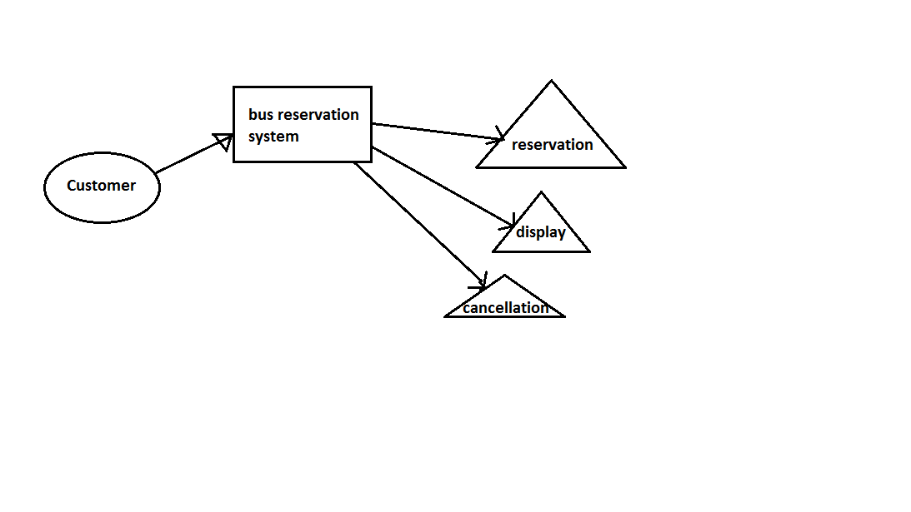

### Non-Functional Requirements

### Performance

Performance is not going to be problem for this software. Our program will be using small amount of memory and will not affect the performance

### Reliability

For this kind of small project reliability is not a problem. System crashes are mostly happens for big projects. Our software will be reliable and stabile.

### Availability

System will be available 24 hours. Because all the system is based on automations. User can enter the system and can choose the options and make a deal anytime.

### Portability

Our software will be portable and will be able to use on any computers. Since people will use this agency system all around the world. We assume that there will be many different OS users so portability is a necessity for the program.

## Hardware & OS Requirements

All windows versions supports our software (XP,Windows 7,Vista,Windows 8.1 and Windows 10 And all new version of OS such as Mac OS, Linux.

We recommend to have at least 512 mb memory in order to use the software.

## Database Requirements

For each functions we will have database values and connections between the data. We are going to use simple database for our program. We are going to show detailed database and relations after all database finish. Here are the data that we are going to use:

|  |  |
| --- | --- |
| username | password |
| resNumber | date |
| fName | mName |
| sName | age |
| Gender  email | Country  Cities |

# 4. System Evolution

Program will contain a login system which will enable multiple users to use the program on the same machine (if needed). Each user can search for bus and route details, bus bookings for a particular destination, date and time so changing user’s needs is supported.

GPS system could be used in order to track down any bus trip and displays it to the user, this service could be used as well for close relatives and friends to follow up the status of the trip and eliminate stress making the trip worry free.