Course Name | Fundamentals of Software Engineering
Project Name | Evidentia
Member 1 | Gul-e-Zara (24L-2592)
Member 2 | Rumesha Naveed (24L-2603)
Deliverable No | 3
Submission Date | 03-05-2026

Evidentia

A desktop-based digital evidence timeline system that extracts and organizes metadata from digital files to support structured investigation analysis.

Introduction

Evidentia is a desktop application built for digital forensic investigators, legal professionals, and cybersecurity analysts who need a faster and more organized way to manage digital evidence. The problem it solves is simple but real. When you are dealing with hundreds of files spread across folders, manually clicking through each one to find dates, check metadata, or understand the sequence of events is slow, error-prone, and genuinely frustrating. Evidentia removes that manual work by automatically reading the hidden metadata inside files and presenting everything in one clean interface, complete with a timeline, status tracking, risk charts, and a one-click PDF report.

The application was developed over three two-week sprints, each delivering a working version of the product. The first sprint focused on the core evidence engine, covering bulk folder upload, metadata extraction, and case management. The second sprint added the timeline view, evidence status tracking, risk level visualization, and global search. The third and final sprint completed the product with a recent activity feed, a quick stats dashboard, and automated report generation. Built as a strictly offline desktop application, Evidentia is designed to be practical, focused, and reliable, doing a specific job well rather than trying to do everything.

Module Name: Reporting & History

All User Stories

(Sprint 1 and Sprint 2)

STORY ID: US-01 Story Title: Bulk Folder Upload |  | Priority: High  Estimated Hours: 12
User Story:
As a user, I want to drag and drop a whole folder of files into the Evidence Management area so that I don't have to pick files one by one.

Description:
This story involves developing the "Evidence Engine" backend to handle directory selection, recursive file scanning, drag-and-drop functionality, and real-time progress tracking.

Sub User Stories:

- As a user, I want to drag a folder from my computer into the app interface so that uploading is quick and intuitive.

- As a user, I want to browse and select a folder using a dialog so that I have an alternative to drag-and-drop.

- As a user, I want the system to recursively read all files within the dropped folder so that files in subfolders are included.

- As a user, I want to see real-time progress during file analysis and a completion message so that I know the app is working and when the upload is finished.

- As a user, I want to upload multiple batches of evidence to the same case so that I can add evidence incrementally.

Acceptance Criteria:

- Drop zone must respond to drag-and-drop events and provide visual feedback on hover.

- System must accept folder drops only and reject individual file drops with an error message.

- A "Browse Folder" button must be available to open a native folder selection dialog (cross-platform).

- The system must recursively scan all subdirectories and collect all files without freezing.

- Drop zone should be hidden during processing and replaced with a real-time progress bar showing "X/Y files" and percentages.

- A live file list must display processed files with icons, names, types, sizes, and a green checkmark upon completion.

- "✓ Analysis Complete!" message must display when finished, along with summary statistics.

- An "Upload More Evidence" button must allow users to reset the drop zone for new batches, separating them visually in the list while linking them to the same case.

STORY ID: US-02 Story Title: Metadata Overview Table |  | Priority: High  Estimated Hours: 14
User Story:
As a user, I want to see a list of file names and dates automatically so that I don't have to type them manually or check each file's properties individually.

Description:
This story involves implementing automatic metadata extraction from various file types and displaying the results in a comprehensive, searchable, and sortable table with filtering capabilities and summary statistics.

Sub User Stories:

- As a user, I want the app to automatically extract file metadata from various file types so that I can see file properties without opening them.

- As a user, I want to view all evidence in a comprehensive table so that I can review all files at once.

- As a user, I want to search the metadata table by filename so that I can find specific files quickly.

- As a user, I want to filter the metadata table by file type so that I can focus on specific categories.

- As a user, I want to see summary statistics so that I can understand the evidence collection at a glance.

Acceptance Criteria:

- System must automatically extract file name, size, type, extension, timestamps, and specific metadata for .docx, .pdf, and .txt files during upload.

- System must calculate an MD5 hash for file integrity verification.

- Missing or corrupted metadata must be handled gracefully ("Unknown" or "N/A" displayed).

- The metadata table must have 7 auto-resizing columns: ID, File Name, Type, Size, Created Date, Modified Date, and Hash.

- The table must be scrollable, use alternating row colors, and display human-readable file sizes.

- A real-time, case-insensitive search box must filter the table by filename.

- A dropdown menu must allow real-time filtering by specific file type categories (Documents, Images, etc.).

- A summary bar at the bottom must display dynamic statistics for total file count, total size, and type breakdown based on active filters.

STORY ID: US-03 Story Title: Case Type Sorting |  | Priority: High  Estimated Hours: 10
User Story:
As a user, I want to label my case (e.g., "Financial Fraud") to keep my workspace organized and categorize different types of investigations.

Description:
This story involves implementing a complete case management system with case creation, type selection, custom case types, and a dashboard to view all cases organized by type.

Sub User Stories:
- As a user, I want to create a new case with a name, description, and select a case type so that I can start and categorize my investigation.

- As a user, I want to add custom case types so that I can handle specialized investigations not covered by defaults.

- As a user, I want my case to be saved to the database so that I can access it later.

- As a user, I want to view all my cases in a dashboard with case type indicators so that I can access existing investigations.

- As a user, I want the app to automatically navigate to evidence upload after case creation and show which case I'm working on.

Acceptance Criteria:

- Case creation must include a 2-step wizard: Basic Info (requires non-empty name) and Type Selection (displays visual cards for predefined types).

- Users must be able to add custom case types, which save to the database, prevent duplicates, and persist across restarts.

- Cases must be saved to the database with a unique case_id, name, type, "Active" status, and creation timestamp.

- A dashboard must display all existing cases as cards sorted by most recent, showing name, type (with icon), date, and status.

- After creating a case, the app must automatically navigate to the Evidence Upload screen.

- The current case_id must persist in the app state, and the UI must visually confirm the active case name in the status bar and headers.

STORY ID: US-04 Story Title: Timeline Grid |  | Priority: High  Estimated Hours: 10
User Story:
As a user, I want to see case milestones and evidence events on a timeline so I can quickly understand event order.

Description:
This story documents the implemented timeline view with chronological evidence markers, case progression stages, and milestone management.

Sub User Stories:
- As a user, I want to open a timeline screen that displays evidence events in chronological order.
- As a user, I want to update case progression stages from a dropdown so the timeline reflects current case status.
- As a user, I want to filter timeline entries by date range and date field so I can focus on relevant periods.

Acceptance Criteria:
- Timeline view shows evidence in chronological order for the selected case.
- Case progression stage can be changed from the status dropdown and updates the progression bar.
- Date field and date range filters apply and reset correctly from the timeline controls.

STORY ID: US-05 Story Title: Evidence Status Tracking |  | Priority: High  Estimated Hours: 9
User Story:
As a user, I want to track evidence status so I can monitor which files are pending, analyzed, or flagged.

Description:
This story documents the implemented status tracking in the metadata table with status filters, single-item updates, and bulk actions.

Sub User Stories:
- As a user, I want checkbox filters for Pending, Analyzed, and Flagged statuses so I can control which rows are shown.
- As a user, I want to update an individual file status directly from the table so status changes are quick.
- As a user, I want to apply bulk status updates to selected files so I can process multiple items at once.

Acceptance Criteria:
- Status checkboxes filter table rows by Pending, Analyzed, and Flagged values.
- Clicking a status cell allows status change and persists it to the database.
- Bulk status action updates all selected files after confirmation.

STORY ID: US-06 Story Title: Risk Level Charts |  | Priority: Medium  Estimated Hours: 8
User Story:
As a user, I want to view risk-level distribution so I can prioritize high-risk evidence first.

Description:
This story documents the implemented analytics dashboard risk chart with Low, Medium, and High counts and risk-level filtering controls.

Sub User Stories:
- As a user, I want a bar chart showing Low, Medium, and High risk counts for the active case.
- As a user, I want checkboxes for Low, Medium, and High risk so I can include or exclude categories in the chart.
- As a user, I want to update a file's risk level from the metadata table so risk values stay current in analytics.

Acceptance Criteria:
- Risk chart renders Low, Medium, and High totals using case evidence data.
- Risk checkbox toggles update chart values immediately.
- Risk changes made in the metadata table are saved and reflected in analytics after refresh.

STORY ID: US-07 Story Title: Global Search and Filter |  | Priority: High  Estimated Hours: 11
User Story:
As a user, I want to search and filter evidence globally so I can find specific files quickly.

Description:
This story documents the implemented advanced search engine and metadata table search UI with operators and combined filtering.

Sub User Stories:
- As a user, I want a global search input with advanced operators so I can run precise evidence queries.
- As a user, I want to combine search with type and status filters so I can narrow down large evidence lists.
- As a user, I want submitted search queries saved to search history so recent searches are retained per case.

Acceptance Criteria:
- Search accepts supported operators including exact phrase, OR, NOT, wildcard, and field filters.
- Search results update with debounce and work together with type and status filters.
- Submitted search queries are stored and retrievable from case-specific history.

User Stories for Sprint 3:

STORY ID: US-08 Story Title: Recent Activity Feed | Priority: High  Estimated Hours: 8
User Story:
As a user, I want to see a list of my last actions so I remember what I did.

Description:
This story adds a live activity feed that shows recent actions taken in the investigation. Users can see what they did recently, like uploading files or adding milestones, so they don't forget their progress.

Sub User Stories:
- As a user, I want to see when I uploaded evidence files so I know what work I completed today.
- As a user, I want to see when I created a new case so I can track my case history.
- As a user, I want to see when I added milestones so I remember important dates I marked.
- As a user, I want to see timestamps like "5 minutes ago" so I can quickly understand how recent an action was.

Acceptance Criteria:
- Activity feed displays the last 20 actions taken by the user.
- Each activity shows the action type, details, case name, and timestamp.
- Timestamps show relative time (e.g., "2 hours ago", "Yesterday"). - Activity feed automatically refreshes every 30 seconds.
- Activities are color-coded by type (uploads are green, deletions are red, etc.).

STORY ID: US-09 Story Title: Quick Stats Dashboard | Priority: High  Estimated Hours: 10
User Story:
As a user, I want to see a total count of my files and team members on one screen.

Description:
This story creates a dashboard that shows important numbers at a glance. Users can see how many cases they have, how many evidence files are collected, and how many are analyzed without clicking through multiple screens.

Sub User Stories:
- As a user, I want to see my total number of cases so I know how much work I have.
- As a user, I want to see how many evidence files I collected so I can track my progress.
- As a user, I want to see how many files are still pending review so I know what work is left.
- As a user, I want to see how many high-risk files I have so I can prioritize dangerous evidence.
- As a user, I want the dashboard to refresh automatically so the numbers stay up to date.

Acceptance Criteria:
- Dashboard shows 6 stat cards: Total Cases, Active Cases, Total Evidence, Analyzed, Pending, and High Risk.
- Each stat card displays a large number with a descriptive label.
- Stats are color-coded (green for active, red for high risk, blue for evidence, etc.).
- Dashboard has a manual refresh button.
- Dashboard automatically refreshes every 30 seconds. - Back button returns user to the cases list.

STORY ID: US-10 Story Title: Automated Final Report | Priority: Medium  Estimated Hours: 12
User Story:
As a user, I want to click a button to save my findings as a professional PDF.

Description:
This story adds a report generation feature that creates a PDF document with all the case information, evidence details, timeline, and charts. Users can export their investigation results in a professional format for submission or sharing.

Sub User Stories:
- As a user, I want to click a "Generate Report" button so I can create a PDF without manual work.
- As a user, I want the report to include case details like case name and type so the report is complete.
- As a user, I want the report to include a list of all evidence files so I have a record of what was collected.
- As a user, I want the report to include risk level charts so I can show which files are dangerous.

Acceptance Criteria:
- Risk chart renders Low, Medium, and High totals using case evidence data.
- Report generation button is visible on the case home screen.
- Clicking the button creates a PDF file with case information. - PDF includes case name, type, description, and investigator name.
- PDF includes a table of all evidence files with names, dates, and status.
- PDF includes risk level distribution chart.
- PDF includes timeline of case milestones.
- User can choose where to save the PDF file.
- Success message appears after PDF is generated.

Sub-User Stories for Sprint 3:

User Story #8

STORY ID: US-08.1 Story Title: View Evidence Upload Activities | Priority: High  Estimated Hours: 2
User Story:
As a user, I want to see when I uploaded evidence files so I know what work I completed today.

Description:
The activity feed shows all evidence uploads. Each upload shows the file name and when it was added. Users can see their recent work.

Acceptance Criteria:
- Activity feed shows evidence upload actions
- Each upload shows file name and timestamp
- Uploads appear in the feed right after adding files

STORY ID: US-08.2 Story Title: View Case Creation Activities | Priority: Medium  Estimated Hours: 1
User Story:
As a user, I want to see when I created a new case so I can track my case history.

Description:
When a user creates a new case, it shows up in the activity feed. This helps users remember what cases they started.

Acceptance Criteria:
- Activity feed shows case creation actions.
- Each entry shows case name and creation time.
- Case creation appears immediately after creating a case

STORY ID: US-08.3 Story Title: View Milestone Activities | Priority: Medium  Estimated Hours: 2
User Story:
As a user, I want to see when I added milestones so I remember important dates I marked.

Description:
The activity feed shows when milestones are added to cases. Users can see what important dates they marked.

Acceptance Criteria:
- Activity feed shows milestone creation actions
- Each entry shows milestone name and date
- Milestone activities appear after adding milestones

STORY ID: US-08.4 Story Title: View Relative Timestamps | Priority: High  Estimated Hours: 3
User Story:
As a user, I want to see timestamps like "5 minutes ago" so I can quickly understand how recent an action was.

Description:
Instead of showing full dates, the activity feed shows relative time. This makes it easier to see what happened recently.
Acceptance Criteria:
- Recent activities show "Just now" or "5 minutes ago"
- Activities from today show hours ago
- Yesterday activities show "Yesterday"
- Older activities show the actual date

User Story #9

STORY ID: US-09.1 Story Title: View Total Cases Count | Priority: High  Estimated Hours: 2
User Story:
As a user, I want to see my total number of cases so I know how much work I have.

Description:
The dashboard shows a card with the total number of cases. Users can see all their cases at a glance.

Acceptance Criteria:
- Dashboard shows "Total Cases" stat card
- Card displays the correct count of all cases
- Count updates when new cases are created

STORY ID: US-09.2 Story Title: View Evidence Files Count | Priority: High  Estimated Hours: 2
User Story:
As a user, I want to see how many evidence files I collected so I can track my progress..

Description:
The dashboard shows how many evidence files are in all cases. This helps users see their collection progress.

Acceptance Criteria:
- Dashboard shows "Total Evidence" stat card
- Card displays correct count of all evidence files
- Count updates when files are uploaded

STORY ID: US-09.3 Story Title: View Pending Files Count | Priority: High  Estimated Hours: 2
User Story:
As a user, I want to see how many files are still pending review so I know what work is left.

Description:
The dashboard shows how many evidence files need to be reviewed. Users can see their remaining work.

Acceptance Criteria:
- Dashboard shows "Pending" stat card
- Card displays count of files with "Pending" status
- Count updates when file status changes

STORY ID: US-09.4 Story Title: View High Risk Files Count | Priority: High  Estimated Hours: 2
User Story:
As a user, I want to see how many high-risk files I have so I can prioritize dangerous evidence.

Description:
The dashboard shows how many files are marked as high risk. This helps users focus on critical evidence first.

Acceptance Criteria:
- Dashboard shows "High Risk" stat card
- Card displays count of high-risk evidence files
- Count updates when risk levels change

STORY ID: US-09.5 Story Title: Auto-Refresh Dashboard | Priority: High  Estimated Hours: 2
User Story:
As a user, I want the dashboard to refresh automatically so the numbers stay up to date.

Description:
The dashboard updates itself every 30 seconds. Users don't need to manually refresh to see new data.

Acceptance Criteria:
- Dashboard refreshes every 30 seconds automatically
- Manual refresh button is also available
- Stats update without user action

User Story #10

STORY ID: US-10.1 Story Title: Generate Report Button | Priority: High  Estimated Hours: 2
User Story:
As a user, I want to click a "Generate Report" button so I can create a PDF without manual work.

Description:
Users can click a button to generate a PDF report. The system creates the report automatically.

Acceptance Criteria:
- "Generate Report" button is visible on case home screen
- Clicking button starts PDF generation
- Progress bar shows generation status

STORY ID: US-10.2 Story Title: Include Case Details in Report | Priority: High  Estimated Hours: 2
User Story:
As a user, I want the report to include case details like case name and type so the report is complete.

Description:
The PDF report includes all case information. This makes the report professional and complete.

Acceptance Criteria:

- PDF includes case name on title page
- PDF includes case type and status
- PDF includes creation date and report date

STORY ID: US-10.3 Story Title: Include Evidence List in Report | Priority: High  Estimated Hours: 3
User Story:
As a user, I want the report to include a list of all evidence files so I have a record of what was collected.

Description:
The PDF report has a table showing all evidence files. Each file shows its name, type, date, status, and risk level.

Acceptance Criteria:
- PDF includes "Evidence Inventory" section
- Table shows file name, type, date, status, and risk
- Table is formatted clearly and professionally

STORY ID: US-10.4 Story Title: Include Risk Charts in Report | Priority: High  Estimated Hours: 3
User Story:
As a user, I want the report to include risk level charts so I can show which files are dangerous.

Description:
The PDF report includes a risk analysis section. It shows how many files are low, medium, and high risk.

Acceptance Criteria:
- PDF includes "Risk Analysis" section
- Table shows risk level breakdown
- Risk levels are color-coded (green, yellow, red)

STORY ID: US-10.5 Story Title: Include Activity Log in Report | Priority: Medium  Estimated Hours: 2
User Story:
As a user, I want the report to include recent activities so I have a record of what was done.

Description:
The PDF report can include an activity log section. It shows the last 20 activities for the case.

Acceptance Criteria:
- DF includes "Activity Log" section (if enabled)
- Shows last 20 activities with timestamps
- Activities show action type and details

STORY ID: US-10.6 Story Title: Choose Save Location | Priority: High  Estimated Hours: 2
User Story:
As a user, I want to choose where to save the PDF file so I can organize my reports.

Description:
Users can browse and select where to save the PDF report. They can also name the file.

Acceptance Criteria:
- Browse button opens file location picker
- User can select any folder on their computer
- User can enter custom filename
- Default location is "reports" folder

STORY ID: US-10.7 Story Title: Show Success Message | Priority: Medium  Estimated Hours: 1
User Story:
As a user, I want to see a success message after the PDF is generated so I know it worked.

Description:
After the PDF is created, a message appears confirming success. Users know the report is ready.

Acceptance Criteria:
- Success message appears after PDF generation
- Message shows the file location
- "Open Report" button becomes enabled

Evidentia - Layered Architecture

Architecture Pattern: 3-Tier Layered Architecture

Architecture Justification

The 3-Tier Layered Architecture is ideal for Evidentia because:

1. Desktop Application Nature: The application runs locally with clear separation between UI and backend
2. Data-Driven: Heavy reliance on database operations for cases, evidence, and user management
3. Complex Business Logic: Multiple processing modules (scanning, extraction, risk assessment) need isolation
4. Educational Context: Demonstrates industry-standard architectural patterns for academic evaluation
5. Future Extensibility: Easy to add new file types, analysis algorithms, or export formats
6. Security: Clear boundaries help implement authentication and authorization at appropriate layers

Key Architectural Benefits

1. Separation of Concerns
- Each layer has a distinct responsibility
- Changes in one layer don't affect others
- Clear boundaries between UI, logic, and data

2. Maintainability
- Easy to locate and fix bugs
- Can update UI without changing business logic
- Can switch database without affecting frontend

3. Testability
- Each layer can be tested independently
- Mock objects can simulate other layers
- Unit tests for business logic
- Integration tests for layer interactions

4. Scalability
- Can add new features to appropriate layer
- Can optimize individual layers
- Can replace components without full rewrite

5. Team Collaboration
- Team members can work on different layers simultaneously
- Clear interfaces between layers reduce conflicts
- Easier code reviews and merging

6. Reusability
- Business logic can be reused across different UIs
- Database layer can support multiple applications
- Modules can be extracted for other projects

Architecture Diagram

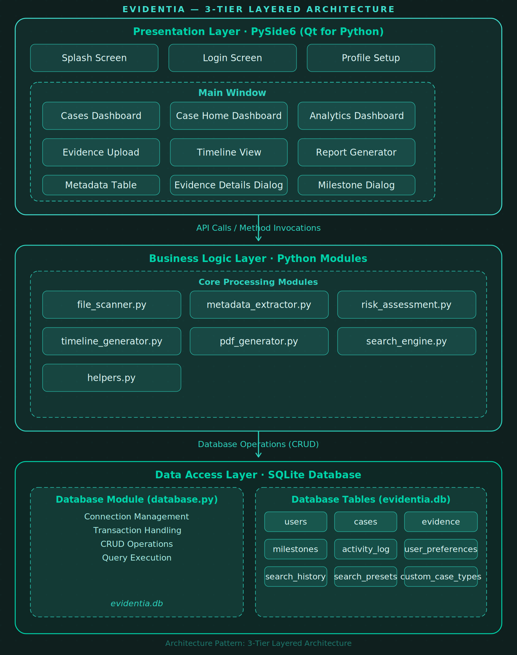

Boundary Value Analysis (BVA) Testing
Evidentia – Login and Sign Up Interfaces

Validation Rules

Sign Up Interface
Field | Constraint | Validation Rule
Full Name | Required | Must not be empty or whitespace only
Email | Optional | No length constraint, can be empty
Username | Required, min 4 chars | len(username) >= 4
Password | Required, min 6 chars | len(password) >= 6
Confirm Password | Required | Must match Password field exactly
Username Uniqueness | Must be unique | Cannot use an existing username

Login Interface
Field | Constraint | Validation Rule
Username | Required | Must not be empty
Password | Required | Must not be empty
Authentication | Must exist | Username and password must match database record

3. BVA Test Cases – Sign Up Interface

3.1 Username Field (Minimum Length = 4)
Boundary values tested: 0, 1, 2, 3, ★4, 5, 7, 50, 100 (★ = boundary point)
Test ID | Input Value | Length | Boundary Type | Expected Result | Actual Result | Status
SU-U-01 | "" (empty) | 0 | Below Min – empty | Error: Username is required | Error shown | PASS
SU-U-02 | "a" | 1 | Below Min (min − 3) | Error: Username ≥ 4 chars | Error shown | PASS
SU-U-03 | "ab" | 2 | Below Min (min − 2) | Error: Username ≥ 4 chars | Error shown | PASS
SU-U-04 | "abc" | 3 | Below Min (min − 1) | Error: Username ≥ 4 chars | Error shown | PASS
SU-U-05 | "abcd" | 4 | At Minimum Boundary ★ | Accept (if unique) | Accepted | PASS
SU-U-06 | "abcde" | 5 | Above Min (min + 1) | Accept (if unique) | Accepted | PASS
SU-U-07 | "user123" | 7 | Valid Middle Value | Accept (if unique) | Accepted | PASS
SU-U-08 | "a" × 50 | 50 | Large Valid Value | Accept (if unique) | Accepted | PASS
SU-U-09 | "a" × 100 | 100 | Very Large Value | Accept (if unique) | Accepted | PASS
SU-U-10 | "test" (existing) | 4 | Duplicate Username | Error: Username already taken | Error shown | PASS

3.2 Password Field (Minimum Length = 6)
Boundary values tested: 0, 1, 2, 3, 4, 5, ★6, 7, 11, 50, 128
Test ID | Input Value | Length | Boundary Type | Expected Result | Actual Result | Status
SU-P-01 | "" (empty) | 0 | Below Min – empty | Error: Password is required | Error shown | PASS
SU-P-02 | "a" | 1 | Below Min (min − 5) | Error: Password ≥ 6 chars | Error shown | PASS
SU-P-03 | "ab" | 2 | Below Min (min − 4) | Error: Password ≥ 6 chars | Error shown | PASS
SU-P-04 | "abc" | 3 | Below Min (min − 3) | Error: Password ≥ 6 chars | Error shown | PASS
SU-P-05 | "abcd" | 4 | Below Min (min − 2) | Error: Password ≥ 6 chars | Error shown | PASS
SU-P-06 | "abcde" | 5 | Below Min (min − 1) | Error: Password ≥ 6 chars | Error shown | PASS
SU-P-07 | "abcdef" | 6 | At Minimum Boundary ★ | Accept | Accepted | PASS
SU-P-08 | "abcdefg" | 7 | Above Min (min + 1) | Accept | Accepted | PASS
SU-P-09 | "password123" | 11 | Valid Middle Value | Accept | Accepted | PASS
SU-P-10 | "a" × 50 | 50 | Large Valid Value | Accept | Accepted | PASS
SU-P-11 | "a" × 128 | 128 | Very Large Value | Accept | Accepted | PASS

3.3 Full Name Field (Required, No Length Constraint)
Boundary values tested: 0 (empty), ★1, 2, 8, 100, 255
Test ID | Input Value | Length | Boundary Type | Expected Result | Actual Result | Status
SU-N-01 | "" (empty) | 0 | Empty String | Error: Full name is required | Error shown | PASS
SU-N-02 | " " (spaces) | 3 | Whitespace Only | Error: Full name is required | Error shown | PASS
SU-N-03 | "A" | 1 | At Minimum Boundary ★ | Accept | Accepted | PASS
SU-N-04 | "AB" | 2 | Above Min (min + 1) | Accept | Accepted | PASS
SU-N-05 | "John Doe" | 8 | Valid Name | Accept | Accepted | PASS
SU-N-06 | "A" × 100 | 100 | Long Name | Accept | Accepted | PASS
SU-N-07 | "A" × 255 | 255 | Very Long Name | Accept | Accepted | PASS

3.4 Confirm Password Field (Must Match Password)
Test ID | Password | Confirm Password | Match Status | Expected Result | Actual Result | Status
SU-C-01 | "password123" | "password123" | Exact Match ★ | Accept | Accepted | PASS
SU-C-02 | "password123" | "password124" | Off by 1 char | Error: Passwords do not match | Error shown | PASS
SU-C-03 | "password123" | "Password123" | Case Mismatch | Error: Passwords do not match | Error shown | PASS
SU-C-04 | "password123" | "password12" | Missing 1 char | Error: Passwords do not match | Error shown | PASS
SU-C-05 | "password123" | "password1234" | Extra 1 char | Error: Passwords do not match | Error shown | PASS
SU-C-06 | "password123" | "" (empty) | Empty Confirm | Error: Passwords do not match | Error shown | PASS
SU-C-07 | "abcdef" | "abcdef" | Min Length Match ★ | Accept | Accepted | PASS

3.5 Email Field (Optional, No Constraints)
Test ID | Input Value | Boundary Type | Expected Result | Actual Result | Status
SU-E-01 | "" (empty) | Empty Optional ★ | Accept (optional field) | Accepted | PASS
SU-E-02 | "a" | Single Character | Accept | Accepted | PASS
SU-E-03 | "test@example.com" | Valid Email Format | Accept | Accepted | PASS
SU-E-04 | "invalid-email" | Invalid Format (no validation) | Accept (no format check) | Accepted | PASS
SU-E-05 | "a" × 100 | Long String | Accept | Accepted | PASS

4. BVA Test Cases – Login Interface

4.1 Login Username Field (Required)
Test ID | Input Value | Boundary Type | Expected Result | Actual Result | Status
LI-U-01 | "" (empty) | Empty String ★ | Error: Please enter both username and password | Error shown | PASS
LI-U-02 | " " (spaces) | Whitespace Only | Error: Invalid username or password | Error shown | PASS
LI-U-03 | "a" | Single Character | Error: Invalid username or password (not exists) | Error shown | PASS
LI-U-04 | "validuser" | Valid Existing User | Proceed to password check | Proceeded | PASS
LI-U-05 | "nonexistent" | Non-existent User | Error: Invalid username or password | Error shown | PASS

4.2 Login Password Field (Required)
Test ID | Input Value | Boundary Type | Expected Result | Actual Result | Status
LI-P-01 | "" (empty) | Empty String ★ | Error: Please enter both username and password | Error shown | PASS
LI-P-02 | "a" | Single Character | Error: Invalid username or password | Error shown | PASS
LI-P-03 | "wrongpass" | Incorrect Password | Error: Invalid username or password | Error shown | PASS
LI-P-04 | "correctpass" | Correct Password | Login Successful | Logged in | PASS

4.3 Combined Login Scenarios
Test ID | Username | Password | Scenario | Expected Result | Actual Result | Status
LI-C-01 | "" (empty) | "" (empty) | Both Empty ★ | Error: Please enter both username and password | Error shown | PASS
LI-C-02 | "user" | "" (empty) | Empty Password | Error: Please enter both username and password | Error shown | PASS
LI-C-03 | "" (empty) | "pass" | Empty Username | Error: Please enter both username and password | Error shown | PASS
LI-C-04 | "validuser" | "validpass" | Valid Credentials ★ | Login Successful | Logged in | PASS
LI-C-05 | "validuser" | "wrongpass" | Wrong Password | Error: Invalid username or password | Error shown | PASS
LI-C-06 | "wronguser" | "validpass" | Wrong Username | Error: Invalid username or password | Error shown | PASS

5. Test Execution Results
Category | Total | Passed | Failed | Status | Key Boundary
Sign Up – Username | 10 | 10 | 0 | PASS | min = 4 chars
Sign Up – Password | 11 | 11 | 0 | PASS | min = 6 chars
Sign Up – Full Name | 7 | 7 | 0 | PASS | Required, no max
Sign Up – Confirm Password | 7 | 7 | 0 | PASS | Must match exactly
Sign Up – Email | 5 | 5 | 0 | PASS | Optional, no constraints
Login – Username | 5 | 5 | 0 | PASS | Required, non-empty
Login – Password | 4 | 4 | 0 | PASS | Required, non-empty
Login – Combined | 6 | 6 | 0 | PASS | Both fields required
TOTAL | 55 | 55 | 0 | PASS | 100% Pass Rate

Design (from Sprint 2)

Activity Diagrams
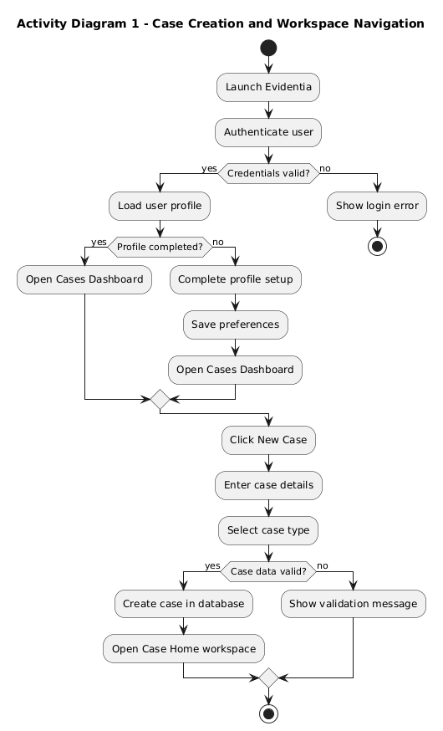

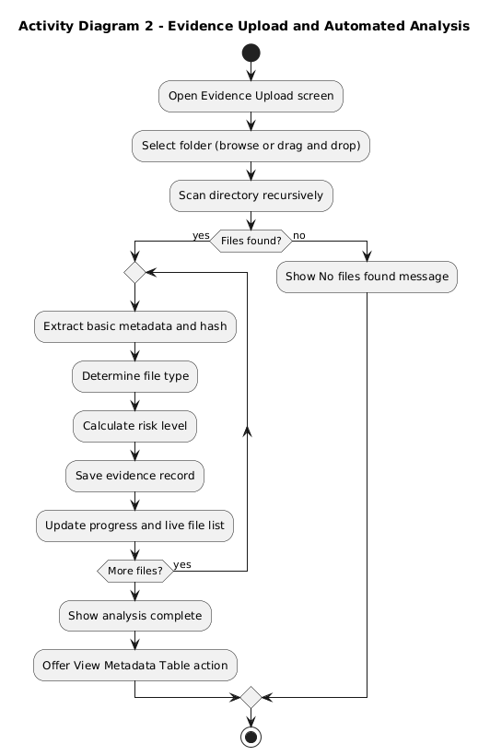
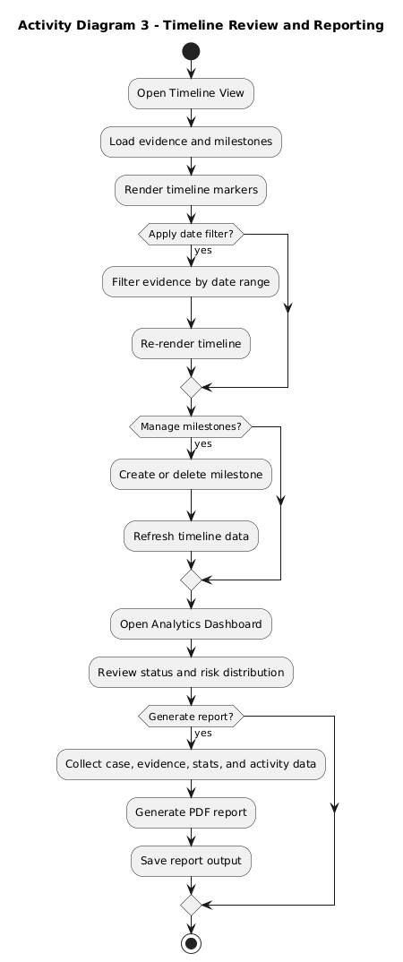
Use Case Diagram
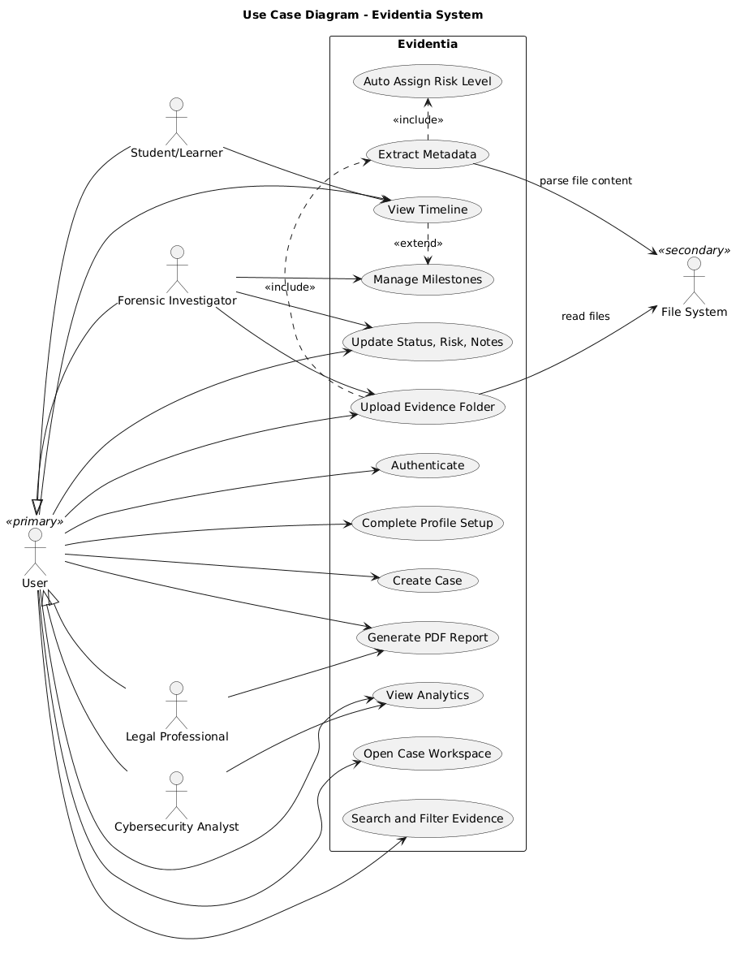
Sequence Diagrams

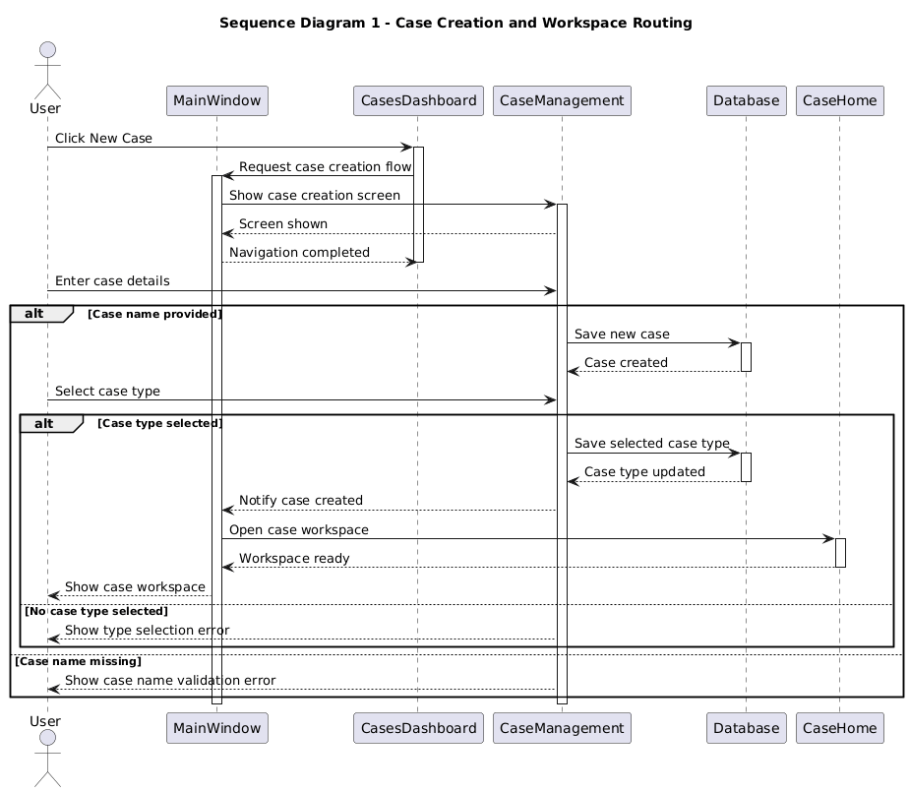
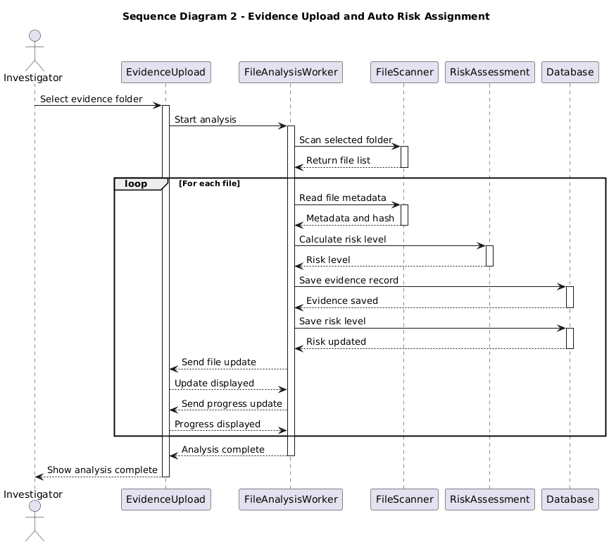
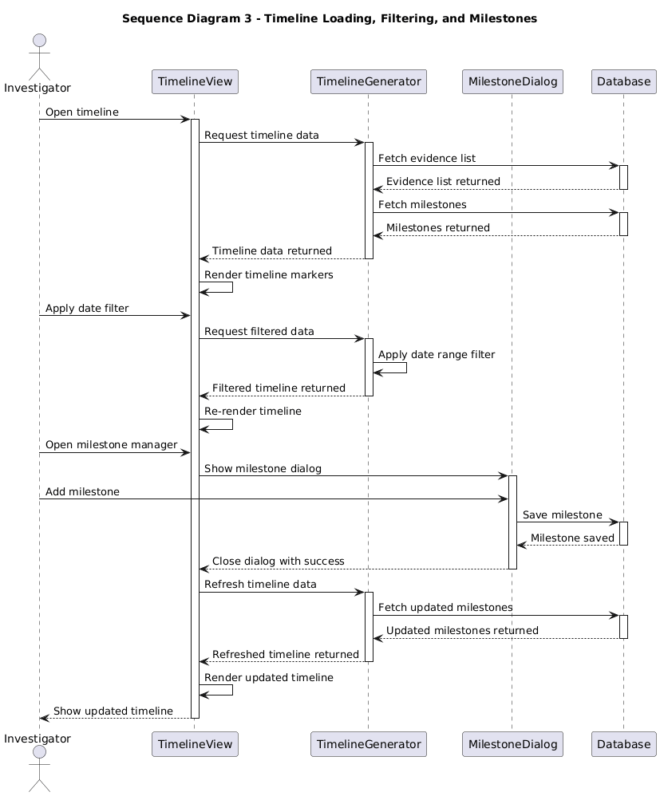

Class Diagram
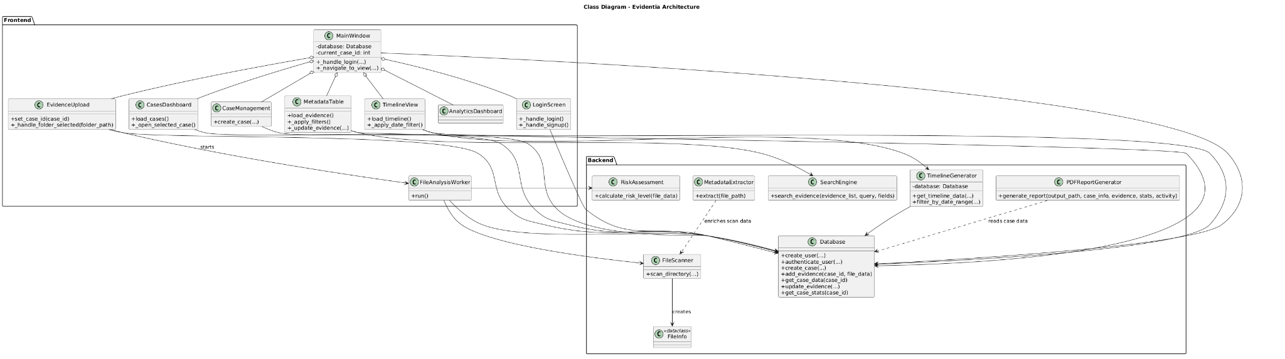

TRELLO BOARD SCREENSHOTS

Snapshot 1: At the Start

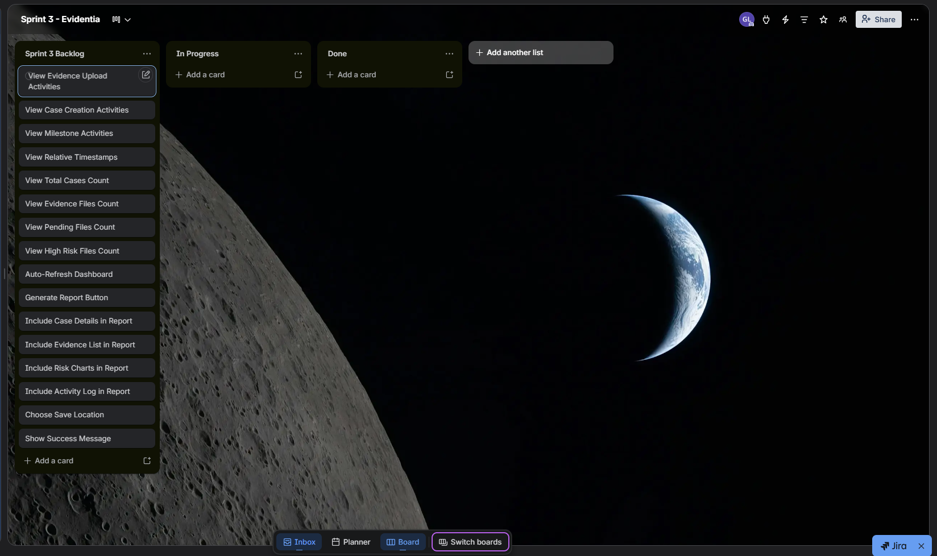

Snapshot 2: In the Middle

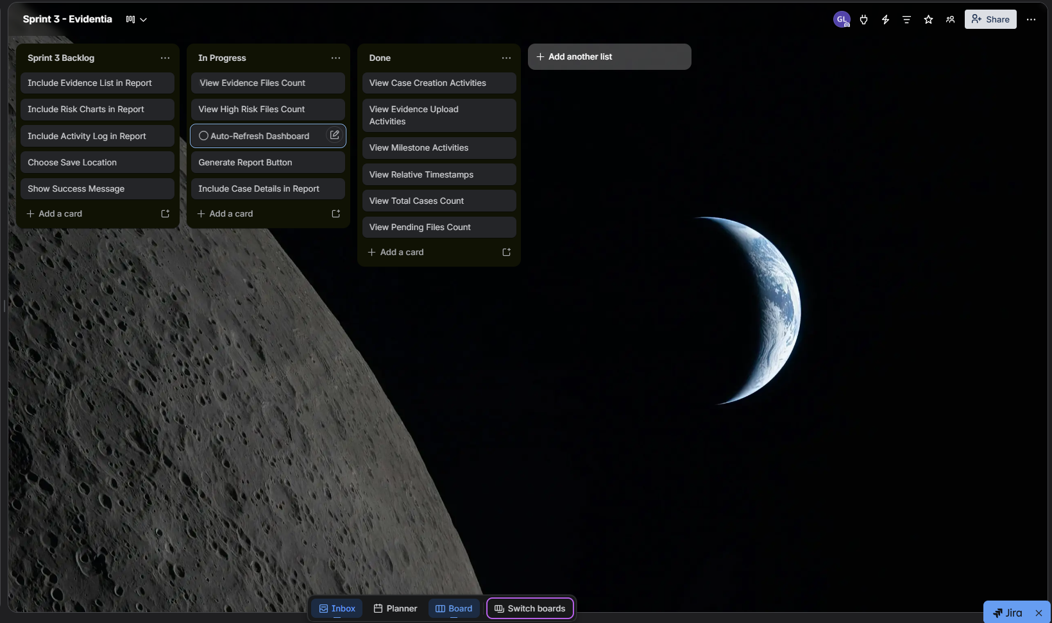

Snapshot 3: At the end

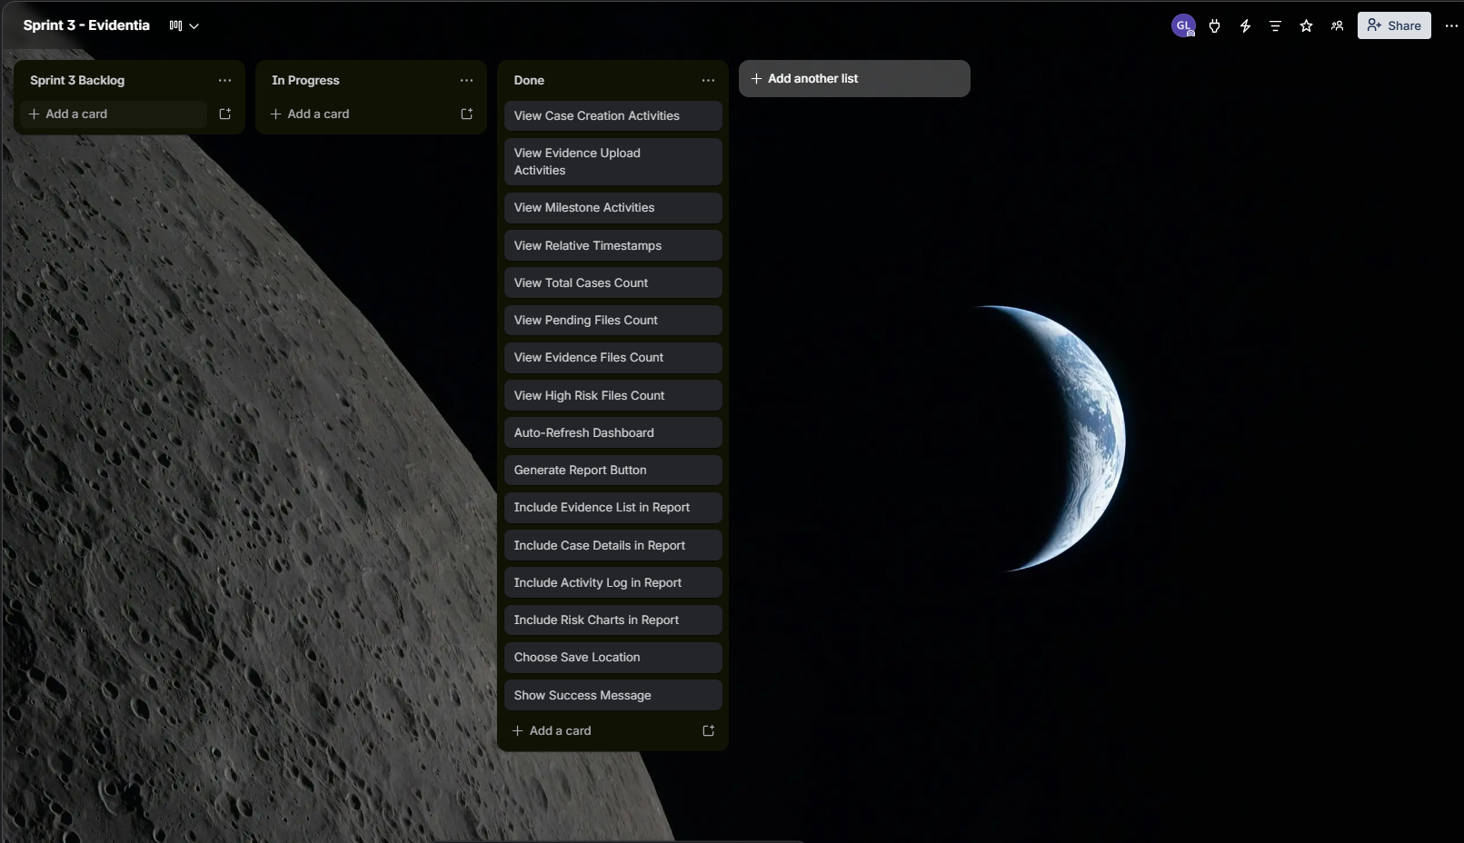
User Stories Data

Story ID | Story Title | Sprint | Priority | Est. Hours | Status | Sub-Stories | Sub Est. Hours
US-01 | Bulk Folder Upload | Sprint 1 | High | 12 | Completed | 5 | 12
US-02 | Metadata Overview Table | Sprint 1 | High | 14 | Completed | 5 | 14
US-03 | Case Type Sorting | Sprint 1 | High | 10 | Completed | 5 | 10
US-04 | Timeline Grid | Sprint 2 | High | 10 | Completed | 3 | 10
US-05 | Evidence Status Tracking | Sprint 2 | High | 9 | Completed | 3 | 7
US-06 | Risk Level Charts | Sprint 2 | Medium | 8 | Completed | 3 | 8
US-07 | Global Search and Filter | Sprint 2 | High | 11 | Completed | 3 | 11
US-08 | Recent Activity Feed | Sprint 3 | High | 8 | Completed | 4 | 8
US-09 | Quick Stats Dashboard | Sprint 3 | High | 10 | Completed | 5 | 10
US-10 | Automated Final Report | Sprint 3 | High | 12 | Completed | 7 | 15
TOTAL |  |  |  | 104 |  |  | 105

Sub-user Stories Data

Sub-Story ID | Sub-Story Title | Parent Story | Sprint | Est. Hours
US-01.1 | Drag Folder Interface | US-01 | Sprint 1 | 2
US-01.2 | Browse Folder Dialog | US-01 | Sprint 1 | 2
US-01.3 | Recursive Folder Scanning | US-01 | Sprint 1 | 3
US-01.4 | Progress Tracking & Completion | US-01 | Sprint 1 | 3
US-01.5 | Multiple Batch Uploads | US-01 | Sprint 1 | 2
US-02.1 | Automatic Metadata Extraction | US-02 | Sprint 1 | 3
US-02.2 | Comprehensive Table Display | US-02 | Sprint 1 | 3
US-02.3 | Filename Search | US-02 | Sprint 1 | 2
US-02.4 | File Type Filtering | US-02 | Sprint 1 | 2
US-02.5 | Summary Statistics | US-02 | Sprint 1 | 4
US-03.1 | Case Creation & Type Selection | US-03 | Sprint 1 | 2
US-03.2 | Custom Case Types | US-03 | Sprint 1 | 2
US-03.3 | Database Persistence | US-03 | Sprint 1 | 2
US-03.4 | Cases Dashboard with Type Indicators | US-03 | Sprint 1 | 2
US-03.5 | Auto-Navigation & Case Context | US-03 | Sprint 1 | 2
US-04.1 | Chronological Timeline Display | US-04 | Sprint 2 | 3
US-04.2 | Case Progression Stage Update | US-04 | Sprint 2 | 3
US-04.3 | Timeline Date Filtering | US-04 | Sprint 2 | 4
US-05.1 | Evidence Status Filters | US-05 | Sprint 2 | 3
US-05.2 | Single File Status Update | US-05 | Sprint 2 | 2
US-05.3 | Bulk Status Action | US-05 | Sprint 2 | 2
US-06.1 | Risk Distribution Chart | US-06 | Sprint 2 | 3
US-06.2 | Risk Category Toggle | US-06 | Sprint 2 | 2
US-06.3 | Risk Update from Table | US-06 | Sprint 2 | 3
US-07.1 | Advanced Global Search Input | US-07 | Sprint 2 | 4
US-07.2 | Combined Search and Filters | US-07 | Sprint 2 | 4
US-07.3 | Search History Logging | US-07 | Sprint 2 | 3
US-08.1 | View Evidence Upload Activities | US-08 | Sprint 3 | 2
US-08.2 | View Case Creation Activities | US-08 | Sprint 3 | 1
US-08.3 | View Milestone Activities | US-08 | Sprint 3 | 2
US-08.4 | View Relative Timestamps | US-08 | Sprint 3 | 3
US-09.1 | View Total Cases Count | US-09 | Sprint 3 | 2
US-09.2 | View Evidence Files Count | US-09 | Sprint 3 | 2
US-09.3 | View Pending Files Count | US-09 | Sprint 3 | 2
US-09.4 | View High Risk Files Count | US-09 | Sprint 3 | 2
US-09.5 | Auto-Refresh Dashboard | US-09 | Sprint 3 | 2
US-10.1 | Generate Report Button | US-10 | Sprint 3 | 2
US-10.2 | Include Case Details in Report | US-10 | Sprint 3 | 2
US-10.3 | Include Evidence List in Report | US-10 | Sprint 3 | 3
US-10.4 | Include Risk Charts in Report | US-10 | Sprint 3 | 3
US-10.5 | Include Activity Log in Report | US-10 | Sprint 3 | 2
US-10.6 | Choose Save Location | US-10 | Sprint 3 | 2
US-10.7 | Show Success Message | US-10 | Sprint 3 | 1

Burndown Data

Day | Sprint | Ideal Remaining (hrs) | Actual Remaining (hrs) | Daily Burned (Actual)
Day 1 | Sprint 1 | 102 | 104 | 0
Day 2 | Sprint 1 | 99 | 102 | 2
Day 3 | Sprint 1 | 97 | 99 | 3
Day 4 | Sprint 1 | 94 | 96 | 3
Day 5 | Sprint 1 | 92 | 92 | 4
Day 6 | Sprint 1 | 89 | 89 | 3
Day 7 | Sprint 1 | 87 | 88 | 1
Day 8 | Sprint 1 | 84 | 87 | 1
Day 9 | Sprint 1 | 82 | 83 | 4
Day 10 | Sprint 1 | 79 | 79 | 4
Day 11 | Sprint 1 | 77 | 75 | 4
Day 12 | Sprint 1 | 74 | 72 | 3
Day 13 | Sprint 1 | 72 | 70 | 2
Day 14 | Sprint 1 | 69 | 68 | 2
Day 15 | Sprint 2 | 67 | 67 | 1
Day 16 | Sprint 2 | 64 | 66 | 1
Day 17 | Sprint 2 | 62 | 63 | 3
Day 18 | Sprint 2 | 59 | 59 | 4
Day 19 | Sprint 2 | 57 | 57 | 2
Day 20 | Sprint 2 | 54 | 56 | 1
Day 21 | Sprint 2 | 52 | 55 | 1
Day 22 | Sprint 2 | 49 | 50 | 5
Day 23 | Sprint 2 | 47 | 45 | 5
Day 24 | Sprint 2 | 44 | 42 | 3
Day 25 | Sprint 2 | 42 | 40 | 2
Day 26 | Sprint 2 | 39 | 37 | 3
Day 27 | Sprint 2 | 37 | 33 | 4
Day 28 | Sprint 2 | 34 | 30 | 3
Day 29 | Sprint 3 | 32 | 30 | 0
Day 30 | Sprint 3 | 29 | 30 | 0
Day 31 | Sprint 3 | 27 | 28 | 2
Day 32 | Sprint 3 | 24 | 27 | 1
Day 33 | Sprint 3 | 22 | 23 | 4
Day 34 | Sprint 3 | 19 | 20 | 3
Day 35 | Sprint 3 | 17 | 20 | 0
Day 36 | Sprint 3 | 14 | 18 | 2
Day 37 | Sprint 3 | 12 | 14 | 4
Day 38 | Sprint 3 | 9 | 10 | 4
Day 39 | Sprint 3 | 7 | 7 | 3
Day 40 | Sprint 3 | 5 | 5 | 2
Day 41 | Sprint 3 | 2 | 2 | 3
Day 42 | Sprint 3 | 0 | 0 | 2

Product Burndown Chart for full project

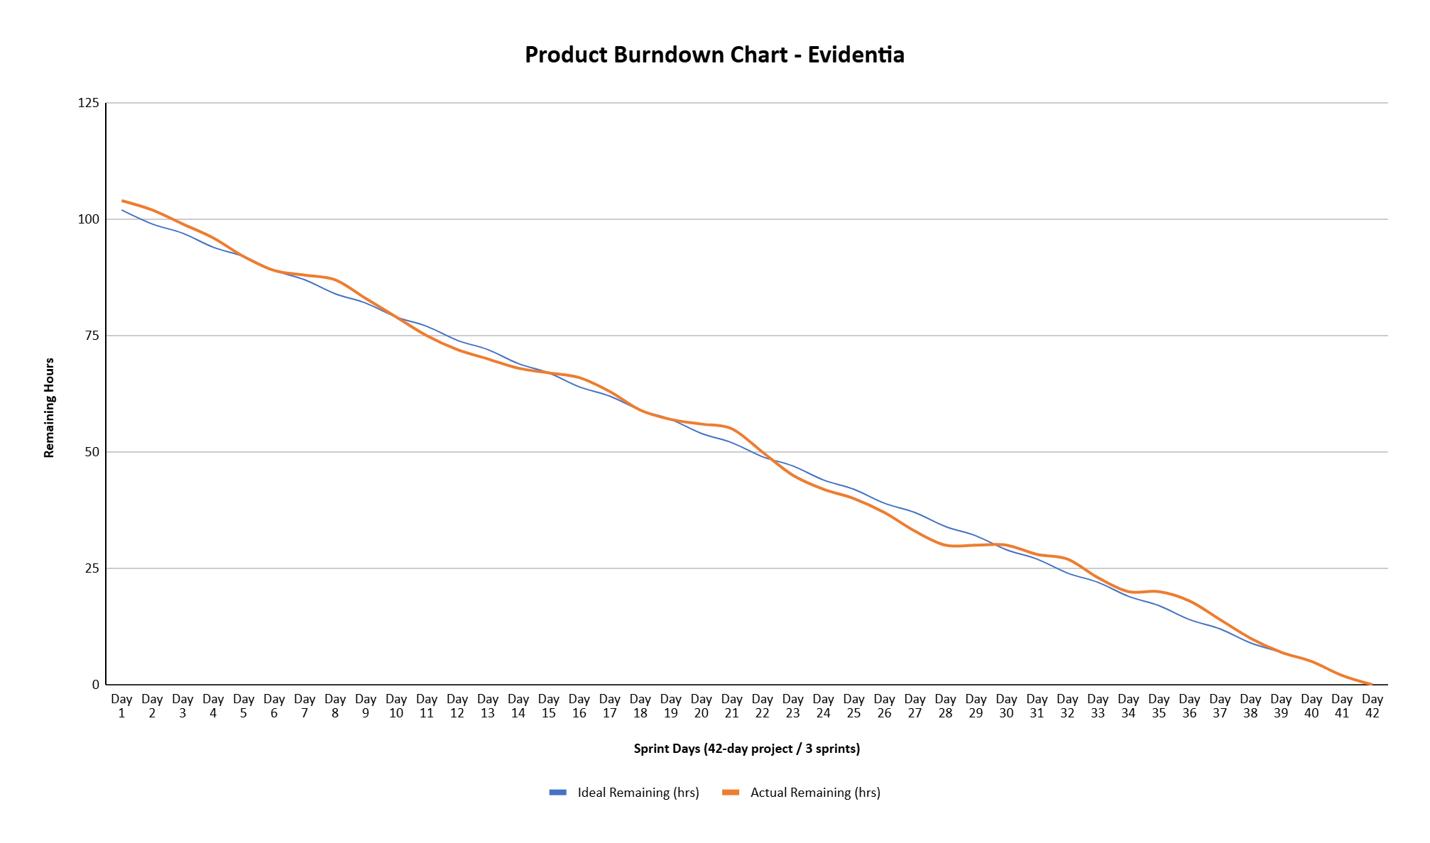
Work Division
Sprint | Team Member | User Stories | Est. Hours
Sprint 1 — Evidence Management Module
Sprint 1 | Gul-e-Zara (24L-2592) | US-01: Bulk Folder Upload  US-02: Metadata Overview Table | 26 hrs  (12 + 14)
Sprint 1 | Rumesha Naveed (24L-2603) | US-03: Case Type Sorting | 10 hrs
Sprint 2 — Timeline & Analytics Module
Sprint 2 | Rumesha Naveed (24L-2603) | US-04: Timeline Grid  US-05: Evidence Status Tracking | 19 hrs  (10 + 9)
Sprint 2 | Gul-e-Zara (24L-2592) | US-06: Risk Level Charts  US-07: Global Search and Filter | 19 hrs  (8 + 11)
Sprint 3 — Reporting & History Module
Sprint 3 | Rumesha Naveed (24L-2603) | US-08: Recent Activity Feed  US-09: Quick Stats Dashboard | 18 hrs  (8 + 10)
Sprint 3 | Gul-e-Zara (24L-2592) | US-10: Automated Final Report | 12 hrs
Total Estimated Hours |  |  | 104 hrs

Lesson Learnt

Testing is Not Optional, Even for "Simple" Features

We initially treated testing as an afterthought rather than a core part of software engineering, which caught up with us during Sprint 2. When we added the timeline feature, it broke the evidence upload from Sprint 1 in ways we did not expect, files with special characters in their names caused the timeline to fail silently, and uploading an empty folder crashed the application entirely. We had to stop Sprint 2 midway and go back to fix Sprint 1 code, which cost us almost a full day of unplanned rework. This made us realize that software engineering is not just about writing code that works under ideal conditions, it is about building software that holds up under real ones.
By Sprint 3, we changed our approach and treated testing as an engineering discipline rather than a final checklist. Before implementing the report generation feature, we tested boundary cases ourselves: empty cases with no evidence, files with missing metadata, very long file names and caught several issues before they became real problems. Applying techniques like Boundary Value Analysis showed us that good software engineering means thinking about failure from the very beginning, not after the feature is already built.

Implementation Screenshots
Filename: cases_dashboard.py
Description: Displays all investigation cases with case type indicators, creation dates, and status. Users can create new cases or open existing ones.
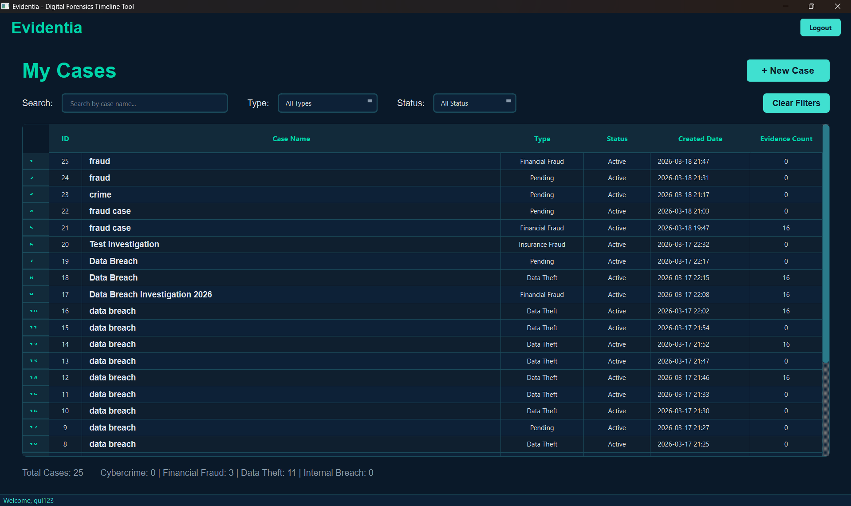

Filename: case_management.py
Description: Form for entering case name and description with validation. First step of the case creation wizard.
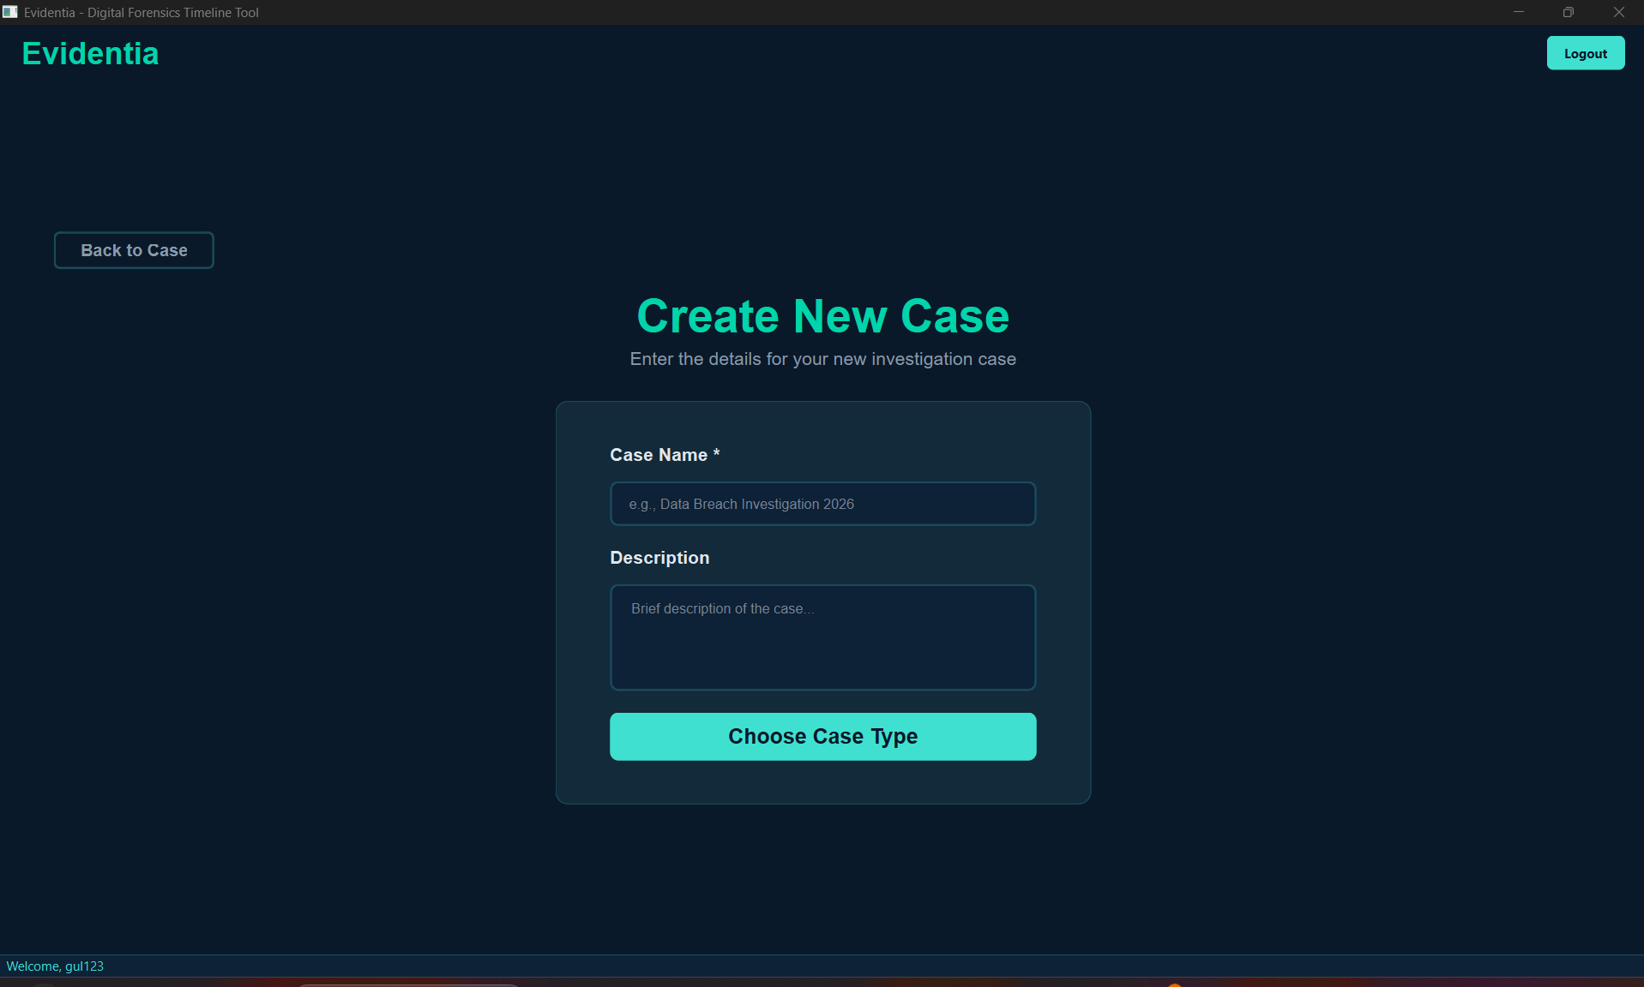

Filename: case_management.py
Description: Visual card-based selection of investigation type (Cybercrime, Financial Fraud, Data Theft, Internal Breach) with option to add custom types.
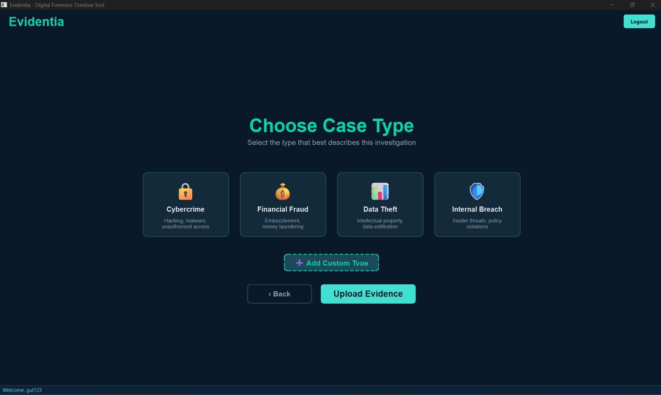

Filename: evidence_upload.py
Description: Bulk folder upload interface with drag-and-drop zone and browse button for selecting evidence folders.
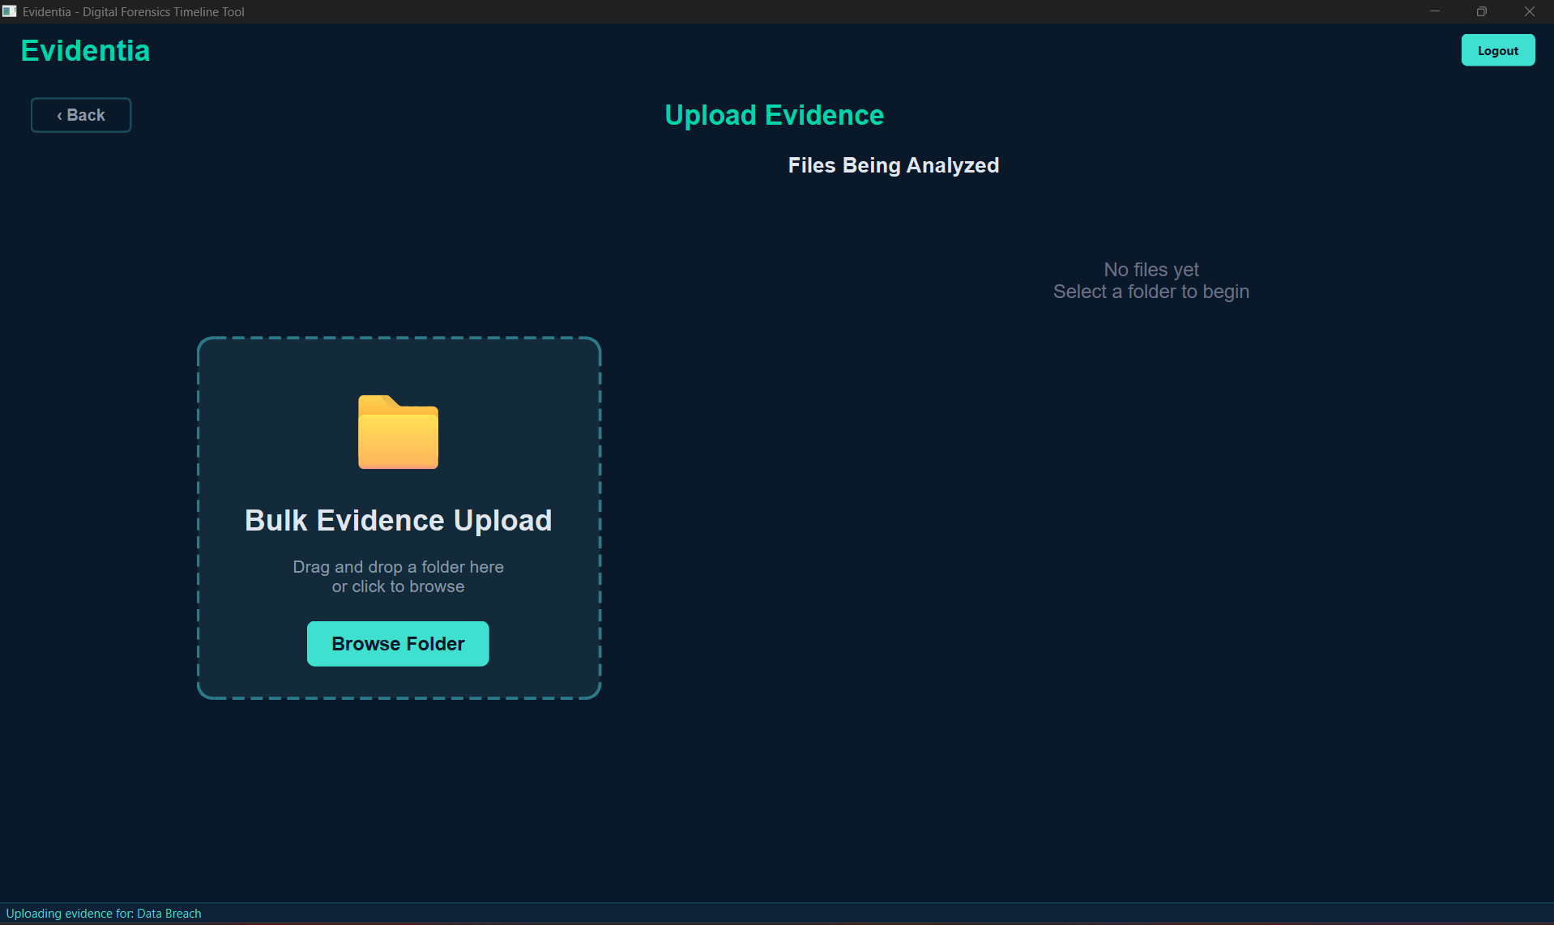

Filename: evidence_upload.py
Description: Real-time progress tracking showing files being analyzed with progress bar, current file status, and live file list with type icons and metadata.
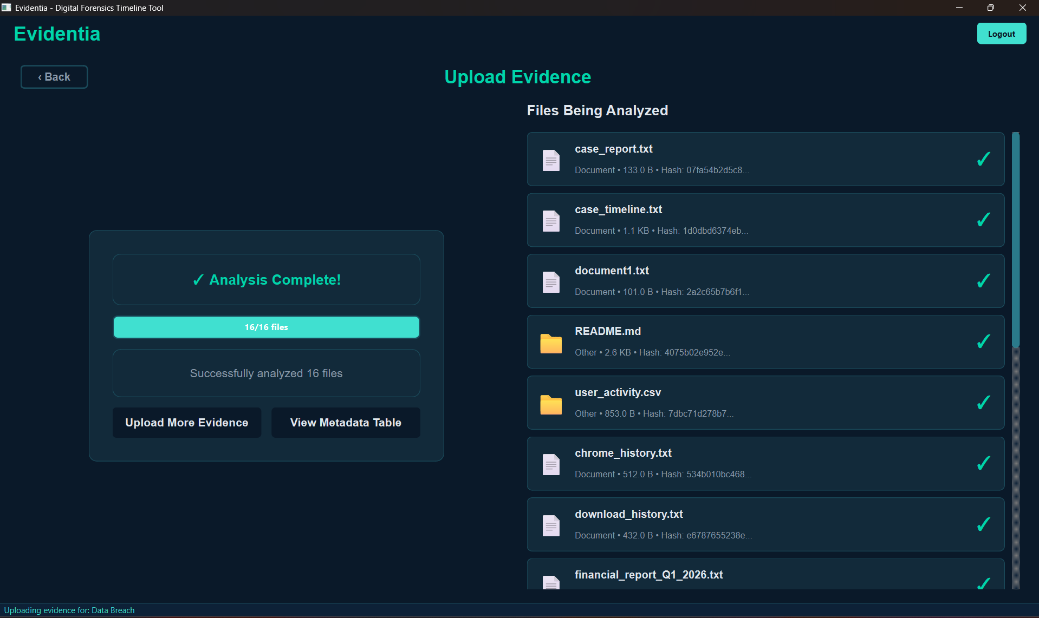

Filename: metadata_table.py
Description: Comprehensive table displaying all evidence files with 7 columns (ID, File Name, Type, Size, Created Date, Modified Date, Hash) and summary statistics.
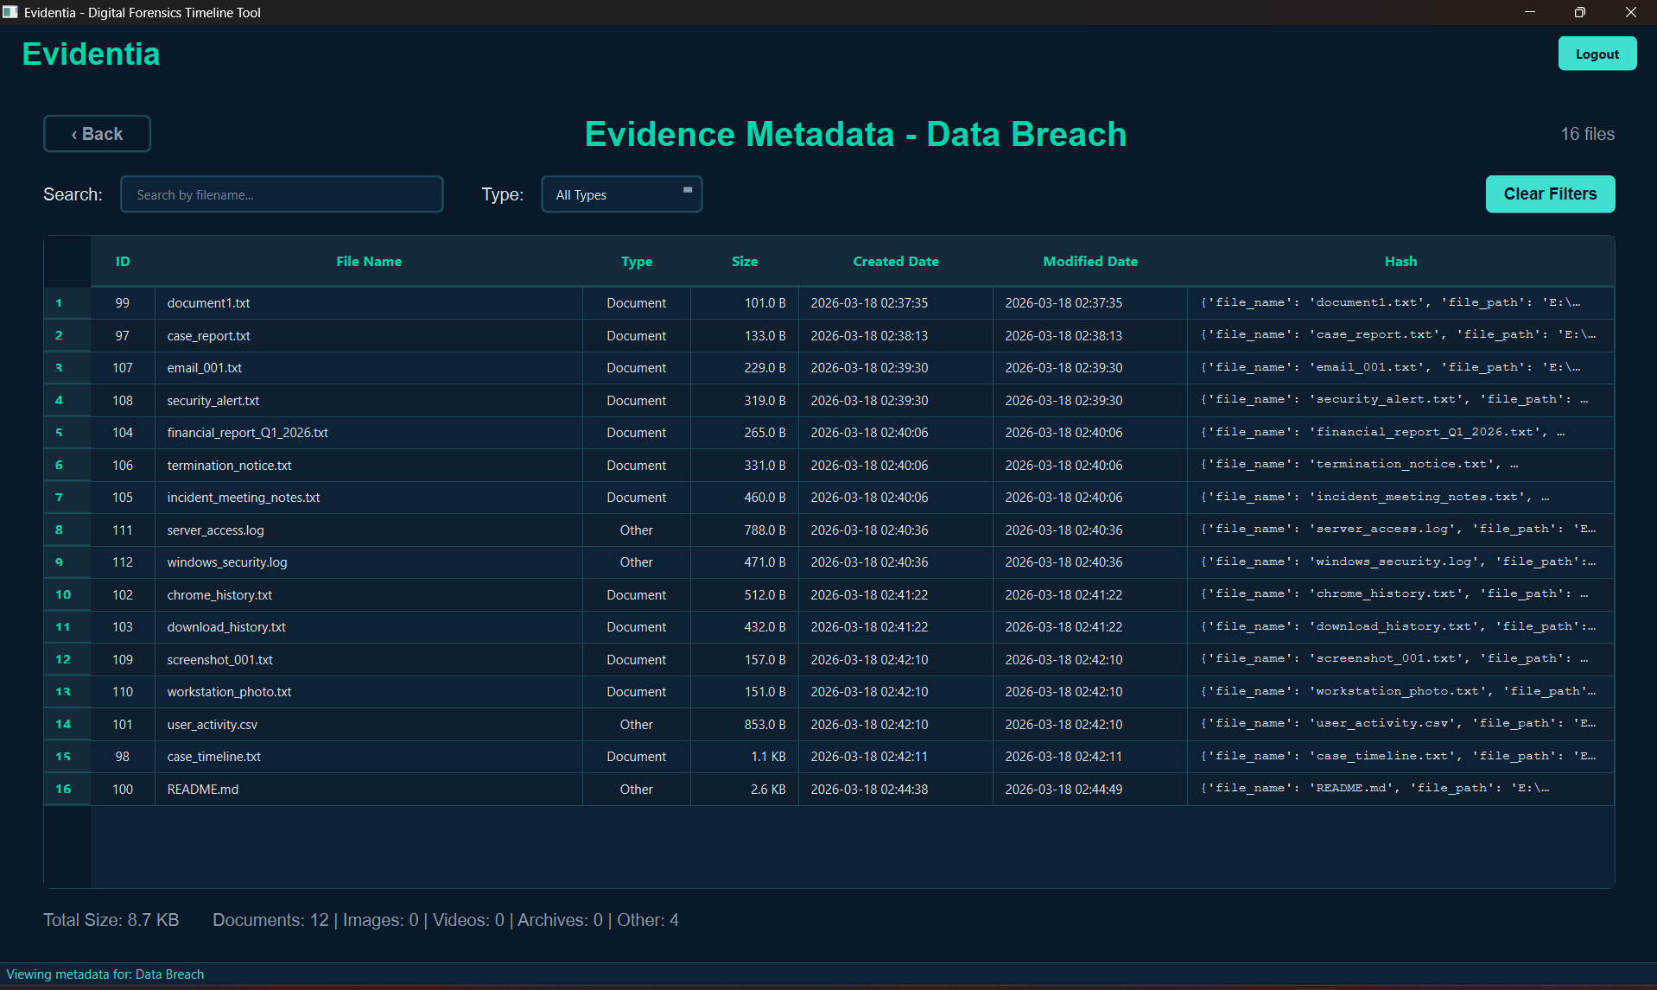

Filename: metadata_table.py
Description: Demonstrates search by filename and updated summary statistics alongside.
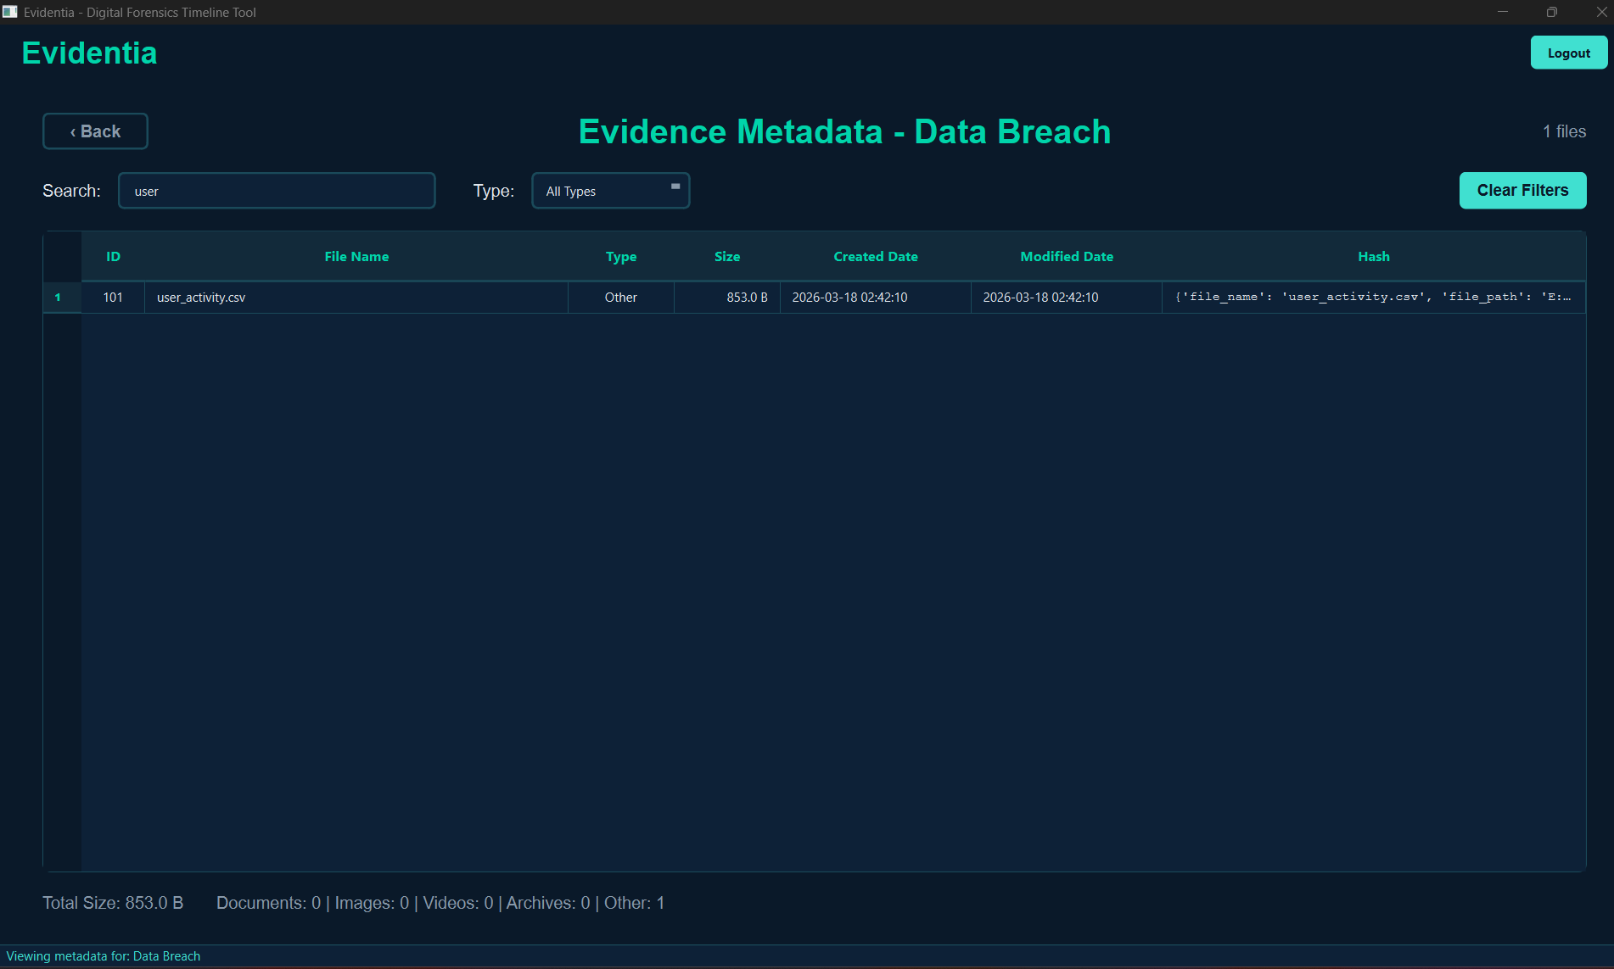
Splash Screen
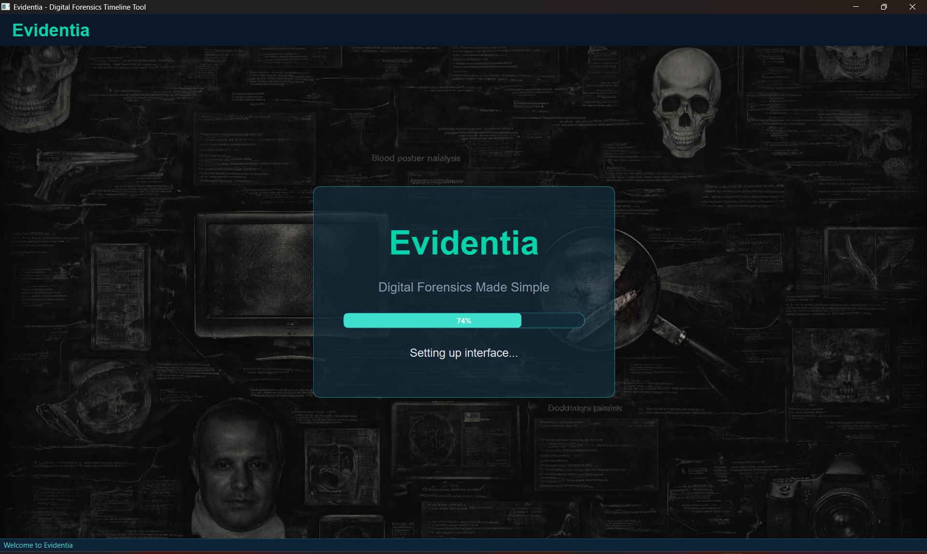

Sign Up screen
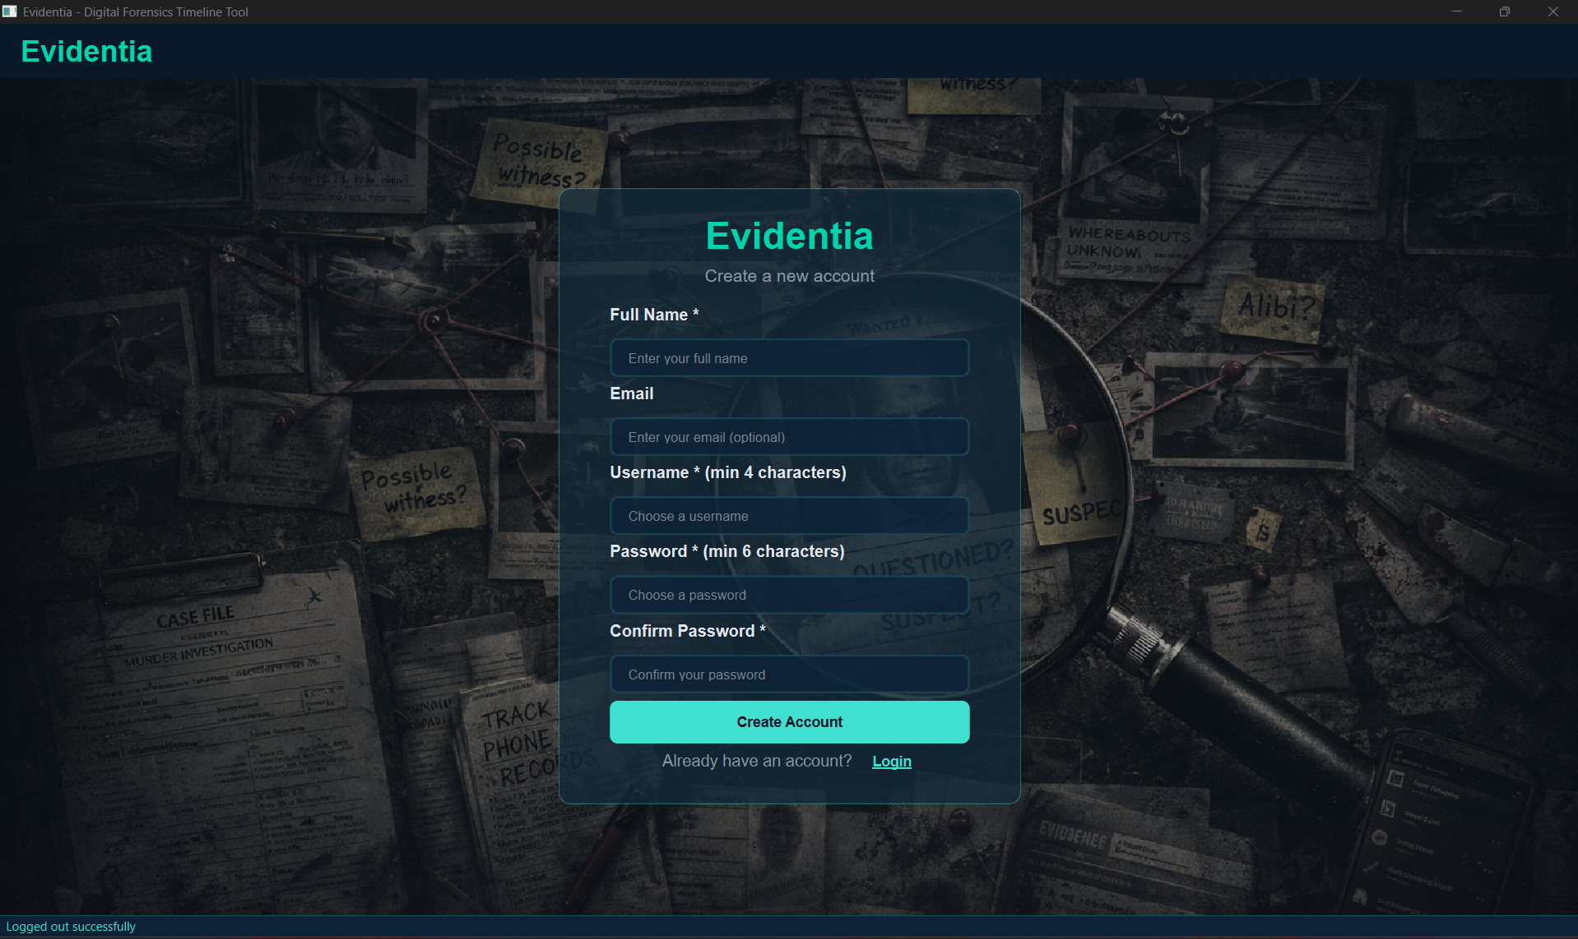

Login Screen
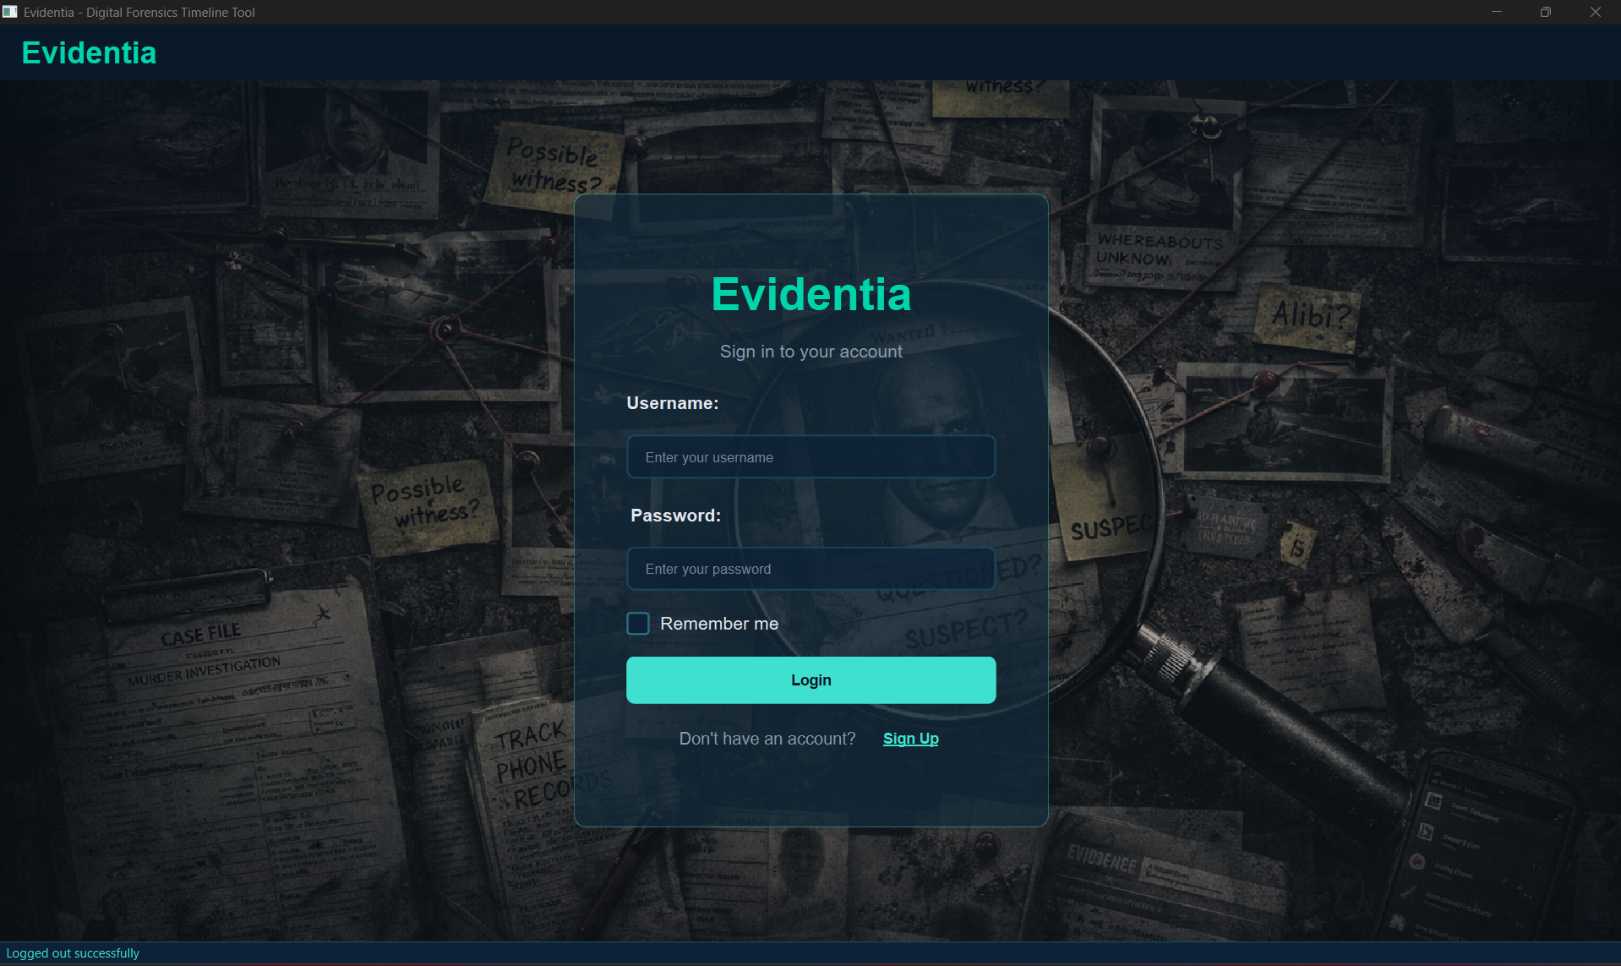

Cases Dashboard

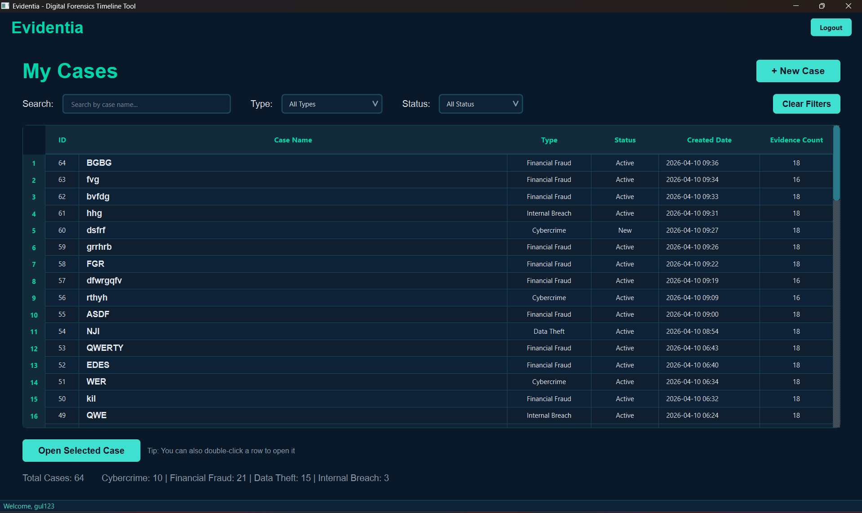

Case Home screen

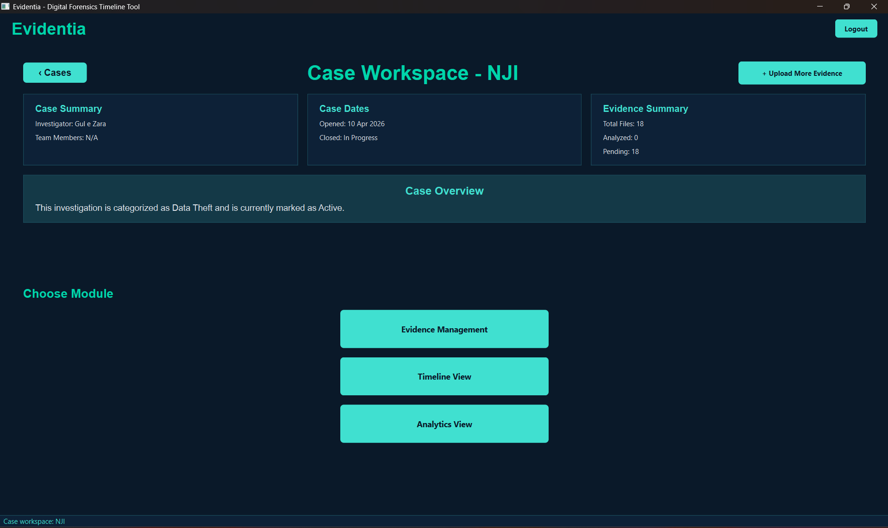

Evidence Management

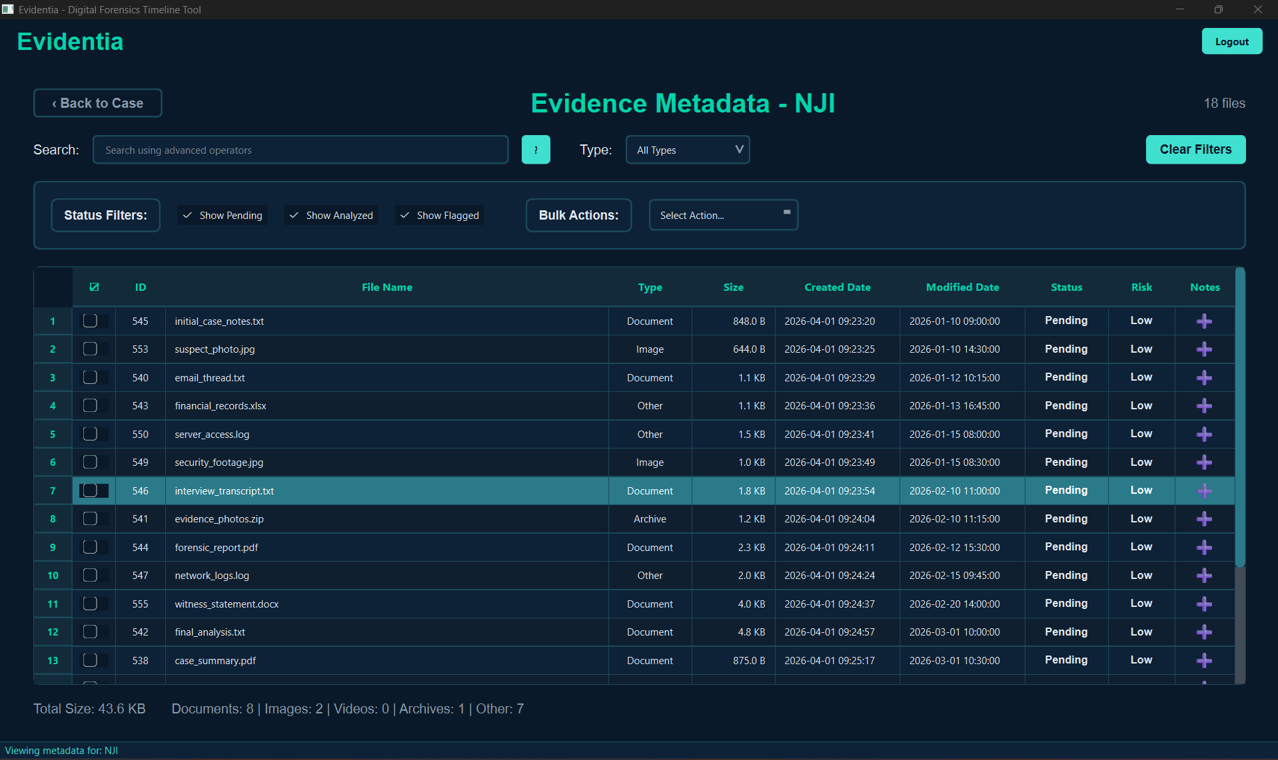

Add Notes feature in metadata table:

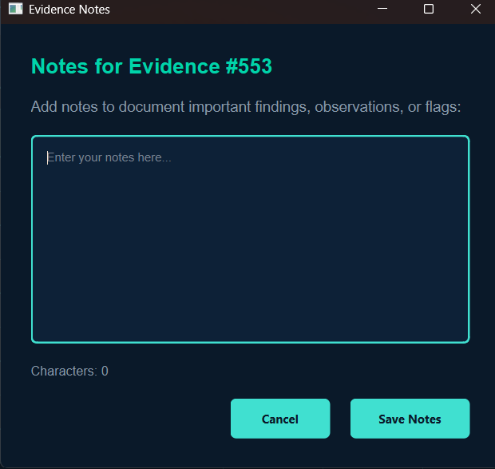

Timeline View

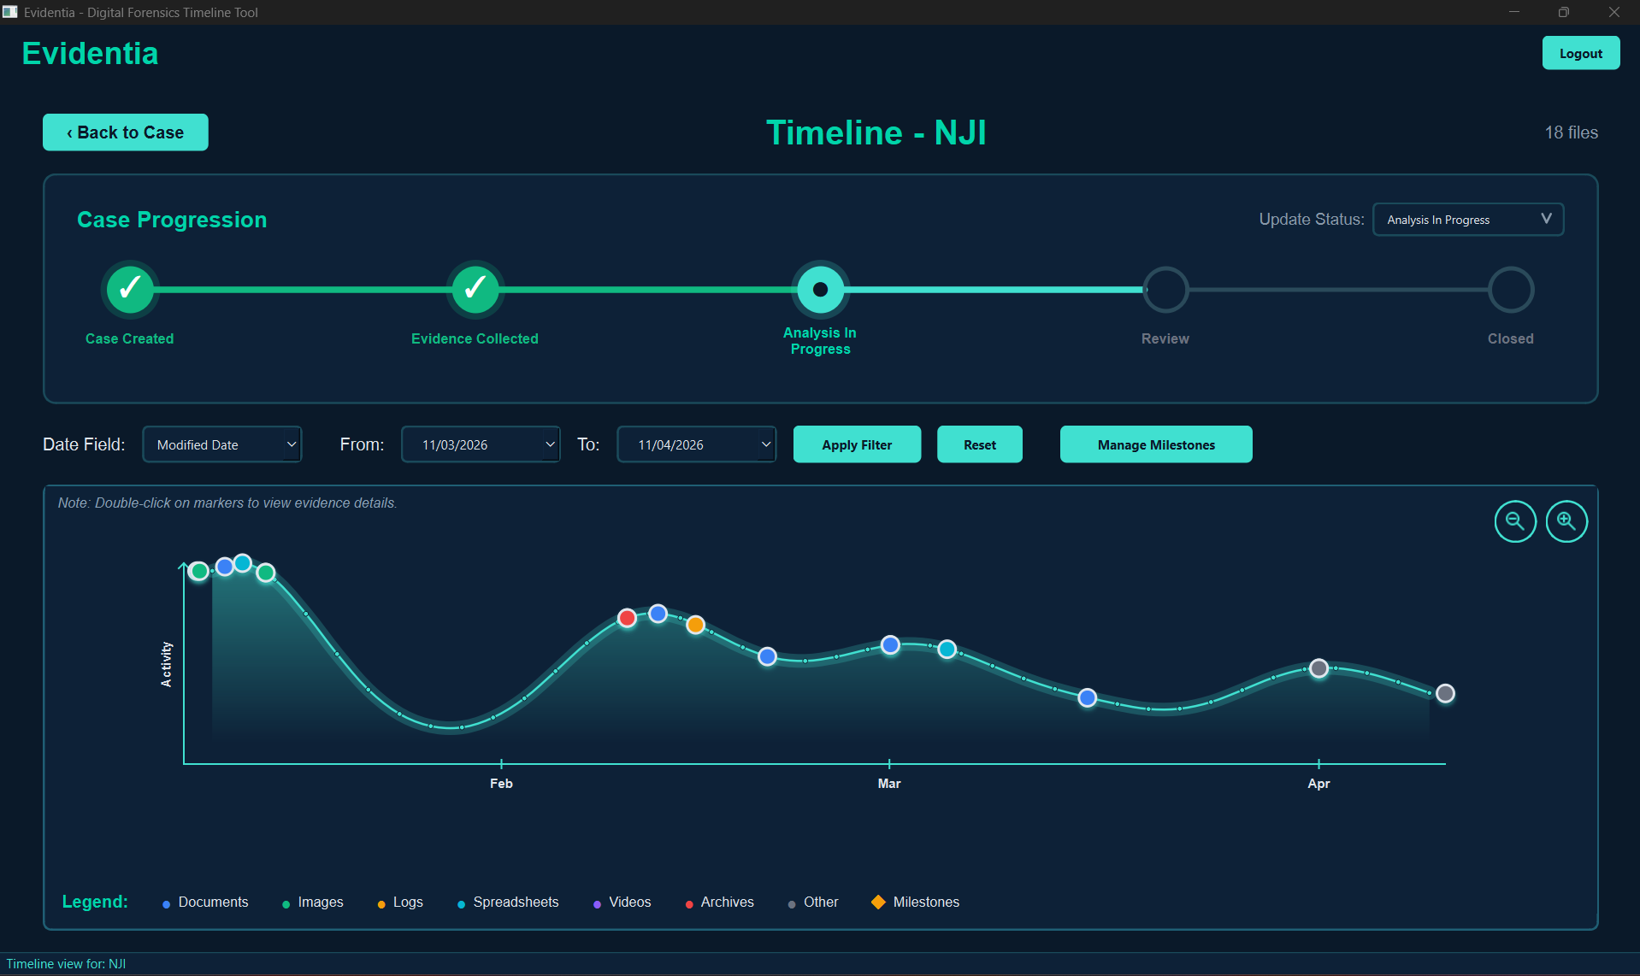

Manage Milestones Popup

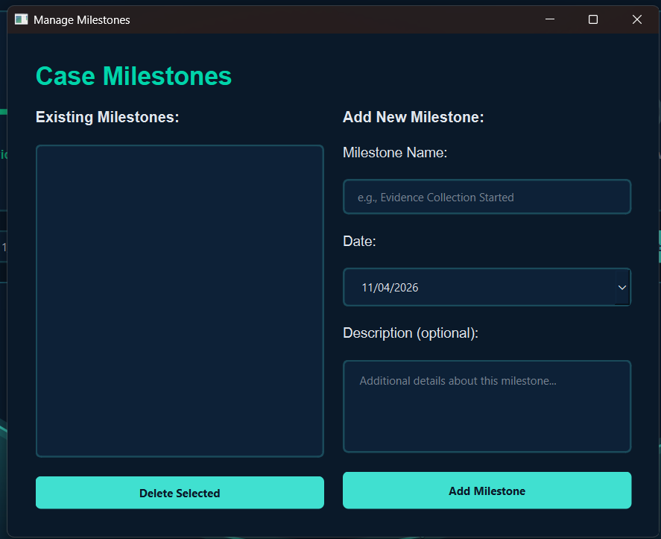

When user clicks on colourful markers in the timeline graph:
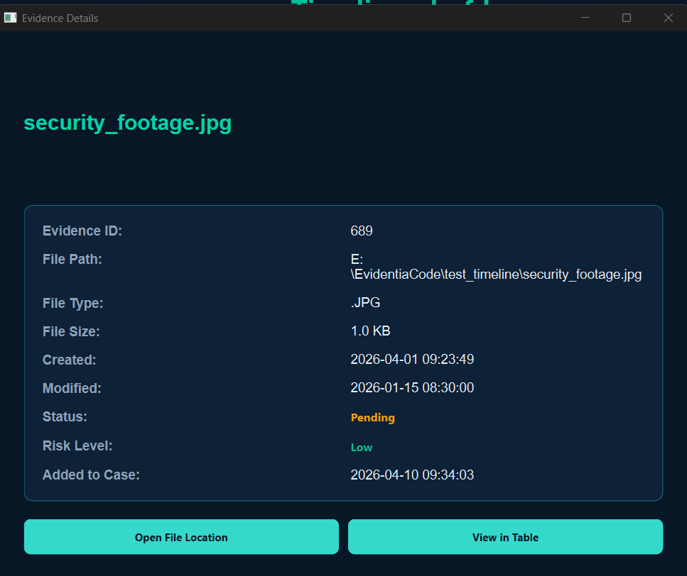

Analytics View/Risk Level Charts

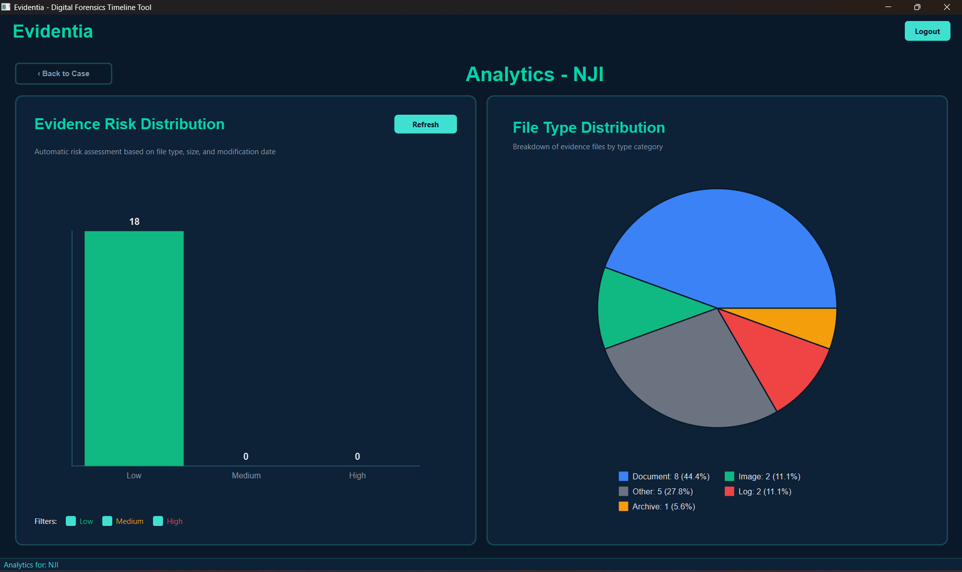

Evidence Upload
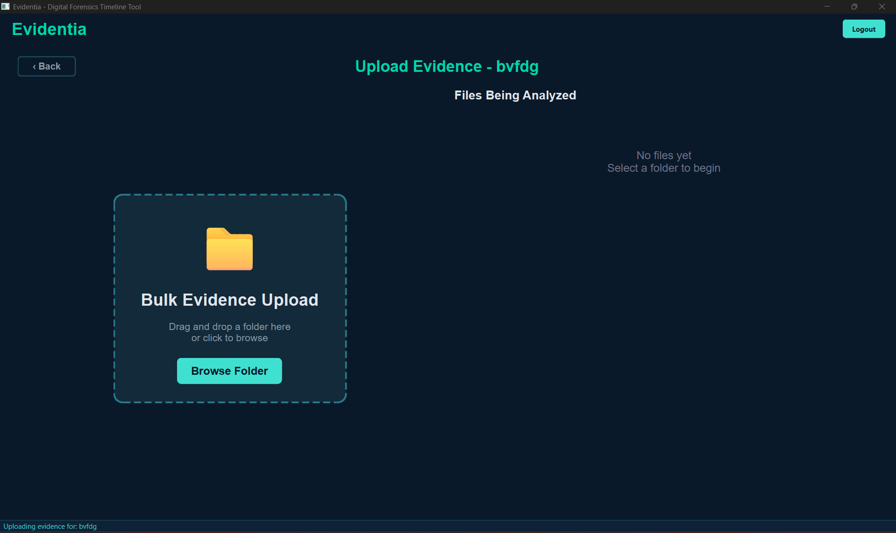

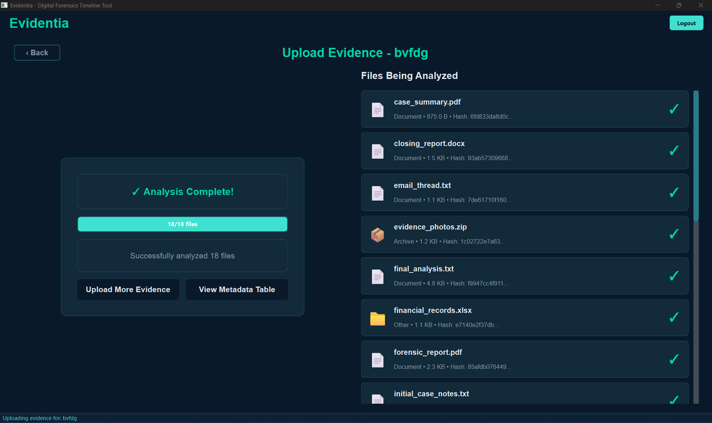

Recent Activity Feed and Quick Stats Dashbaard

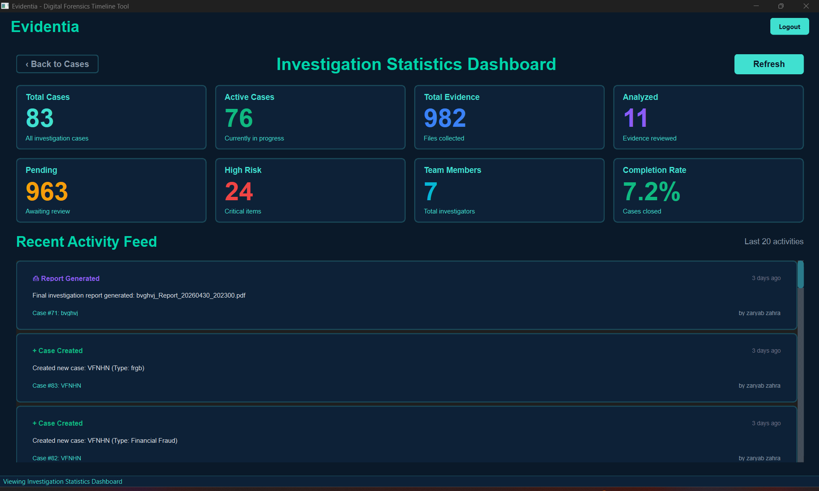

Case Workspace
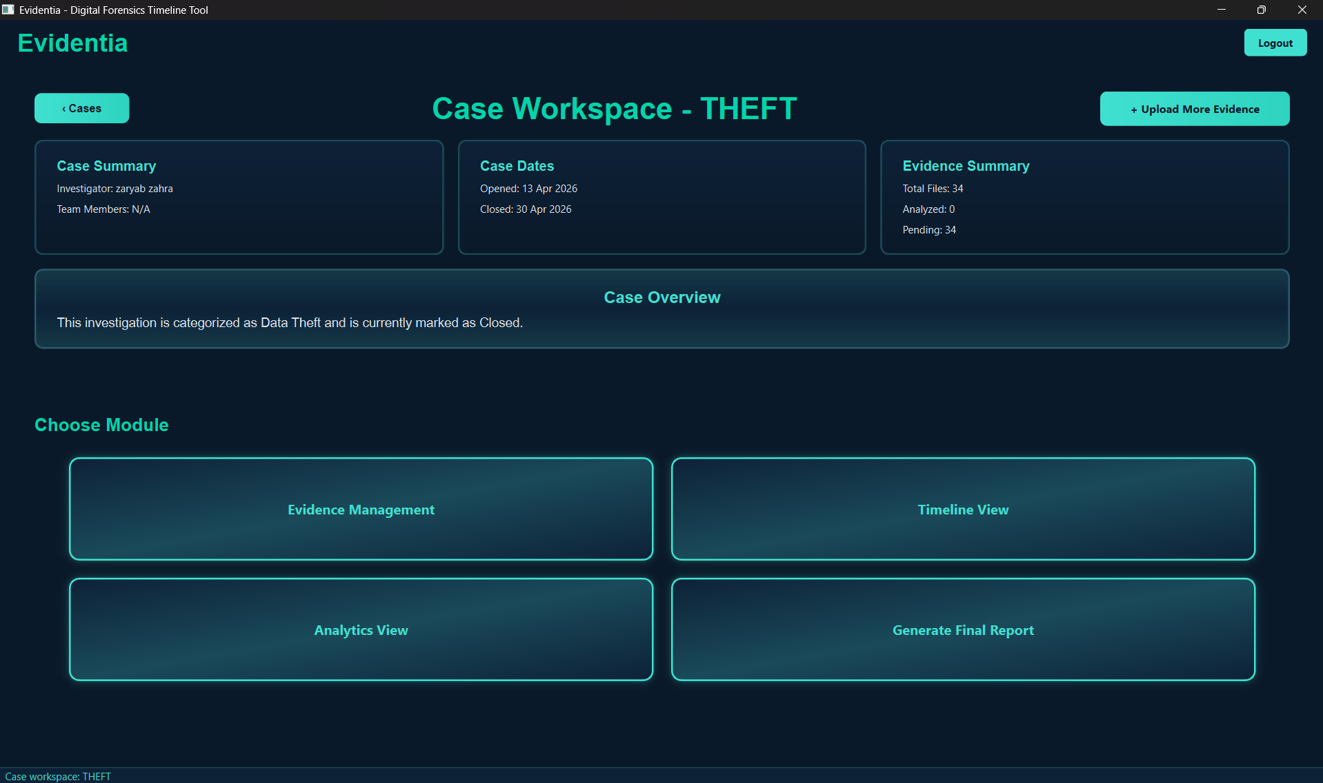

Generate Report

