1.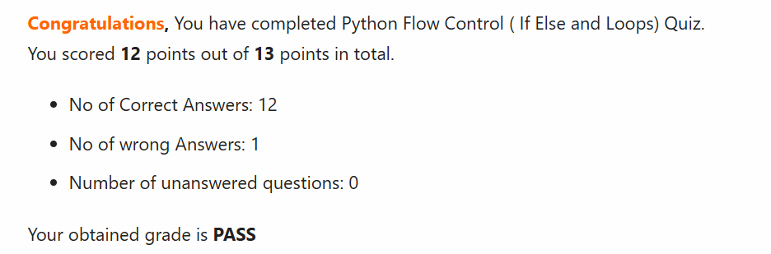

2. The difference between continue and break statement is that continue function skips the code remaining after the statement for one value of the loop, while break function stops the loop from functioning.

3. For for loop, a range of values, either list, dictionary items, etc. is presented, but while loop works continuously as long as its conditions are fulfilled.

4.

hexadecimal = [0,1,2,3,4,5,6,7,8,9,'A','B','C','D','E','F']

for i in hexadecimal:

   for j in hexadecimal:

        if i != 'F' or j != 'F':

            print(str(i)+str(j), end =', ')

        else:

            print(str(i)+str(j)+'.')