

**Internship Progress Report**

**MCA**

**Section - 5 (C)**

**Group – (G1)**

Submitted To: Submitted By:

Ms. Mansirat Mann Ashish Kumar - 19MCA8060

# **About the company**

TMotions delivers digital transformation and technology services from ideation to execution, enabling our global customers to challenge the competition. TMotions takes an agile and collaborative approach to build customised solutions across the digital value chain.

Flexibility is the key to our business model, which offers an unparalleled advantage to our customers in meeting their specific needs.

We provide our clients with the perfect blend of creativity, reliability, expertise and technological unassailability.

TMotions has its head office in London (UK) and resourceful service centre based in India. We serve our customers in the UK, Europe, USA, Canada, UAE and Australia. The excelling expansion plans are something that leads to the interconnected and corresponding growth in the related areas of technical and other business dimensions.

TMotions started its operations in 2004 as an IT Consulting firm and in 2012 extended its operations in Software Development from its facilities based in India.

With proven experience and high level of expertise in eCommerce, Content Management, Application Development and Quality Assurance, TMotions acquires and implements projects with the latest technical tools and an exceptional degree of creative originality that helps our projects to stand out and create a lasting impression. With an art of tuning ourselves with a variety of customers, be it a start-up, a small size company or an established enterprise, we have been immensely successful in meeting and exceeding our customers' expectations.

|  |  |
| --- | --- |
| Tools and Technology Used | **TOOLS USED**  Visual Studio  SQL Server    **SOFTWARE REQUIRMENTS**  Visual Studio 2010  SQL Server 2019  Google Chrome  Operating System: Window10  Microsoft Office 2016 Student  **HARDWARE REQUIRMENTS**  Intel(R) Core(TM) i7-8565U CPU @ 1.80GHz 1.99 GHz  8.00 GB RAM  ASP.NET 4.5  **WORKING METHODOLOGY**  Waterfall Model    **TECHNOLOGY**  ASP DOTNET  JQUERY Java Script  SQL Server |
| About my Role | Software Trannie |

**About the Project**

**Introduction**

The Car Sharing Website has been developed to override the human error which found in the manual systems. The website is designed to reduce the workload of the employees and help them in the smooth functioning of the organization. The website help in eliminating the error by certain validations before accepting the data and storing it into the database. The problems faced by the organization in organizing the data like Customer information, Car data, Bookings, Source, Destination and the customer or user history are now automatically organized and easily managed. The website is so simple to use that the clients does not require any prior knowledge to use it thus making it user friendly.

**Objective**

The main objective of the project Car Sharing Website is to manage the details of Car, Customer, Share, Booking, Source, Destination, pricing etc. The project is built at administrative end and only the administrator is allowed to access. In the older system the client who wants to hire a taxi was required to go to a taxi stand in order to book a taxi for his desired date of travel. There could be scenario where there is no taxi available on the date which the client wants to travel resulting in unnecessary back and forth to the taxi stand. The purpose of the project is to reduce the manual work which comes into play while organizing the above-mentioned details and also provide the client with a website where they can easily find a car to travel in from the ease of sitting in their homes on their desired date at a much lesser cost. And also the user can post details of his ride so that other users could see his ride and could travel along.

The system will also provide an easy access to the information collected in the past which can be used for further research and development in order to improve the functionality of the website based on past reviews.

**Problem Statement**

Car Sharing Website is used to manage the details of cars, users and provide a platform for the users to easily find a car for travelling on sharing basis. Basically, it will store the information regarding the cars available on different dates travelling to different destinations and the cost of travelling. Then this information will be displayed on the website which could be easily seen by the users. Each user can post rides and also can see the available rides.

**Existing Systems**

The older system has many drawbacks as every part was being managed manually which included human errors time to time making the whole system less reliable. Every process which included managing, storing and retrieving the data were being done by humans which as compared to todays computers are much slower. It was very difficult to find errors while entering the data manually and once the data was entered it was not possible to update the records. It was also very difficult to find a record related to some specific scenario. If a piece of information was required from the manually stored data, we had to go through several registers and then pages to find the data which result in unnecessary consumption of valuable time.

**Proposed System**

After detailed study of the existing system, it is evident that it does not ease the work of neither the organization nor the user. The proposed system is designed in such a way it helps the organization in storing, managing, and easily retrieving the data received from the users and also provide the user a website where they can access all the rides available and also post their rides for other users to see and travel along on particular date from comfort of their home.

**ER-Diagram**

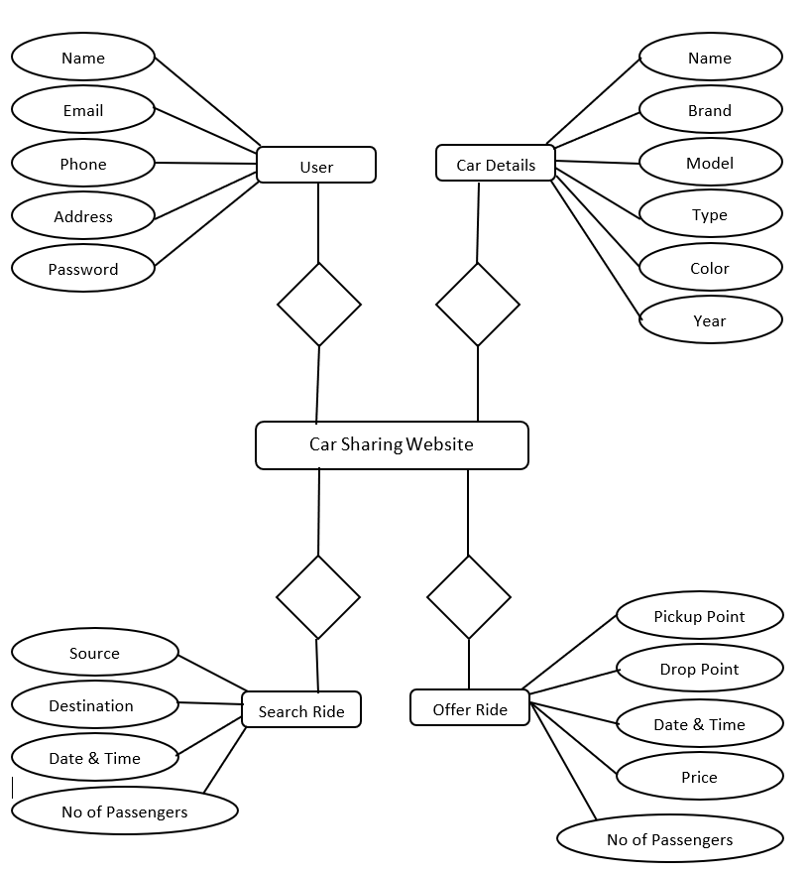

# **WEEKLY OVERVIEW OF INTERNSHIP ACTIVITIES**

|  |  |  |  |
| --- | --- | --- | --- |
| 1st WEEK | DATE | DAY | CONCEPT OF OOPS |
| DD-MM-YY | Monday | Classes / Objects |
| DD-MM-YY | Tuesday | Class Members, Enums |
| DD-MM-YY | Wednesday | Constructors/ Access Modifiers / Properties |
| DD-MM-YY | Thursday | Inheritance / Polymorphism |
| DD-MM-YY | Friday | Abstraction /Interface |
| DD-MM-YY | Saturday | OFF |

|  |  |  |  |
| --- | --- | --- | --- |
| 2nd WEEK | DATE | DAY | SQL SERVER |
| DD-MM-YY | Monday | Create Database, Tables, SQL Roles |
| DD-MM-YY | Tuesday | Procedures, Views, Functions |
| DD-MM-YY | Wednesday | DML, DDL, Grant, Revoke Commands |
| DD-MM-YY | Thursday | Group By, Having, CTE |
| DD-MM-YY | Friday | Joins |
| DD-MM-YY | Saturday | OFF |

|  |  |  |  |
| --- | --- | --- | --- |
| 3rd WEEK | DATE | DAY | SQL SERVER |
| DD-MM-YY | Monday | Creating Database Backup |
| DD-MM-YY | Tuesday | Primary Key, Foreign Key |
| DD-MM-YY | Wednesday | Constraints, Cursors |
| DD-MM-YY | Thursday | SQL Relationship, Triggers |
| DD-MM-YY | Friday | Temporary Table, Global Table, Union, Union All |
| DD-MM-YY | Saturday | OFF |

|  |  |  |  |
| --- | --- | --- | --- |
| 4th WEEK | DATE | DAY | CONCEPTS OF ADO DOTNET |
| DD-MM-YY | Monday | SQL Connection |
| DD-MM-YY | Tuesday | SQL Command, SQL Data reader, |
| DD-MM-YY | Wednesday | SQL Data Adaptor, Data Set |
| DD-MM-YY | Thursday | SQL Parameters, Execute Scalar |
| DD-MM-YY | Friday | Data List |
| DD-MM-YY | Saturday | OFF |