- Star Schema
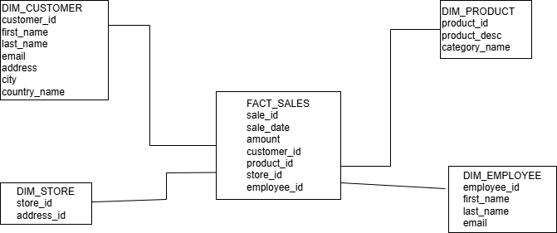

Step 1: Identify the Business Process
The main business process in the provided schema is sales transactions.
The goal of analysis is to evaluate sales performance by customer, product, store, employee, and transaction date, which is stored directly in the fact table.

Step 2: Declare the Grain
The grain of the fact table is defined as one record per individual sales transaction, for one product sold to one customer by one employee in one store on a specific transaction date.

Step 3: Identify the Dimensions
The following dimensions were identified:
Customer dimension
Product dimension
Store dimension
Employee dimension
All dimension tables were denormalized by merging related hierarchical data.

Step 4: Identify the Facts
The fact table contains measurable and aggregatable data such as sales amount.
Foreign keys link the fact table to all dimension tables.

- Snowflake Sche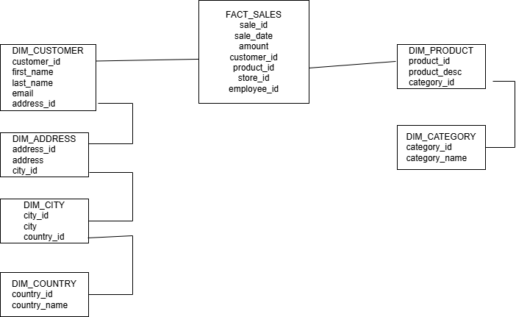

Normalization Step 1: Preserve the Fact Table Structure
The fact table remains unchanged during the normalization process.

Normalization Step 2: Normalize the Customer Dimension
To construct the snowflake schema, hierarchical customer data was separated into multiple related dimension tables to reduce redundancy.
The customer dimension was divided into:
Customer dimension
Address dimension
City dimension
Country dimension
Each table represents a single entity and is connected using foreign keys, forming a hierarchical structure.

Normalization Step 3: Normalize the Product Dimension
Product data in the star schema included both product details and product category information.
During normalization, product category data was separated into its own dimension table.
Product dimension
Category dimension
The product dimension references the category dimension through a foreign key.

Normalization Step 4: Maintain Referential Integrity Between Dimensions
After normalization, all dimension tables were linked using foreign keys to reflect their natural hierarchical relationships.
The fact table remains directly connected only to the lowest-level dimension tables, while higher-level attributes are accessed through additional joins.

