# Merubah port apache di xamp

## Klik httpd.conf, ubah 80 menjadi 8012

## 

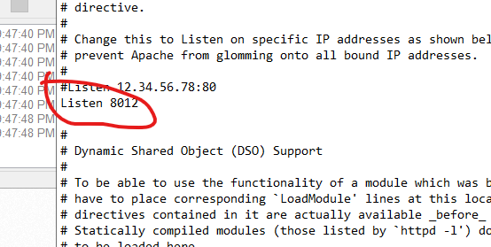

## Klik httpd-ssl.cong, ubah 443 mejadi 8013

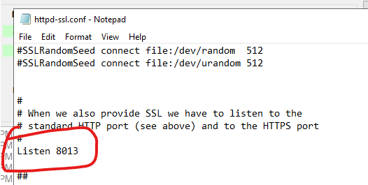

# Merubah upload max file pad phpMyAdmin

* Buka php.ini

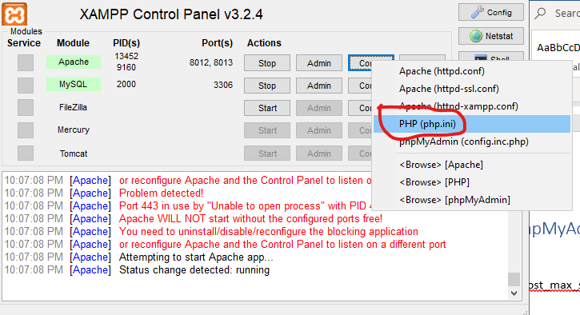

* Update upload_max_filesize=100M, post_max_size=100M
* Restart