getting started:

shitmyself has been tested on:
manjaro
mint
fedora
ubuntu
debian
freebsd
mac

for basic local use, you'll need the following in your path:

perl
lighttpd
php-cgi

on mac, if you don't want to use something like brew,
compiling from source instructions are in mac_lighttpd.txt

git clone https://www.github.com/qvtqht/hike
cd hike
./build.sh
./server_local_lighttpd.pl

this should be enough to get a working server at http://localhost:2784/

if you are prompted for http auth, use admin/admin

data flow:

shitmyself uses several scripts to move data around:

the php files are optional, and only used if php module is enabled

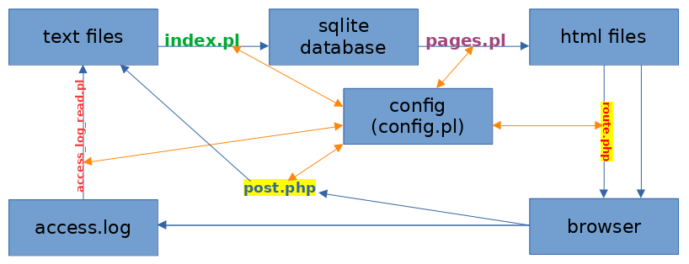

index.pl
reads textfiles and puts them into a relational database (sqlite3)

pages.pl
generates html files from the relational database
also generates: php, javascript, some webserver config

route.php
if php is enabled, helps auto-generate the html pages as needed

post.php
writes text files when user submits a new item

access_log_read.pl
reads the web server's access.log and writes any new submissions to text files

config.pl
(shown as orange arrows)
reads config from config/ and default/ and does the overlay things described below. (require'd by the other scripts)

directory structure:

cache/
cache things, one file per cache item
in subdirectories by cache type

config/
this is where the instance's configuration lives.
most of the things in here are duplicated from default.
(not tracked by git.)

config/query/
sql query definitions used for e.g. views

config/setting/
most settings, one file per setting, are stored under here

config/string/
strings, one per file

config/template/
templates, including mosf of the code
at the top level, they're by language:
config/template/html/
config/template/perl/
config/template/js/
config/template/php/
templates also include config for dependencies:
config/template/htaccess/
lists of things:
config/template/list/

config/theme/
themes are basically overlays for all the things above
when one or more themes are set, they're looked up in order before the default config values are used

default/
all the default values for the above settings are here

doc/
documentation

doc/bin/
all non-ascii files

doc/inbox/
this is automatically added to whenever tags like #bug, #todo, or #meta are used in a post. this is done using the _dev_collect_inbox.pl script, which automatically copies them to this directory. they can then be checked into the repo.

html/
this is the webroot and contains mostly html files, but also javascript, text, and anything else to be served up the web server.

html/txt/
this is where the base data lives by default. it's under the webroot so that users can access it directly.

html/upload/
uploaded files, if allowed, go here

lib/
text-only third-party Perl libraries which are commonly not included in many distributions by default

log/
various logs are output here, including access.log for lighttpd, the debug log (log/log.log) and individual debug dumps like sql queries including query and error output, strings which failed sanity checks, etc.

once/
contains hash-named output from processes which must only be done once, e.g. external page fetches.

configuration overlays:

so, for example, let's say two themes, are set: banana, and chicago.
the lookup for a template called html/page/welcome.template would then happen in this order: (spaces added for readability)

config / theme / banana / template / html / page / welcome.template
default / theme / banana / template / html / page / welcome.template
config / theme / chicago / template / html / page / welcome.template
default / theme / chicago / template / html / page / welcome.template
config / template / html / page / welcome.template
default / template / html / page / welcome.template

if none of these succeed, the lookup would fail and issue a warning, returning an empty string.

small tweaks can be applied to almost any aspect of the system as a "theme".

