EdgeASIC v4.8
Detailed Primary-Target Architecture Specification
Host-Assisted INT8 Conv/GEMM Accelerator with YOLOv8n Compute-Layer Primary Targets

Field | Value
Project | Synthesizable Pipelined INT8 Edge Inference Accelerator
Architecture version | v4.8 detailed primary-target specification
System identity | Host-assisted accelerator for CNN / YOLOv8n compute-layer prototyping
Primary hardware target | N=8 Conv/GEMM core plus Conv2D, tensor movement, C2f/SPPF/LUT-SiLU/detect raw tensor extensions
Host software target | Preprocess, INT8 quantization, tiling, descriptor submission, CPU-only comparison, decode/NMS, display
Boundary | Decode/NMS remain host-side in v4.8; no full autonomous YOLOv8n hardware claim

Primary-target clarification: All blocks explicitly marked PRIMARY TARGET in this document are now part of the intended architecture target. They are not described as far future scope. A block is still not claimable as implemented until its RTL and verification evidence exist.

Document Control, Intent, and Reading Guide
Version | Main purpose | Important correction
v4.4 | Documentation cleanup | Fixed deadlocks, sticky errors, metadata separation.
v4.5 | RTL-ready baseline | Made baseline N=8 Conv/GEMM safer for implementation.
v4.6 | Host-assisted framing | Added CPU-only vs CPU+IP evaluation concept.
v4.7 | Reduced documents | Reduced document count but diagrams were too simplified.
v4.8 | Detailed primary-target architecture | Promotes YOLOv8n compute extensions to primary targets and expands architecture detail.

- This document is an architecture specification, not RTL implementation.
- It is intentionally strict about what is hardware, what is host software, and what evidence is required before claims are made.
- The document uses baseline required and primary target extension labels instead of future-scope labels for the main planned blocks.
- The diagrams and Mermaid source are included separately in the package for large-format editing and rendering.

Chapter 1 - Executive Architecture Summary
EdgeASIC v4.8 is a host-assisted INT8 accelerator architecture. It is intended to accelerate compute-heavy CNN and YOLOv8n compute-layer operations while the host software manages image preprocessing, quantization, tiling, descriptor submission, unsupported postprocessing, and demonstration orchestration.
The baseline compute foundation is an N=8, 8 by 8 INT8 weight-stationary systolic array. It performs dense Conv/GEMM tile computation, drains skewed results through an SDDU, performs INT32 accumulation with dynamic K-tile metadata, requantizes into INT8, and writes output tiles through output SRAM and a packing FIFO.
The primary target extensions now include Conv2D window generation, 1x1 and 3x3 convolution, stride and padding, partial tile masking, residual ADD, Tensor Table, descriptor ring, graph scheduler, C2f decomposition, split, concat, upsample, maxpool, SPPF, LUT-SiLU, detect-head convolution, and raw detection tensor export. These are no longer written as remote future scope in this architecture specification.
Decode, confidence filtering, NMS, and box drawing remain host-side in v4.8. This makes the project a hardware/software co-design rather than a standalone full YOLOv8n hardware engine.
Layer | Architecture responsibility | Primary output
Host software | Preprocess, quantize, tile, submit descriptors, compare CPU-only vs CPU+IP, decode/NMS. | Prepared INT8 tensors, descriptors, final display.
Control plane | CSR, descriptor manager, descriptor ring, graph scheduler, dispatcher, status/error/counters. | Safe operation sequencing and host-visible status.
Memory plane | DMA abstraction, read router, SRAM banks, Tensor Table, packing FIFO. | Correct tile transfer and tensor lifetime support.
Baseline compute | 8x8 systolic array, SDDU, accumulation, requantization, activation, output. | Correct INT8 output tiles.
Primary extensions | Conv2D, C2f, tensor movement, SPPF/maxpool, LUT-SiLU, detect-head raw tensor. | YOLOv8n compute-layer capability.

Chapter 2 - Scope Taxonomy and Primary Target Matrix
The architecture uses four status labels. These labels must appear consistently in architecture, implementation, verification, and presentation material.
Status label | Meaning | Claim rule
Baseline required | Minimum core needed to demonstrate a correct accelerator. | Must be implemented and verified for project success.
Primary target extension | A planned deliverable that is now part of the main architecture target. | Can be claimed only when implemented and tested.
Host software primary | Software required for correct operation or demo. | Must be implemented for demo, but not as hardware.
Explicit non-claim | Not claimed by v4.8 hardware. | Do not present as achieved.

Feature | v4.8 status | Location | Architecture note
N=8 INT8 Conv/GEMM | Baseline required | Hardware | Core dense compute engine.
8x8 weight-stationary array | Baseline required | Hardware | 64 MAC/cycle theoretical.
SDDU delay rule | Baseline required | Hardware | delay[i]=N-1-i.
K_TILE_FIRST/LAST | Baseline required | Compute FSM metadata | Dynamic, not descriptor bits.
CSR and sticky errors | Baseline required | Hardware control | Host-visible safety.
DMA 4KB local rejection | Baseline required | Hardware memory | No deadlock, no illegal AXI issue.
Partial tile masking | Primary target extension | Hardware | Required for general shapes.
Residual ADD | Primary target extension | Hardware | Needed for residual-style blocks.
Conv2D window generator | Primary target extension | Hardware | 1x1, 3x3, stride, padding.
Tensor Table | Primary target extension | Hardware/control | Base/shape/stride/producer metadata.
Descriptor ring | Primary target extension | Hardware/control | Multi-layer queue.
Graph scheduler | Primary target extension | Hardware/control | In-order dependency-based sequencing.
C2f decomposition | Primary target extension | Graph primitives | Conv + split + concat + residual sequence.
Split/concat/upsample | Primary target extension | Tensor movement | YOLOv8n graph support.
SPPF/maxpool | Primary target extension | Hardware | Pooling and SPPF primitive support.
LUT-SiLU | Primary target extension | Activation hardware | Approximation or LUT-based activation.
Detect-head convolution | Primary target extension | Hardware compute | Generate raw detection tensor.
Raw tensor export | Primary target extension | HW/SW contract | Host-readable raw output.
Decode/NMS/draw | Host software primary | Host | Not hardware in v4.8.

Chapter 3 - Detailed Architecture Diagrams
This chapter provides both a system-level master map and focused subsystem diagrams. The full-size PNG files are also supplied separately so they can be used in reports and slides without scaling loss.

Figure 1 - Master Architecture Map
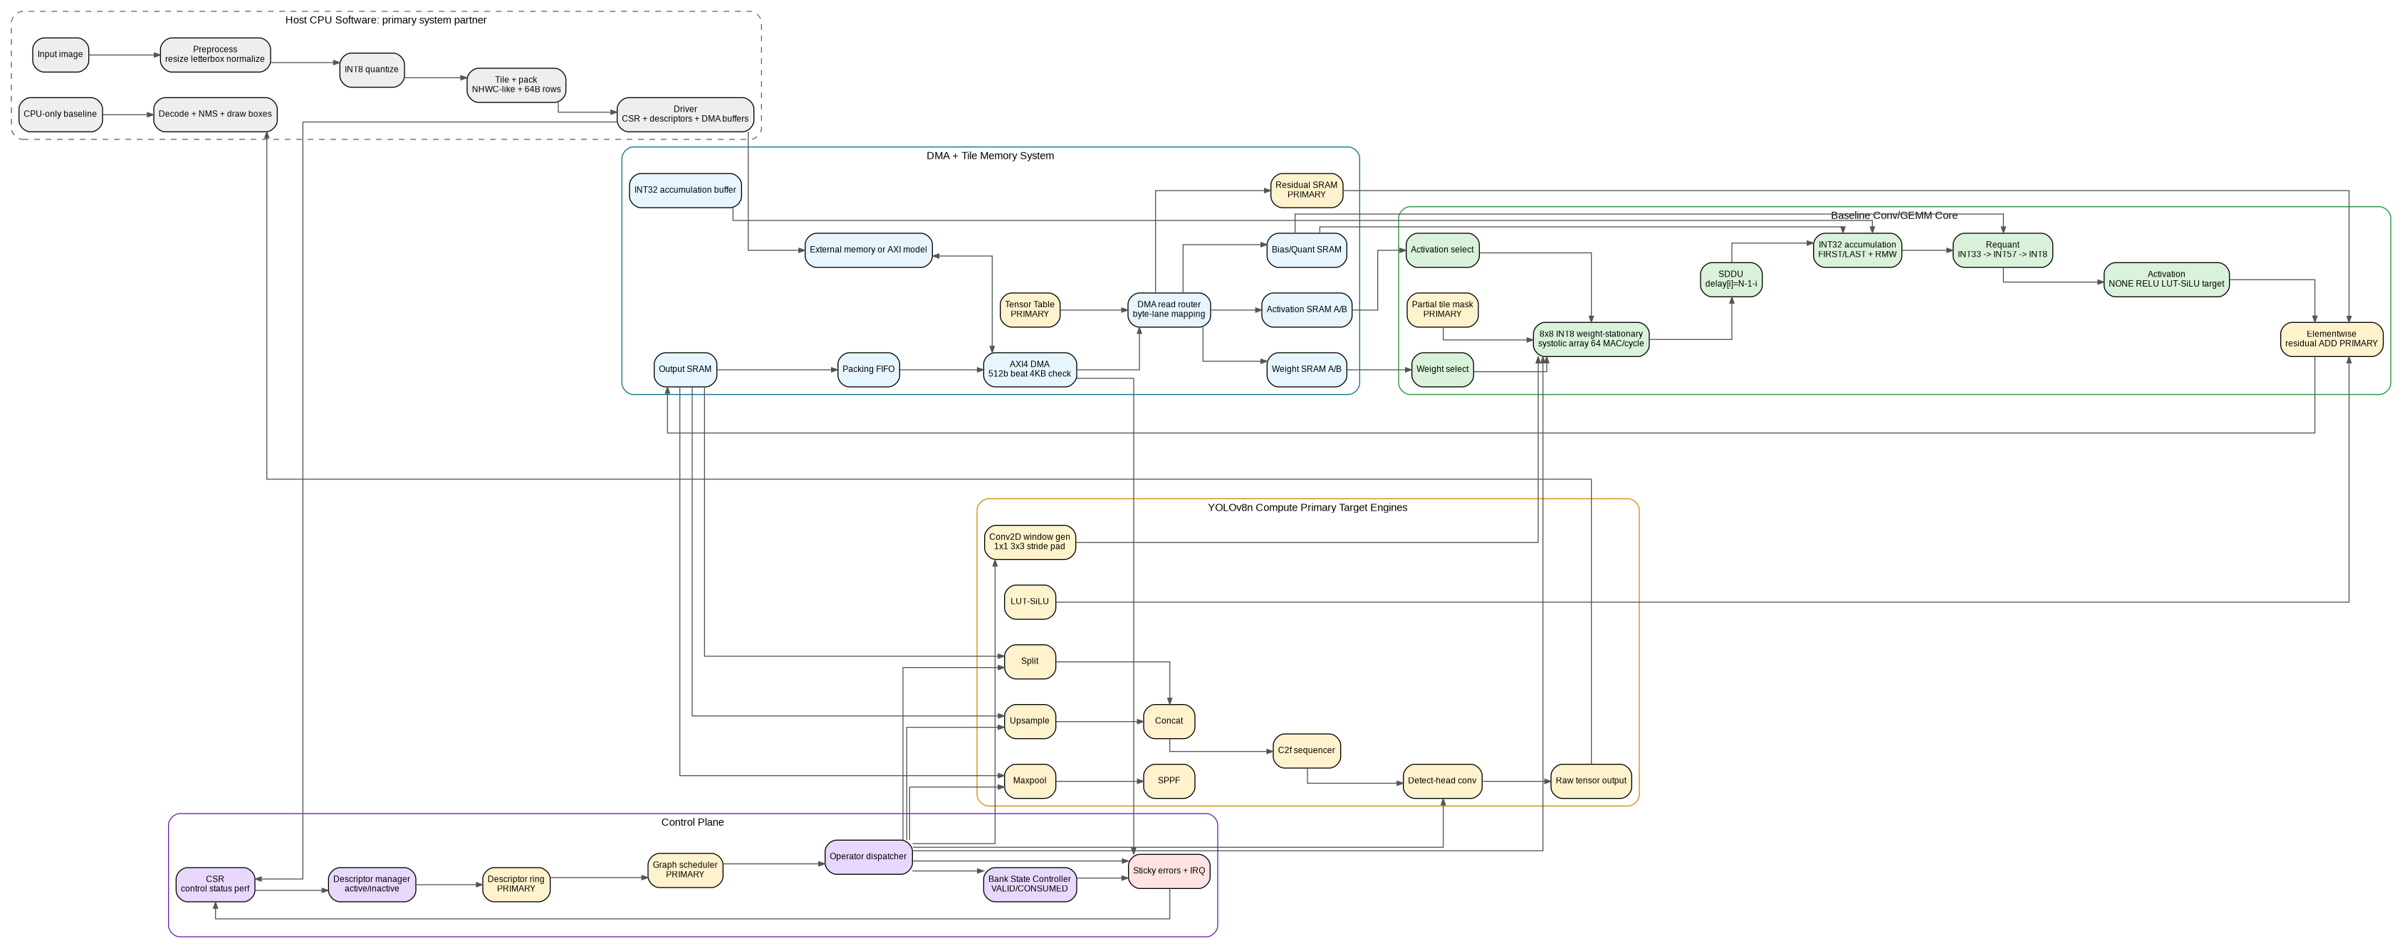
Figure 1 - Detailed EdgeASIC v4.8 master architecture map with baseline blocks and primary target extensions.

Focused Subsystem Diagrams
The following diagrams are smaller views that should be used in slides or implementation reviews.
Figure 2 - Host-assisted execution and postprocessing flow.
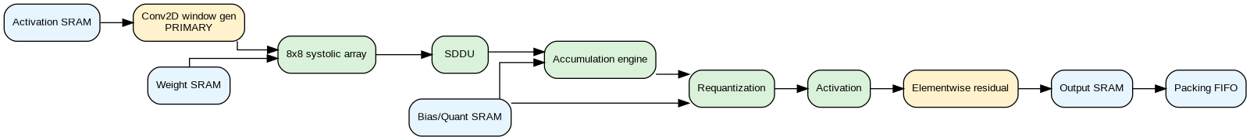
Figure 3 - Core datapath and primary target extension attach points.
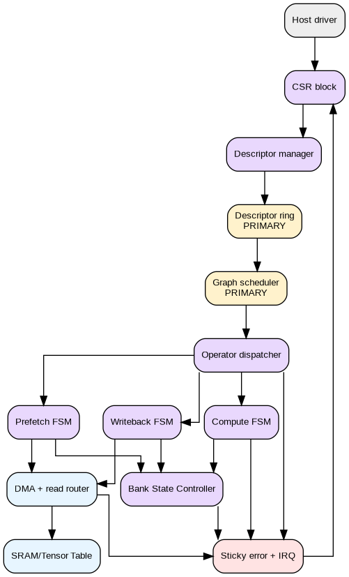
Figure 4 - Control plane, FSMs, memory, and error/status path.

Chapter 4 - Host-Assisted Execution Contract
The host is a required part of the system, not a temporary debugging tool. It owns model-level orchestration unless and until the descriptor ring and graph scheduler are fully implemented and verified. The host must be able to run a CPU-only reference path and a CPU+IP path on the same input data so that the project can present a fair comparison.
The hardware receives prepared tensor tiles rather than raw images. This is the most important architectural boundary. The accelerator is designed to be a compute offload engine: it accepts INT8 tensor data, weights, parameters, and descriptors, then returns output tensor tiles or raw detection tensors.
The demo should measure the compute kernel and full system separately. Kernel-only speedup demonstrates the value of the 64-PE systolic array; end-to-end timing shows the practical impact of host transfer and software overhead.
Host stage | Action | Output to hardware or next stage
Preprocess | Load image, resize/letterbox, normalize. | Floating or fixed-point tensor.
Quantize | Convert activations/weights to INT8 with chosen scale/zero point policy. | INT8 activation and weight tensors plus quant metadata.
Tile and pack | Pack tensors into NHWC-like 64-byte aligned memory images. | DMA buffers and tensor descriptors.
Submit descriptors | Write CSR/descriptor registers or descriptor-ring entries. | Operation start event.
Poll/interrupt | Wait for DONE or ERROR and read counters. | Status and performance data.
Collect output | Read output tensor tiles and reconstruct tensors. | Raw output tensor.
Postprocess | Decode, filter, NMS, draw boxes. | Final boxes/image or tensor comparison.

Chapter 5 - Tensor Layout, Tiling, and Quantization Contract
This contract must be frozen before DMA router and host packer implementation. A large fraction of accelerator bugs come from mismatched byte order, row stride, channel order, or quantization interpretation.
Contract item | Definition | Verification requirement
Element format | Signed INT8 activations and weights. | Signed-product tests using positive and negative operands.
Tensor order | NHWC-like host-visible layout. | Known tensor pattern test through DMA router and output unpacker.
Row alignment | 64-byte row padding for host-visible tensors. | Stride and padding tests must verify unused bytes do not corrupt output.
DMA beat | 512-bit beat equals 64 bytes. | Byte pattern 0x00 through 0x3F maps exactly to expected SRAM lanes.
Bias | Signed INT32 per output channel. | Bias applied exactly once on K_TILE_FIRST.
Scale | INT24 fixed-point scale. | Golden-model comparison for scale edge cases.
Shift | Per-channel non-negative shift. | Negative result signed-shift test.
Saturation | Clamp to signed INT8 [-128,127]. | Dedicated +127 and -128 boundary test.
Tile storage | Local SRAM stores active tiles only, not necessarily full model. | Host tiling tests and BRAM capacity checks.

Chapter 6 - CSR Map and Software-Visible Control
The CSR block is the host-visible control and observability surface. The project should not rely on top-level debug-only ports for status or performance measurement.
CSR group | Representative registers | Reset behavior | Access
Control | START, SOFT_RESET, PERF_CLEAR, IRQ_ENABLE | 0 after reset | Host write. START is pulse or W1S depending implementation.
Status | BUSY, DONE, ERROR, ERR_UNSUPPORTED_OP, ERR_UNSUPPORTED_ACT, ERR_AXI_BOUNDARY, ERR_SHAPE | 0 after reset except implementation-specific debug bits | Host read; sticky errors W1C.
Descriptor window | OP_TYPE, ACT_MODE, EW_MODE, bases, dims, strides, flags | 0 or invalid descriptor state | Host write into inactive descriptor.
Descriptor ring | RING_HEAD, RING_TAIL, RING_STATUS, RING_CAPACITY | empty | Host and scheduler read/write.
Tensor Table | TENSOR_ID, base, shape, stride, scale, ready state | invalid entries | Host and scheduler access.
Performance | TOTAL, COMPUTE, DMA_WAIT, STALL, WRITEBACK, MAC_ACTIVE, LAYER_COUNT, ERROR_COUNT | 0 | Host read; PERF_CLEAR resets.

Software recovery sequence: After a fatal sticky error, the host reads STATUS, logs the cause, clears W1C bits, optionally asserts SOFT_RESET, rewrites or re-commits a descriptor, and restarts only when BUSY is 0. Automatic restart after error is forbidden.

Chapter 7 - Descriptor Format and Dynamic Pipeline Metadata
Descriptors are static operation records. They must not contain per-subtile dynamic control such as K_TILE_FIRST or K_TILE_LAST. Those signals are produced by the Compute FSM and transported through the datapath as metadata.
Descriptor field | Status | Used by | Meaning
op_type | Baseline + primary | dispatcher | Selects engine or primitive.
act_mode | Baseline + primary | activation | NONE, RELU, LUT_SILU target.
ew_mode | Primary | elementwise | passthrough or residual ADD.
a_base, w_base, o_base, bq_base | Baseline | DMA/router | Tensor and parameter base addresses.
input1_base | Primary | residual/tensor ops | Second input tensor base.
m,n,k | Baseline | compute FSM | GEMM/tile dimensions.
h,w,c,out_c | Primary | Conv2D/window gen | Spatial and channel dimensions.
kernel, stride, padding | Primary | Conv2D/window gen | 1x1/3x3, stride, zero-pad.
flags | Baseline + primary | control/datapath | row padding, residual enable, partial tile enable, per-channel quant.
tensor_id fields | Primary | Tensor Table/graph | Input/output tensor references.

pipe_meta_t field | Width / type | Meaning
valid | 1 bit | This data item is valid.
k_tile_first | 1 bit | This item belongs to the first K subtile; bias is applied.
k_tile_last | 1 bit | This item belongs to the final K subtile; final output may be generated.
acc_addr | ACC_ADDR_W | Address in accumulation buffer for partial sum.
out_chan_base | CHAN_W | Base output channel index for bias/quant lookup and output formatting.
lane_mask | N bits if implemented | Suppress invalid lanes for partial tiles.

Chapter 8 - Tensor Table, Descriptor Ring, and Graph Scheduler
These blocks are now primary targets. To keep them implementable, the first scheduler should be in-order and conservative. Out-of-order scheduling, multi-context execution, and full dynamic runtime allocation are not required for the initial architecture.
Tensor Table field | Purpose | Hazard if wrong
tensor_id | Unique tensor reference. | Descriptors may read or overwrite wrong tensor.
base_addr | Host-visible or local memory base. | DMA loads/stores wrong location.
shape_h, shape_w, shape_c | Tensor dimensions. | Conv/window/tensor movement produces wrong output.
stride_h, stride_w, stride_c | Memory layout strides. | Byte-addressing mismatch.
scale/zero point or quant_id | Quantization reference. | Activation/residual mismatch.
producer_desc | Descriptor that writes tensor. | Dependency tracking fails.
consumer_count | Expected future readers. | Tensor may be overwritten early.
ready_valid | Tensor available flag. | Scheduler starts too early or stalls forever.

Scheduler rule | Required behavior
In-order issue | Initial graph scheduler issues descriptors in ring order when dependencies are ready.
Dependency check | Descriptor may start only when all input tensors are ready.
Resource check | Descriptor may start only when required SRAM/engine resources are available.
Completion update | On successful writeback, output tensor entry becomes ready.
Error propagation | On fatal error, scheduler halts and sets sticky status until host recovery.
Fallback mode | Single-descriptor baseline mode remains supported even if ring/scheduler is disabled.

Chapter 9 - DMA, SRAM Banks, and Bank State Controller
The DMA and bank-control subsystem must be designed to avoid deadlock. Every request either completes normally or completes locally with an error. Every bank transition has one owner at a time.
Bank state | Meaning | Legal producer | Legal consumer
EMPTY | Bank has no valid tile. | Prefetch FSM may fill. | Compute must not read.
FILLING | DMA write into bank is in progress. | Prefetch FSM/DMA. | No consumer.
VALID | Bank contains complete tile. | Prefetch FSM sets after DMA done. | Compute or operator engine may consume.
CONSUMING | Compute/engine is reading bank. | BSC grants ownership. | Current consumer only.
CONSUMED | Consumer finished tile. | Consumer marks consumed. | Prefetch FSM may reclaim.
ERROR | Bank transaction failed. | DMA or validation error. | Host recovery required.

DMA event | Behavior | Status effect
Normal aligned request | Issue AXI read/write and wait for response. | Set dma_done when response completes.
4KB boundary violation | Do not issue AXI. Complete locally. | dma_done=1, dma_error=1, ERR_AXI_BOUNDARY=1.
AXI response error | Finish request with error. | Set DMA error and transition requesting FSM to error state.
Request during busy | Reject or stall according to one-outstanding rule. | Increment stall if applicable.
FIFO full during writeback | Hold writeback until ready. | Increment writeback/stall counters.

Chapter 10 - Baseline Conv/GEMM Core Detailed Behavior
The core is designed around deterministic timing and metadata alignment. Correctness depends on signed PE arithmetic, registered activation propagation, SDDU deskewing, and correct FIRST/LAST accumulation policy.
Core component | Detailed behavior
PE | Holds or loads weight according to weight-stationary dataflow. Multiplies signed INT8 activation and signed INT8 weight. Propagates activation through registered act_out.
Systolic array | Instantiates 64 PEs arranged as 8 rows by 8 columns. Outputs are skewed by systolic timing.
SDDU | Applies lane-specific delay so all lanes align at the accumulation engine. pipe_meta_t receives identical delay to its data.
Accumulator | Implements bias add on first subtile, RMW for middle subtiles, and final drain only on last subtile.
Requant | Converts INT32/INT33 accumulated values to INT8 using scale, signed shift, and saturation.
Activation | Applies passthrough or ReLU in baseline; LUT-SiLU primary target attaches here.
Elementwise | Passes value through or performs residual ADD using residual SRAM and saturating 9-bit intermediate.

FIRST | LAST | Accumulator action | Output action
1 | 1 | bias + MAC | send to requant/output.
1 | 0 | bias + MAC, write partial | no final output.
0 | 0 | read partial + MAC, write partial | no final output.
0 | 1 | read partial + MAC | send to requant/output.

Chapter 11 - Arithmetic, Quantization, and Activation
Stage | Width | Signedness | Rule
Activation input | INT8 | signed | Host and PE agree on signed interpretation.
Weight input | INT8 | signed | No unsigned multiply.
Product | INT16 | signed | Sign extend before accumulation.
Accumulator | INT32 | signed | Sufficient for chosen tile sizes; overflow policy should be validated.
Accumulator + bias | INT33 | signed | Use one extra bit for safe addition.
Scale product | INT57 | signed | INT33 x INT24.
Shift | implementation shift width | signed arithmetic | Logical right shift is forbidden.
Saturation | INT8 | signed | Clamp to -128..127.
Residual add | INT9 intermediate | signed | Saturate after addition.

Chapter 12 - Conv2D Window Generator Primary Target
The Conv2D window generator is the bridge from image-like tensors to the dense Conv/GEMM array. It converts spatial windows into channel-depth vectors and manages stride/padding. The recommended bring-up order is 1x1, then fixed 3x3 stride-1 padding-1, then stride variants.
Subfeature | Required behavior | Bring-up recommendation
1x1 conv | For each output pixel, present the input channel vector directly to GEMM. | Implement first.
3x3 window | Collect 9 spatial positions per input channel. | Implement after 1x1 passes.
Zero padding | Out-of-bound window samples become zero. | Test corners and edges.
Stride | Output coordinate maps to input coordinate with stride factor. | Add stride-2 only after stride-1 works.
Channel order | Maintain NHWC-like channel-contiguous order. | Use known-pattern tests.
Partial spatial tile | Suppress writes outside valid output shape. | Use partial-tile mask.

Chapter 13 - YOLOv8n Primary Target Compute Engines
The architecture treats YOLOv8n support as a set of primitive engines and a sequencer, not as one monolithic YOLO block. This reduces RTL complexity and makes testing tractable.
Target | Primitive decomposition | Minimum verification
C2f | Descriptor sequence of Conv2D, split, residual/elementwise, concat, and Conv2D. | Small synthetic C2f-like block compared to Python reference.
Split | Address-view split or physical copy split. | Channel-order test.
Concat | Channel-wise merge of two or more tensors. | Known-pattern tensors and output order test.
Upsample | Nearest-neighbor spatial repeat. | 2x scale known-pattern test.
Maxpool | Windowed max compare. | Boundary and stride test.
SPPF | Repeated maxpool and concat-like output. | Small tensor SPPF reference.
LUT-SiLU | INT8/fixed-point LUT or approximation. | Error bound vs Python approximation.
Detect-head conv | Conv layers mapped to Conv2D/GEMM path. | Raw output tensor shape and order test.
Raw tensor export | Host-readable tensor output. | Host decode input compatibility test.

Chapter 14 - Operator Dispatch and Engine Routing
The dispatcher is the hardware routing point for baseline and primary target OP_TYPE values. Unsupported combinations must not start an engine; they must set sticky errors. The dispatcher also prevents illegal simultaneous ownership of shared SRAMs and DMA resources.
OP_TYPE | Target engine | Data dependencies | Error cases
CONV_GEMM | Conv/GEMM core | activation, weight, bias/quant, output | invalid M/N/K, missing banks.
CONV2D | Window generator + Conv/GEMM core | input tensor, weights, bias/quant, output | unsupported kernel/stride/padding.
MAXPOOL | Maxpool engine | input tensor, output | invalid window/shape.
SPPF | Maxpool + concat sequence | input tensor, temporary tensors, output | insufficient buffer or unsupported shape.
SPLIT | Tensor movement engine | input tensor, output tensor refs | invalid split dimension.
CONCAT | Tensor movement engine | multiple input tensors, output | mismatched spatial dimensions.
UPSAMPLE | Upsample engine | input tensor, output | unsupported scale or shape.
DETECT_CONV | Conv2D/GEMM path | detect weights and feature map | raw tensor format mismatch.

Chapter 15 - Detect Output and Host Postprocessing Boundary
The hardware produces raw detection tensors. The host software decodes those tensors into bounding boxes, applies confidence filtering, performs NMS, and draws the final image. This boundary must be stated clearly in reports and presentations.
Function | v4.8 location | Why
Detect-head convolution | Hardware primary target | Compute-heavy convolution.
Raw tensor writeback | Hardware + host contract | Needed for host decode compatibility.
YOLO decode | Host software | Model-specific indexing and box formulas are easier in software.
Confidence threshold | Host software | Simple but not worth hardware scope.
NMS | Host software | Irregular and control-heavy.
Box drawing | Host software | Display/UI task.

Chapter 16 - Performance Evaluation Architecture
The architecture supports two kinds of performance evaluation: kernel-only and full-system. Both are valuable, but they answer different questions.
Metric | Definition | How measured
Peak MAC/cycle | 64 MAC/cycle for 8x8 array. | Analytical from array size.
Target GMAC/s | 64 x target clock. | Analytical; not Fmax claim.
Kernel compute cycles | Cycles where array is active. | PERF_COMPUTE_CYCLES / PERF_MAC_ACTIVE_CYCLES.
DMA wait cycles | Cycles compute waits for memory. | PERF_DMA_WAIT_CYCLES.
Stall cycles | Pipeline stall or backpressure. | PERF_STALL_CYCLES.
CPU kernel time | CPU implementation of same INT8 Conv/GEMM. | Host timing.
IP kernel time | Compute cycles divided by measured or target clock. | Counter-based.
End-to-end CPU-only time | Full host reference pipeline. | Host timing.
End-to-end CPU+IP time | Host preprocess + transfer + IP + postprocess. | Host timing plus IP counters.

Chapter 17 - Verification Strategy and Test Coverage
Verification must be built in from the start. Each hardware block must have unit tests before integration, and every primary target block must have a TC-PRIM test ID if claimed in final documentation.
Test family | Examples
TC-CUR-CORE | PE signed arithmetic, registered act_out, array timing, SDDU delay, metadata alignment.
TC-CUR-ACC | FIRST/LAST four cases, bias once, RMW order, final drain only.
TC-CUR-QNT | signed shift, saturation boundaries, ReLU/passthrough.
TC-CUR-CTRL | CSR reset, W1C, descriptor commit, unsupported op/act errors.
TC-CUR-DMA | 4KB rejection, AXI response error, byte ordering, packing FIFO backpressure.
TC-PRIM-CONV2D | 1x1, 3x3, stride, padding, partial spatial tiles.
TC-PRIM-GRAPH | Tensor Table dependency, descriptor ring, 2-layer and 3-layer sequence.
TC-PRIM-TENSOR | split, concat, upsample memory order tests.
TC-PRIM-POOL | maxpool and SPPF reference comparison.
TC-PRIM-ACT | LUT-SiLU accuracy/error-bound tests.
TC-PRIM-DETECT | raw tensor export and host decode compatibility.
TC-DEMO | CPU-only vs CPU+IP output and timing comparison.

Chapter 18 - Reset, Error Handling, and Recovery
Condition | Required hardware behavior | Host recovery
Reset | Clear FSMs, invalidate banks, clear counters unless debug mode says otherwise, clear sticky errors. | Reload descriptors and tensors.
Unsupported OP_TYPE | Do not start engine. Set ERR_UNSUPPORTED_OP. | Clear error and submit valid descriptor.
Unsupported ACT_MODE | Do not start or stop safely. Set ERR_UNSUPPORTED_ACT. | Clear error and select supported/implemented mode.
Shape error | Do not start operation. Set ERR_SHAPE. | Fix descriptor dimensions or alignment.
DMA 4KB violation | No AXI issue; local done+error. | Fix host alignment/tiling.
BSC illegal state | Stop safely or assert in verification. | Reset and debug ownership sequence.
Graph dependency deadlock | Scheduler halts and reports error/status. | Host inspects tensor table and descriptors.

Chapter 19 - Implementation Constraints and Design Rules
- Do not implement K_TILE_FIRST or K_TILE_LAST as static descriptor bits.
- Do not call the current array output-stationary; it is weight-stationary with external accumulation.
- Do not allow 4KB-crossing DMA requests to issue AXI transactions in the baseline.
- Do not claim full YOLOv8n hardware while decode/NMS remain software.
- Do not claim measured clock, FPS, FPGA success, or synthesis unless actual tool evidence exists.
- Every primary target block must have a final status: implemented and verified, implemented but partial, architecture-only, or removed.

Chapter 20 - Final Claim Boundary
Recommended title: Host-Assisted INT8 Conv/GEMM Accelerator for Edge CNN Inference with YOLOv8n Compute-Layer Primary Targets

Safe final claim: The architecture defines a host-assisted INT8 accelerator with a verified baseline Conv/GEMM core and primary targets for YOLOv8n compute-layer support, including Conv2D, graph/tensor management, tensor movement, SPPF/maxpool, LUT-SiLU, detect-head convolution, and raw tensor export. Host software performs image preprocessing, descriptor orchestration where needed, decode, NMS, and final display. Claims of implementation require RTL and verification evidence.

No-go claim | Reason
Full standalone YOLOv8n hardware accelerator | v4.8 keeps decode/NMS host-side and relies on host software.
Real-time FPS | Requires measured end-to-end prototype data.
FPGA timing closure | Requires FPGA implementation and timing reports.
N=16 physical array | Not part of v4.8 N=8 primary architecture.
Sparsity speedup | Not included unless a sparsity engine is separately specified and verified.

Appendix A - Interface Checklist
Interface | Must define before RTL integration
Host CSR bus | address width, data width, reset values, W1C bits, start pulse behavior.
Descriptor write path | active/inactive commit, busy rejection, shape validation.
DMA request | address, length, read/write, done/error, 4KB crossing check.
SRAM ports | width, byte enable, read latency, write latency, arbitration.
Systolic array | activation stream timing, weight load timing, valid/ready/stall.
SDDU | lane delays, metadata delays, valid handling, stall behavior.
Accumulation buffer | addressing, RMW latency, collision handling.
Tensor Table | entry format, ready state, producer/consumer update.
Graph scheduler | descriptor issue, dependency checks, error halt.
Host output format | raw tensor shape, quant scale, byte order, decode expectations.

Appendix B - Mermaid Source File
The complete Mermaid source is provided as a separate file named EdgeASIC_v4_8_Master_Architecture.mmd in the package. It is kept outside the Word document to avoid page overflow and to allow direct editing in Mermaid Live Editor, VS Code, or Antigravity.
Mermaid file | Purpose | Notes
EdgeASIC_v4_8_Master_Architecture.mmd | Editable source for the master architecture diagram. | Uses conservative Mermaid syntax with simple node labels and class definitions.
01_master_architecture_map.png | Rendered high-resolution Graphviz architecture map for reports. | Use in architecture document and poster.
02_host_assisted_execution_flow.png | Focused host-assisted execution diagram. | Use in presentation/demo slides.
03_core_datapath.png | Current datapath and extension attach points. | Use in RTL implementation slides.
04_control_memory_map.png | Control plane, memory, FSM, error path. | Use in control-plane explanation.

