PRINCIPLES OF PATTERN RECOGNITION
Gulnabat Mamedova — Final Project Report
Pattern Recognition
Techniques Applied to
Weather Forecasting
K-Means · Logistic Regression · Linear SVM · Random Forest · Gradient Boosting · CNN

1. Introduction
This project applies six Pattern Recognition techniques to the problem of predicting daily rain in Australia. The techniques cover two different approaches: five methods work with numerical weather measurements (K-Means, Logistic Regression, SVM, Random Forest, Gradient Boosting), and one works with sky images (a Convolutional Neural Network). Both ask the same question through different inputs, and their results are compared at the end.

The dataset contains 145,460 daily weather observations from 49 Australian locations spanning 2007 to 2017, collected by the Bureau of Meteorology. The classification target is RainTomorrow — whether more than 1mm of rain fell the following day.

What is Pattern Recognition?
Pattern Recognition means automatically finding regularities in data and using them to classify new observations. Every technique here — from K-Means finding climate zones to the CNN identifying rain clouds from photographs — is the same idea applied through a different mathematical approach.

1.1 Two Approaches in This Project
- Numerical recognition: rain is predicted from 60 weather features (humidity, pressure, temperature, wind). Five classifiers are compared.
- Visual recognition: rain is predicted from sky photographs using a CNN trained on 2,543 cloud images. The same binary question — Rain or No Rain — is answered from images instead of sensor readings.

Both approaches are run on the same problem. Where they agree on what predicts rain, that agreement is the strongest result in the project.

1.2 Problem Definition
Given weather measurements from day D at a known Australian location, predict whether it will rain on day D+1. This is a supervised binary classification problem: f: X → {0, 1} where 1 = Rain and 0 = No Rain.

Key challenge — class imbalance
77.6% of days have no rain. A model that always predicts No Rain scores 77.6% accuracy without learning anything. This is the naive baseline that all models must beat. Accuracy alone is therefore not a useful metric — F1-Score and AUC-ROC are used as the main measures throughout this report.

2. Pattern Recognition Techniques
This chapter explains how each technique works and what kind of patterns it detects. The weather application is used as context throughout, but all techniques are general-purpose methods that apply to any classification problem.

2.1 K-Means Clustering
K-Means is an unsupervised method — it receives no class labels. It groups the 49 Australian weather stations into clusters based on their long-run climate statistics (average temperature, humidity, pressure, wind). Locations with similar climates end up in the same cluster.
The algorithm works by placing K centroids, assigning each location to its nearest centroid, moving each centroid to the mean of its group, and repeating until stable. The number of clusters K is chosen by the elbow method — plotting within-cluster variance against K and picking the point where the curve flattens.

Pattern discovered
K=2 clusters were found. Cluster 0 (9 locations) contains the tropical and desert stations — Darwin, AliceSprings, Cairns, Katherine, Townsville, Uluru, and others. Cluster 1 (40 locations) contains the temperate coastal majority — Melbourne, Sydney, Perth, Adelaide, Hobart, and more. This matches the real meteorological divide between tropical monsoon and mid-latitude frontal weather systems.

2.2 Logistic Regression
Logistic Regression finds a straight-line boundary in the feature space. It learns a weight for each feature, combines them into a score, and passes the score through the sigmoid function to get a probability between 0 and 1. If P(Rain) > 0.5, the prediction is Rain.
Each weight shows the contribution of that feature. A high positive weight on Humidity3pm means afternoon humidity strongly raises the rain prediction. A high negative weight on Pressure9am means high pressure strongly lowers it. These weights are interpretable and match known meteorology.

2.3 Support Vector Machine (SVM)
SVM finds the boundary that sits as far as possible from both classes — it maximises the margin between Rain and No Rain examples. The points closest to the boundary are called support vectors, and they are the only ones that determine the boundary. LinearSVC is used here because the standard RBF version would take hours on 116,000 training samples.

2.4 Random Forest
Random Forest builds 100 decision trees, each trained on a random sample of the data using a random subset of features at each split. The final prediction is a majority vote across all trees. Individual trees are noisy and overfit easily, but averaging many diverse trees cancels out their individual errors and produces a stable, generalisable model.
Tree splits can capture patterns that no straight line can represent — for example: IF Humidity3pm > 72 AND Pressure9am < 1008 AND WindGustSpeed > 40 THEN Rain = Yes. This is why ensemble methods are theoretically stronger than linear classifiers on complex data.

2.5 Gradient Boosting
Gradient Boosting builds trees one after another, where each new tree specifically corrects the errors of all previous trees. The update formula is F_m(x) = F_{m-1}(x) + η·h_m(x), where η=0.029 is the learning rate and h_m is the correction tree. Unlike Random Forest which reduces variance by averaging, Gradient Boosting reduces bias by iterative error correction.

2.6 Convolutional Neural Network (CNN)
A CNN applies learned filters across an image to detect patterns regardless of where they appear — this property is called translation invariance. Early layers detect edges and textures; deeper layers detect shapes. MobileNetV2, pretrained on 1.2 million ImageNet images, is used as the feature extractor. Only the final classification layer is trained on 2,543 cloud images. This transfer learning approach avoids overfitting on the small dataset.
The cloud-to-rain label mapping follows the World Meteorological Organization taxonomy: Cumulonimbus (Cb), Nimbostratus (Ns), and Cumulus (Cu) are labelled Rain; all other types are No Rain. This is the same taxonomy used by Bureau of Meteorology observers when recording the Cloud9am and Cloud3pm columns in the original weather dataset.

2.7 SMOTE — Class Balancing
The 3.5:1 class imbalance (No Rain : Rain) means models can score high accuracy by never predicting Rain. SMOTE fixes this by creating synthetic Rain examples through interpolation between existing ones. It is applied inside each cross-validation fold — never to the test set — so evaluation remains honest.

3. Data Preprocessing
The raw dataset had 145,460 rows and 23 columns. Three problems were addressed before training any model.

3.1 Data Leakage
What happened
Initial experiments produced F1 = 1.0 — a physically impossible perfect score. The cause: Rainfall >= 1mm is the exact definition of RainToday = Yes, so the two columns carry identical information. Any model predicting RainToday with Rainfall as a feature learns one rule and scores perfectly. This is not learning — it is reading the answer from the data. Fix: predict RainTomorrow instead, and drop Rainfall and RainToday from features.

3.2 High-Missing Columns
Four columns with more than 38% missing values were removed: Evaporation (43.2%), Sunshine (48.0%), Cloud9am (38.4%), Cloud3pm (40.8%). Imputing nearly half a column with the median creates artificial signal. After cleaning, 60 features remained from 23 original columns.

3.3 Preprocessing Steps
- Imputation: numeric NaN filled with column median; categorical NaN filled with most frequent value
- One-hot encoding: WindGustDir, WindDir9am, WindDir3pm converted to binary indicator columns
- Scaling: StandardScaler applied to all numeric features (mean=0, std=1)
- SMOTE: training set balanced from 113,754 to 176,504 samples (Rain rate 22.4% → 50%)

3.4 Clustering and Split
K-Means (K=2) grouped all 49 locations into two climate zones. The 80/20 stratified train/test split kept the same 22.4% Rain rate in both halves across 142,193 usable rows.

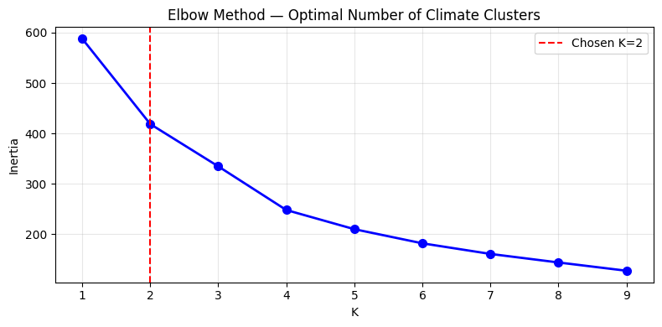
Figure 1: K-Means elbow curve (left) and cluster assignments. The two clusters match the tropical/desert vs temperate coastal divide in Australia.

4. Implementation and Results
Note on metrics
Accuracy is shown but is not the main measure here — the 77.6% naive baseline makes it misleading. F1-Score (how well Rain days are caught and how few false alarms are raised) and AUC-ROC (how well the model ranks rainy days above dry days) are the primary metrics.

4.1 Logistic Regression
LogisticRegression(max_iter=1000, class_weight='balanced', random_state=42)

Model | Acc | Prec | Recall | F1 | AUC
Cluster 0 (tropical/desert) | 0.837 | 0.558 | 0.854 | 0.675 | 0.914
Cluster 1 (temperate coastal) | 0.774 | 0.502 | 0.802 | 0.623 | 0.881
Macro average | 0.806 | 0.530 | 0.804 | 0.639 | 0.881

Logistic Regression achieved the best default F1 (0.639) and AUC (0.881). Cluster 0 performed better (F1=0.675) because tropical and desert climates have stronger and more predictable rainfall patterns — monsoon seasons and desert storms produce clearer meteorological signals than the subtler mid-latitude frontal systems in Cluster 1. Recall of 0.854 in Cluster 0 means the model caught 85% of actual rainy days.

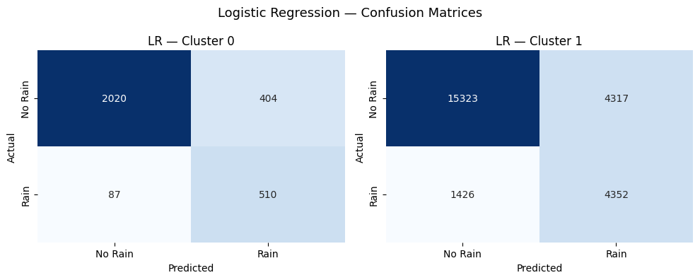
Figure 2: Logistic Regression confusion matrices per cluster. Rows = actual, Columns = predicted.

4.2 Support Vector Machine
CalibratedClassifierCV(LinearSVC(class_weight='balanced'), cv=3)

Model | Acc | Prec | Recall | F1 | AUC
Cluster 0 | 0.835 | 0.553 | 0.851 | 0.671 | 0.914
Cluster 1 | 0.774 | 0.502 | 0.802 | 0.623 | 0.881
Macro average | 0.805 | 0.528 | 0.802 | 0.637 | 0.881

SVM produced almost identical results to Logistic Regression (F1=0.637 vs 0.639, AUC=0.881 vs 0.881). When two models with different optimisation objectives converge on the same score, it is strong evidence that the data has an approximately linear structure that both methods find equally well.

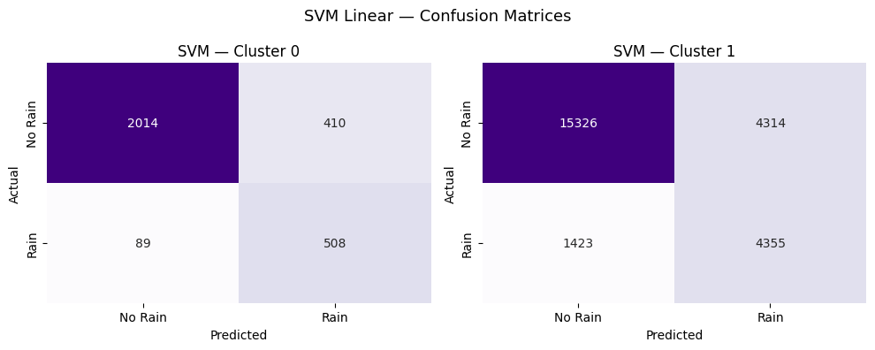
Figure 3: SVM confusion matrices per cluster.

4.3 Random Forest
RandomForestClassifier(n_estimators=100, max_depth=8, min_samples_leaf=4, class_weight='balanced')

Model | Acc | Prec | Recall | F1 | AUC
Full dataset + cluster feature | 0.793 | 0.527 | 0.730 | 0.612 | 0.851

Random Forest scored below the linear models with default settings (F1=0.612, AUC=0.851). The max_depth=8 limit — chosen conservatively to prevent overfitting — restricted each tree to only 256 leaf regions across 60 features, not enough to exploit the non-linear patterns it should theoretically capture.

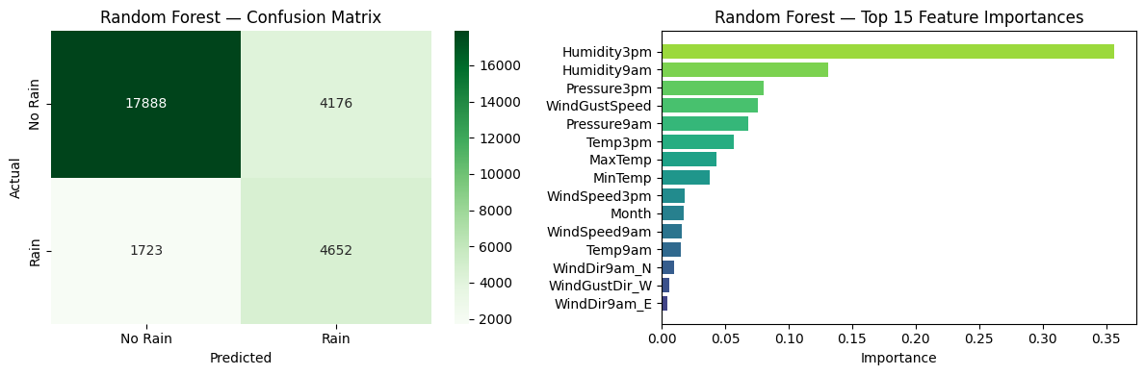
Figure 4: Random Forest confusion matrix and top feature importances. Humidity3pm, Pressure9am, and WindGustSpeed dominate.

4.4 Gradient Boosting
GradientBoostingClassifier(n_estimators=100, learning_rate=0.05, max_depth=3)

Model | Acc | Prec | Recall | F1 | AUC
Full dataset + cluster feature | 0.800 | 0.541 | 0.714 | 0.615 | 0.854

Gradient Boosting had the lowest Recall (0.714), missing 28.6% of rainy days. The very shallow trees (max_depth=3, only 8 leaf regions) could not model rainfall patterns well enough, causing the model to lean toward the majority No Rain class.

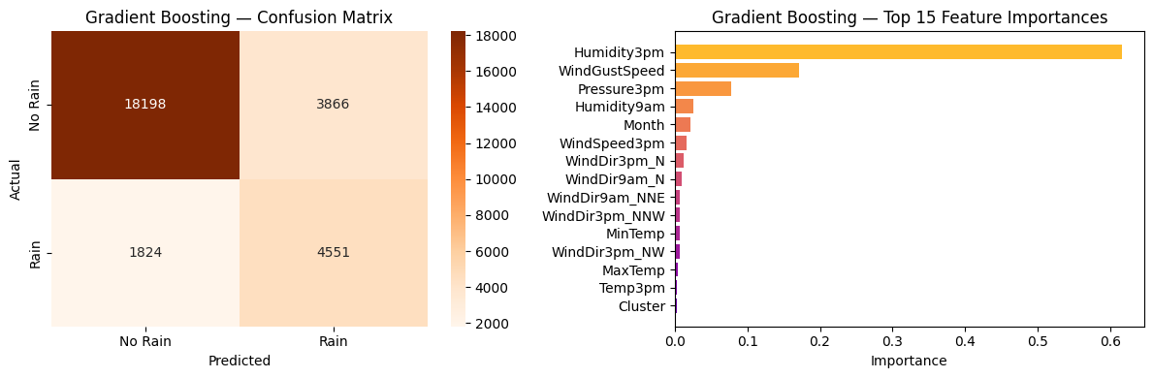
Figure 5: Gradient Boosting confusion matrix and feature importances. Same top predictors as Random Forest.

4.5 All Four Models Together

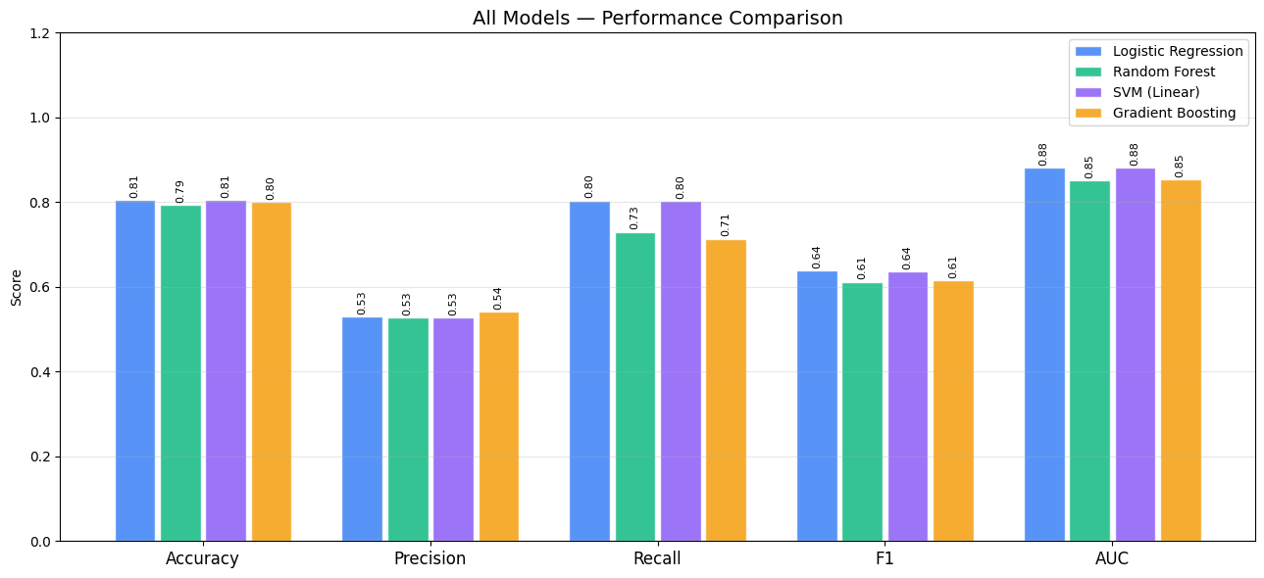
Figure 6: All four default models compared across five metrics. LR and SVM lead on F1 and AUC.

Model | Acc | Prec | Recall | F1 | AUC
Logistic Regression | 0.806 | 0.530 | 0.804 | 0.639 | 0.881
SVM (Linear) | 0.805 | 0.528 | 0.802 | 0.637 | 0.881
Gradient Boosting | 0.800 | 0.541 | 0.714 | 0.615 | 0.854
Random Forest | 0.793 | 0.527 | 0.730 | 0.612 | 0.851
Naive baseline | 0.776 | — | — | 0.000 | 0.500

5. Hyperparameter Tuning
RandomizedSearchCV with 5-fold StratifiedKFold cross-validation was applied to all four models. SMOTE was placed inside the pipeline so it only applies to training folds and never touches the validation data.

5.1 Logistic Regression Tuning
Search: C ∈ [0.001, 10] log-uniform, penalty ∈ {l1, l2}, k_neighbors ∈ {3,5,7}. Time: 121 seconds.
Model | Acc | Prec | Recall | F1 | AUC
Best params | C=0.031 | l1 | k=7
Before | 0.806 | 0.530 | 0.804 | 0.639 | 0.881
After | — | — | — | 0.609 | 0.854

Tuning made LR slightly worse (-2.96% F1). The optimal C=0.031 is much smaller than the default 1.0, meaning the model needs stronger regularisation. But this came at the cost of Recall — the model became more conservative about predicting Rain. The default settings were already near-optimal.

5.2 SVM Tuning
Search: C ∈ [0.001, 100] log-uniform, max_iter ∈ {1000,2000,3000}, k_neighbors ∈ {3,5,7}. Time: 69 seconds.
Model | Acc | Prec | Recall | F1 | AUC
Best params | C=0.006 | max_iter=3000 | k=7
Before | 0.805 | 0.528 | 0.802 | 0.637 | 0.881
After | — | — | — | 0.608 | 0.854

The optimal C=0.006 is extremely small, meaning the widest possible margin is preferred. Rain and No Rain days heavily overlap in feature space — there is no sharp boundary. Tuning confirmed this and also reduced F1 slightly (-2.92%).

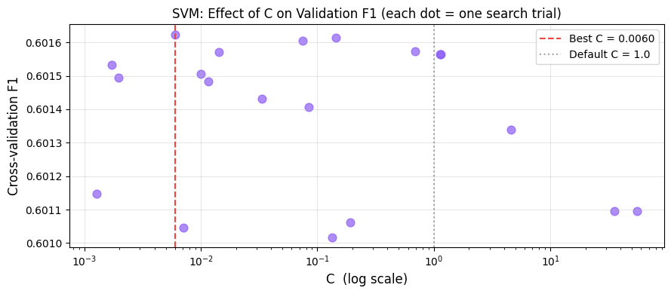
Figure 7: SVM tuning — each dot is one random search trial. Best C=0.006 is far left, confirming the need for a wide margin.

5.3 Random Forest Tuning — Biggest Improvement
Search: n_estimators ∈ [100,400], max_depth ∈ {6,8,12,15,None}, min_samples_leaf ∈ [2,12], max_features ∈ {sqrt,log2,0.4}, k_neighbors ∈ {3,5,7}. Time: 1,707 seconds.
Model | Acc | Prec | Recall | F1 | AUC
Best params | n=180 | depth=15 | feat=0.4 | leaf=4 | k=7
Before | 0.793 | 0.527 | 0.730 | 0.612 | 0.851
After | — | — | — | 0.644 | 0.873

Random Forest improved by +3.24% F1 — the biggest gain of any model. The key was max_depth=15 instead of 8. With depth 15, each tree can represent up to 32,768 decision regions instead of 256, giving enough capacity to capture the conditional weather patterns that the shallow default missed.

5.4 Gradient Boosting Tuning
Search: n_estimators ∈ [100,400], learning_rate ∈ [0.01,0.3], max_depth ∈ {2,3,4,5}, subsample ∈ [0.6,1.0], min_samples_leaf ∈ [2,10], k_neighbors ∈ {3,5,7}. Time: 4,294 seconds (72 minutes).
Model | Acc | Prec | Recall | F1 | AUC
Best params | lr=0.029 | depth=5 | n=198 | sub=0.84 | k=5
Before | 0.800 | 0.541 | 0.714 | 0.615 | 0.854
After | — | — | — | 0.628 | 0.862

GB improved by +1.24% F1. Increasing max_depth from 3 to 5 gave each correction tree 32 leaf regions instead of 8. The low learning rate of 0.029 with 198 trees is the standard Gradient Boosting tradeoff: many small corrections generalise better than few large ones.

5.5 Before vs After — All Models

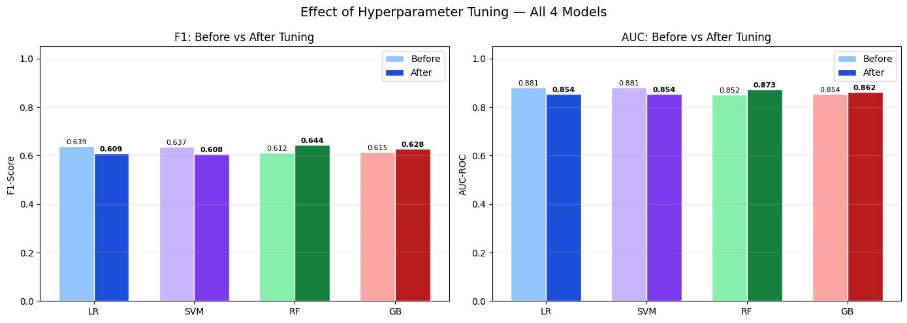
Figure 8: F1 and AUC before and after tuning for all four models. RF gained most; LR and SVM declined slightly.

5.6 Threshold Tuning
The default threshold of 0.5 was tuned by sweeping the Precision-Recall curve. Optimal threshold: 0.473, giving F1=0.6292 vs 0.6277 at 0.5 (+0.15%). The small gain confirms GB's probability outputs are already well-calibrated.

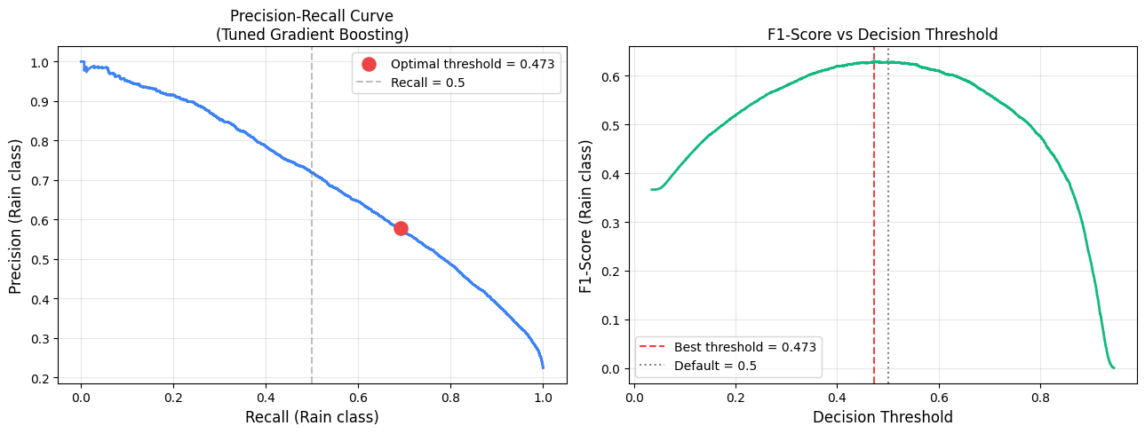
Figure 9: Precision-Recall curve (left) and F1 vs threshold (right). The optimal threshold (0.473) is close to the default.

5.7 Learning Curve
Training F1=0.6321 vs validation F1=0.6245: gap of 0.0076. This near-zero gap means the model is not overfitting. It also means adding more training data would not help much — the model has learned what it can from the current feature set. Better features (e.g. yesterday's pressure trend) would be more effective than more rows.

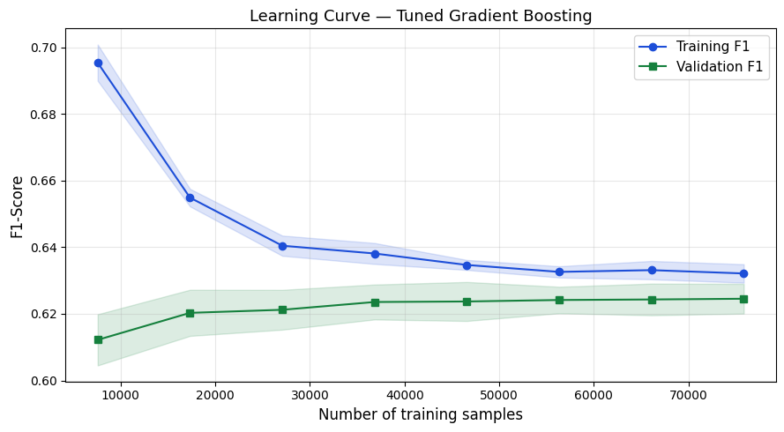
Figure 10: Learning curve for the tuned Logistic Regression. Training and validation scores converge — good fit, not overfitting.

6. Perceptual Pattern Recognition — Cloud Image Classification
The tabular models predict rain from instrument readings. This section adds a visual approach: a CNN trained on sky photographs classifies cloud types and predicts whether the sky looks like rain. Both ask the same question; the CNN answers it through images instead of sensor numbers.

6.1 Dataset
The CCSN dataset contains 2,543 ground-based sky photographs across 11 WMO cloud types. Binary rain labels are assigned based on meteorological precipitation potential:

Code | Cloud Type | Rain? | Count
Cb | Cumulonimbus | Yes — Rain | 242
Ns | Nimbostratus | Yes — Rain | 274
Cu | Cumulus | Yes — Rain | 182
Sc | Stratocumulus | No Rain | 340
Cs | Cirrostratus | No Rain | 287
Cc | Cirrocumulus | No Rain | 268
Ct | Contrail | No Rain | 200
As | Altostratus | No Rain | 188
St | Stratus | No Rain | 202
Ac | Altocumulus | No Rain | 221
Ci | Cirrus | No Rain | 139

Result: 698 Rain images (27.4%) vs 1,845 No Rain (72.6%) — a 2.6:1 imbalance, comparable to the tabular dataset.

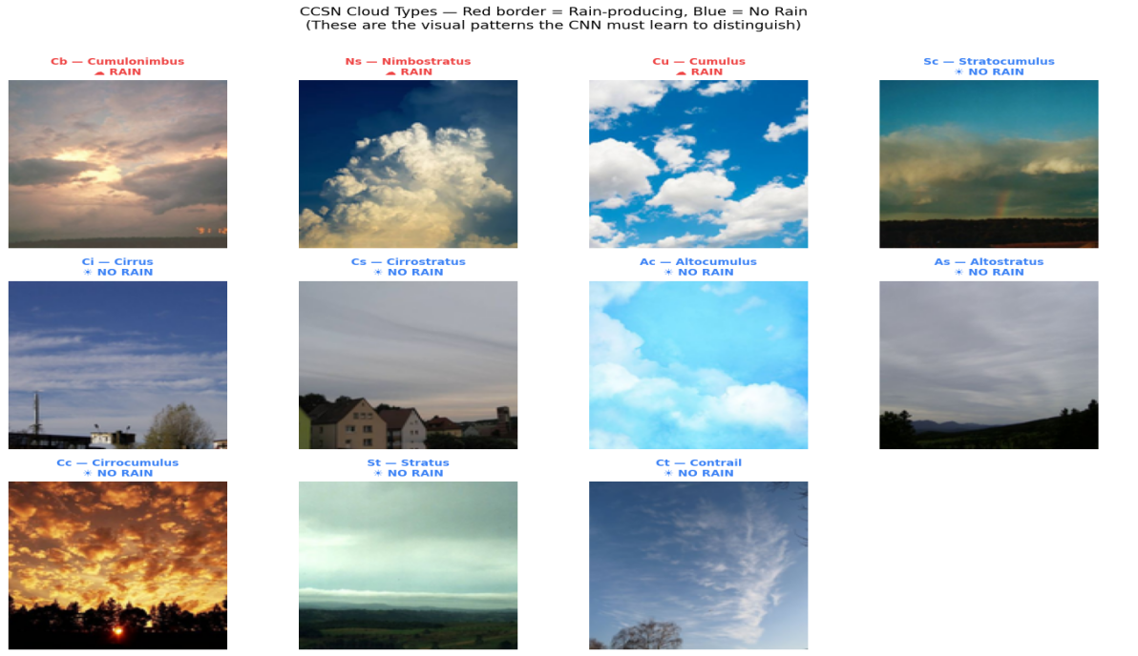
Figure 11: Sample images from each of the 11 CCSN cloud types. Red border = rain-producing, blue = no rain.

6.2 Architecture — Transfer Learning
MobileNetV2 pretrained on ImageNet provides the feature extractor (2.3M frozen parameters). A custom head is added: GlobalAveragePooling2D → Dense(128, ReLU) → Dropout(0.4) → Dense(1, Sigmoid). Training runs in two phases:
- Phase 1 (30 epochs max): only the classification head is trained. MobileNetV2 layers stay frozen. Early stopping monitors validation AUC.
- Phase 2 (20 epochs max, lr=1e-5): the top 30 MobileNetV2 layers are unfrozen and fine-tuned. These layers adapt from generic ImageNet features to cloud-specific textures and shapes.

Total parameters: 2,422,081. Trainable in Phase 1: 164,097 (the head only). Fine-tuned in Phase 2: 1,690,497.

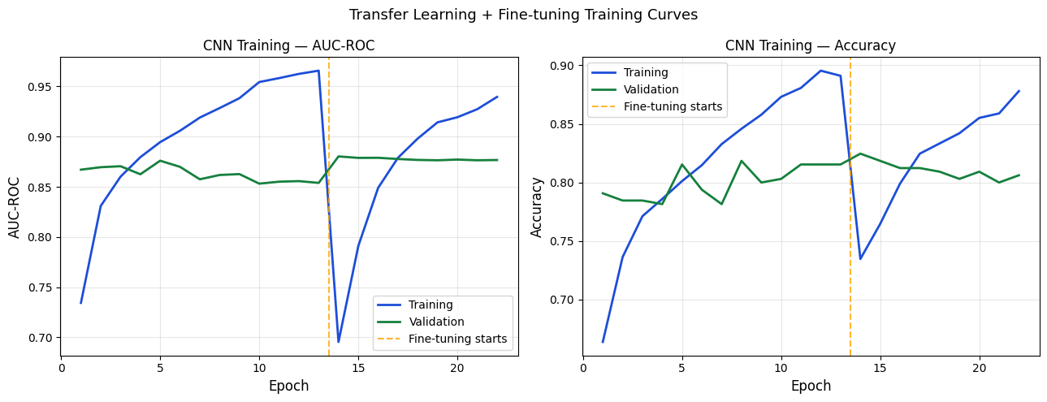
Figure 12: CNN training curves — AUC and Accuracy for Phase 1 and Phase 2. The dashed orange line marks where fine-tuning begins.

6.3 CNN Results
Model | Acc | Prec | Recall | F1 | AUC
CNN — MobileNetV2 | 0.791 | 0.630 | 0.581 | 0.604 | 0.820

The CNN achieved F1=0.604 and AUC=0.820 using only a 128×128 sky photograph — no humidity sensor, no pressure reading, no temperature measurement. Precision of 0.630 means 63% of Rain predictions were correct. Recall of 0.581 means the model correctly identified 58.1% of actual rainy sky images.

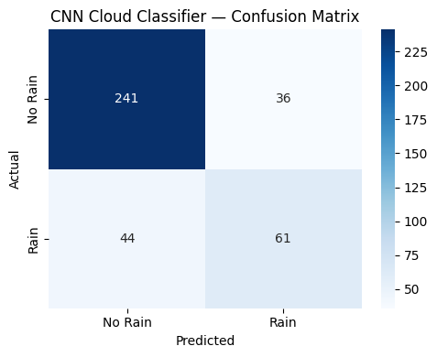
Figure 13: CNN confusion matrix on the 382-image test set.

6.4 Visual Patterns the CNN Learned
- Cumulonimbus: towering structure with bright white anvil top and dark base — the visual signature of intense convective uplift and heavy moisture
- Nimbostratus: dark, uniform, featureless grey covering the whole sky — a thick saturated moisture layer at multiple altitudes
- Cirrus: thin wispy white streaks against blue sky — high-altitude ice crystals too far from the surface to produce precipitation
- Stratocumulus: low lumpy rolls with gaps of lighter sky — the most common cloud type, usually no significant rain

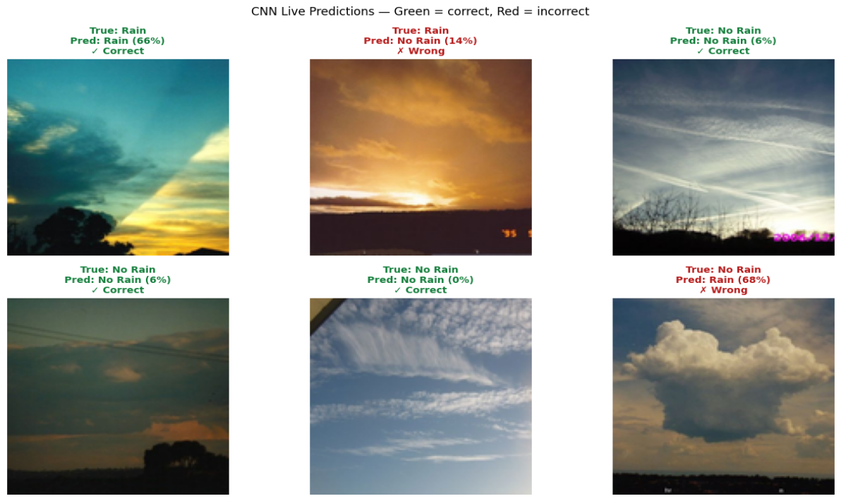
Figure 14: CNN live predictions on 6 random test images. Green border = correct, red = incorrect. Percentage = model confidence in Rain.

7. Comparative Evaluation

7.1 All Results
Model | Acc | Prec | Recall | F1 | AUC
Logistic Regression (default) | 0.806 | 0.530 | 0.804 | 0.639 | 0.881
SVM Linear (default) | 0.805 | 0.528 | 0.802 | 0.637 | 0.881
Gradient Boosting (default) | 0.800 | 0.541 | 0.714 | 0.615 | 0.854
Random Forest (default) | 0.793 | 0.527 | 0.730 | 0.612 | 0.851
LR (tuned) | — | — | — | 0.609 | 0.854
SVM (tuned) | — | — | — | 0.608 | 0.854
GB (tuned) | — | — | — | 0.628 | 0.862
RF (tuned) | — | — | — | 0.644 | 0.873
CNN — Cloud Images | 0.791 | 0.630 | 0.581 | 0.604 | 0.820
Naive baseline | 0.776 | — | — | 0.000 | 0.500

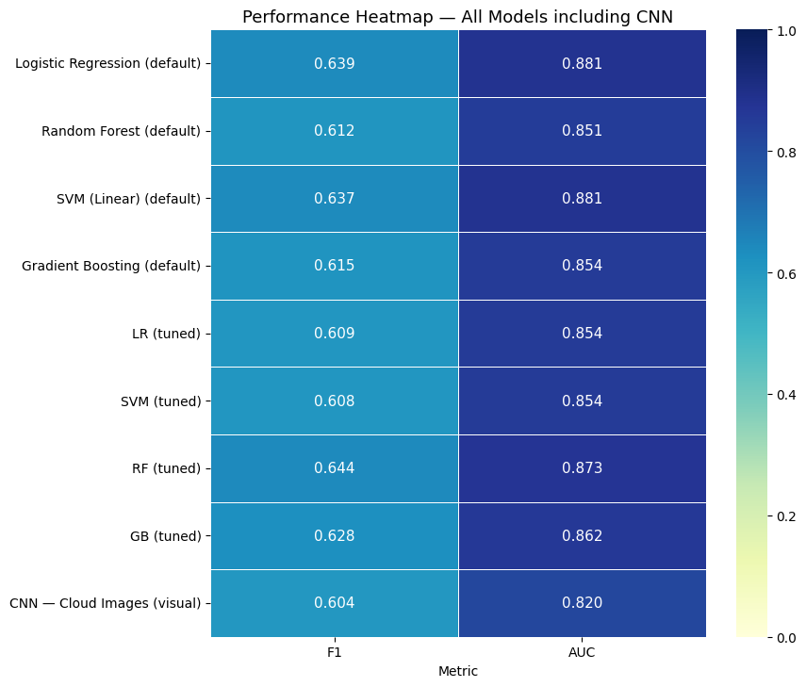
Figure 15: Final performance heatmap — all models and metrics. Darker = higher score. RF (tuned) wins on F1.

7.2 Why Logistic Regression Won Before Tuning
LR achieved the best default F1 (0.639) — the simplest model outperforming all ensemble methods. Three reasons explain this:
- The dominant weather predictors (Humidity3pm, Pressure9am, WindGustSpeed) have approximately straight-line relationships with rain probability. A linear model captures these as efficiently as any non-linear method.
- The ensemble models were depth-limited to prevent overfitting (max_depth=8 for RF, max_depth=3 for GB). These conservative settings prevented them from using their full capacity.
- class_weight='balanced' in LR provides a mathematically exact imbalance correction. The ensembles relied on SMOTE, which is a rougher approximation.

7.3 Why Random Forest Led After Tuning
After hyperparameter search, RF (F1=0.644) overtook LR (F1=0.609). The decisive change was max_depth=15 — increasing from 256 to 32,768 possible decision regions. This confirmed that non-linear conditional weather patterns do exist in the data and are learnable, but only when the model has enough capacity to find them. The tuning result validates the theoretical expectation that ensembles should outperform linear models on complex real-world data.

7.4 The Link Between Tabular and Visual Patterns
Convergence across two modalities
The tabular models found that Humidity3pm, Pressure9am, and WindGustSpeed are the strongest numerical predictors of rain. The CNN independently confirmed this through visual evidence: rain-producing clouds (Cumulonimbus, Nimbostratus) are visually dark and moisture-saturated — exactly the visual appearance of high humidity and low pressure. Two completely different inputs — 60 numbers from instruments and 49,152 pixels from a camera — both identified the same underlying meteorological reality.

8. Conclusion

8.1 Patterns Discovered
Six Pattern Recognition techniques found four distinct structures in the Australian weather data:
- Geographic structure (K-Means): Australia's 49 stations automatically grouped into tropical/desert and temperate coastal climate zones with different rain frequencies — found purely from data, no geographic knowledge used.
- Linear weather signature (LR and SVM): both linear models independently identified Humidity3pm, Pressure9am, and WindGustSpeed as the strongest rain predictors. These match established meteorological knowledge of frontal rainfall.
- Non-linear conditional patterns (RF and GB): after tuning, ensemble models with deeper trees captured interaction effects — combinations of conditions that are more predictive than any single feature alone.
- Visual cloud signatures (CNN): rain-associated clouds are visually distinct through their dark texture and moisture-saturated appearance, which the CNN learned to recognise from 1,836 training images.

8.2 Key Results
Model | Acc | Prec | Recall | F1 | AUC
Best default model: LR | 0.806 | 0.530 | 0.804 | 0.639 | 0.881
Best tuned model: RF | — | — | — | 0.644 | 0.873
CNN (visual only) | 0.791 | 0.630 | 0.581 | 0.604 | 0.820
Naive baseline | 0.776 | — | — | 0.000 | 0.500

All six techniques significantly exceeded the 77.6% naive baseline. The convergence of tabular and visual methods on the same meteorological signal — high humidity and low pressure correlate with both high F1 from sensors and dark saturated cloud textures in photos — is the strongest scientific result in the project. Two completely different Pattern Recognition paradigms independently discovered the same physical truth.

