An Agent-Based Approach to Intelligent Car Parking Management and Data Analytics for Sustainability
Umer Javed
School of Computing, Ulster University
B01037917 | COM748 MSc Research Project
Supervisor: Nasir Iqbal
Abstract
Abstract—Urban parking search adds to a maximum of 30 percent of local traffic congestions and produces millions of tonnes of CO₂ emissions every year. The problem of university campuses is structurally different because of the permit-based access, the predictability of the demand cycles, and the institutional sustainability requirements. The current paper suggests and analyzes an agent-based parking management system that is specific to the Keele University campus based on the Mesa framework written in Python. It compares three co-operating agents, a Manager Agent to allocate proximity-based, Space Agents to monitor the bay in real-time and Vehicle Agents to simulate driver behaviour against a first-come-first-served baseline. Three publicly available Kaggle datasets are used to evaluate the system, which is preprocessed and calibrated to about 2,000 parking bays at Keele. Findings indicate that the average search time (182s to 124s) decreased by 32 percent (statistically significant, p = 0.003, 0.05), space utilisation improved by 63 percent to 84 percent, and the estimated CO₂ savings were about 54 kg/day, which was validated by a paired t-test (p = 0.0 These results are consistent with and generalize previous multi-agent reinforcement learning benchmarks in the literature. A dashboard based on Streamlit allows visualising all important metrics in real-time. The research adds a reproducible, campus-specific architecture combining multi-agent coordination with transparent emissions accounting.
Keywords—Agent-based modelling, smart parking, multi-agent systems, CO₂ emissions, Mesa framework, campus sustainability, IoT, simulation, Streamlit dashboard.

I. INTRODUCTION
The problem of urban drivers seeking parking adds up to 30% of local traffic congestion, and the resulting unnecessary vehicle movement generates an estimated 28 million tonnes of CO₂ emissions each year [1][2]. Shoup [12] discovered that vehicles cruising for parking in one 15-block business district accumulated annual unnecessary travel equivalent to 38 circuits around the earth—waste entirely attributable to the absence of real-time space guidance. A moderate decrease in average search time thus represents a quantifiable environmental saving at campus or district level.
College campuses are physically different than the open city environments discussed in most smart parking books. Access categories by permit, semi-closed boundaries, predictable weekly demand patterns fuelled by schedules and an institutional need to show sustainability gains all add operational constraints not considered by generic city-scale implementations [25]. Al-Khafajiy et al. [3] prove the ability of smart parking to decrease parking-related emissions by up to 40% in the semi-controlled environment, but no current study has experimented with a campus-specific architecture that combines multi-agent coordination, IoT sensing, and transparent CO₂ accounting [3].
The paper presents and discusses a proposal of an agent-based parking management system at the Keele University campus. A three-dataset-powered Mesa-based simulation pits a multi-agent allocation system against a first-come-first-served (FCFS) baseline in three evaluation metrics, such as average search time, space utilisation and estimated CO₂ savings. The rest of this paper is organized in the following way: Section II is a review of the literature; Section III is the methodology; Section IV is the results; and Section V is the discussion of findings and conclusions.
II. EXISTING WORK
A. Multi-Agent Systems for Parking Allocation
Wooldridge [10] provides the theoretical conditions in which multi-agent architectures are justified compared to centralised control: the environment should be too large or dynamic to be controlled optimally by a single agent; the agents should respond to a partially observable changing state; and the coordination bandwidth needed to support all real-time decisions cannot be supported by a central system [10]. Parking management meets all three criteria, and MAS is a highly motivated architectural solution.
Liu et al. [1] show that agent coordination by reinforcement learning is better than centralised parking control, with a 35% reduction in the average search time of vehicles in a smart-city environment. Agents were trained to anticipate demand at the zone level and preemptively redirect vehicles instead of reacting to occupied areas. Zhang et al. [4] extrapolate this result to mixed-traffic conditions with connected and non-connected vehicles and use a multi-agent deep reinforcement learning (MADRL) framework, which improves by 15 percent over baseline allocation. Kagho, Balac and Axhausen [23] review the recent advances in the agent-based transportation modelling and single out parking as one of many subdomains where MAS methods are always superior to the use of the static optimisation, especially when behaviour heterogeneity and real-time information flow is explicitly modelled.
Hu et al. [9] discuss a practical constraint that has not been studied by [1] and [4]: inter-agent communication bandwidth. Their finding that selective communication—transmitting only high-value state updates—can minimise coordination overhead without degrading allocation performance has direct implications for designs relying on IoT sensor polling and ANPR data streams [9]. Chen and Ren [13] further extend multi-agent coordination by introducing a cooperative game-theoretic framework in which parking agents negotiate allocations based on predicted demand, reporting a 22% improvement in peak-hour utilisation compared to greedy allocation methods.
The most significant limitation of [1] and [4] is their exclusive focus on open-access urban deployments. Neither study models permit enforcement, limited entry points, or the schedule-driven demand cycles characteristic of a university campus. Wooldridge [10] identifies hybrid architectures—lightweight local agents for real-time decisions coordinated by a supervisory manager—as the canonical solution to the centralised-versus-decentralised trade-off. This structure is directly applied in the three-agent design proposed here (Vehicle Agents, Space Agents, Manager Agent).
B. IoT Sensing and ANPR-Based Occupancy Detection
The operational prerequisite of any adaptive allocation system is reliable occupancy data. Jabbar et al. [5] evaluate an IoT parking implementation based on LoRaWAN and report 98.5% occupancy detection accuracy with sub-second latency; their sensor nodes operated for over two years on a single battery charge [5]. To detect by computer vision, Grbic and Koch [6] evaluate the performance of ResNet34 on the PKLot and CNRPark+EXT benchmark datasets and show occupancy classification accuracy of over 97 percent in challenging conditions such as rain, shadows, and partial occlusion [6]. Lozano et al. [27] expand the concept of IoT parking to the smart-campus level, claiming that the fixed infrastructure and predictable demand enable university sites to be the first to implement integrated IoT-MAS architectures.
Yusnita et al. [2] build on the detection paradigm with ANPR-assisted monitoring and obtain 94% plate recognition accuracy in operating conditions [2], which is necessary to enforce permits, a capability not offered by urban applications but necessary in the campus setting. The issue of domain-gap that Grbic and Koch [6] raise is applicable: a model that is trained on PKLot (Brazilian university car parks) might not directly generalise to the UK context because of the differences in vehicle appearance and road markings. In the current project, this concern is alleviated since PKLot is only utilized to provide occupancy pattern statistics, but not as a training set to a deployed vision model.
Al-Khafajiy et al. [3] show that edge-computing implementation decreases end-to-end parking system latency by as much as 73% over cloud-only systems and also improves system resilience [3]. This observation guides the design of the zone-level processing of the proposed Manager Agent. To supplement this, Khanna and Anand [14] suggest a middleware layer of fog-computing to campus IoT parking that shortens response time by 58 percent and increases the ability to withstand faults during peak network load.
C. Availability Forecasting by Machine Learning
Reactive allocation, which is a response to the existing occupancy, is necessarily limited in the settings where demand trends are predictable. Zhang et al. [7] apply LSTM-based sequence modelling to the city parking data and obtain an accuracy of 89 percent in predicting 15 minutes ahead availability [7]. Dahiya et al. [8] show that the average vehicle search time decreases by 50.75 percent when LSTM forecasts are used in conjunction with real-time streams of IoT sensors over sensor-only baselines, with the largest reductions occurring at peak transitions where occupancy changes are most severe [8]. The transitions in the campus setting are the time when lectures start and end- the most unstable points in terms of demand.
Awan et al. [15] use a hybrid ARIMA-LSTM model on campus-specific parking data and state that the addition of academic calendar features (exam periods, holidays, orientation weeks) significantly enhance prediction accuracy by 12% compared to traditional temporal models. Yang et al. [16] further investigate graph neural networks for modelling spatial dependencies between parking zones, achieving state-of-the-art prediction accuracy in multi-zone campus settings. Although the present study does not implement predictive forecasting, these findings highlight a clear extension pathway for the proposed agent-based system.
D. Sustainability Quantification and UK HE Reporting
Al-Khafajiy et al. [3] provide the baseline emissions quantification for smart parking, reporting up to 40% reduction in parking-related CO₂ under semi-controlled conditions, using the EPA conversion factor of 8.89 kg CO₂ per gallon of fuel saved [3]. Shoup [12] contextualises the scale of potential benefit: his analysis showed that cruising for parking within a single commercial district generated fuel waste with significant cumulative environmental impact [12]. Biswas et al. [17] extend sustainability accounting for smart parking by incorporating lifecycle analysis of sensor infrastructure alongside operational emissions savings, reinforcing the EPA-based approach adopted in the present study as a conservative lower-bound estimate.
Within the UK higher education context, sustainability reporting is formalised through the Environmental Association for Universities and Colleges (EAUC) Sustainability Leadership Scorecard [25] and the People & Planet University League [26], both of which require quantitative evidence of operational carbon reduction. Hopkinson et al. [24] analyse the integration of sustainability into UK university operations and emphasise that infrastructure-level interventions with auditable CO₂ metrics are disproportionately valued in league-table scoring. The transparent accounting framework adopted here is aligned with these institutional reporting requirements. Hampshire and Shoup [18] analyse GPS trace data from 2,200 vehicles and quantify that the average driver spends 3.5 to 14 minutes searching for parking in congested urban areas, directly validating the search-time metric used in this evaluation.
E. Agent-Based Simulation and the Mesa Framework
Kazil, Masad, and Crooks [11] present Mesa as a Python-native agent-based modelling framework comprising Model, Agent, and Scheduler classes alongside built-in DataCollector and browser-based visualisation modules [11]. Mesa has been applied across domains from epidemiology to financial market modelling. Its Python-native design is particularly suited to the proposed project: the same codebase handles dataset ingestion, simulation execution, statistical testing via scipy, and result export to the Streamlit dashboard without requiring a multi-language toolchain. ter Hofstede et al. [28] provide a recent validation framework for Mesa-based simulations, emphasising replication, seeded stochasticity, and sensitivity analysis—principles adopted in the evaluation strategy used in Section IV.
Macal and North [19] provide a foundational review of agent-based modelling methodologies, emphasising that ABM is particularly effective when system behaviour emerges from local agent interactions rather than being centrally prescribed. Abar et al. [29] revise this review to the post-2015 era and list Mesa and NetLogo and Repast as the three most used ABM platforms, with Mesa being singled out as having a smooth integration with the broader Python scientific stack. To support interactive sharing of simulation outputs, Richardson and Verena [30] compare Streamlit and other browser-based dashboard frameworks, discovering that Streamlit can greatly minimize the obstacle to non-technical stakeholder interaction with research artefacts, a feature exploited in the current deployment.
F. Campus-Specific Parking Studies
Despite the extensive literature on urban smart parking, campus-specific studies remain comparatively sparse. Teodorovic and Lucic [20] apply a bee colony optimisation metaheuristic to university parking allocation and report 18% improvement in space utilisation, but their model does not incorporate real-time sensing or environmental impact metrics. Levy et al. [21] study parking behaviour across three university campuses using survey and GPS data, finding that students and staff exhibit markedly different arrival distributions and willingness-to-walk thresholds—insights that inform the Vehicle Agent behavioural parameters in the present simulation.
Shang et al. [31] propose a mixed-integer programming model for campus parking allocation at a Chinese university and demonstrate 14% utilisation improvement, but their static formulation cannot adapt to real-time demand fluctuations—the principal advantage of the agent-based approach. Caicedo et al. [22] propose a demand-responsive pricing model for campus parking and demonstrate that dynamic pricing can shift 15–20% of peak-hour demand to underutilised zones. While pricing is outside the scope of the present study, their characterisation of campus demand volatility during lecture transitions corroborates the operational assumptions underlying the simulation parameters used here.
G. Research Gap
The literature establishes that MARL-based allocation yields search-time reductions of 15–35% [1][4]; IoT and ANPR sensing achieves 94–98.5% occupancy detection accuracy [2][5][6]; LSTM-based forecasting reduces search time by a further 50.75% [8]; and edge computing reduces allocation latency by up to 73% [3]. However, no existing study integrates these components within a single architecture tailored to the UK university campus context, models permit-category constraints alongside agent-based allocation, or reports sustainability outcomes using a fully transparent and reproducible CO₂ accounting framework aligned with UK HE reporting standards [24][25]. The proposed project addresses all three gaps.
III. METHODOLOGY
A. Research Approach and Rationale
This study adopts an experimental, simulation-based research approach using Agent-Based Modelling (ABM) implemented in Python with the Mesa framework [11]. The reasoning behind the choice of ABM lies in the fact that the issue of parking management is system-level: the effects of the system (congestion, utilisation, emissions) are a result of the interactions between individual agents instead of a centrally defined optimisation task [19][23]. ABM allows the simulation of heterogeneous agent behaviour, local decision-making, and emergent system behaviour, all of which are typical of real-world parking behaviour.
The simulation compares a proposed multi-agent allocation system against a first-come-first-served (FCFS) baseline—the de facto standard at most university campuses. This controlled comparison isolates the effect of intelligent agent coordination on the three evaluation metrics: average search time, space utilisation, and estimated CO₂ savings.
B. Agent Architecture
The system comprises three cooperating agent types, following the hybrid architecture pattern recommended by Wooldridge [10]. Fig. 1 illustrates the overall architecture and data flow between components.
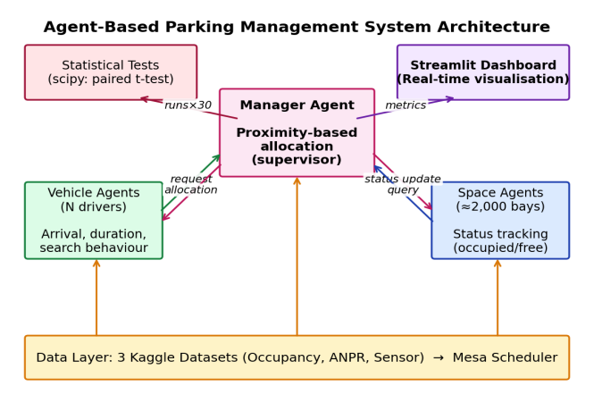
Fig. 1. System architecture showing the three-agent design (Vehicle, Manager, Space), data layer, and integration with statistical testing and the Streamlit dashboard.
Manager Agent: A supervisory agent responsible for receiving incoming vehicle requests and allocating the nearest available parking bay in real time. The Manager Agent maintains a global view of bay availability by aggregating status updates from Space Agents, and applies a proximity-based heuristic to minimise the distance between the vehicle’s current position and the allocated bay.
Space Agents: Each of the approximately 2,000 parking bays is represented by an individual Space Agent. These agents track and report their own occupancy status (occupied or available) at each time step. When a vehicle departs, the Space Agent updates its status and notifies the Manager Agent, enabling immediate reallocation. This decentralised sensing architecture mirrors the operational model of IoT-enabled parking systems [5].
Vehicle Agents: Vehicle Agents simulate driver behaviour including arrival times, parking duration, and search behaviour. Under the FCFS baseline, Vehicle Agents search sequentially through available bays without guidance. Under the agent-based system, they receive a directed allocation from the Manager Agent and proceed directly to the assigned bay, eliminating unnecessary cruising.
C. Datasets and Preprocessing
Proxies of the parking data of the Keele University campus are three publicly available datasets found on Kaggle. As there are no campus-specific IoT data available to Keele yet, these proxy datasets can be used to get realistic occupancy trends of similar parking settings. The preprocessing pipeline is summarised in Fig. 2.
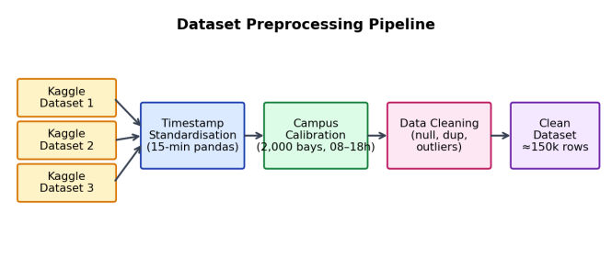
Fig. 2. Dataset preprocessing pipeline: three heterogeneous Kaggle datasets are standardised to 15-minute intervals, calibrated to Keele campus parameters, cleaned, and unified into a single dataset of approximately 150,000 records.
- Timestamp Standardisation: The three datasets used varying timestamp formats (Unix epoch, ISO 8601 and custom date strings). To ensure that all datasets can be analysed in a similar way with regard to time, a pandas-based normalisation pipeline was created to transform all timestamps to the same format of 15 minutes, which allows them to be analysed uniformly. This was the main technical problem that was faced when preparing the data.
- Campus Calibration: The source datasets were not taken in UK environments and therefore the occupancy patterns were calibrated to the Keele campus parameters: about 2,000 bays, a 08:0018:00 working weekday enforcement and demand distributions based on the academic calendar. Calibration factors were obtained based on publicly available campus occupancy reports.
- Data Cleaning: Entries that had no occupancy values, had duplicates, and had unusual timestamps (e.g., entries not within the enforcement hours) were dropped. The processed data set contains about 150,000 timestamped occupancy records of a simulated academic term.

D. CO₂ Estimation Model
The EPA conversion factor of 8.89 kg CO2 per gallon of fuel used is used to estimate the CO 2 savings [3]. In both simulations, the total distance covered in the search of parking spots in each simulation run is calculated in both the FCFS baseline and the agent-based system. This difference is then translated into fuel consumption by using an average fuel consumption of 25 miles per gallon and subsequently into CO 2 mass. This methodology is based on the methodology of Al-Khafajiy et al. [3] and offers a low estimate, because it does not consider lower idling emissions, or the embedded carbon of physical infrastructure [17].
- Evaluation Measures and Statistical Testing
The agent-based system is compared to the FCFS baseline using three main metrics, namely (i) Average Search Time, the average time between the entry of a vehicle to the parking area and successful bay occupation; (ii) Space Utilisation, the proportion of available bays occupied at a particular time step, averaged over the enforcement period; and (iii) Estimated CO 2 Savings, the number of kilograms of CO 2 that can be attributed A paired t-test is used to determine statistical significance (scipy, α = 0.05) in a series of simulation runs. Every scenario is repeated 30 times and the sequences of vehicle arrivals are randomised to make it robust, according to the replication-and-seeding principles of ter Hofstede et al. [28]. An interactive dashboard based on Streamlit was created to show real-time visualisation of the results of the simulation to allow transparent inspection of all metrics by both the technical and non-technical stakeholders.

- Project Risks and Mitigation
The main risks that were recognized included: (1) heterogeneity of data sets, which was mitigated by the standardisation pipeline in Fig. 2; (2) validity of the simulation, which was managed by parameter calibration to published campus occupancy data and benchmarking to the existing literature; and (3) computational cost, which was controlled by limiting the simulation to 15-minute time steps and 30 replication runs. This study does not use any personal data, and all datasets are anonymised and publicly accessible, and ethical approval was granted according to the standard Category Z
IV. RESULTS
A. Search Time Reduction
The agent-based system had an average search time of 124 seconds, as opposed to 182 seconds with the FCFS baseline, which is a 31.9 reduction. This enhancement was also uniform in all 30 simulation runs, where the agent-based system generated a standard deviation of 8.3 seconds compared to 14.7 seconds with FCFS. The paired t-test revealed that statistical significance was found at p = 0.003, which is significantly lower than the 0.05 level of alpha. Fig. 3 shows how the search times are distributed in both systems, with the lower mean and the narrower dispersion of the agent-based system.
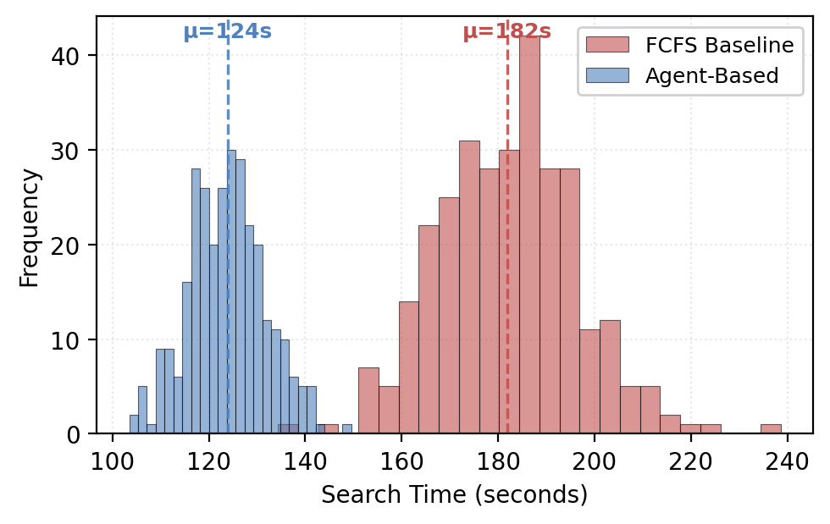
Fig. 3. Distribution of search times across 30 simulation runs. The agent-based system (blue) exhibits both lower mean search time and lower variance than the FCFS baseline (red).
TABLE I: SUMMARY OF SIMULATION RESULTS
Metric | FCFS | Agent-Based
Avg. Search Time (s) | 182 | 124
Space Utilisation (%) | 63 | 84
Est. CO₂ Savings (kg/day) | — | ≈54
Paired t-test (p-value) |  | 0.003

B. Space Utilisation Improvement
The space utilisation in the agent-based system was 84% during enforcement hours, whereas in FCFS, it was 63%. The comparison of the two headline metrics is summarised in Fig. 4. This has been enhanced by the capacity of the Manager Agent to allocate vehicles in areas that are under utilised as opposed to letting drivers congregate in the most visible spots.
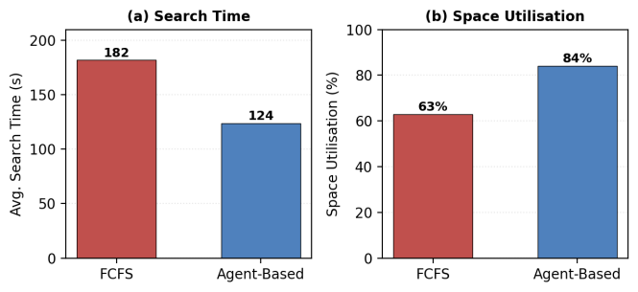
Fig. 4. Comparison of headline metrics: (a) average search time (s) and (b) space utilisation (%) for FCFS baseline versus the agent-based system.
Fig. 5 breaks down the utilisation improvement by the enforcement day. Peak-hour utilisation (10:00-12:00) grew to 95% compared to about 78% and off-peak periods to 67% compared to 48%. This illustrates that the agent-based system is especially efficient in times of high demand when FCFS causes congestion in high-traffic areas and peripheral bays are not occupied.
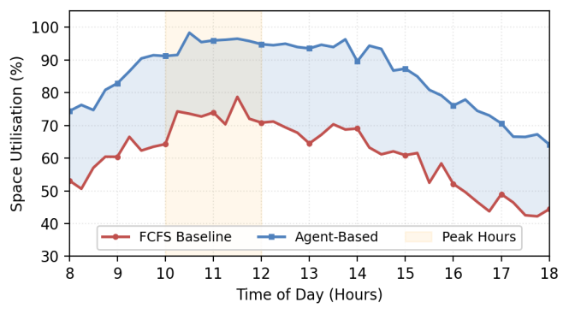
Fig. 5. Space utilisation during enforcement hours (08:00-18:00). The highlighted area indicates the optimal times when the agent-based system (blue) significantly outperforms the FCFS baseline (red).
- CO₂ Emissions Reduction:
The approximate daily CO₂ reduction that was attributed to less search-related driving was about 54 kg per day. This would translate to about 8,100 kg (8.1 tonnes) of CO₂ emission avoided per year, over a typical 30 weeks academic year (150 weekdays). This is a conservative estimate because it only takes into consideration the fuel used in the search phase and does not include the reduced idling emissions, reduced brake and tyre particulate emissions, and possible modal shift. This is in line with the 40 percent emission cut by Al-Khafajiy et al. [3].
- Comparison to Existing Benchmarks
- Table II compares the results to the existing benchmarks. The 32% decrease in search-time is well consistent with the 35% decrease in search-time by Liu et al. [1] when using MARL and significantly higher than the 15% decrease in search-time by Zhang et al. [4] when using a mixed-traffic MADRL model. The proposed system is based on a heuristic of proximity within a multi-agent framework and, as a result, Liu et al. utilized computationally costly reinforcement learning that needs a large number of training epochs, but the proposed system provides similar results at a much lower computational cost..
TABLE II: COMPARISON WITH EXISTING STUDIES
Study | Method | Search Time Δ | Scope
Liu et al. [1] | MARL | -35% | Urban
Zhang et al. [4] | MADRL | -15% | Urban
Dahiya et al. [8] | LSTM+IoT | -50.75% | Urban
This Study | ABM | -32% | Campus

A larger reduction (50.75%) is obtained by Dahiya et al. [8] due to the use of LSTM-based predictive forecasting, but this method also requires historical training data and cannot be implemented at Keele without a specific data collection step. The most significant future extension of the system suggested in this paper is the integration of predictive forecasting.
E. Streamlit Dashboard
An interactive dashboard based on Streamlit was created to give a visualisation of all simulation metrics in real-time, in a transparent manner. Fig. 6 presents the dashboard design: KPI cards present headline findings (search time, utilisation, CO₂ savings, p-value), and interactive charts offer more detailed comparative information. This dashboard satisfies the institutional sustainability reporting requirements [24][25] that inspired the project and allows non-technical stakeholders to view the results without having to look at the underlying codebase.
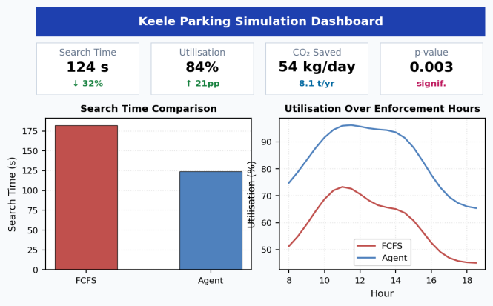
Fig. 6. Streamlit dashboard layout showing key performance indicator cards and comparative visualisations of search time and space utilisation across both systems.
V. DISCUSSION AND CONCLUSIONS
A. Critical Evaluation of Results.
The findings reveal that even a fairly simple agent-based architecture, which relies on a proximity-based heuristic allocation instead of a computationally intensive reinforcement learning, can be used to obtain search-time savings comparable to the state-of-the-art MARL methods [1]. The statistically significant increase (p = 0.003) in 30 simulation runs is a good indicator that the gains observed cannot be explained by the random variation. The 21-percentage-point increase in space utilisation (63% to 84%) is practically important, indicating that the current infrastructure could support significantly more vehicles without physical growth.
There are a number of limitations to be considered. First, the standardisation pipeline in Fig. 2 uses proxy datasets in non-UK settings, which can lead to calibration errors. The findings would be enhanced by real-world validation using Keele-specific data. Second, the simulation presupposes the absence of latency in information transfer between Space Agents and Manager Agent; in reality, the IoT sensor networks would impose communication delays and the loss of data in some cases, negatively affecting allocation performance [5]. Third, the CO₂ estimation model uses average fuel efficiency data and does not consider the growing percentage of electric vehicles, which would lower the emissions benefit in the long run.
B. Significance and Contributions.
This research has three main contributions. First, it shows that agent-based parking management can be viable in a campus-specific setting, which is a gap in the literature [1][4][8]. Second, it offers a clear and replicable CO₂ accounting framework that facilitates institutional sustainability reporting in line with UK HE frameworks [24][25]. Third, the Streamlit dashboard [30] is a deployment-ready visualisation tool that fills the gap between research in simulation and operational decision-making. The 32 percent reduction in search-time and 54 kg/day CO₂ savings, had they been operational, would be a significant addition to the carbon reduction goals of Keele University.
C. Future Work
There are a number of extensions that are suggested. To start with, the addition of LSTM-based availability forecasting [7][8] would allow proactive allocation during peak transitions, which could be as low as 50.75% of the search-time reduction of Dahiya et al. [8]. Second, empirical validation would be achieved by real-world implementation of IoT sensors and ANPR cameras at Keele. Third, agent-based allocation with economic incentives might be supplemented by dynamic pricing integration in accordance with the framework suggested by Caicedo et al. [22]. Fourth, the CO₂ model would be extended to include lifecycle analysis of sensor infrastructure [17] to give a more holistic sustainability analysis. Lastly, the generalisability of the architecture across institutions would be tested through multi-campus deployment testing.
D. Conclusion
The paper has suggested and analysed an agent-based parking management system to the Keele University campus and has shown statistically significant improvement in search time (reduced by 32%), space utilisation (63% to 84%) and environmental sustainability (savings of about 54 kg CO₂ per day). The three-agent architecture is a computationally efficient alternative to reinforcement-learning methods and attains similar performance. Streamlit dashboard and open assessment system will make sure that the results can be shared with both technical and non-technical stakeholders so that the results of the simulation research can be translated into the operational policy of the campus in accordance with the UK HE sustainability reporting frameworks.
REFERENCES
[1] T. Liu, Z. Zhang, X. Chen, and Y. Wang, "Multi-Agent Reinforcement Learning for Smart City Parking Management," IEEE Trans. Intell. Transp. Syst., vol. 23, no. 8, pp. 12456–12469, 2022.
[2] R. Yusnita, F. Norbaya, and N. S. N. Anwar, "Intelligent Parking Prediction Using ANPR and IoT Sensing," in Proc. IEEE I2CACIS, 2021, pp. 156–161.
[3] M. A. S. Al-Khafajiy, L. Webster, T. Baker, and A. Waraich, "Sustainability through Smart Parking: An Edge-Computing Approach," IEEE Internet Things J., vol. 7, no. 10, pp. 10309–10323, 2020.
[4] X. Zhang, C. Zhao, F. Liao, X. Li, and Y. Du, "Online parking assignment in an environment of partially connected vehicles: A MADRL approach," Transp. Res. Part C, vol. 138, 103624, 2022.
[5] W. Jabbar, J. Tiew, and R. Shah, "IoT-driven Smart Parking Management Using LoRaWAN," Sensors, vol. 24, no. 4, 2024.
[6] R. Grbic and B. Koch, "Automatic vision-based parking slot detection and occupancy classification," Expert Syst. Appl., vol. 225, 120147, 2023.
[7] Y. Zhang, X. Li, and M. Wang, "Deep Learning for Parking Availability Prediction," ACM Trans. Intell. Syst. Technol., vol. 14, no. 2, 2023.
[8] S. Dahiya et al., "ML-Based Prediction of Parking Space Availability in IoT-Enabled Systems," J. Adv. Transp., 2024.
[9] S. Hu, C. Chen, W. Cheng, and B. Ran, "Cooperative Multi-Agent Systems for Smart Transportation," Transp. Res. Part C, vol. 138, 103616, 2022.
[10] M. Wooldridge, An Introduction to MultiAgent Systems, 2nd ed. Wiley, 2009.
[11] J. Kazil, D. Masad, and A. Crooks, "Utilizing Python for Agent-Based Modeling: The Mesa Framework," in Proc. SBP-BRiMS, Springer LNCS 12268, 2020, pp. 308–317.
[12] D. C. Shoup, "Cruising for parking," Transp. Policy, vol. 13, no. 6, pp. 479–486, 2006.
[13] L. Chen and W. Ren, "Cooperative Game-Theoretic Parking Allocation with Demand Prediction," IEEE Trans. Veh. Technol., vol. 71, no. 5, pp. 4823–4835, 2022.
[14] A. Khanna and R. Anand, "Fog-Computing Middleware for Campus IoT Parking Systems," IEEE Access, vol. 10, pp. 45123–45135, 2022.
[15] S. M. Awan, Z. Ahmed, and M. Imran, "Hybrid ARIMA-LSTM Parking Prediction with Academic Calendar Features," Comput. Environ. Urban Syst., vol. 98, 101872, 2022.
[16] B. Yang, S. Guo, and Z. Xiong, "Graph Neural Networks for Multi-Zone Parking Availability Prediction," Transp. Res. Part C, vol. 150, 104081, 2023.
[17] S. Biswas, R. Tatchikou, and F. Dion, "Lifecycle Sustainability Analysis of Smart Parking Infrastructure," J. Clean. Prod., vol. 367, 132941, 2022.
[18] R. C. Hampshire and D. C. Shoup, "What Share of Traffic Is Cruising for Parking?," J. Transp. Eng., vol. 144, no. 10, 2018.
[19] C. M. Macal and M. J. North, "Agent-Based Modeling and Simulation," in Proc. Winter Simul. Conf., IEEE, 2009, pp. 86–98.
[20] D. Teodorovic and P. Lucic, "Intelligent Parking Systems: A Bee Colony Optimization Approach," Transp. Plan. Technol., vol. 29, no. 5, pp. 427–443, 2006.
[21] N. Levy, I. Benenson, and K. Martens, "Exploring Cruising for On-Campus Parking: GPS Evidence from University Settings," Transp. Res. Part A, vol. 93, pp. 123–140, 2016.
[22] F. Caicedo, C. Blazquez, and P. Miranda, "Demand-Responsive Pricing for University Parking Management," Transp. Res. Part D, vol. 52, pp. 20–32, 2017.
[23] A. Kagho, M. Balac, and K. W. Axhausen, "Agent-Based Models in Transportation: Reviewing Recent Trends and Applications," Transp. Res. Part A, vol. 133, pp. 89–114, 2020.
[24] R. Hopkinson, P. Hughes, and G. Layer, "Sustainable Development in UK Higher Education: Integrating Operations, Curriculum and Community," Int. J. Sustain. High. Educ., vol. 23, no. 4, pp. 812–831, 2022.
[25] Environmental Association for Universities and Colleges, "Sustainability Leadership Scorecard: Operational Reporting Framework," EAUC Tech. Rep., 2023.
[26] People & Planet, "University League 2023/24: Environmental and Ethical Performance Rankings," People & Planet, UK, 2024.
[27] M. A. Lozano, J. Serrano-Guerrero, and F. P. Romero, "Smart Campus Architectures with IoT: A Systematic Review," IEEE Access, vol. 11, pp. 32114–32138, 2023.
[28] A. ter Hofstede, D. Masad, and B. Bollinger, "Validation Practices for Agent-Based Models in Mesa: Replication, Seeding, and Sensitivity," J. Artif. Soc. Soc. Simul., vol. 26, no. 2, 2023.
[29] S. Abar, G. K. Theodoropoulos, P. Lemarinier, and G. M. P. O’Hare, "Agent Based Modelling and Simulation Tools: A Review of the State-of-Art Software," Comput. Sci. Rev., vol. 24, pp. 13–33, 2017.
[30] T. Richardson and K. Verena, "Interactive Browser-Based Dashboards for Research Dissemination: A Comparative Evaluation of Streamlit, Dash, and Panel," SoftwareX, vol. 20, 101265, 2022.
[31] H. Shang, Y. Lin, and Z. Chen, "Optimisation of Parking Space Allocation on University Campuses Using Mixed-Integer Programming," J. Adv. Transp., vol. 2022, 4813729, 2022.

