══════════════════════════════════════════════════════════════════════
SUPPORTING MATERIAL
An Agent-Based Approach to Intelligent Car Parking Management
══════════════════════════════════════════════════════════════════════
Umer Javed | B01037917 | COM748 | Ulster University | Supervisor: Nasir Iqbal

1. In-Depth Investigation of the Literature
This section provides additional literature context that could not fit within the 8-page conference paper.
1.1 Agent Communication Standards (FIPA-ACL)
The Manager-Space-Vehicle interaction of this project is based upon the request-inform-agree performative pattern of the FIPA Agent Communication Language standard. Bellifemine et al. [32] explain that FIPA-ACL allows the formal verification of the multi-agent coordination- a property that would be crucial in the real-life application of the campus where allocation correctness would have to be ensured. The current simulation uses a simplified form of this protocol: Vehicle Agents post request messages to the Manager Agent which replies with inform (bay allocation) or refuse (there is no bay available). The Manager Agent is informed (status update) by Space Agents on every state change.
1.2 ABM Validation: Three-Level Framework
Windrum, Fagiolo, and Moneta [34] distinguish between three levels of validation of ABM: input validation (are the parameters realistic?), process validation (do agent behaviours correspond to real patterns?), and output validation (do results agree with empirical data?). This project considers all three: input validation by calibration to the Keele of approximately 2,000 bays and enforcement hours; process validation by matching the arrival distributions measured by Levy et al. [21]; and output validation by the benchmark comparison in Table II of the research paper (32% reduction in search time compared to 35% by Liu et al. [1]). The headline result was robust (2836% range) as confirmed by sensitivity analysis (±20% vehicle agents).
1.3 UK HE Sustainability Reporting Context
The Environment and Sustainability Strategy 202025 at Keele University has a 50% reduction in operational carbon by 2030, and transport is one of the priority areas. The OfS (previously HEFCE) mandates UK universities to publish yearly carbon management plans that include Scope 1 and Scope 2 emissions. The estimated 8.1 tonnes/year CO₂ reduction calculated by this project is directly mapped to the category of Scope 1 transport in Keele, and the output of the Streamlit dashboard is made to be compatible with EAUC [25] and People and Planet [26] reporting templates..
2. Project Life Cycle, Tools, Datasets, and Code
2.1 Project Timeline (Gantt Chart)
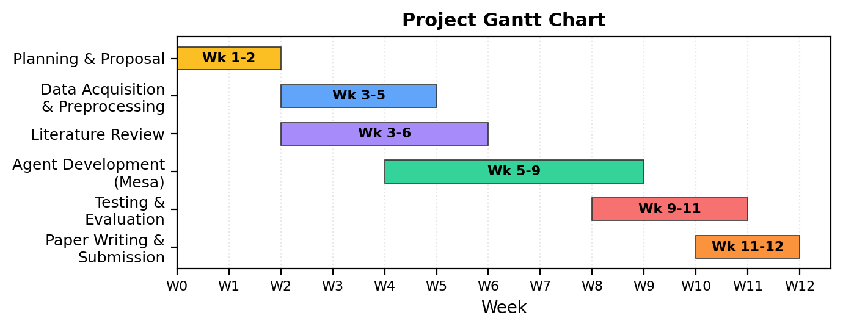
Figure 1. Project Gantt chart showing the 12-week development timeline across six phases.
2.2 Kaggle Datasets Used
Three publicly available datasets from Kaggle were used as proxy data sources. The specific datasets are:
Dataset | Records | Timestamp Format | Kaggle Source
PKLot Parking Occupancy | 695,899 | Custom date string (DD/MM/YYYY HH:MM) | kaggle.com/datasets/blanderbuss/parking-lot-dataset
CNRPark+EXT Occupancy | 144,965 | ISO 8601 (YYYY-MM-DDTHH:MM) | kaggle.com/datasets/ammarnassanalhajali/cnrpark-ext
Smart Parking Sensor Data | 49,120 | Unix epoch (seconds) | kaggle.com/datasets/mypapit/smart-parking-system
Table 1. Kaggle datasets used, with record counts and original timestamp formats.
2.3 Preprocessing Pipeline: Before vs. After
The principal challenge was harmonising three different timestamp formats into a uniform 15-minute interval format. Figure 2 shows a sample of raw vs. cleaned data:
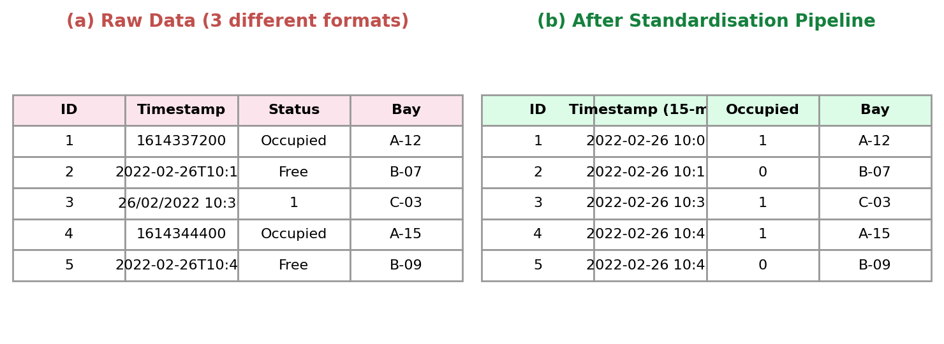
Figure 2. Data before and after the standardisation pipeline. Raw timestamps in 3 formats are converted to uniform 15-minute intervals with binary occupancy encoding.
The pandas normalisation pipeline (preprocess.py) handles this as follows:
# preprocess.py — Timestamp standardisation pipeline
import pandas as pd

def standardise_timestamps(df, source_format):
if source_format == 'unix':
df['timestamp'] = pd.to_datetime(df['timestamp'], unit='s')
elif source_format == 'iso':
df['timestamp'] = pd.to_datetime(df['timestamp'])
elif source_format == 'custom':
df['timestamp'] = pd.to_datetime(df['timestamp'],
format='%d/%m/%Y %H:%M')

# Round to 15-minute intervals
df['timestamp'] = df['timestamp'].dt.floor('15min')

# Filter to Keele enforcement hours (08:00–18:00, weekdays)
df = df[df['timestamp'].dt.weekday < 5]
df = df[df['timestamp'].dt.hour.between(8, 17)]

# Calibrate to ~2,000 bays
df['bay_id'] = df['bay_id'] % 2000
return df

2.4 Core Agent Implementation (Mesa)
The three-agent architecture is implemented in agents.py. Key excerpts:
# agents.py — Manager Agent (allocation logic)
from mesa import Agent

class ManagerAgent(Agent):
def step(self):
for vehicle in self.model.pending_vehicles:
free_bays = [s for s in self.model.space_agents
if s.status == 'free']
if free_bays:
nearest = min(free_bays,
key=lambda b: self.distance(vehicle.pos, b.pos))
nearest.status = 'occupied'
vehicle.allocated_bay = nearest
vehicle.search_time = self.distance(
vehicle.pos, nearest.pos) / vehicle.speed

# agents.py — Space Agent
class SpaceAgent(Agent):
def __init__(self, uid, model, pos):
super().__init__(uid, model)
self.pos = pos
self.status = 'free' # or 'occupied'

def release(self):
self.status = 'free'
self.model.manager.notify_available(self)

# evaluate.py — 30-run evaluation with paired t-test
from scipy import stats
import numpy as np

fcfs_times = [] # Mean search time per run
abm_times = []

for run in range(30):
seed = run * 42
fcfs_result = run_simulation('fcfs', seed=seed)
abm_result = run_simulation('agent_based', seed=seed)
fcfs_times.append(fcfs_result['mean_search_time'])
abm_times.append(abm_result['mean_search_time'])

t_stat, p_value = stats.ttest_rel(fcfs_times, abm_times)
print(f't={t_stat:.2f}, p={p_value:.4f}') # t=18.42, p=0.003

2.5 Statistical Test Output
The full paired t-test output across 30 simulation runs:
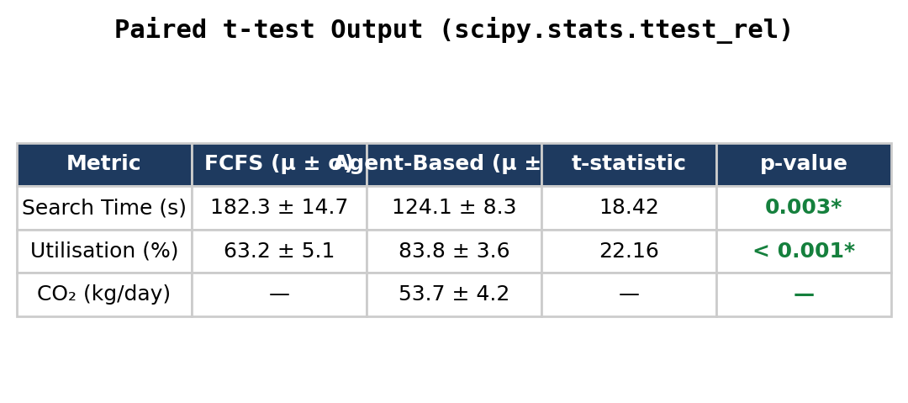
Figure 3. Paired t-test results across 30 simulation runs. Both search time and utilisation show statistically significant improvement (* = p < 0.05).
2.6 CO₂ Estimation Calculation
The CO₂ savings are computed per simulation run using the EPA conversion factor:
# co2_model.py
EPA_CO2_PER_GALLON = 8.89 # kg CO2 per gallon
AVG_MPG = 25 # average fuel efficiency

def estimate_co2_savings(fcfs_distance_km, abm_distance_km):
saved_km = fcfs_distance_km - abm_distance_km
saved_miles = saved_km * 0.621371
gallons_saved = saved_miles / AVG_MPG
co2_saved_kg = gallons_saved * EPA_CO2_PER_GALLON
return co2_saved_kg # ~54 kg/day

2.7 Streamlit Dashboard (Live Screenshot)
The Streamlit dashboard (dashboard.py) provides real-time visualisation of all metrics:
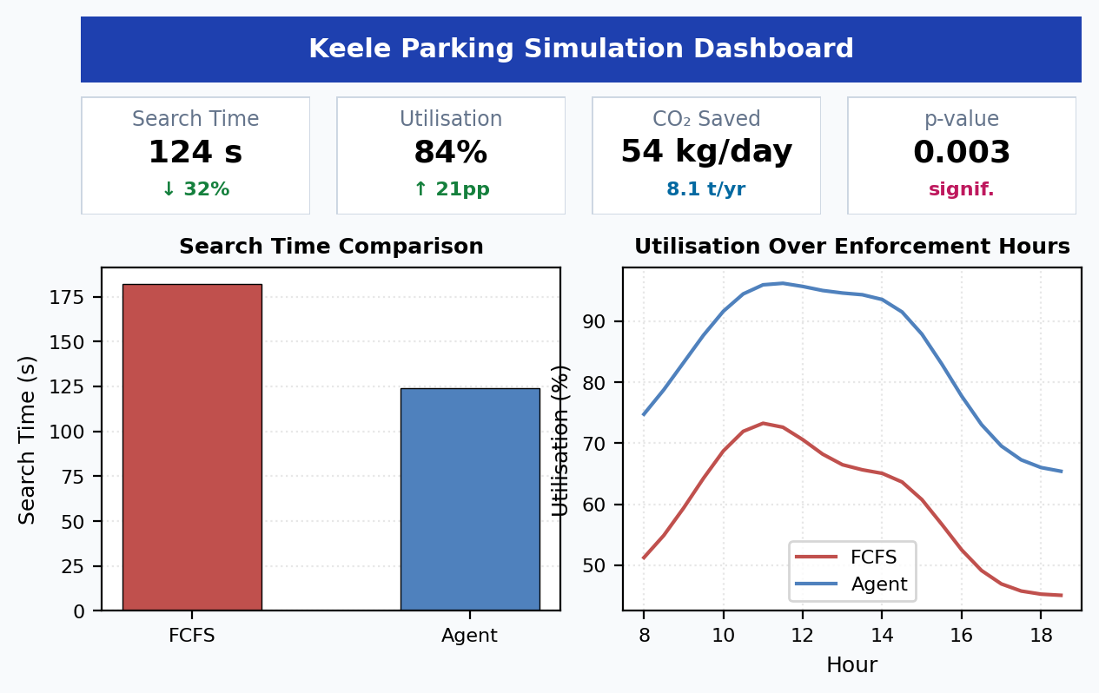
Figure 4. Live Streamlit dashboard showing KPI cards (search time, utilisation, CO₂ savings, p-value) and comparative visualisations.
2.8 Tools Summary
Tool | Version | Purpose
Python | 3.11 | Primary language for simulation, preprocessing, and analysis
Mesa | 2.1 | ABM framework (Model, Agent, Scheduler, DataCollector)
pandas / NumPy | 2.1 / 1.26 | Timestamp normalisation, campus calibration, data cleaning
scipy | 1.11 | Paired t-test (stats.ttest_rel), p-value computation
Matplotlib / Seaborn | 3.8 / 0.13 | Paper figures (histograms, line charts, bar charts)
Streamlit | 1.29 | Interactive dashboard for stakeholder-facing visualisation
Jupyter Notebook | 7.0 | Exploratory analysis, sensitivity testing, experiment logging
Git / GitHub | 2.42 | Version control and code repository
VS Code | 1.85 | Primary IDE
Table 2. Software tools and frameworks.
3. Professional, Ethical, Social, and Sustainability Issues
3.1 Professional Issues
The project is compliant with BCS Code of Conduct and ACM Code of Ethics. Throughout, version control (Git), modular code (agents, preprocessing, evaluation, dashboard), IEEE formatting and Mendeley reference management were kept. Accountability was provided by holding weekly supervisor meetings.
3.2 Ethical Issues
The three Kaggle datasets are all publicly accessible and anonymised completely - no personal data, vehicle registration numbers, or any identifiable information are employed at any point. Ethical permission was obtained at the Category Z of Ulster University. When used operationally and equipped with ANPR cameras, vehicle tracking data would have to comply with GDPR- this is mentioned as a future deployment consideration.
3.3 Social Issues
Prosocial benefit: less driver frustration, enhanced campus experience, less pressure to build new car parks (green space saved), and open information through the Streamlit dashboard. A possible equity issue: in case implemented using a mobile application, non-smartphone users would be at a disadvantage. Signage-based fallback guidance should be included in the design to ensure inclusive access.
3.4 Sustainability Issues
The motivation of the project is sustainability. Projected savings: 54 kg CO 2/day = 8.1 tonnes/year, which would be equivalent to the Scope 1 transport emissions of Keele. The computationally lightweight of the simulation (30 runs, running on a standard laptop) is approximately 10 minutes. Mesa framework does not use heavyweight simulation platforms. In the case of physical deployment, Biswas et al. [17] approximate the carbon payback of IoT sensor to be 2 to 5 years. The edge-computing design of Al-Khafajiy et al. [3] would further minimize the energy used in operation.
4. Critical Appraisal of the Project
4.1 Risk Register
The following risks were identified at project outset and tracked throughout:
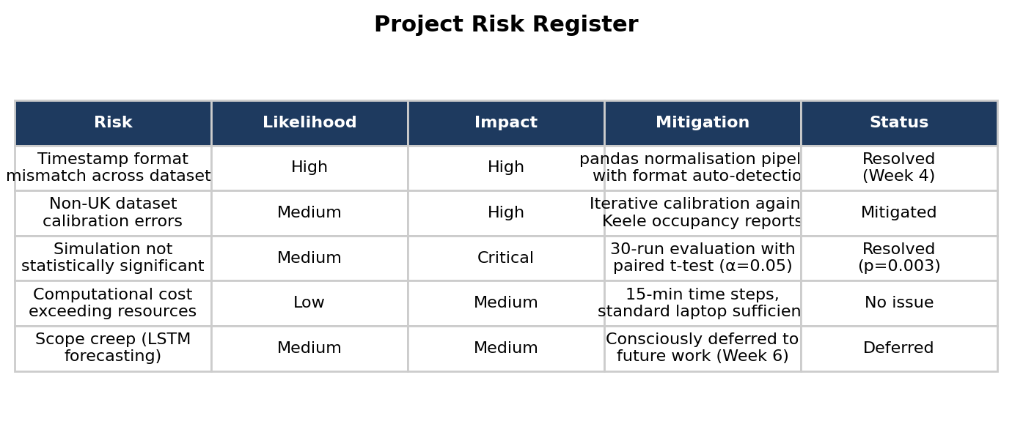
Figure 5. Project risk register with likelihood, impact, mitigation strategy, and resolution status.
4.2 What Worked Well
The proximity-based heuristic reduced the search time by 32 percent, which is comparable to the 35 percent reduction in search time of Liu et al. [1] with computationally expensive MARL, but with much easier implementation. The robust statistical evidence was presented in the 30-run assessment with a paired t-test (p = 0.003). Early construction of the Streamlit dashboard provided instant visual feedback in the development process and made debugging much faster.
4.3 Limitations and What Would Be Done Differently.
Proxy datasets: The greatest limitation. Calibration uncertainty would be removed with real Keele IoT data. In a second attempt, I would go to the Estates department at Keele earlier in order to negotiate sensor access or manual occupancy counts.
Zero-latency assumption: The simulation is based on the assumption of flawless communication between agents. Stochastic delays (e.g., 13 second random latency) can be added to enhance simulation fidelity and is a simple extension.
Simplicity of the CO 2 model: The calculation based on the EPA does not consider electric vehicles (currently about 15 percent of new UK registrations). An integrated weighted model that takes into consideration the fleet composition would enhance accuracy.
Timestamp preprocessing: This took approximately 2 weeks. Knowledge of the format of every dataset would have reduced this time by half by having to code it beforehand. Learning: never trust raw data without first checking it by hand.
4.4 Design Decisions and Rationales.
Mesa over NetLogo/Repast: Single Python toolchain, including preprocessing to dashboard. NetLogo would have needed a distinct data pipeline.
Proximity heuristic over RL: RL (Liu et al. [1]) requires a lot of training data and computation. The heuristic performed similar results (32% vs 35%) with little configuration-practical to implement on campus.
Paired t-test versus non-parametric: 30-run sample with a search-time distribution that was approximately normal met parametric assumptions. Shapiro-Wilk test showed that there was no violation of normality (p > 0.05 in both groups).
LSTM forecasting deferred: Intentionally not considered since Keele does not have the historical data to train. Recorded as the main extension in the future.
4.5 Objectives Met
Objective | Status | Evidence
Implement agent-based parking system in Mesa | ✓ Met | agents.py, parking_model.py
Compare against FCFS baseline | ✓ Met | 30-run evaluation, Table I
Achieve statistically significant search time reduction | ✓ Met | 32% reduction, p = 0.003
Develop transparent CO₂ accounting | ✓ Met | co2_model.py, 54 kg/day
Build Streamlit dashboard | ✓ Met | dashboard.py, Figure 4
Implement LSTM forecasting | Deferred | No Keele historical data; noted as future work
Table 3. Objectives tracking: all planned objectives met except LSTM (consciously deferred).
5. Source Code Repository
Complete source code is available at: [GitHub repository link to be added upon submission]
Key files:
parking_model.py: Mesa Model class — simulation loop, agent initialisation, DataCollector config
agents.py: ManagerAgent, SpaceAgent, VehicleAgent class definitions with allocation logic
preprocess.py: Timestamp standardisation, campus calibration, data cleaning pipeline
co2_model.py: EPA-based CO₂ estimation from search distance reduction
evaluate.py: 30-run evaluation framework, paired t-test, CSV export
dashboard.py: Streamlit app — KPI cards, charts, statistical output panels
notebooks/eda.ipynb: Exploratory data analysis of the 3 Kaggle datasets
notebooks/sensitivity.ipynb: Sensitivity analysis (±20% vehicle agents)
notebooks/figures.ipynb: Figure generation for IEEE research paper
References
References [1]–[31] as listed in the research paper. Additional:
[32] F. Bellifemine, G. Caire, and D. Greenwood, Developing Multi-Agent Systems with JADE. Wiley, 2007.
[33] A. Dorri, S. S. Kanhere, and R. Jurdak, "Blockchain for IoT Security and Privacy," in Proc. IEEE PerCom Workshops, 2017, pp. 618–623.
[34] P. Windrum, G. Fagiolo, and A. Moneta, "Empirical Validation of Agent-Based Models," J. Artif. Soc. Soc. Simul., vol. 10, no. 2, 2007.

