***Bowling Defense***

By *Team Maverick*

**Overview/Theme**

## **Idea Summary**

The game is based on the “Bowling Game”, in which we throw a ball towards the set of pins to wipe out maximum of number of pins. In our case it is reversed we play as pin/s and must protect ourselves from the incoming balls. We can add obstacles (like bombs that will be rolling towards us like balls, etc.) and power-ups/special abilities (like pin invisibility, throwing acid to create holes in the level so the ball falls through the holes, bombs that will destroy the upcoming balls, etc.) to the game which will not only help in increasing the difficulty level of the game as it progresses but also keep the user engaged.

## **Goal**

**What's the ultimate aim of the player playing this game? Why will it be fun, entertaining or satisfying?**

The simplicity and progressive difficulty would make it a great game. It would be addictive as it would get harder after each passing level that would urge players to do better. Moreover, it would psychologically help people in increasing their critical thinking ability and reaction time.

# **Mock-Ups**

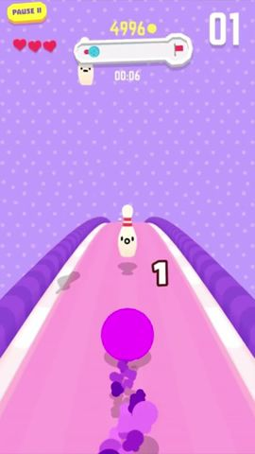

# **References**

* [Bowling Ballers](https://play.google.com/store/apps/details?id=com.netflix.NGP.BowlingBallers&hl=en_CA) (Netflix Inc.)
* [Bowling King](https://play.google.com/store/apps/details?id=com.pnixgames.bowlingking&hl=en&gl=US) (Miniclip.com).

# **Art Style** (check any number of boxes that apply)

* 2D
* 3D
* Pixel
* Cartoon
* Cell Art
* Low Poly
* High Poly
* Photo Realism
* Stylized Realism
* Isometric
* Other

## Sample images or references

# **Look & Feel / Camera**

* First Person
* Third Person
* Over The Shoulder
* Top Down
* Face On
* Other

# **Mechanic**

## **Controls**

* Portrait
* Landscape
* Single Touch
* Joystick
* Tap
* Slide
* Swipe
* Hold
* Release
* Drag
* Other

The player’s movement will be controlled by dragging a invisible joystick on the bottom center of the screen and special powers gained over time can be triggered by tapping on the icon/s.

**Core Loop**

Press Play button to start…

Player drags on the bottom center of the screen to move the character.

Player has to dodge the incoming balls and collect the power-ups to enhance its abilities for a specific time period.

In order to complete the level successfully, the player has to dodge all the incoming balls and obstacles.

# Progression

* Level Based
* Score Based
* Upgrade Based
* Star Based
* % Complete Based
* Engagement Based
* Content Based
* Other

**Briefly describe how the progression in the game works?**

The game will progress in levels, to complete a level it is necessary for the player to dodge all the incoming balls and collect as many power-ups and coins, as possible. If the pin (player) gets hit by a ball, the player will lose a life (out of 3) and the game will restart from the level player got hit. If the player loses all its lives the game restarts from level 1. The player can pick up power-ups like invisibility (that causes the bowling ball to pass through the pin without any effect), acid bottles (that eats away the area it is thrown causing the ball to fall into the hole created by the acid), etc.