**FORMAN CHRISTIAN COLLEGE**

**(A CHARTERED UNIVERSITY)**

**COMP 421 (Information Security)**

**SECTION - B**

**2023 FALL**

**ASSIGNMENT # 3**

**NMAP Basic Port Scans**

**Gulraiz Noor Bari (231-525536)**

**SCAN # 1 – TCP CONNECT SCAN**

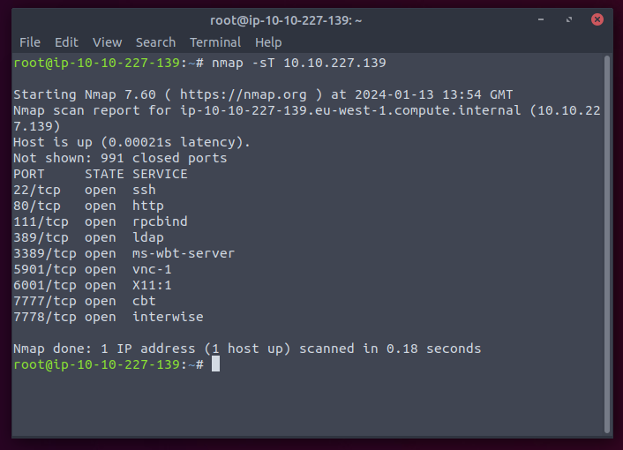

**SCAN # 2 – TCP SYN SCAN**

**SCAN # 3 – UDP SCAN**

**SCAN # 4 – TCP SCAN ON SPECIFIC PORTS**

