**FORMAN CHRISTIAN COLLEGE**

**(A CHARTERED UNIVERSITY)**

**COMP 421 (Information Security)**

**SECTION - B**

**2023 FALL**

**QUIZ # 4**

**BURP SUITE: THE BASICS**

**Gulraiz Noor Bari (231-525536)**

**TASK # 1 – INTRODUCTION**

**TASK # 2 – WHAT IS BURP SUITE**

**TASK # 3 – FEATURES OF BURP COMMUNITY**

**TASK # 4 – INSTALLATION**

**TASK # 5 – THE DASHBOARD**

**TASK # 6 – NAVIGATION**

**TASK # 7 – OPTIONS**

**TASK # 8 – INTRODUCTION TO BURP PROXY**

**TASK # 9 – CONNECTING THROUGH THE PROXY (FOXYPROXY)**

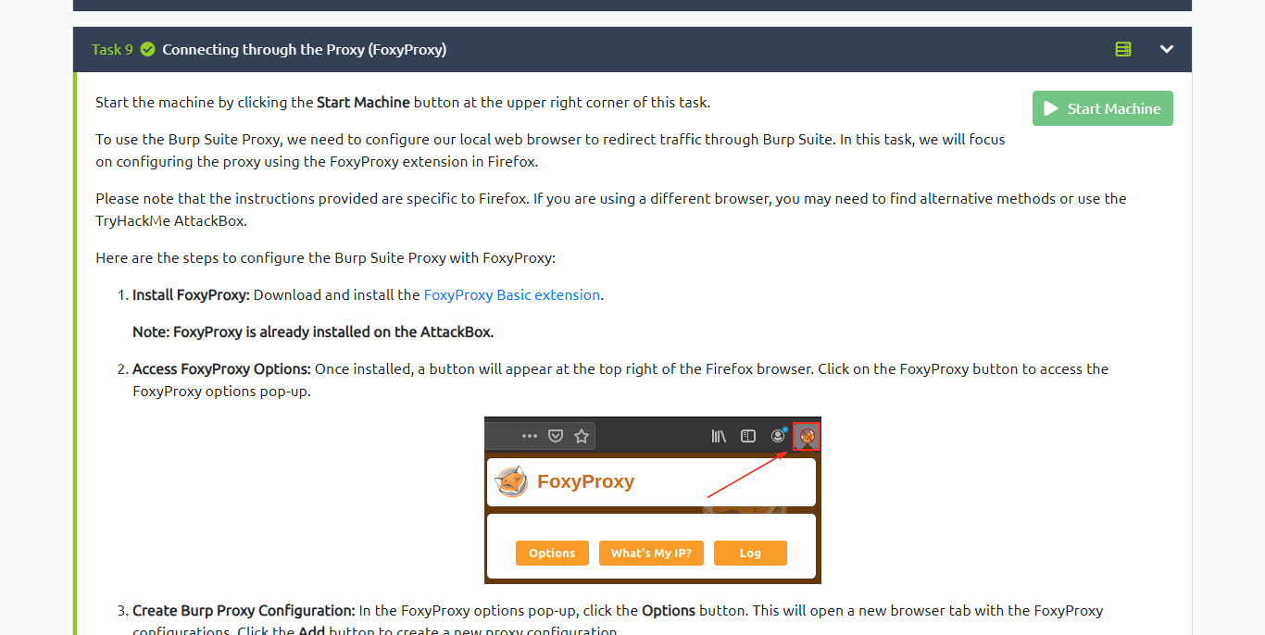

**TASK # 10 – SITE MAP AND ISSUE DEFINITIONS**

**TASK # 11 – THE BURP SUITE BROWSER**

**TASK # 12 – SCOPING AND TARGETING**

**TASK # 13 – PROXYING HTTPS**

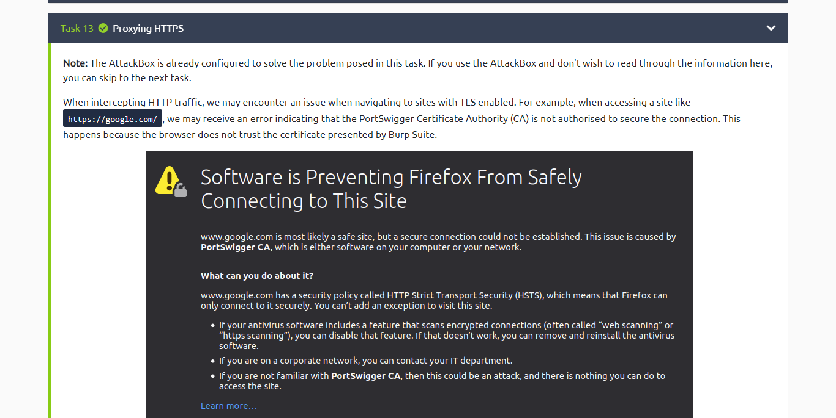

**TASK # 14 – EXAMPLE ATTACK**

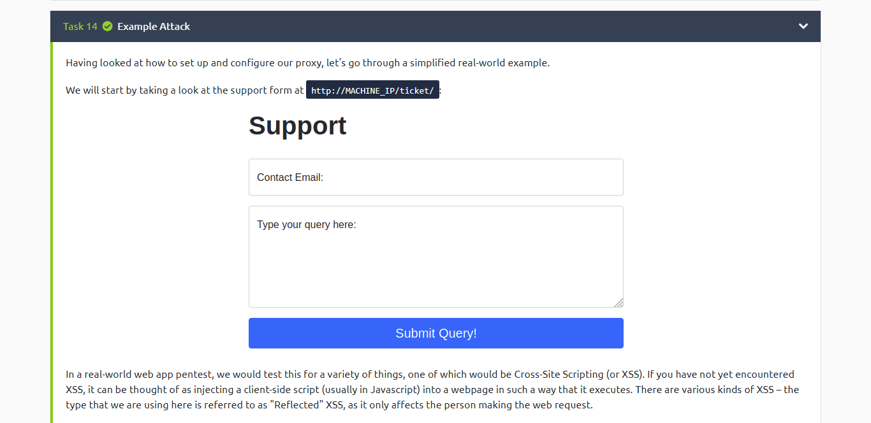

**TASK # 15 – CONCLUSION**

**ACCOUNT PROOF**

