**FORMAN CHRISTIAN COLLEGE**

**(A CHARTERED UNIVERSITY)**

**COMP 421 (Information Security)**

**SECTION - B**

**2023 FALL**

**QUIZ # 5**

**NMAP: Live Host Discovery**

**Gulraiz Noor Bari (231-525536)**

**TASK # 1 – INTRODUCTION**

**TASK # 2 – SUBNETWORKS**

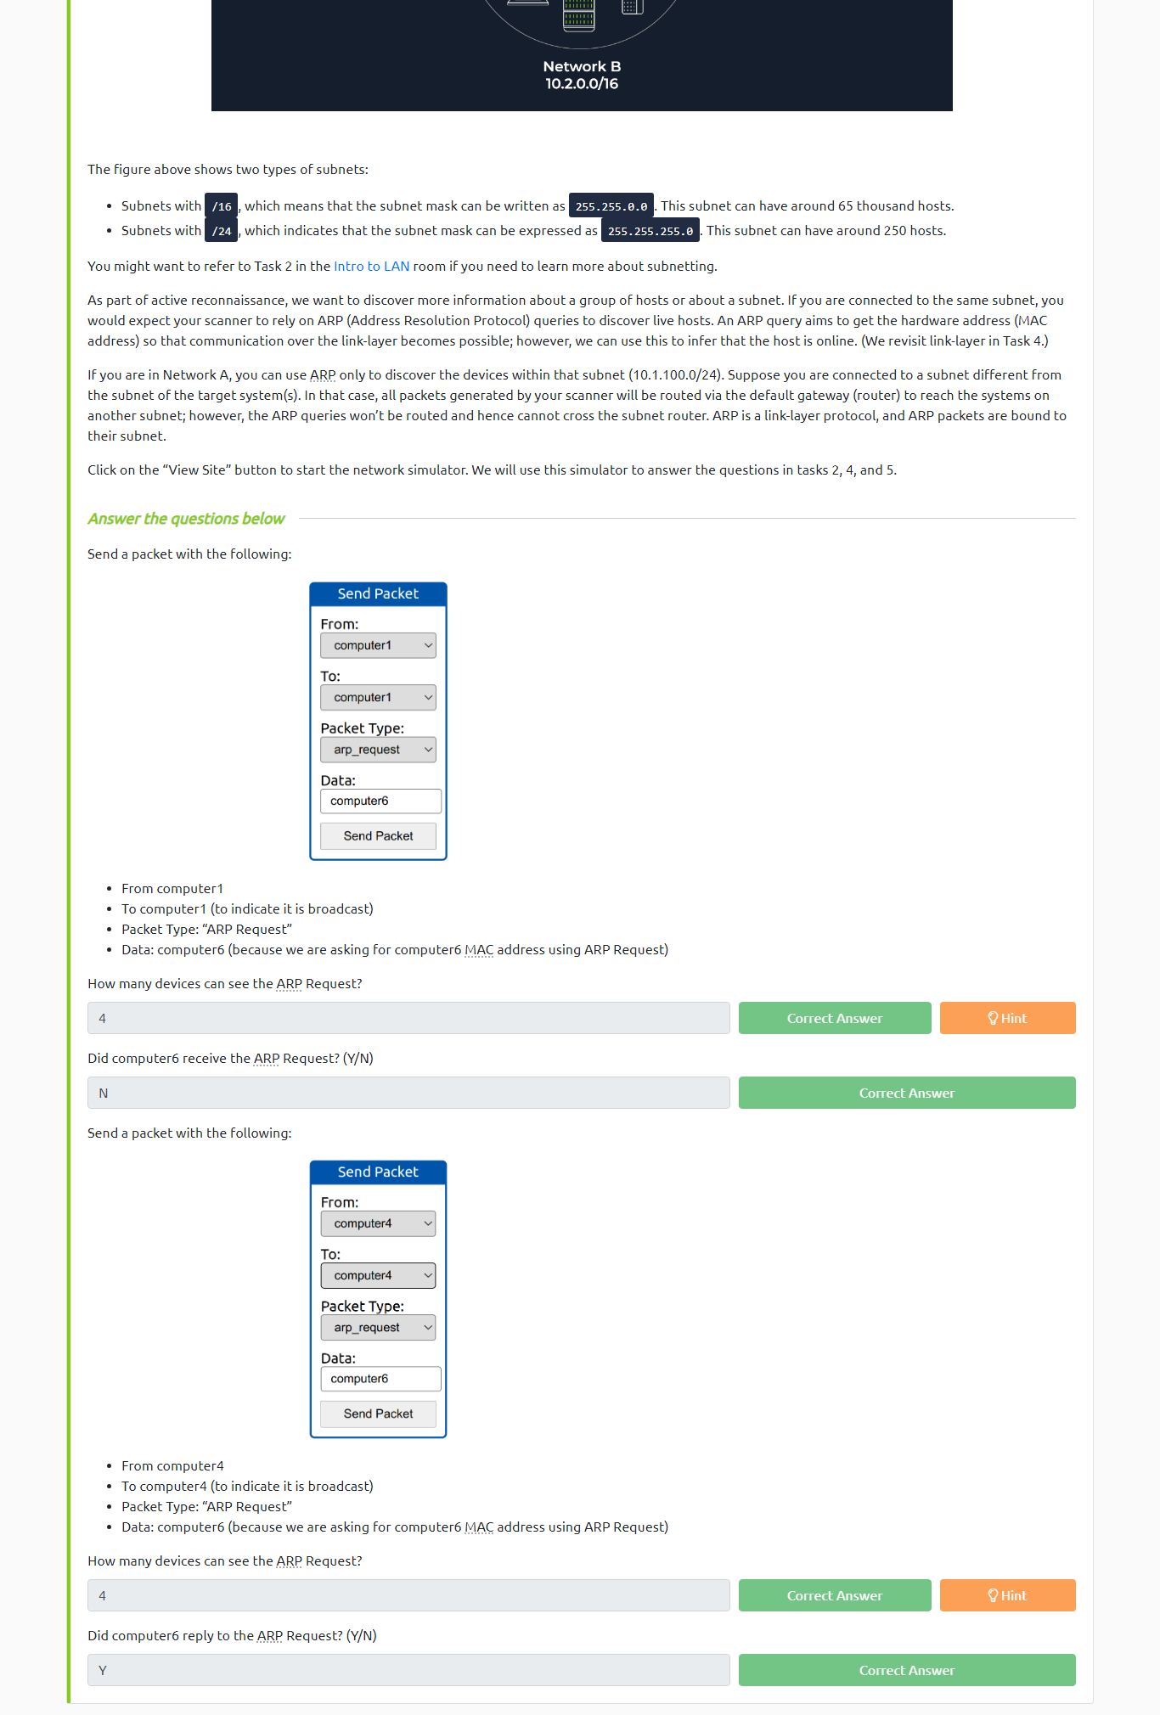

**TASK # 3 – ENUMERATING TARGETS**

**TASK # 4 – DISCOVERING LIVE HOSTS**

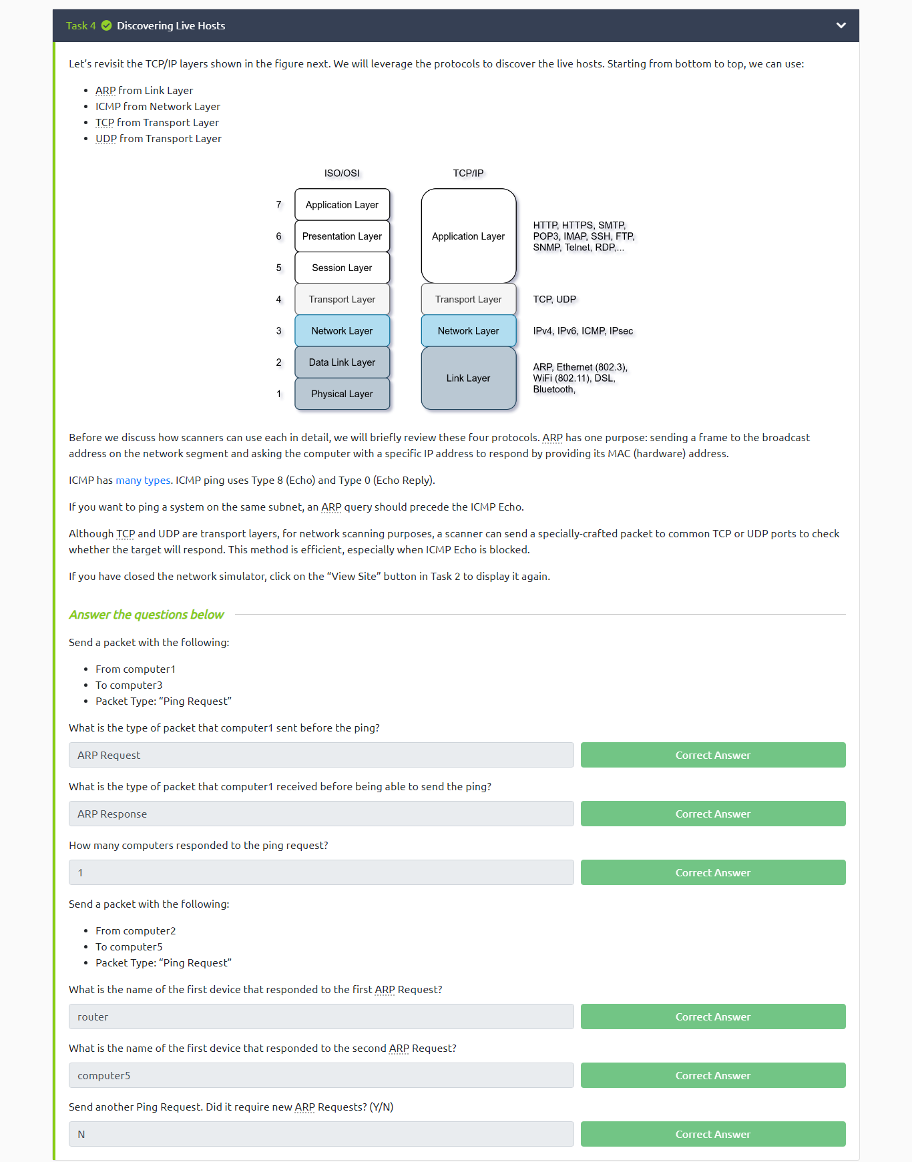

**TASK # 5 – NMAP HOST DISCOVERY USING ARP**

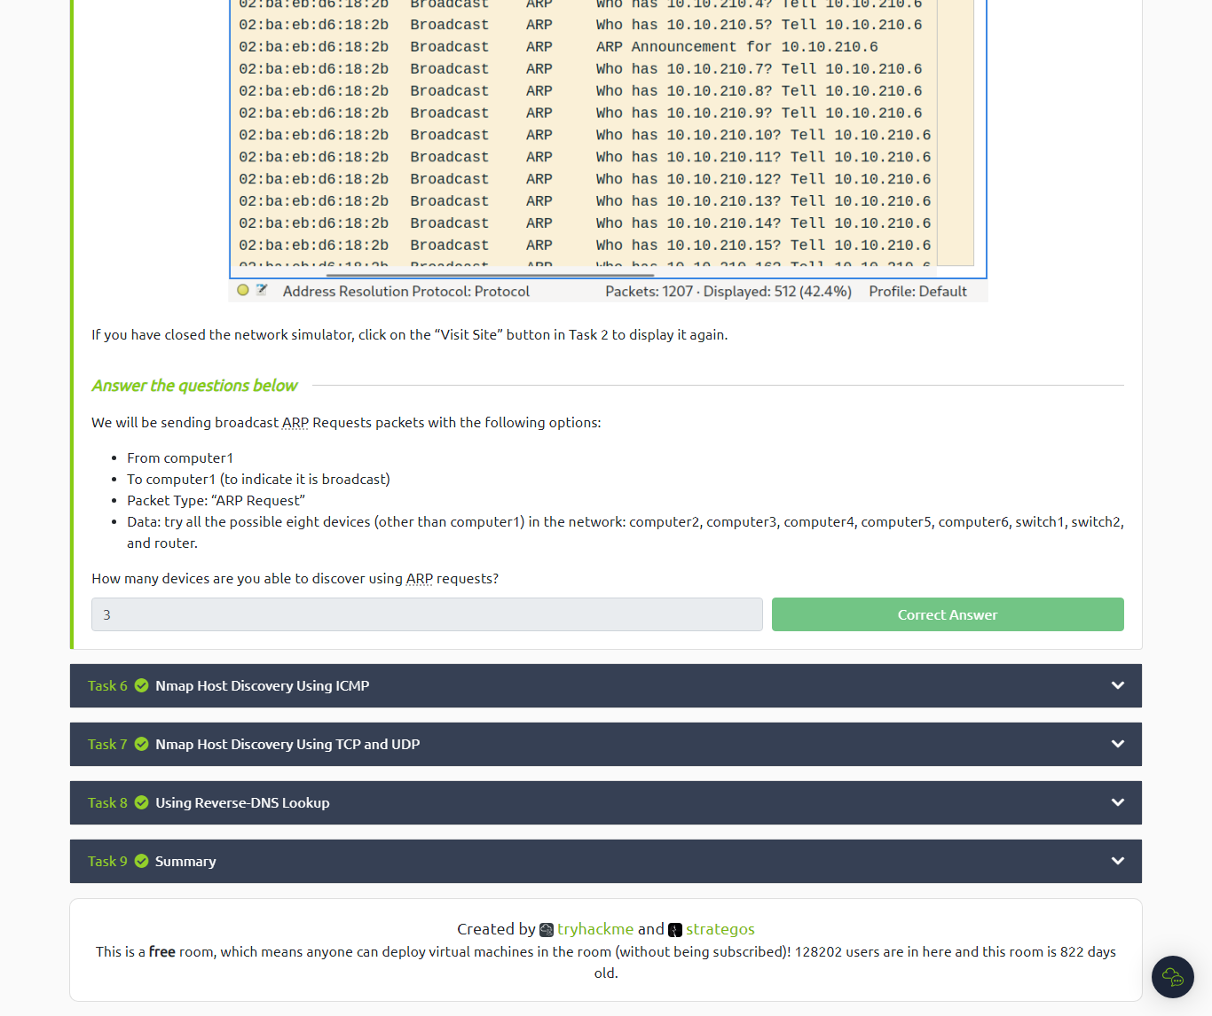

**TASK # 6 – NMAP LIVE DISCOVERY USING ICMP**

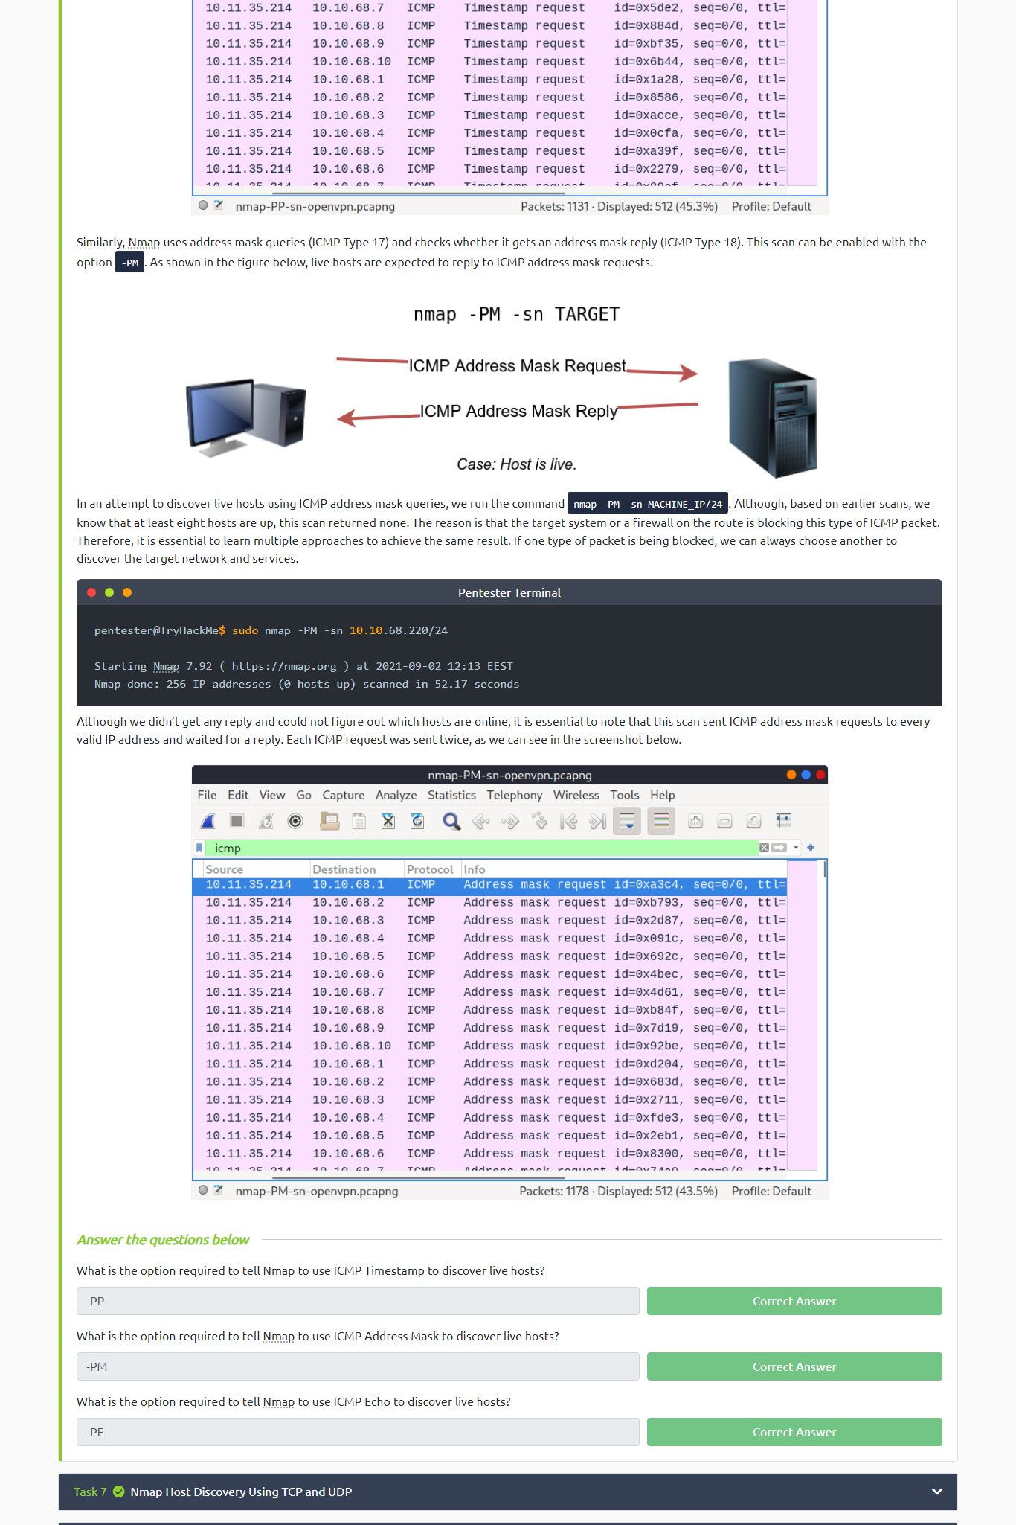

**TASK # 7 – NMAP LIVE DISCOVERY USING TCP AND UDP**

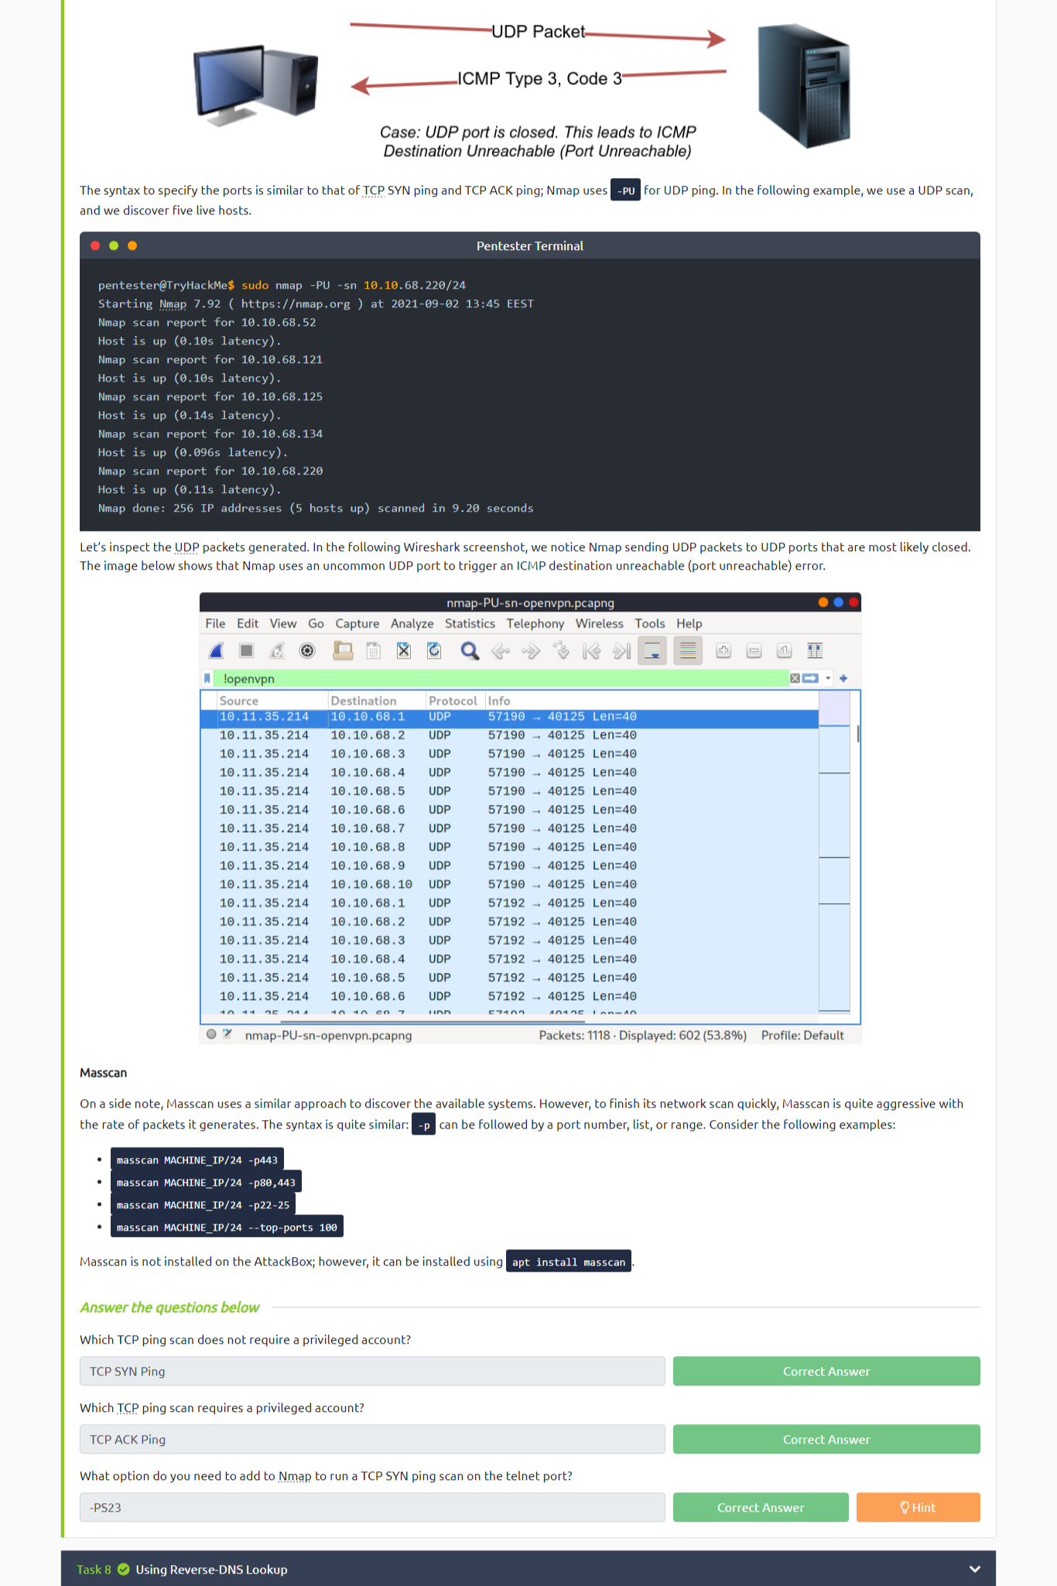

**TASK # 8 – USE REVERSE-DNS LOOKUP**

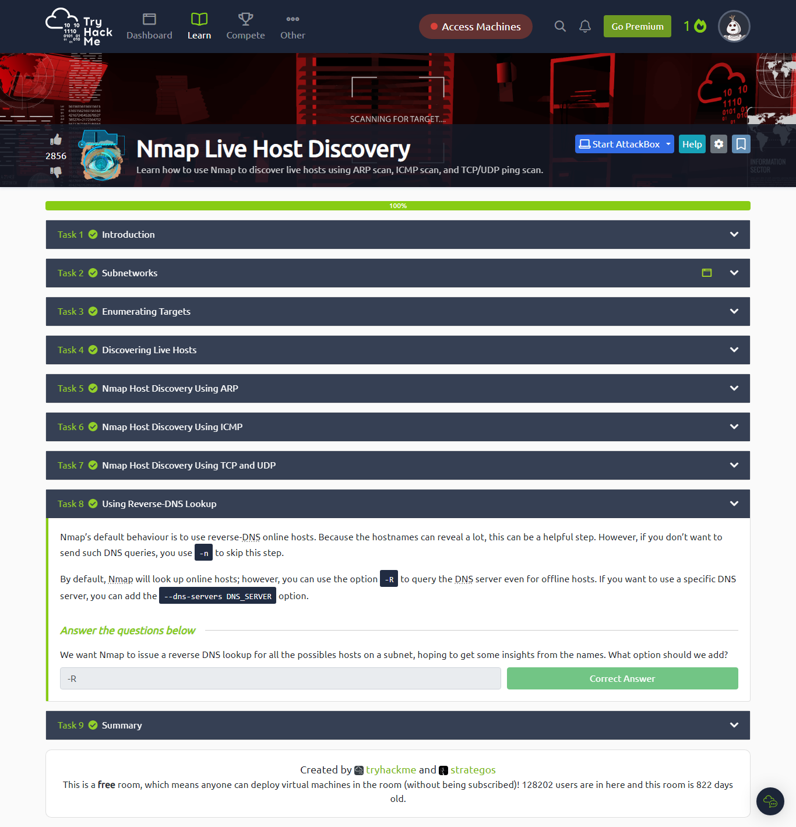

**TASK # 9 – SUMMARY**

**PROFILE SCREENSHOT**

