**FORMAN CHRISTIAN COLLEGE (A CHARTERED UNIVERSITY)**



**COMP 451 (Compiler Construction)**

**2022 FALL**

**Lab - 7**

**Gulraiz Noor Bari (231-525536)**

**LOGIC/ALGORITHM:**

The code is a FLEX program that validates a string depending on the rules provided in the translation rule section of the program, which is a regular expression.

* The first program only accepts a string of digits that has a pair of two consecutive 0’s.

**(0|1)*00(0|1)\***

Here **(0|1)\*** represents unlimited possibilities of occurrences of 0’s and 1’s in any pattern (including NULL), but **00** represents that there must be a pair of two consecutive 0’s in the string.

* The second program only accepts a string of digits that follow a specific format that is CNIC Number Format.

**[0-9]{5}[ -][0-9]{7}[ -][0-9]{1}**

The format is:

* + A series of five random digits (each between 0-9) followed by a space or hyphen, followed by a series of seven random digits (each between 0-9), followed by a space or hyphen and a single random digit (between 0-9) at the end.

**12345-1234567-1**

**CODE:**

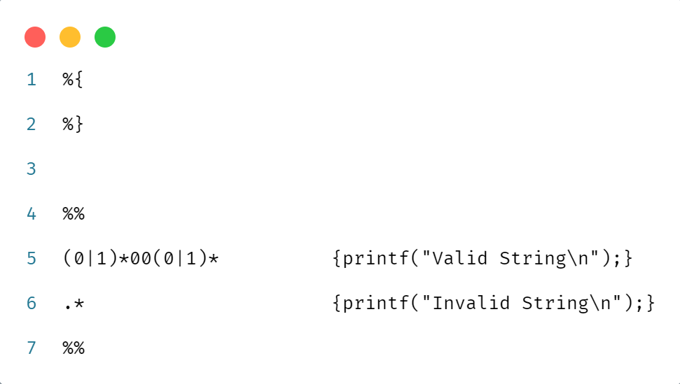

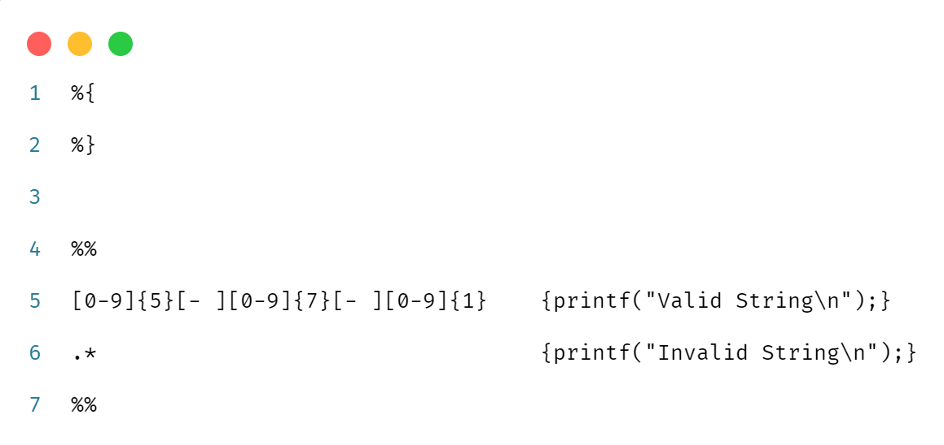

**OUTPUT:**

