**FORMAN CHRISTIAN COLLEGE (A CHARTERED UNIVERSITY)**



**COMP 451 (Compiler Construction)**

**2022 FALL**

**Lab - 8**

**Gulraiz Noor Bari (231-525536)**

**Muhammad Hamza (231-450349)**

**INTRODUCTION:**

* **stdio.h** (standard input/output)is a header file that contains declarations for functions like, printf, scanf, etc.
* **main():** The main function serves as the starting point of the program execution in C language. User can pass any number of parameters depending upon the requirements of the program logic or structure.

**LOGIC/ALGORITHM:**

The code is a program that implements a recursive descent parser for the following grammar:

**S 🡪 rXd | rZd**

**X 🡪 oa | ea**

**Z 🡪 ai**

* The program starts by initializing non-Terminal symbol functions, a char array that stores the string that is being checked and a int-type variable count that acts as a pointer that iterates over the characters in the production.
* First, we read the string entered by the user (using **fgets**) in the command-line and store it in **expr array** of type characters.
* As the starting point is **S**, so we first match with the production **S** and if the first character we encounter is **“r”** then move the count pointer to the next character. As the next symbol in the production is non-terminal (either X or Z), so we check if next character in the input string is equal to the symbol

X and Z are pointing towards.

* + In case of **X,** we can only encounter **“oa”** or **“ea”** as valid characters of the string.
  + In case of **Z**, we can only encounter **“ai”** as valid characters of the string.
* Whether the production goes to X or Z, a valid string will go to **“d”** and ends with a sentinel symbol **“$”**.

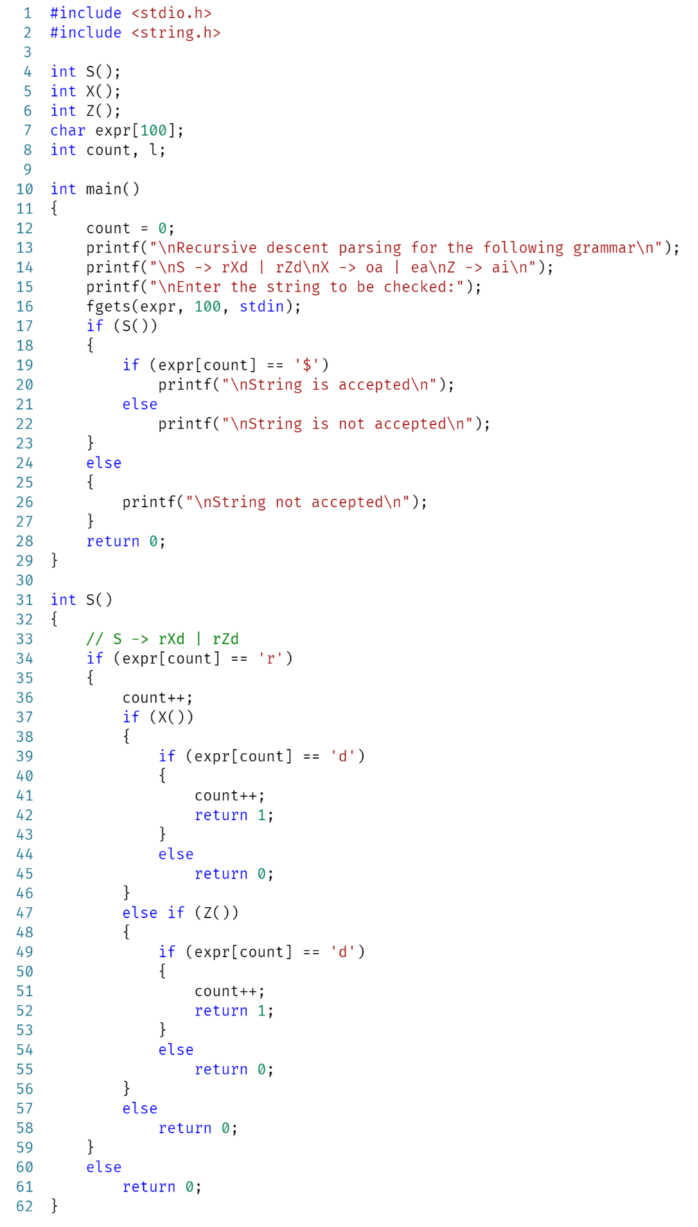**CODE:**

**OUTPUT:**



