
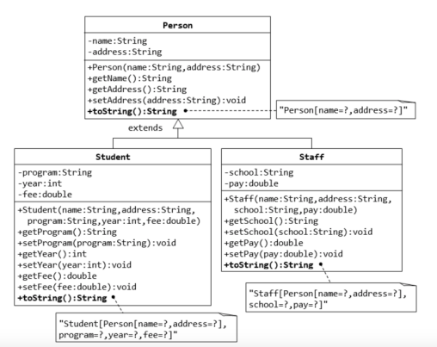
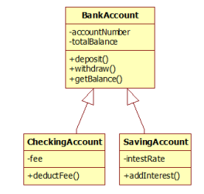
Introduction to Java Programming
CSCS 290 – Section A
Fall 2022
Instructor: Akheem Yousaf
Lab Instructor: Abu Bakar

Lab 6

Topics: Inheritance

Name: _Gulraiz Noor Bari_
Student ID: __231525536___

Note:

Marks will be deducted in case if students have not completed the assigned task.
This lab is time constrained. Please note that you must finish and submit your work within given time

Department of Computer Science
Forman Christian College University
Activity 1: [Weightage: 75%]
Write Java code to implement the UML given below. Provide driver program as well.
Paste your code below:
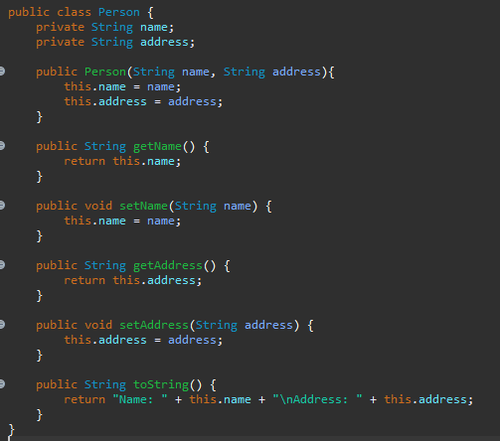

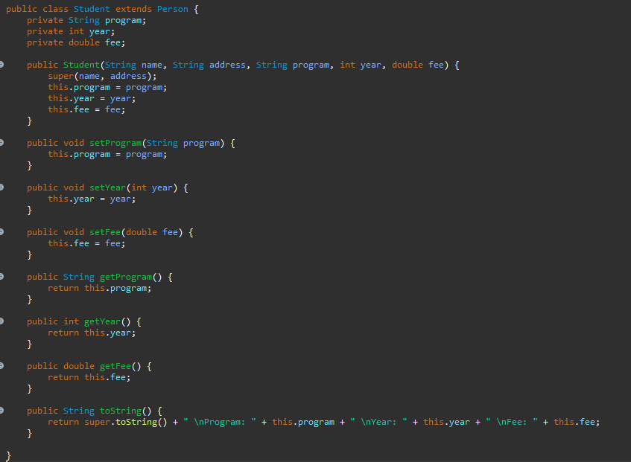
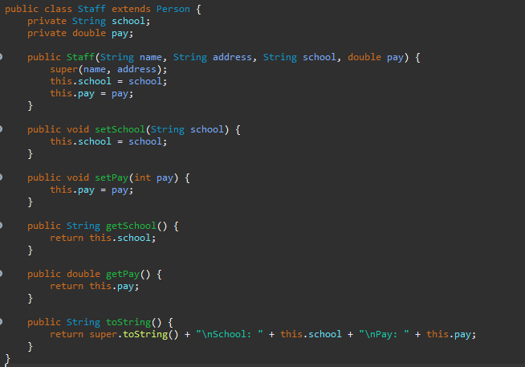

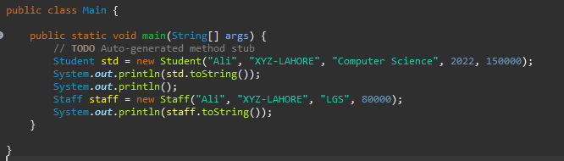

Screenshot of the output:
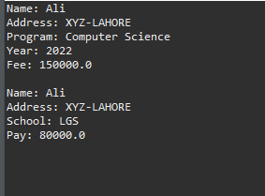

Activity 2: [Weightage: 25%]
Implement the UML given below. Write driver code as well
Paste your code below:
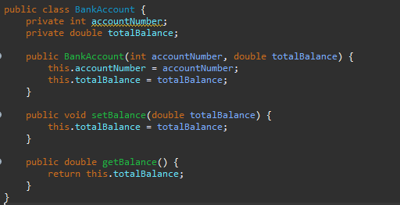

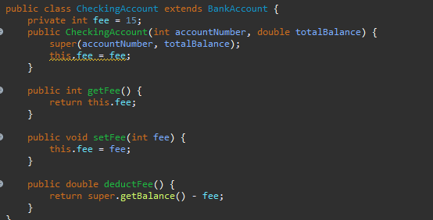
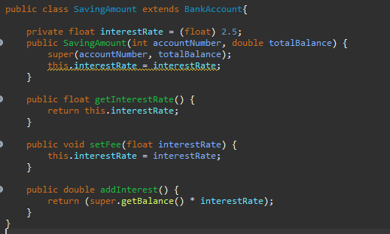

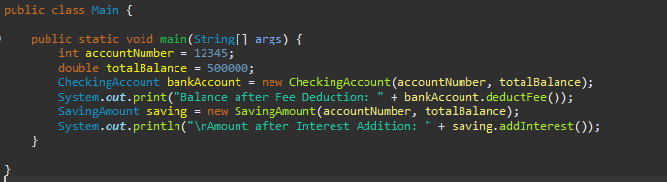

Screenshot of the output:

