AN INTERNSHIP REPORT
ON
"ARTIFICIAL INTELLIGENCE INTERNSHIP"
Submitted
To
School of Computer Science and Engineering
IILM University, Greater Noida, U.P.
In partial fulfilment of the requirement for the degree of
Bachelor of Technology (B.Tech)

By
GULSHAN RAJ
Roll Number: 25SCS1003001289
Internship Organization
Codec Technologies Pvt. Ltd.
Internship Period: 07 June 2026 to 08 August 2026

CANDIDATE'S DECLARATION
I, GULSHAN RAJ, hereby declare that the internship report titled “Artificial Intelligence Internship at Codec Technologies Pvt. Ltd.” has been prepared by me as part of the academic requirements of the Bachelor of Technology (B.Tech) programme.
The report presents the learning and practical exposure gained during the internship period. The work described in this report is based on the internship certificate and offer letter supplied for this academic report. The certificate confirms a two-month AICTE & ICAC approved internship program conducted by Codec Technologies Pvt. Ltd. in the role of Artificial Intelligence Intern.
I further declare that this report has been prepared for academic submission and that I am responsible for the authenticity of the information presented in it.

Student Name: GULSHAN RAJ
Roll No.: 25SCS1003001289

ACKNOWLEDGEMENT
I take this opportunity to express my sincere gratitude to everyone who supported and guided me during my internship and in the preparation of this report.
I am thankful to Codec Technologies Pvt. Ltd. for providing me with the opportunity to undertake a two-month internship in the field of Artificial Intelligence. The internship provided exposure to Artificial Intelligence learning and practical activities in an organizational environment.
I am also grateful to my institute, the School of Computer Science and Engineering, IILM University, Greater Noida, U.P., for providing the academic environment and encouragement required to complete this internship as part of my B.Tech programme.
I sincerely appreciate the guidance, feedback and professional environment that helped me understand how Artificial Intelligence concepts can be approached in practical work.
Finally, I express my gratitude to my family for their continuous encouragement and support.

Student Name: GULSHAN RAJ
Roll No.: 25SCS1003001289

TABLE OF CONTENTS
1. Internship Completion Certificate ........................................................ —
2. Project Description ........................................................ 1
2.1 Introduction ........................................................ 1
2.2 Organization Profile ........................................................ 2
2.3 Problem Statement ........................................................ 3
2.4 Project / Internship Objectives ........................................................ 3
2.5 Scope of the Internship ........................................................ 4
2.6 Technologies and Tools Used ........................................................ 4
2.7 System / AI Architecture ........................................................ 5
2.8 Methodology ........................................................ 6
2.9 Expected Outcomes ........................................................ 7
2.10 Internship Completion Proof ........................................................ 8
3. Bibliography / References ........................................................ 9

1. INTERNSHIP COMPLETION CERTIFICATE
The original Internship Completion Certificate issued by Codec Technologies Pvt. Ltd. should be inserted on this page.
The certificate confirms that Gulshan Raj completed a 2 Month AICTE & ICAC Approved internship program as an Artificial Intelligence Intern, conducted from 07/06/2026 to 08/08/2026.

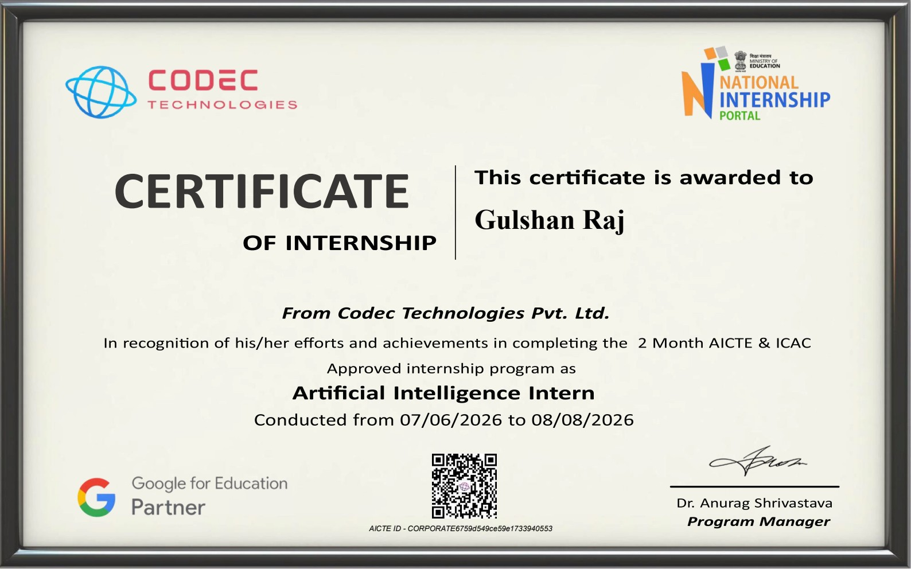
2. PROJECT DESCRIPTION
2.1 Introduction
This report presents an account of the two-month Artificial Intelligence Internship completed at Codec Technologies Pvt. Ltd. from 07 June 2026 to 08 August 2026. The internship was undertaken by GULSHAN RAJ, a student of Bachelor of Technology (B.Tech).
The internship focused on practical exposure to Artificial Intelligence. As stated in the internship certificate, the program was a 2 Month AICTE & ICAC Approved internship and the assigned role was Artificial Intelligence Intern.
The internship helped connect academic concepts with practical Artificial Intelligence learning. It provided an opportunity to understand AI-related concepts, workflows, problem solving and the importance of systematic implementation and evaluation.
2.2 Organization Profile
Codec Technologies Pvt. Ltd. is the organization where the internship was completed. The internship certificate identifies Codec Technologies Pvt. Ltd. as the organization conducting the two-month AICTE & ICAC approved internship program.
The offer letter describes Codec Technologies as a global platform dedicated to empowering learners and connecting diverse talent to create meaningful career opportunities worldwide. It states that the organization delivers dedicated IT and business consultancy services across 27+ countries.
The internship was conducted in the Artificial Intelligence domain, with the student serving as an Artificial Intelligence Intern.
2.3 Problem Statement
Artificial Intelligence concepts are often studied theoretically, but practical exposure is necessary to understand how AI problems are approached systematically. A learner needs to understand the relationship between data, algorithms, model development, evaluation and problem solving.
The internship addressed this practical learning requirement by providing exposure to Artificial Intelligence concepts and an organizational learning environment. The objective was to strengthen the connection between academic knowledge and practical AI-oriented work.
2.4 Project / Internship Objectives
• To gain practical exposure to Artificial Intelligence concepts and workflows.
• To strengthen understanding of Machine Learning and AI fundamentals.
• To understand the importance of data preparation and analysis in AI applications.
• To understand the basic stages of model development and evaluation.
• To improve programming, analytical thinking and problem-solving skills relevant to AI.
• To develop a systematic approach to identifying and resolving technical issues.
• To connect academic AI concepts with practical organizational learning.
• To improve professional discipline, responsibility and willingness to learn in a workplace environment.
2.5 Scope of the Internship
The scope of the internship covers Artificial Intelligence learning and practical exposure within the role specified on the completion certificate. It includes understanding AI concepts, machine-learning workflows, data-related considerations, model development concepts, evaluation and systematic problem solving.
The internship scope is primarily practical and learning-oriented. The supplied documents confirm the AI internship role, program approval and dates, but do not specify a particular production project, dataset, model architecture, database system, application name, deployment platform, or numerical performance result. Accordingly, this report does not claim unsupported project-specific deliverables.
2.6 Technologies and Tools Used
Technology / Area | Purpose / Application Relevance
Python | Programming and implementation of AI/ML concepts; commonly used for AI workflows.
Artificial Intelligence | Understanding intelligent systems and problem-solving approaches; primary internship domain.
Machine Learning | Understanding learning, prediction and model-based approaches; major AI sub-area.
Data Processing | Preparing and understanding input data; important stage of AI workflows.
Model Evaluation | Assessing model behaviour and performance; supports improvement and comparison.
Development / Debugging Tools | Testing and troubleshooting implementation; supports practical development and problem solving.

2.7 System / AI Architecture
The internship activities can be represented through a simple report-level Artificial Intelligence workflow. The architecture begins with a problem definition and data, followed by preparation, model development, evaluation and improvement.
• Input / Problem Layer – identifies the problem and required inputs.
• Data Layer – organizes and prepares relevant data for the AI workflow.
• Processing Layer – performs required preprocessing or transformation.
• Model Layer – applies an appropriate AI or Machine Learning approach.
• Evaluation Layer – examines model outputs and performance.
• Improvement Layer – identifies issues and refines the approach.
• Application / Output Layer – represents the final result or insight produced by the workflow.
This is a report-level representation of an AI workflow and is not a claim about a proprietary internal architecture of Codec Technologies Pvt. Ltd.
2.8 Methodology
A practical, task-oriented methodology was followed during the internship. Since the supplied certificate and offer letter do not provide a day-wise or week-wise task log, the methodology below groups the Artificial Intelligence internship into logical learning phases.
Phase / Area | Description
Phase 1 – AI Fundamentals | Understanding basic Artificial Intelligence and Machine Learning concepts.
Phase 2 – Problem Understanding | Studying how an AI problem is defined and what inputs are required.
Phase 3 – Data Understanding | Learning the importance of data preparation and suitable input representation.
Phase 4 – Model Development | Understanding the general process of selecting and developing an AI/ML model.
Phase 5 – Evaluation and Improvement | Reviewing outputs, identifying issues and considering improvements.
Phase 6 – Professional Learning | Completing assigned responsibilities with dedication, professionalism and willingness to learn.
The methodology emphasizes learning through practical implementation, observation, testing, evaluation and improvement rather than treating Artificial Intelligence concepts only as theory.
2.9 Expected Outcomes
• Improved understanding of Artificial Intelligence and Machine Learning fundamentals.
• Stronger practical familiarity with the basic AI project workflow.
• Better understanding of data preparation and model evaluation.
• Improved analytical and problem-solving skills.
• Greater confidence in applying AI concepts in practical environments.
• Improved programming and technical learning discipline.
• Improved professional responsibility and willingness to learn.
2.10 Internship Completion Proof
The internship completion certificate issued by Codec Technologies Pvt. Ltd. confirms that GULSHAN RAJ successfully completed a two-month AICTE & ICAC approved internship program as an Artificial Intelligence Intern. The certificate records the internship period as 07/06/2026 to 08/08/2026.


3. BIBLIOGRAPHY / REFERENCES
1. Codec Technologies Pvt. Ltd., Internship Certificate – Artificial Intelligence Intern, internship period 07 June 2026 to 08 August 2026.
2. Codec Technologies Pvt. Ltd., Internship Offer Letter – Artificial Intelligence Intern / Project Intern, issued 07 June 2026.
3. Python documentation and learning resources used for understanding Python programming concepts.
4. General Artificial Intelligence and Machine Learning learning resources consulted during the internship.

