**Lesson 03 Demo 03**

**Developing a Backup and Restore Plan for Docker Volumes**

**Objective:** To develop a backup and restore plan for Docker volumes for enhanced data management and disaster recovery

**Tools required:** Ubuntu

**Prerequisites:** None

Steps to be followed:

1. Create, backup, and restore a Docker volume

**Step 1: Create, backup, and restore a Docker volume**

1. Create a new container named **dbstore** using the following command: **sudo docker run -v /dbdata --name dbstore ubuntu /bin/bash**

1. Run the following command to list all containers:  
   **sudo docker ps -a  
     
   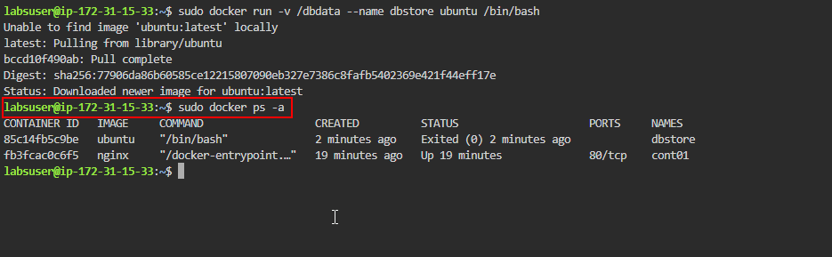**
2. Mount a local host directory as **/backup** and pass a command to tar the contents of the **dbdata** volume into a backup.tar file using the following command:  
   **sudo docker run --rm --volumes-from dbstore -v $(pwd):/backup ubuntu tar cvf /backup/backup.tar /dbdata**  
     
   A computer screen shot of a black screen

   Description automatically generated
3. Run the following command to list the files and directories:  
   **sudo ls**

1. Create a new container named **dbstore2** using the following command:  
   **sudo docker run -v /dbdata --name dbstore2 ubuntu /bin/bash**  
     
   A screen shot of a computer

   Description automatically generated
2. Execute the following command to un-tar the backup file in the new container's data volume:  
   **sudo docker run --rm --volumes-from dbstore2 -v $(pwd):/backup ubuntu bash -c "cd /dbdata && tar xvf /backup/backup.tar --strip 1"**  
     
   A black screen with white text

   Description automatically generated
3. Run the following command to list all containers:  
   **sudo docker ps -a**  
     
   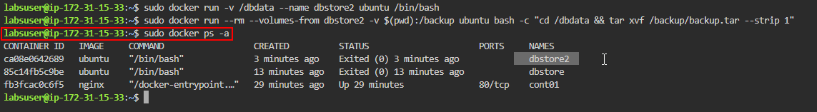  
     
   By following these steps, you have successfully developed a backup and restore plan for Docker volumes to ensure data resilience and facilitate efficient disaster recovery strategies.