LABORATORIYA ISHI № 1
Mavzu: jQuery va PHP yordamida AJAX so‘rovlari yuborish va javobni qayta ishlash
1. Ishning maqsadi
Ushbu laboratoriya ishining maqsadi talabalarga jQuery va PHP texnologiyalari yordamida AJAX so‘rovlarini yuborish, server tomondan kelgan javoblarni qabul qilish hamda ularni veb sahifada sahifani yangilamasdan dinamik tarzda aks ettirish ko‘nikmalarini hosil qilishdan iborat.
2. Nazariy ma’lumotlar
2.1. AJAX tushunchasi
AJAX (Asynchronous JavaScript and XML) — bu veb sahifani to‘liq qayta yuklamasdan turib server bilan ma’lumot almashish texnologiyasidir. AJAX yordamida foydalanuvchi interfeysi tezkor va qulay bo‘ladi.
AJAX asosan quyidagi texnologiyalar asosida ishlaydi:
- HTML / CSS
- JavaScript
- jQuery
- PHP
- JSON yoki oddiy matn formatlari
2.2. jQuery AJAX metodlari
jQuery AJAX bilan ishlashni soddalashtiradi. Eng ko‘p ishlatiladigan metodlar:
- $.ajax()
- $.get()
- $.post()
Ularning afzalligi:
- Kam kod yoziladi
- Xatoliklarni oson boshqarish mumkin
- Brauzerlararo moslik mavjud
2.3. PHP server tomoni
PHP — server tomonda ishlovchi dasturlash tili bo‘lib, foydalanuvchidan kelgan AJAX so‘rovlarini qabul qiladi va qayta ishlaydi. PHP orqali:
- Ma’lumot qabul qilish
- Tekshirish
- JSON yoki matn ko‘rinishida javob qaytarish mumkin
3. Kerakli dasturiy vositalar
- Web-brauzer (Google Chrome, Mozilla Firefox)
- Matn muharriri (VS Code, Sublime Text)
- Lokal server (XAMPP, OpenServer yoki Denwer)
- PHP 7.x yoki undan yuqori
4. Laboratoriya ishining bajarilish tartibi
4.1. Loyiha tuzilmasini yaratish
ajax_lab/
│
├── index.php
├── script.js
└── server.php
5. Amaliy qism
5.1. Foydalanuvchi interfeysini yaratish (index.php)
<!DOCTYPE html>
<html lang="uz">
<head>
<meta charset="UTF-8">
<title>AJAX jQuery + PHP</title>

<script src="https://code.jquery.com/jquery-3.6.0.min.js"></script>
<script src="script.js"></script>
</head>
<body>

<h2>AJAX orqali ma’lumot yuborish</h2>

<label>Ism:</label><br>
<input type="text" id="name"><br><br>

<label>Yosh:</label><br>
<input type="number" id="age"><br><br>

<button id="sendBtn">Yuborish</button>

<h3>Natija:</h3>
<div id="result"></div>

</body>
</html>
5.2. jQuery AJAX kodi (script.js)
$(document).ready(function () {

$("#sendBtn").click(function () {

let name = $("#name").val();
let age = $("#age").val();

$.ajax({
url: "server.php",
type: "POST",
data: {
name: name,
age: age
},
success: function (response) {
$("#result").html(response);
},
error: function () {
$("#result").html("Xatolik yuz berdi!");
}
});

});

});
5.3. Server tomoni (server.php)
<?php

if(isset($_POST['name']) && isset($_POST['age'])) {

$name = htmlspecialchars($_POST['name']);
$age = intval($_POST['age']);

if($name == "" || $age <= 0){
echo "Iltimos, barcha maydonlarni to‘ldiring!";
} else {
echo "Ism: <b>$name</b><br>";
echo "Yosh: <b>$age</b>";
}

} else {
echo "Ma’lumot kelmadi!";
}

?>
6. Ish natijasi
Laboratoriya ishi bajarilgandan so‘ng talaba:
- jQuery yordamida AJAX so‘rovi yubora oladi
- PHP orqali POST ma’lumotlarni qabul qiladi
- Serverdan qaytgan javobni sahifani yangilamasdan ko‘rsatadi
- Xatoliklarni boshqarishni o‘rganadi
Mustaqil topshiriqlar
7-topshiriq. Fikr bildirish
Foydalanuvchi fikrini yuboruvchi forma yarating.
Talablar:
- Forma maydonlari: feedback_ism, feedback_email, feedback_baho, feedback_mavzu, feedback_matn
- Baho 1–5 oralig‘ida bo‘lsin
- Fikr uzunligi kamida 20 ta belgidan iborat bo‘lsin
- Javob animatsiya bilan ko‘rsatilsin
Laboratoriya ishining bajarilish tartibi
- 4.1. Loyiha tuzilmasini yaratish

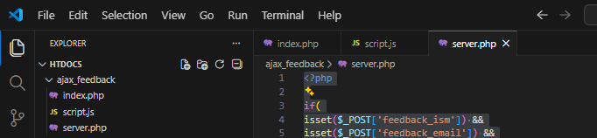
5. Amaliy qism
5.1. Foydalanuvchi interfeysini yaratish (index.php)
<!DOCTYPE html>
<html lang="uz">
<head>
<meta charset="UTF-8">
<title>Fikr bildirish</title>

<script src="https://code.jquery.com/jquery-3.6.0.min.js"></script>
<script src="script.js"></script>

<style>

body{
font-family: Arial;
margin:40px;
}

input, textarea{
width:300px;
padding:8px;
margin:5px 0;
}

button{
padding:10px 20px;
background:#3498db;
color:white;
border:none;
cursor:pointer;
}

#result{
margin-top:20px;
display:none;
padding:15px;
border-radius:5px;
}

.success{
background:#d4edda;
color:#155724;
}

.error{
background:#f8d7da;
color:#721c24;
}

</style>

</head>

<body>

<h2>Fikr bildirish formasi</h2>

<label>Ism:</label><br>
<input type="text" id="feedback_ism"><br>

<label>Email:</label><br>
<input type="email" id="feedback_email"><br>

<label>Baho (1-5):</label><br>
<input type="number" id="feedback_baho" min="1" max="5"><br>

<label>Mavzu:</label><br>
<input type="text" id="feedback_mavzu"><br>

<label>Fikr matni:</label><br>
<textarea id="feedback_matn"></textarea><br>

<button id="sendBtn">Yuborish</button>

<div id="result"></div>

</body>
</html>

5.2. jQuery AJAX kodi (script.js)
$(document).ready(function(){

$("#sendBtn").click(function(){

let ism = $("#feedback_ism").val();
let email = $("#feedback_email").val();
let baho = $("#feedback_baho").val();
let mavzu = $("#feedback_mavzu").val();
let matn = $("#feedback_matn").val();

$.ajax({

url: "server.php",
type: "POST",

data:{
feedback_ism: ism,
feedback_email: email,
feedback_baho: baho,
feedback_mavzu: mavzu,
feedback_matn: matn
},

success:function(response){

$("#result").hide();

$("#result")
.removeClass("error")
.addClass("success")
.html(response)
.fadeIn(800);

},

error:function(){

$("#result").hide();

$("#result")
.removeClass("success")
.addClass("error")
.html("Server bilan aloqa xatosi!")
.fadeIn(800);

}

});

});

});

5.3. Server tomoni (server.php)
<?php

if(
isset($_POST['feedback_ism']) &&
isset($_POST['feedback_email']) &&
isset($_POST['feedback_baho']) &&
isset($_POST['feedback_mavzu']) &&
isset($_POST['feedback_matn'])
){

$ism = htmlspecialchars($_POST['feedback_ism']);
$email = htmlspecialchars($_POST['feedback_email']);
$baho = intval($_POST['feedback_baho']);
$mavzu = htmlspecialchars($_POST['feedback_mavzu']);
$matn = htmlspecialchars($_POST['feedback_matn']);

if($ism == "" || $email == "" || $mavzu == "" || $matn == ""){
echo "Iltimos barcha maydonlarni to‘ldiring!";
exit;
}

if($baho < 1 || $baho > 5){
echo "Baho 1 dan 5 gacha bo‘lishi kerak!";
exit;
}

if(strlen($matn) < 20){
echo "Fikr kamida 20 ta belgidan iborat bo‘lishi kerak!";
exit;
}

echo "<h3>Fikr qabul qilindi!</h3>";
echo "Ism: <b>$ism</b><br>";
echo "Email: <b>$email</b><br>";
echo "Baho: <b>$baho</b><br>";
echo "Mavzu: <b>$mavzu</b><br>";
echo "Fikr: <b>$matn</b>";

}else{

echo "Ma'lumot kelmadi!";

}

?>
6. Ish natijasi
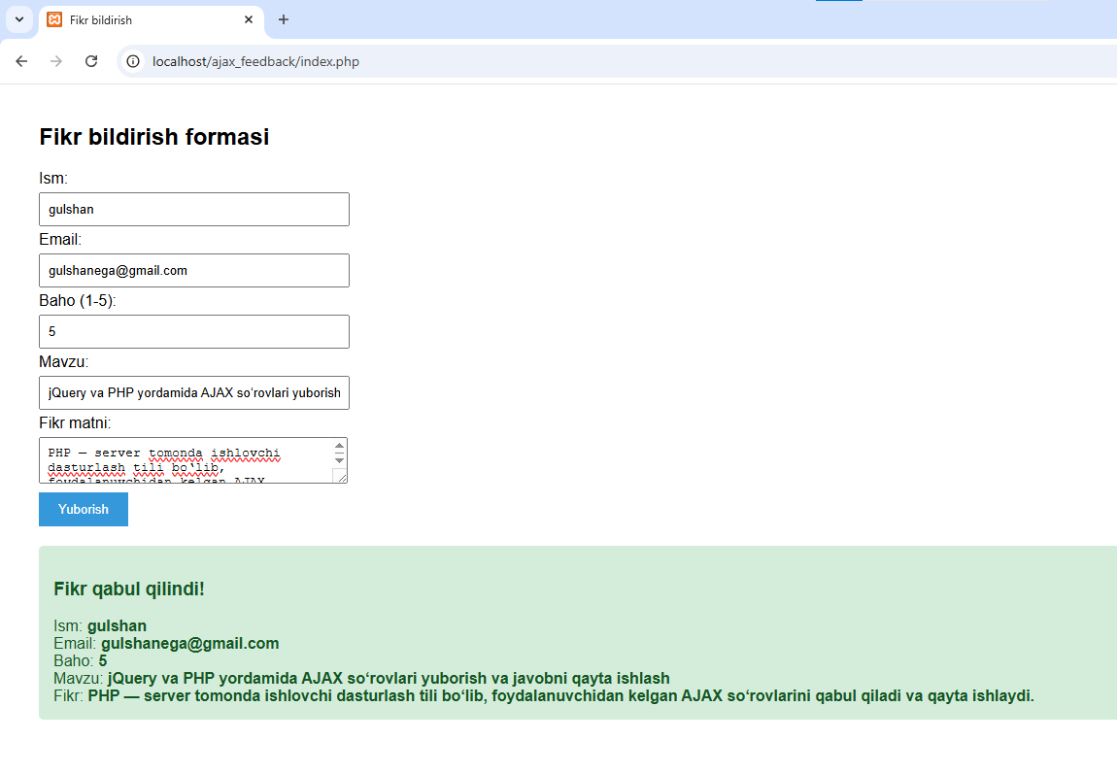

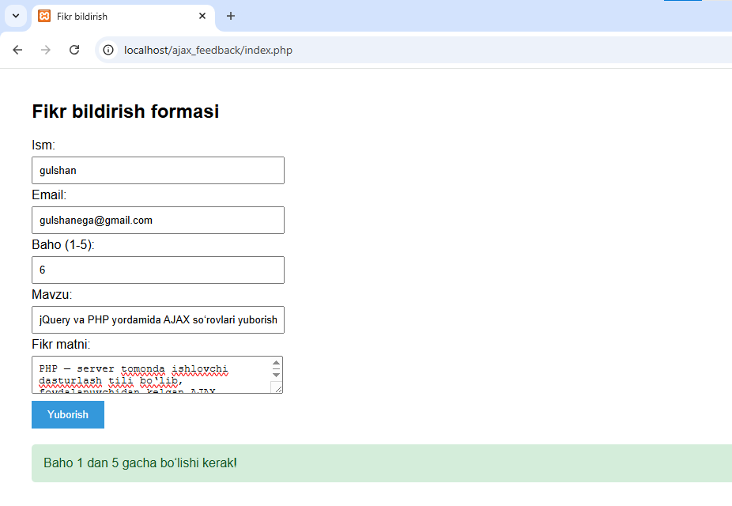
XULOSA
jQuery va PHP yordamida AJAX so‘rovlari sahifa qayta yuklanmasdan server bilan ma’lumot almashishni ta’minlaydi. jQuery orqali so‘rov yuborish va javobni olish oson, PHP esa server tomonida ma’lumotni qayta ishlaydi va odatda JSON formatida javob beradi.
Bu usul sahifani dinamik, tezkor va foydalanuvchi uchun qulay qiladi, lekin xavfsizlik va xatoliklarni boshqarishga e’tibor berish zarur.

