5-Lobaratoriya.
PHP orqali CRUD (Create, Read, Update, Delete) amallarini bajarish

Ishdan maqsad
- PHP va MySQL yordamida ma’lumotlar bazasi bilan ishlashni o‘rganish
- CRUD (Create, Read, Update, Delete) amallarini amalda bajarish
- HTML forma orqali ma’lumotlarni kiritish va qayta ishlash
- Ma’lumotlar bazasidagi yozuvlarni chiqarish, tahrirlash va o‘chirish

Kerakli dasturiy vositalar
- XAMPP / OpenServer / Denwer
- PHP 7.x yoki yuqori
- MySQL
- Brauzer (Chrome, Edge va h.k.)
- Kod muharriri (VS Code, Sublime va boshqalar)

Nazariy qism
CRUD tushunchasi
CRUD – bu ma’lumotlar bazasida bajariladigan 4 asosiy amal:
Amal | Tavsif
Create | Yangi ma’lumot qo‘shish
Read | Ma’lumotlarni o‘qish (ko‘rish)
Update | Ma’lumotni tahrirlash
Delete | Ma’lumotni o‘chirish

1-qadam: Ma’lumotlar bazasini yaratish
phpMyAdmin orqali quyidagi SQL so‘rovni bajaring:
CREATE DATABASE talaba_db;
USE talaba_db;
CREATE TABLE talabalar (
id INT AUTO_INCREMENT PRIMARY KEY,
ism VARCHAR(50) NOT NULL,
familiya VARCHAR(50) NOT NULL,
yosh INT NOT NULL
);

2-qadam: Loyihaning fayl tuzilmasi
crud/
│
├── db.php
├── index.php
├── add.php
├── edit.php
├── delete.php

3-qadam: Ma’lumotlar bazasiga ulanish (db.php)
<?php
$conn = new mysqli("localhost", "root", "", "talaba_db");
if ($conn->connect_error) {
die("Ulanishda xatolik: " . $conn->connect_error);
}
?>

4-qadam: CREATE – Ma’lumot qo‘shish (add.php)
<?php
include 'db.php';
if(isset($_POST['submit'])){
$ism = $_POST['ism'];
$familiya = $_POST['familiya'];
$yosh = $_POST['yosh'];
$sql = "INSERT INTO talabalar (ism, familiya, yosh)
VALUES ('$ism', '$familiya', '$yosh')";
$conn->query($sql);
header("Location: index.php");
}
?>
<form method="POST">
Ism: <input type="text" name="ism"><br>
Familiya: <input type="text" name="familiya"><br>
Yosh: <input type="number" name="yosh"><br>
<button type="submit" name="submit">Saqlash</button>
</form>

5-qadam: READ – Ma’lumotlarni chiqarish (index.php)
<?php include 'db.php'; ?>
<a href="add.php">Yangi talaba qo‘shish</a>
<table border="1">
<tr>
<th>ID</th>
<th>Ism</th>
<th>Familiya</th>
<th>Yosh</th>
<th>Amallar</th>
</tr>
<?php
$result = $conn->query("SELECT * FROM talabalar");
while($row = $result->fetch_assoc()){
echo "<tr>
<td>{$row['id']}</td>
<td>{$row['ism']}</td>
<td>{$row['familiya']}</td>
<td>{$row['yosh']}</td>
<td>
<a href='edit.php?id={$row['id']}'>Tahrirlash</a>
<a href='delete.php?id={$row['id']}'>O‘chirish</a>
</td>
</tr>";
}
?>
</table>

6-qadam: UPDATE – Ma’lumotni tahrirlash (edit.php)
<?php
include 'db.php';
$id = $_GET['id'];
$result = $conn->query("SELECT * FROM talabalar WHERE id=$id");
$row = $result->fetch_assoc();
if(isset($_POST['update'])){
$ism = $_POST['ism'];
$familiya = $_POST['familiya'];
$yosh = $_POST['yosh'];
$conn->query("UPDATE talabalar
SET ism='$ism', familiya='$familiya', yosh='$yosh'
WHERE id=$id");
header("Location: index.php");
}
?>
<form method="POST">
Ism: <input type="text" name="ism" value="<?php echo $row['ism']; ?>"><br>
Familiya: <input type="text" name="familiya" value="<?php echo $row['familiya']; ?>"><br>
Yosh: <input type="number" name="yosh" value="<?php echo $row['yosh']; ?>"><br>
<button type="submit" name="update">Yangilash</button>
</form>

7-qadam: DELETE – Ma’lumotni o‘chirish (delete.php)
<?php
include 'db.php';
$id = $_GET['id'];
$conn->query("DELETE FROM talabalar WHERE id=$id");
header("Location: index.php");
?>
7.TOPSHIRIQ: “Universitet Talabalari”
Database: university_student_db
Jadval: academic_records
Ustunlar:
- record_id
- student_identity
- enrollment_number
- faculty_name
- study_year
- grade_average
- scholarship_type
- registration_date

fayl
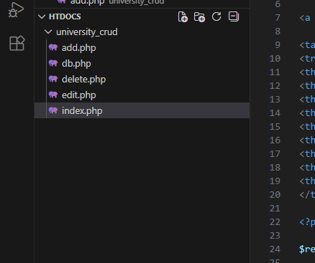
baza yaratish
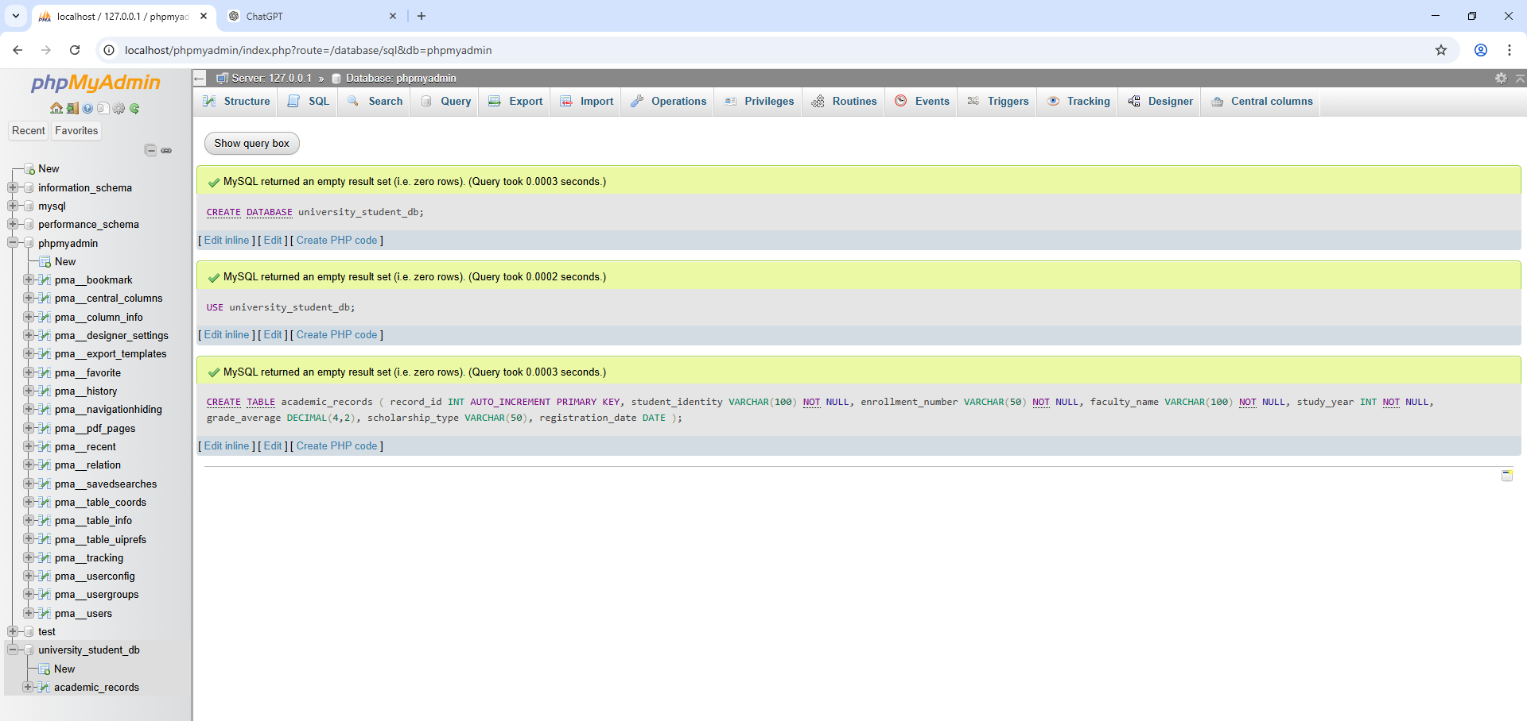

Kod
index.php
<?php
include 'db.php';
?>

<h2>Universitet Talabalari</h2>

<a href="add.php">Yangi talaba qo'shish</a>

<table border="1">
<tr>
<th>ID</th>
<th>Student</th>
<th>Enrollment</th>
<th>Faculty</th>
<th>Year</th>
<th>Average</th>
<th>Scholarship</th>
<th>Date</th>
<th>Action</th>
</tr>

<?php

$result = $conn->query("SELECT * FROM academic_records");

while($row = $result->fetch_assoc()){

echo "<tr>
<td>{$row['record_id']}</td>
<td>{$row['student_identity']}</td>
<td>{$row['enrollment_number']}</td>
<td>{$row['faculty_name']}</td>
<td>{$row['study_year']}</td>
<td>{$row['grade_average']}</td>
<td>{$row['scholarship_type']}</td>
<td>{$row['registration_date']}</td>
<td>
<a href='edit.php?id={$row['record_id']}'>Edit</a>
<a href='delete.php?id={$row['record_id']}'>Delete</a>
</td>
</tr>";

}

?>

</table>

db.php
<?php

$conn = new mysqli("localhost","root","","university_student_db");

if($conn->connect_error){
die("Connection failed: ".$conn->connect_error);
}

?>

add.php
<?php
include 'db.php';

if(isset($_POST['submit'])){

$student_identity = $_POST['student_identity'];
$enrollment_number = $_POST['enrollment_number'];
$faculty_name = $_POST['faculty_name'];
$study_year = $_POST['study_year'];
$grade_average = $_POST['grade_average'];
$scholarship_type = $_POST['scholarship_type'];
$registration_date = $_POST['registration_date'];

$sql = "INSERT INTO academic_records
(student_identity,enrollment_number,faculty_name,study_year,grade_average,scholarship_type,registration_date)

VALUES
('$student_identity','$enrollment_number','$faculty_name','$study_year','$grade_average','$scholarship_type','$registration_date')";

$conn->query($sql);

header("Location:index.php");
}

?>

<h2>Yangi talaba qo'shish</h2>

<form method="POST">

Talaba ismi:
<input type="text" name="student_identity"><br><br>

Enrollment number:
<input type="text" name="enrollment_number"><br><br>

Faculty:
<input type="text" name="faculty_name"><br><br>

Study year:
<input type="number" name="study_year"><br><br>

Grade average:
<input type="text" name="grade_average"><br><br>

Scholarship:
<input type="text" name="scholarship_type"><br><br>

Registration date:
<input type="date" name="registration_date"><br><br>

<button type="submit" name="submit">Saqlash</button>

</form>
edit.php
<?php
include 'db.php';

$id = $_GET['id'];

$result = $conn->query("SELECT * FROM academic_records WHERE record_id=$id");

$row = $result->fetch_assoc();

if(isset($_POST['update'])){

$student_identity = $_POST['student_identity'];
$enrollment_number = $_POST['enrollment_number'];
$faculty_name = $_POST['faculty_name'];
$study_year = $_POST['study_year'];
$grade_average = $_POST['grade_average'];
$scholarship_type = $_POST['scholarship_type'];
$registration_date = $_POST['registration_date'];

$conn->query("UPDATE academic_records SET

student_identity='$student_identity',
enrollment_number='$enrollment_number',
faculty_name='$faculty_name',
study_year='$study_year',
grade_average='$grade_average',
scholarship_type='$scholarship_type',
registration_date='$registration_date'

WHERE record_id=$id");

header("Location:index.php");

}

?>

<h2>Talabani tahrirlash</h2>

<form method="POST">

Student:
<input type="text" name="student_identity" value="<?php echo $row['student_identity']; ?>"><br><br>

Enrollment:
<input type="text" name="enrollment_number" value="<?php echo $row['enrollment_number']; ?>"><br><br>

Faculty:
<input type="text" name="faculty_name" value="<?php echo $row['faculty_name']; ?>"><br><br>

Year:
<input type="number" name="study_year" value="<?php echo $row['study_year']; ?>"><br><br>

Average:
<input type="text" name="grade_average" value="<?php echo $row['grade_average']; ?>"><br><br>

Scholarship:
<input type="text" name="scholarship_type" value="<?php echo $row['scholarship_type']; ?>"><br><br>

Date:
<input type="date" name="registration_date" value="<?php echo $row['registration_date']; ?>"><br><br>

<button name="update">Yangilash</button>

</form>
delete.php
<?php

include 'db.php';

$id = $_GET['id'];

$conn->query("DELETE FROM academic_records WHERE record_id=$id");

header("Location: index.php");

?>

Natija :
