Lobaratoriya ishi – 2
Mavzu: Matn formatlash elementlari bilan ishlash

Ishning maqsadi:
HTML tili yordamida veb-sahifada matnni turli formatlash elementlari orqali to‘g‘ri va chiroyli tarzda aks ettirishni o‘rganish.

Nazariy qism:
HTML tili matnni formatlash uchun turli teglar (elementlar)dan foydalanadi.

Matn formatlash tushunchasi
Matn formatlash — bu hujjatdagi matnning tashqi ko‘rinishini o‘zgartirish jarayonidir. Formatlash yordamida matn chiroyli, o‘qilishi oson va tartibli shaklga keltiriladi.
Matnni formatlashning asosiy maqsadi — foydalanuvchiga axborotni qulay, estetik va aniq shaklda yetkazishdir.

Matn formatlash turlari
Matn formatlash ikki asosiy turga bo‘linadi:

- Belgilarni formatlash (Character formatting)
Bu matndagi harflar yoki belgilar ko‘rinishini o‘zgartiradi. Masalan:
  - Shrift turi (font family)
  - Shrift o‘lchami (font size)
  - Shrift rangi (font color)
  - Qalin, kursiv, tagi chizilgan, belgilangani (bold, italic, underline, mark)
  - Yuqori/past indeks (superscript/subscript)

- Paragrafni formatlash (Paragraph formatting)
Bu butun paragraf yoki satrning joylashuvini o‘zgartiradi:
  - Tekislash (chapga, o‘ngga, markazga yoki ikki tomonga)
  - Satrlar oralig‘i (line spacing)
  - Paragraf oralig‘i (space before/after)
  - Chegaralar (margin)
  - Ro‘yxatlar (bulleted va numbered)
Amaliy topshiriq
Vazifa : Bugungi mavzuda biz matn formatlash teglaridan foydalangan holda web-sahifamizga yangi o’zgarishlar berdik. Foydalanilgan teglar sariq rang bilan ko’rsatildi:
Kod :
<!DOCTYPE html>
<html lang="uz">
<head>
<meta charset="UTF-8">
<meta name="viewport" content="width=device-width, initial-scale=1.0">
<title>BilimUyi Sayti</title>
<style>
body {font-family: Arial, sans-serif; margin:0; padding:0; line-height:1.6; background:#f9f9f9;}
header, footer {background:#1f2c3a; color:white; padding:20px; text-align:center;}
nav ul {list-style:none; padding:0; margin:0; display:flex; justify-content:center; background:#2c3e50;}
nav ul li {margin:0 15px;}
nav ul li a {color:white; text-decoration:none; font-weight:bold;}
main {padding:20px; max-width:1000px; margin:0 auto;}
table {width:100%; border-collapse:collapse; margin:20px 0;}
table, th, td {border:1px solid #ccc; padding:10px; text-align:left;}
form {margin:20px 0; background:#f0f0f0; padding:15px; border-radius:5px;}
form input, form select, form textarea, form button {display:block; margin:10px 0; padding:8px; width:100%;}
.kitoblar {display:grid; grid-template-columns: repeat(3, 1fr); gap:20px; margin-top:20px;}
.kitob {border:1px solid #ddd; padding:10px; border-radius:5px; text-align:center; background:white;}
.kitob img {max-width:120px; margin-bottom:10px; border-radius:5px;}
footer p {margin:5px;}
h1,h2,h3,h4 {color:#1f2c3a;}
blockquote {border-left:4px solid #1f2c3a; padding-left:15px; color:#555; font-style:italic; background:#eef2f7; margin:20px 0;}
</style>
</head>
<body>

<header>
<h1>📚 BilimUyi</h1>
<p><i>Xush kelibsiz! </i>Bilim olamiga yangi qadam tashlang</p>
</header>

<nav>
<ul>
<li><a href="#home">Bosh sahifa</a></li>
<li><a href="#books">Kitoblar</a></li>
<li><a href="#register">A’zolik</a></li>
<li><a href="#contact">Aloqa</a></li>
</ul>
</nav>

<main>
<section id="home">
<h2>💻 Elektron Kutubxona - BilimUyi</h2>
<hr>
<p>
<strong>BilimUyi</strong> — bu <em>zamonaviy kutubxona</em>,
unda <b>kitoblar</b>, <u>maqolalar</u> va <mark>multimedia resurslari</mark> jamlangan.
Maqsadimiz — <em>har kim uchun bilimni tez va qulay yetkazish</em>.
</p>
</section>

<section id="books">
<h3>📖 Mashhur kitoblar</h3>
<div class="kitoblar">
<div class="kitob">
<img src="https://upload.wikimedia.org/wikipedia/commons/thumb/4/4b/Great_Gatsby_Cover.jpg/220px-Great_Gatsby_Cover.jpg" alt="Kitob">
<h4>Buyuk Gatsby</h4>
<p>Amerika adabiyotining mashhur asari, orzular va boylik haqida.</p>
</div>
<div class="kitob">
<img src="https://upload.wikimedia.org/wikipedia/commons/thumb/3/3f/The_Little_Prince_illustration.jpg/220px-The_Little_Prince_illustration.jpg" alt="Kitob">
<h4>Kichik Shahzoda</h4>
<p>Hayot va sevgining ma’nosini o‘rgatadigan ertak.</p>
</div>
<div class="kitob">
<img src="https://upload.wikimedia.org/wikipedia/commons/thumb/f/fd/War_and_Peace_First_Edition.jpg/220px-War_and_Peace_First_Edition.jpg" alt="Kitob">
<h4>Urush va Tinchlik</h4>
<p>Inson, tarix va falsafani aks ettiruvchi epik roman.</p>
</div>
</div>
</section>

<section id="register">
<h3>📝 A’zolik uchun ro‘yxatdan o‘ting</h3>
<form>
<input type="text" placeholder="To‘liq ism" required>
<input type="email" placeholder="Email manzilingiz" required>
<select>
<option>O‘quvchi</option>
<option>Talaba</option>
<option>O‘qituvchi</option>
</select>
<textarea rows="4" placeholder="Fikr yoki so‘rov..."></textarea>
<button type="submit">Jo‘natish</button>
</form>
</section>

<section id="contact">
<h4>📬 Aloqa</h4>
<p>Email: <a href="mailto:info@bilimuyi.uz">info@bilimuyi.uz</a></p>
<p>Manzil: Toshkent shahri, Amir Temur ko‘chasi, 50-uy</p>
</section>

<blockquote>
“BilimUyi — bu bilim olamiga tezkor kirish va cheksiz imkoniyatlar eshigi.”
</blockquote>
</main>

<footer>
<p>&copy; 2025 BilimUyi</p>
</footer>

</body>
</html>
Kodning natijasi:
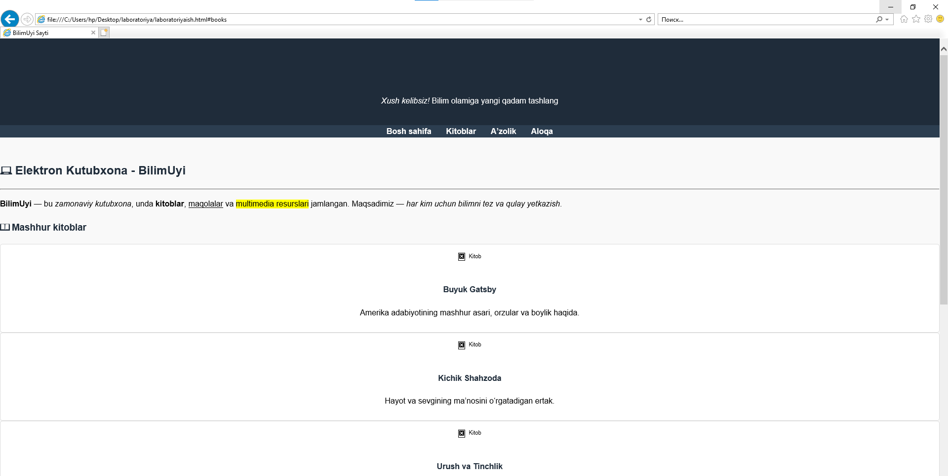

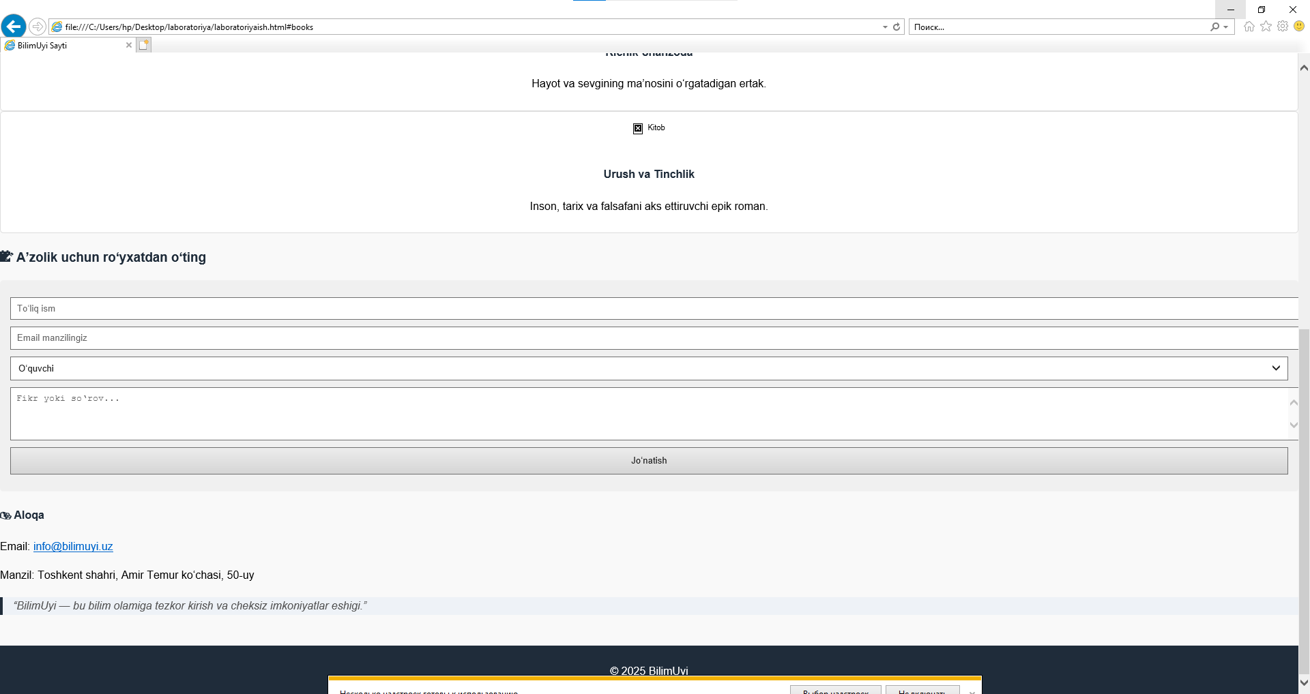
Xulosa
Laboratoriya ishida matn formatlash elementlari nafaqat matnning tashqi ko‘rinishini yaxshilash, balki veb-sahifa semantik tuzilishini yaratish va foydalanuvchi tajribasini oshirish uchun zarur ekanligi amalda tasdiqlandi.
Shu bilan birga, HTML matn elementlari yordamida sahifani vizual, strukturaviy va semantik jihatdan boyitish mumkinligi o‘rganildi.

