Laboratoriya ishi - 14
Mavzu : Formani JavaScript orqali tekshirish (validation)

Ishning maqsadi - Ushbu laboratoriya ishining maqsadi — veb-sahifalarda foydalanuvchi tomonidan forma maydonlariga kiritilayotgan ma’lumotlarni JavaScript yordamida tekshirish, xatoliklarni aniqlash va foydalanuvchiga real vaqt rejimida to‘g‘ri ma’lumot kiritishga yordam berishni o‘rganish.
Bunda talabalar client-side validation tushunchasi, uning afzalliklari, ishlash prinsiplari va amaliy qo‘llanilishini o‘zlashtiradilar.

Nazariy qism

1. Forma tekshirish (Validation) haqida umumiy tushuncha
Validation — bu foydalanuvchi forma maydoniga kiritgan ma’lumotning maqsadga muvofiq, to‘g‘ri va xavfsiz ekanligini tekshirish jarayonidir. To‘g‘ri validatsiya web-ilovalarning xavfsizligi va funksionalligini ta’minlaydi.
Validatsiya ikki turga bo‘linadi:

1) Client-side validation (Brauzerda tekshirish)
- JavaScript yordamida amalga oshiriladi
- Juda tez ishlaydi
- Ma’lumot yuborilishidan oldin xatolarni ko‘rsatadi
- Serverga yukni kamaytiradi
- Optimal foydalanuvchi tajribasini yaratadi

2) Server-side validation (Serverda tekshirish)
- Yakuniy tekshirish serverda (PHP, Node.js va h.k.) bajariladi
- Xavfsizlik uchun majburiy
Client-side validation bilan birgalikda ishlatiladi

2. Nega client-side validation kerak?
- Foydalanuvchi xatolarini darhol ko‘rsatadi
- Foydalanuvchi tomonidan noto‘g‘ri yoki zararli ma’lumot yuborilishining oldini oladi
- Forma yuborilishidan oldin minimal tekshiruvni amalga oshiradi
- Resurslar iqtisodi ta’minlanadi (serverga ortiqcha so‘rovlar kamayadi)

3. JavaScript orqali forma ma’lumotlarini tekshirish usullari

1. Bo‘sh maydonlarni tekshirish
if (name === "") { ... }

2. Email formatini tekshirish (Regex)
/^[^\s@]+@[^\s@]+\.[^\s@]+$/

3. Parolni tekshirish (uzunligi, murakkabligi)
- Kamida 6 ta belgidan iborat bo‘lishi
- Harflar va sonlar kombinatsiyasi

4. Telefon raqam tekshiruvi
- Maxsus format: +998 XX XXX XX XX

5. Sonlar, yosh, qiymatlar diapazonini tekshirish
if (age < 18) { ... }

6. Real-time validation (oninput)
Maydonga yozilganda darhol tekshiruv.
4. JavaScriptda validationning afzalliklari
- Oson amalga oshiriladi
- Ustiga yozish (custom rules) oson
- UX (foydalanuvchi tajribasi) yaxshilanadi
- Xatoliklarni vizual ko‘rsatish imkoniyati bor
- Formaning to‘g‘ri to‘ldirilishini nazorat qiladi
Laboratoriya ishini bajarilish tartibi
Formani JavaScript orqali tekshirish (validation) shu mavzudan foydalanib O`zbеk milliy taоmlari хaQida web sayt yaratish.

Kod:
<!DOCTYPE html>
<html lang="uz">
<head>
<meta charset="UTF-8" />
<meta name="viewport" content="width=device-width, initial-scale=1.0"/>
<title>O‘zbek Milliy Taomlari</title>
<style>
* { margin: 0; padding: 0; box-sizing: border-box; }
body {
font-family: 'Segoe UI', Tahoma, Geneva, Verdana, sans-serif;
line-height: 1.6;
color: #333;
background: #f8f1e9;
}
header {
background: linear-gradient(rgba(0,0,0,0.6), rgba(0,0,0,0.6)), url('https://source.unsplash.com/random/1600x900/?plov') no-repeat center center/cover;
color: white;
text-align: center;
padding: 100px 20px;
}
header h1 { font-size: 3.5rem; margin-bottom: 10px; }
header p { font-size: 1.3rem; }
nav {
background: #8B4513;
padding: 15px 0;
position: sticky; top: 0; z-index: 100;
}
nav ul {
list-style: none;
display: flex;
justify-content: center;
flex-wrap: wrap;
}
nav ul li { margin: 0 20px; }
nav ul li a {
color: white;
text-decoration: none;
font-weight: bold;
font-size: 1.1rem;
transition: color 0.3s;
}
nav ul li a:hover { color: #FFD700; }

section { padding: 60px 20px; text-align: center; }
h2 { font-size: 2.5rem; margin-bottom: 30px; color: #8B4513; }
.taomlar {
display: grid;
grid-template-columns: repeat(auto-fit, minmax(300px, 1fr));
gap: 30px;
max-width: 1200px;
margin: 0 auto;
}
.card {
background: white;
border-radius: 15px;
overflow: hidden;
box-shadow: 0 5px 15px rgba(0,0,0,0.1);
transition: transform 0.3s;
}
.card:hover { transform: translateY(-10px); }
.card img {
width: 100%;
height: 220px;
object-fit: cover;
}
.card h3 { padding: 15px; font-size: 1.6rem; color: #8B4513; }
.card p { padding: 0 15px 20px; }
#aloqa {
background: #fff8f0;
}
form {
max-width: 600px;
margin: 0 auto;
text-align: left;
}
input, textarea {
width: 100%;
padding: 12px;
margin: 10px 0;
border: 1px solid #8B4513;
border-radius: 8px;
font-size: 1rem;
}
button {
background: #8B4513;
color: white;
padding: 12px 30px;
border: none;
border-radius: 8px;
cursor: pointer;
font-size: 1.1rem;
transition: background 0.3s;
}
button:hover { background: #A0522D; }

.error { color: red; font-size: 0.9rem; display: none; }

footer {
background: #333;
color: white;
text-align: center;
padding: 20px;
}
</style>
</head>
<body>

<header>
<h1>O‘zbek Milliy Taomlari</h1>
<p>Dunyo tan olgan mazali va sermahsul taomlarimiz bilan tanishing</p>
</header>
<nav>
<ul>
<li><a href="#bosh">Bosh sahifa</a></li>
<li><a href="#taomlar">Taomlar</a></li>
<li><a href="#aloqa">Aloqa</a></li>
</ul>
</nav>
<section id="bosh">
<h2>Xush kelibsiz!</h2>
<p>O‘zbek oshxonasi – ming yillik tarixga ega, mehmondo‘stlik va saxiylik ramzi. Bu yerda eng mashhur milliy taomlarimiz haqida ma’lumot beramiz.</p>
</section>
<section id="taomlar">
<h2>Eng mashhur taomlar</h2>
<div class="taomlar">

<div class="card">
<img src="https://source.unsplash.com/random/400x300/?plov" alt="Osh">
<h3>Osh (Palov)</h3>
<p>O‘zbek xalqining eng muhim va eng sevimli taomi. Guruch, go‘sht, sabzi, piyoz va ziravorlardan tayyorlanadi.</p>
</div>
<div class="card">
<img src="https://source.unsplash.com/random/400x300/?manti" alt="Manti">
<h3>Manti</h3>
<p>Qatiq yoki smetana bilan iste’mol qilinadigan xamir ichiga qiyma solib pishiriladigan taom.</p>
</div>
<div class="card">
<img src="https://source.unsplash.com/random/400x300/?shashlik" alt="Shashlik">
<h3>Shashlik</h3>
<p>Qo‘zi yoki mol go‘shtidan tayyorlanadigan ko‘mirda qovurilgan shish kabob.</p>
</div>
<div class="card">
<img src="https://source.unsplash.com/random/400x300/?lagman" alt="Lag‘mon">
<h3>Lag‘mon</h3>
<p>Uyg‘ur va duxoba taomi bo‘lib, qo‘l bilan yasalgan uzun makaron va go‘shtli sousdan iborat.</p>
</div>
<div class="card">
<img src="https://source.unsplash.com/random/400x300/?samsa" alt="Somsa">
<h3>Somsa</h3>
<p>Tandirda pishiriladigan qatlamali xamir ichiga go‘sht, kartoshka yoki qovoq solib pishiriladi.</p>
</div>
<div class="card">
<img src="https://source.unsplash.com/random/400x300/?non" alt="Non">
<h3>O‘zbek noni</h3>
<p>Tandirda pishiriladigan turli shakldagi (obi-non, patir, shirma non) milliy nonlar.</p>
</div>
</div>
</section>

<section id="aloqa">
<h2>Biz bilan bog‘laning</h2>
<form id="contactForm" novalidate>
<label for="ism">Ismingiz *</label>
<input type="text" id="ism" name="ism" required />
<span class="error" id="ismError">Iltimos, ismingizni kiriting (kamida 2 harf)</span>
<label for="tel">Telefon raqamingiz *</label>
<input type="tel" id="tel" name="tel" placeholder="+998 __ ___ __ __" required />
<span class="error" id="telError">To‘g‘ri telefon raqam kiriting (masalan: +998901234567)</span>
<label for="email">Email (ixtiyoriy)</label>
<input type="email" id="email" name="email" />

<label for="xabar">Xabar *</label>
<textarea id="xabar" rows="5" required></textarea>
<span class="error" id="xabarError">Xabar maydonini to‘ldiring</span>
<button type="submit">Yuborish</button>
<p id="success" style="color:green; margin-top:15px; display:none;">Xabar muvaffaqiyatli yuborildi!</p>
</form>
</section>
<footer>
<p>&copy; 2025 O‘zbek Milliy Taomlari. Barcha huquqlar himoyalangan.</p>
</footer>
<script>
const form = document.getElementById('contactForm');
const ismInput = document.getElementById('ism');
const telInput = document.getElementById('tel');
const emailInput = document.getElementById('email');
const xabarInput = document.getElementById('xabar');
const successMsg = document.getElementById('success');
// Xato xabarlarini ko‘rsatish funksiyasi
function showError(input, errorElement) {
errorElement.style.display = 'block';
input.style.borderColor = 'red';
}
function hideError(input, errorElement) {
errorElement.style.display = 'none';
input.style.borderColor = '#8B4513';
}
form.addEventListener('submit', function(e) {
e.preventDefault();
let valid = true;
// Ism tekshiruvi
if (ismInput.value.trim().length < 2) {
showError(ismInput, document.getElementById('ismError'));
valid = false;
} else {
hideError(ismInput, document.getElementById('ismError'));
}
// Telefon tekshiruvi (O‘zbekiston formatlari)
const phoneRegex = /^\+998\s?\d{2}\s?\d{3}\s?\d{2}\s?\d{2}$|^\+998\d{9}$/;
if (!phoneRegex.test(telInput.value.trim())) {
showError(telInput, document.getElementById('telError'));
valid = false;
} else {
hideError(telInput, document.getElementById('telError'));
}
// Xabar tekshiruvi
if (xabarInput.value.trim().length < 10) {
showError(xabarInput, document.getElementById('xabarError'));
valid = false;
} else {
hideError(xabarInput, document.getElementById('xabarError'));
}
if (valid) {
successMsg.style.display = 'block';
form.reset();
setTimeout(() => successMsg.style.display = 'none', 5000);
// Bu yerda haqiqiy serverga yuborish kodi bo‘lishi mumkin edi
}
});
// Real-time tekshirish (ixtiyoriy)
ismInput.addEventListener('input', () => {
if (ismInput.value.trim().length >= 2) hideError(ismInput, document.getElementById('ismError'));
});
telInput.addEventListener('input', () => {
if (/^\+998/.test(telInput.value)) hideError(telInput, document.getElementById('telError'));
});
</script>
</body>
</html>

Natija:
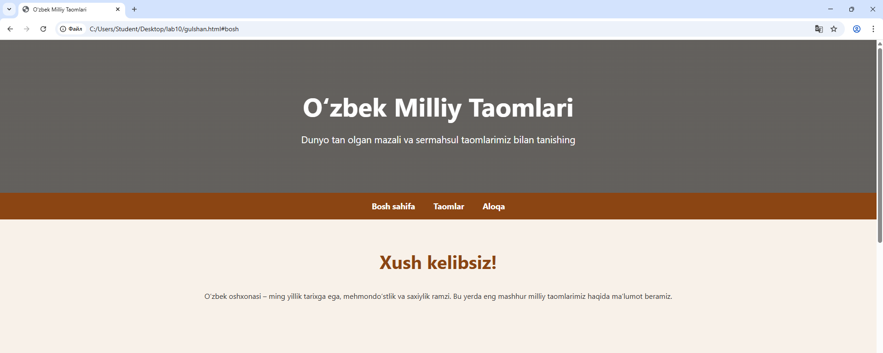
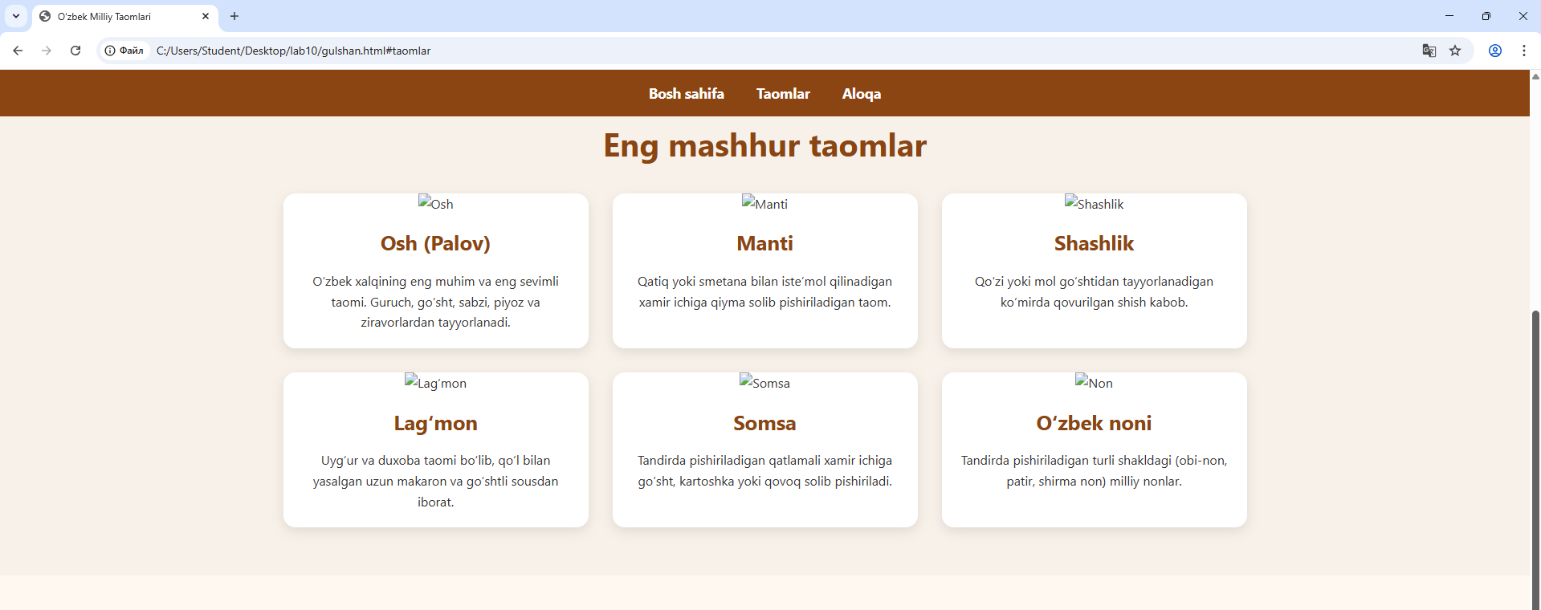

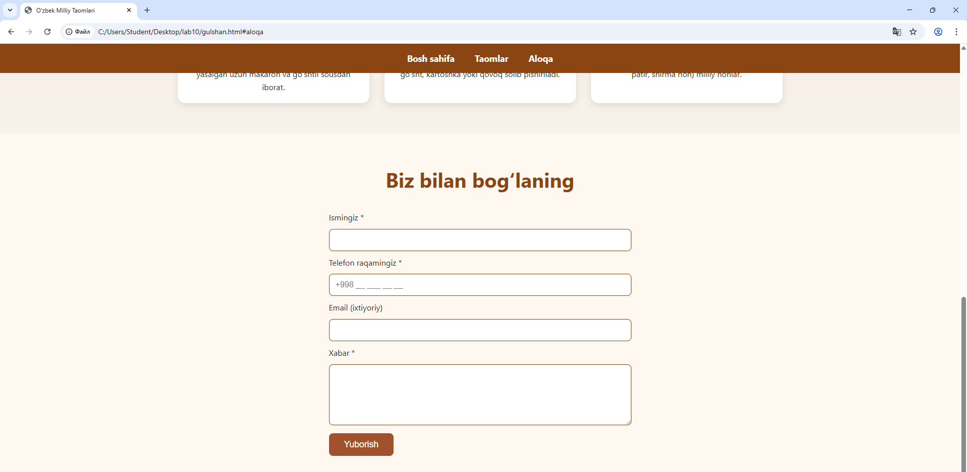

Xulosa
Ushbu laboratoriya ishini bajarish davomida JavaScript yordamida web-formalarda ma’lumotlarni tekshirishning asosiy tamoyillari va usullari o‘rganildi. Forma elementlarining to‘g‘ri to‘ldirilishi web-sahifalarning funksionalligi va xavfsizligini sezilarli darajada oshiradi. Client-side validation foydalanuvchidan kelayotgan ma’lumotni tezkor tekshiradi, foydalanuvchi xatolarini darhol ko‘rsatadi va serverga ortiqcha so‘rov yuborilishining oldini oladi.Shuningdek, email, parol, bo‘sh maydon, raqam va boshqa maydonlarni tekshirish uchun turli texnikalar hamda Regex qo‘llash amaliyotda qo‘llab ko‘rildi. Natijada, JavaScript validatsiyasi web-dasturlarning ajralmas qismi ekanligi aniq ko‘rindi.

