Laboratoriya ishi- 9
Mavzu : CSS media queries orqali responsiv dizayn yaratish

Ishning maqsadi:
Ushbu laboratoriya ishining maqsadi — CSS media queries texnologiyasidan foydalanib web-sahifani turli o‘lchamdagi qurilmalarga (kompyuter, planshet, telefon) moslashuvchan qilishni o‘rganishdir. Shuningdek, foydalanuvchining qurilmasiga qarab dizayn elementlarining o‘zgarishini ta’minlash orqali responsiv web-dizayn yaratish ko‘nikmasini shakllantirish maqsad qilinadi.

Nazariy qism:

Responsiv dizayn (Responsive Design) — bu web-sahifaning turli ekran o‘lchamlariga moslashib, har bir qurilmada qulay va to‘g‘ri ko‘rinishini ta’minlovchi yondashuvdir. Bunday dizayn foydalanuvchi tajribasini yaxshilaydi va saytni universal qiladi. Responsiv dizaynning asosiy texnologiyasi bu — CSS media queries.

Laboratoriya ishning bajarilishi : CSS media queries orqali responsiv dizayn yaratish shu mavzuda O`zbеk milliy taоmlari хaQida foydalanib web sayt yaratish .
Kod:
<!DOCTYPE html>
<html lang="uz">
<head>
<meta charset="UTF-8">
<meta name="viewport" content="width=device-width, initial-scale=1.0">
<title>O'zbek Milliy Taomlari</title>
<style>
/* ======== ASOSIY USLUBLAR ======== */
body {
font-family: 'Segoe UI', sans-serif;
margin: 0;
padding: 0;
background: #fffaf0;
color: #333;
}

header {
background-color: #007a33;
color: white;
text-align: center;
padding: 1rem;
}

nav ul {
list-style: none;
display: flex;
justify-content: center;
gap: 1.5rem;
padding: 0;
margin: 0;
}

nav a {
color: white;
text-decoration: none;
font-weight: bold;
}

.hero {
background: url('https://upload.wikimedia.org/wikipedia/commons/1/16/Uzbek_cuisine.jpg') center/cover no-repeat;
color: white;
text-align: center;
padding: 5rem 1rem;
background-blend-mode: overlay;
background-color: rgba(0, 0, 0, 0.5);
}

.menu {
text-align: center;
padding: 2rem;
}

.taomlar-container {
display: flex;
justify-content: space-around;
flex-wrap: wrap;
gap: 1.5rem;
}

.taom {
background: white;
border-radius: 10px;
box-shadow: 0 2px 6px rgba(0,0,0,0.2);
width: 30%;
padding: 1rem;
}

.taom img {
width: 100%;
border-radius: 10px;
height: 200px;
object-fit: cover;
}

.taom h3 {
color: #007a33;
}

footer {
background-color: #007a33;
color: white;
text-align: center;
padding: 1rem;
margin-top: 2rem;
}

/* ======== RESPONSIV MEDIA QUERIES ======== */

/* Planshetlar uchun */
@media (max-width: 768px) {
nav ul {
flex-direction: column;
gap: 0.5rem;
}

.taomlar-container {
flex-direction: column;
align-items: center;
}

.taom {
width: 80%;
}
}

/* Mobil telefonlar uchun */
@media (max-width: 480px) {
header h1 {
font-size: 1.4rem;
}

.hero {
padding: 3rem 1rem;
}

.taom {
width: 100%;
}

.hero h2 {
font-size: 1.2rem;
}
}
</style>
</head>
<body>

<header>
<h1>O'zbek Milliy Taomlari</h1>
<nav>
<ul>
<li><a href="#bosh">Bosh sahifa</a></li>
<li><a href="#taomlar">Taomlar</a></li>
<li><a href="#aloqa">Aloqa</a></li>
</ul>
</nav>
</header>

<section id="bosh" class="hero">
<h2>Asl o‘zbek taomlarining betakror lazzatini his eting!</h2>
<p>Palov, somsa, lag‘mon, manti — xalqimizning qadimiy taomlari siz uchun!</p>
</section>

<section id="taomlar" class="menu">
<h2>Eng mashhur taomlar</h2>
<div class="taomlar-container">
<div class="taom">
<img src="https://upload.wikimedia.org/wikipedia/commons/5/54/Plov_Uzbekistan.jpg" alt="Palov">
<h3>Palov</h3>
<p>Guruch, sabzi va go‘shtdan tayyorlanadigan milliy taomimiz.</p>
</div>
<div class="taom">
<img src="https://upload.wikimedia.org/wikipedia/commons/2/2d/Samsa_01.jpg" alt="Somsa">
<h3>Somsa</h3>
<p>Go‘shtli yoki sabzavotli tandir pishiriq — milliy nonushta uchun zo‘r tanlov.</p>
</div>
<div class="taom">
<img src="https://upload.wikimedia.org/wikipedia/commons/a/a2/Lagman.jpg" alt="Lag'mon">
<h3>Lag'mon</h3>
<p>Qo‘l bilan cho‘zilgan lapsha va sabzavotli sosdan tayyorlangan noodatiy taom.</p>
</div>
</div>
</section>
<footer id="aloqa">
<p>📞 Biz bilan bog‘laning: <a href="mailto:info@taom.uz">info@taom.uz</a></p>
<p>&copy; 2025 O'zbek Milliy Taomlari. Barcha huquqlar himoyalangan.</p>
</footer>
</body>
</html>
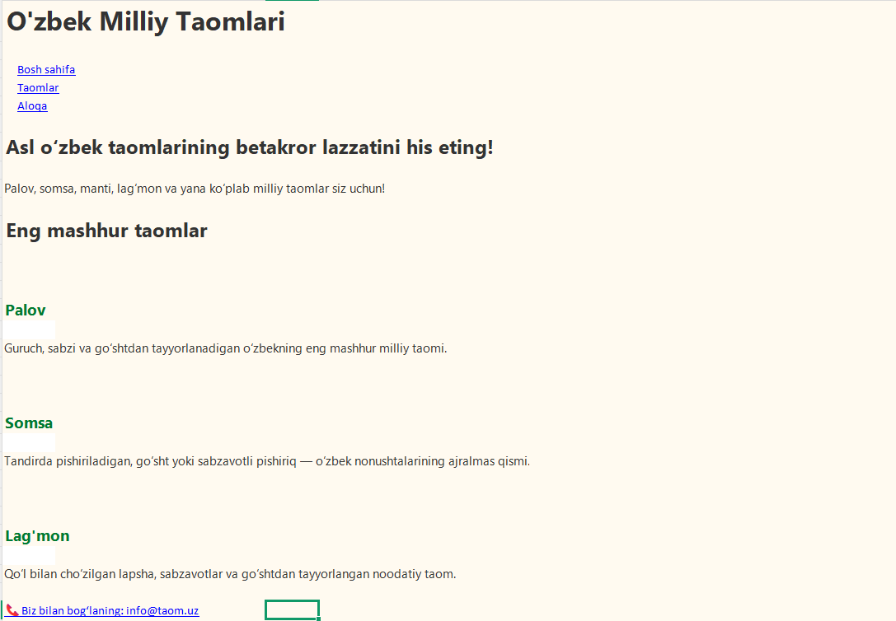

Xulosa :
Ushbu laboratoriya ishida CSS media queries yordamida web-sahifani turli ekran o‘lchamlariga moslashuvchan qilish texnikasi o‘rganildi.
Responsiv dizayn web-dasturlashning ajralmas qismi bo‘lib, u saytning barcha qurilmalarda qulay va estetik ko‘rinishda bo‘lishini ta’minlaydi. Natijada, foydalanuvchilar sayt bilan oson ishlaydi, bu esa sayt samaradorligini oshiradi.

