Laboratoriya ishi – 8
Mavzu: CSS Flexbox va Grid bilan sahifa tartibini yaratish

Ishning maqsadi
Ushbu ishning maqsadi — CSS Flexbox va Grid tizimlaridan foydalanib veb-sahifa tartibini samarali tashkil etish, elementlarni moslashuvchan va estetik tarzda joylashtirish ko‘nikmalarini shakllantirishdir.
Bunda talaba:
- Flexbox va Grid tizimlarining farqini amaliy misollar orqali tushunadi;
- Har xil sahifa strukturalarini yaratish usullarini o‘rganadi;
- Responsiv dizayn (moslashuvchan tartib) yaratish ko‘nikmasini egallaydi.

Nazariy qism
Veb-sahifalarni chiroyli, tartibli va moslashuvchan (responsive) shaklda joylashtirish uchun CSS (Cascading Style Sheets) texnologiyasida maxsus joylashuv tizimlari — Flexbox va Grid qo‘llaniladi.

1. Flexbox (Flexible Box Layout)
Flexbox — bu elementlarni bir o‘q bo‘ylab (gorizontal yoki vertikal) joylashtirishga mo‘ljallangan tizimdir. U elementlarni teng taqsimlash, markazlashtirish, yoki o‘lchamlarini avtomatik moslashtirish imkonini beradi.
Asosiy xususiyatlari:
- display: flex; – konteynerni flex konteynerga aylantiradi;
- flex-direction: – yo‘nalishni belgilaydi (row, column, row-reverse, column-reverse);
- justify-content: – asosiy o‘q bo‘yicha joylashuvni boshqaradi (markazlash, bo‘sh joy qoldirish va h.k.);
- align-items: – ikkinchi o‘q bo‘yicha tekislashni boshqaradi;
- flex-wrap: – elementlarni yangi qatordan joylashtirish imkonini beradi.
Flexbox odatda bir qatordagi yoki ustundagi elementlarni joylashtirish uchun ishlatiladi (masalan, navigatsiya paneli, kartalar qatori, tugmalar bloki).

2. CSS Grid Layout
Grid — bu ikki o‘lchovli (2D) joylashuv tizimi bo‘lib, u qatordan va ustundan iborat tarmoq (grid) orqali elementlarni joylashtirish imkonini beradi.
Asosiy xususiyatlari:
- display: grid; – konteynerni grid tizimiga aylantiradi;
- grid-template-columns: va grid-template-rows: – ustun va qator o‘lchamlarini belgilaydi;
- gap: – qatorlar va ustunlar orasidagi bo‘shliqni belgilaydi;
- grid-column: va grid-row: – elementlarning tarmoqdagi joyini aniqlaydi;
- fr birliklari yordamida joyni mos ravishda taqsimlash mumkin (masalan, 1fr 2fr).
Grid tizimi butun sahifa yoki katta bo‘limlarning tuzilishini yaratishda juda qulay (masalan, header, sidebar, content, footer qismlarini joylashtirish).
Laboratoriya ishini bajarish: CSS Flexbox va Grid bilan sahifa tartibini yaratish shu mavzuda menga shundan foydalanib Ozbеk milliy taоmlari хaQida Web sahifa yaratish .
Kod:
<!doctype html>
<html lang="uz">
<head>
<meta charset="utf-8" />
<meta name="viewport" content="width=device-width, initial-scale=1" />
<title>O'zbek Milliy Taomlari — Flexbox & Grid</title>
<style>
/* GLOBAL */
:root{
--bg: #f7f6f4;
--card: #ffffff;
--accent: #c94f1d;
--muted: #666;
--gap: 18px;
font-family: Inter, system-ui, -apple-system, "Segoe UI", Roboto, "Helvetica Neue", Arial;
}
*{box-sizing: border-box}
body{margin:0;background:var(--bg);color:#222;line-height:1.4}

/* HEADER — Flexbox */
header{
background: linear-gradient(90deg,#fff 0%, #fff0 60%);
border-bottom:1px solid #eee;
padding:16px 20px;
display:flex;
align-items:center;
justify-content:space-between;
gap:12px;
position:sticky;top:0;backdrop-filter:blur(6px);
}
.brand{display:flex;gap:12px;align-items:center}
.logo{
width:52px;height:52px;border-radius:8px;background:var(--accent);display:flex;align-items:center;justify-content:center;color:#fff;font-weight:700;font-size:18px;box-shadow:0 4px 14px rgba(0,0,0,0.06)
}
nav{display:flex;gap:12px;align-items:center}
nav a{color:var(--muted);text-decoration:none;padding:8px 12px;border-radius:8px}
nav a:hover{background:#fff;color:var(--accent);box-shadow:0 2px 8px rgba(0,0,0,0.04)}

/* HERO */
.hero{display:grid;grid-template-columns:1fr 420px;gap:24px;padding:32px 20px;align-items:center}
.hero .lead{background:linear-gradient(180deg,#fff, #fff);padding:26px;border-radius:14px;box-shadow:0 6px 24px rgba(16,24,40,0.06)}
.hero h1{margin:0 0 8px;font-size:28px}
.hero p{margin:0 0 12px;color:var(--muted)}
.cta{display:flex;gap:12px}
.btn{padding:10px 14px;border-radius:10px;border:0;font-weight:600;cursor:pointer}
.btn.primary{background:var(--accent);color:#fff}
.btn.ghost{background:#fff;border:1px solid #eee}

/* MAIN CONTENT — Grid for cards */
main{padding:20px}
.grid{
display:grid;
grid-template-columns:repeat(3,1fr);
gap:var(--gap);
}
/* Card */
.card{background:var(--card);border-radius:12px;padding:12px;box-shadow:0 6px 18px rgba(16,24,40,0.04);display:flex;flex-direction:column;gap:12px}
.card .thumb{height:160px;border-radius:10px;overflow:hidden}
.card img{width:100%;height:100%;object-fit:cover;display:block}
.card h3{margin:0;font-size:18px}
.meta{color:var(--muted);font-size:14px}
.card p{margin:0;color:#333}
.card-footer{margin-top:auto;display:flex;justify-content:space-between;align-items:center}

/* SIDEBAR — Flex column */
.layout{
display:grid;grid-template-columns:1fr 320px;gap:20px;align-items:start
}
aside{background:var(--card);padding:16px;border-radius:12px;box-shadow:0 6px 18px rgba(16,24,40,0.04)}
.tags{display:flex;flex-wrap:wrap;gap:8px}
.tag{background:#fff;padding:8px 10px;border-radius:999px;border:1px solid #f0f0f0;font-size:13px}

/* FOOTER */
footer{padding:20px;border-top:1px solid #eee;margin-top:30px;text-align:center;color:var(--muted)}

/* RESPONSIVE */
@media (max-width:1000px){
.grid{grid-template-columns:repeat(2,1fr)}
.hero{grid-template-columns:1fr}
.layout{grid-template-columns:1fr}
}
@media (max-width:600px){
header{padding:12px}
.brand .logo{width:44px;height:44px}
.grid{grid-template-columns:1fr}
.card .thumb{height:200px}
}

.kitchen{display:flex;gap:8px;align-items:center}
.kitchen img{width:36px;height:36px;border-radius:6px}
</style>
</head>
<body>
<header>
<div class="brand">
<div class="logo">OZ</div>
<div>
<div style="font-weight:700">O'zbek Taomlari</div>
<div style="font-size:12px;color:var(--muted)">An'anaviy taomlar va retseptlar</div>
</div>
</div>
<nav>
<a href="#hero">Bosh sahifa</a>
<a href="#dishes">Taomlar</a>
<a href="#about">Haqida</a>
<a href="#contact">Kontakt</a>
</nav>
</header>

<section class="hero" id="hero">
<div class="lead">
<h1>O'zbek milliy taomlari bilan tanishing</h1>
<p>Plov, manti, samsa va boshqa an'anaviy taomlarimiz haqida qisqacha ma'lumot va rasmli kartalar. Sahifa Flexbox va Grid yordamida yozilgan.</p>
<div class="cta">
<button class="btn primary">Asosiy retseptlar</button>
<button class="btn ghost">Ko'proq o'rganish</button>
</div>
</div>
<div style="display:flex;flex-direction:column;gap:12px;">
<aside style="background:linear-gradient(180deg,#fff,#fff);padding:16px;border-radius:12px;box-shadow:0 6px 18px rgba(16,24,40,0.04)">
<h3 style="margin-top:0">Mashhur taomlar</h3>
<div class="tags">
<div class="tag">Plov</div>
<div class="tag">Manti</div>
<div class="tag">Samsa</div>
<div class="tag">Shashlik</div>
<div class="tag">Lag'mon</div>
<div class="tag">Chak-chak</div>
</div>
<hr style="margin:12px 0;border:none;border-top:1px solid #f0f0f0">
<div style="font-size:14px;color:var(--muted)">Agar xohlasangiz, har bir taom uchun alohida retsept, ingredientlar va tayyorlash bosqichlarini qo'shib beraman.</div>
</aside>
</div>
</section>

<main>
<div class="layout">
<div>
<h2 id="dishes">Taomlar galereyasi</h2>
<p style="color:var(--muted)">Quyida O'zbek milliy taomlarining eng mashhurlari — har biri haqida qisqacha ma'lumot bilan.</p>

<div class="grid">
<!-- Card: Plov -->
<article class="card">
<div class="thumb"><img src="https://images.unsplash.com/photo-1617191515145-5b0b6b5f1b31?q=80&w=1200&auto=format&fit=crop&ixlib=rb-4.0.3&s=1a2b3c" alt="Plov"></div>
<h3>Plov</h3>
<div class="meta">An'anaviy asosiy taom</div>
<p>Plov — guruch, go'sht, piyoz va sabzi asosida tayyorlanadi. Bayram va mehmonxonada pishiriladigan asosiy taomlardan biri.</p>
<div class="card-footer"><span class="meta">Tayyorlanish vaqti: ~1.5 — 2 soat</span><span style="font-weight:700;color:var(--accent)">Asosiy</span></div>
</article>

<!-- Card: Manti -->
<article class="card">
<div class="thumb"><img src="https://images.unsplash.com/photo-1544025162-d76694265947?q=80&w=1200&auto=format&fit=crop&ixlib=rb-4.0.3&s=abcdef" alt="Manti"></div>
<h3>Manti</h3>
<div class="meta">Go'sht bilan pishirilgan dumaloq mantilar</div>
<p>Manti — yupqa xamirga o'ralgan go'sht va piyoz aralashmasi. Ko'pincha bug'da pishiriladi va suyuq yog' bilan servis qilinadi.</p>
<div class="card-footer"><span class="meta">Tayyorlanish vaqti: ~1.5 soat</span><span style="font-weight:700;color:var(--accent)">Mazali</span></div>
</article>

<!-- Card: Samsa -->
<article class="card">
<div class="thumb"><img src="https://images.unsplash.com/photo-1601048141843-8b6f3b1e2b2c?q=80&w=1200&auto=format&fit=crop&ixlib=rb-4.0.3&s=123abc" alt="Samsa"></div>
<h3>Samsa</h3>
<div class="meta">Yog'li xamirli pishiriq</div>
<p>Samsa — go'shtli yoki kartoshkali to'ldirish bilan pechda pishiriladi. Nonushta va mehmondo'stlik uchun juda mashhur.</p>
<div class="card-footer"><span class="meta">Tayyorlanish vaqti: ~1 soat</span><span style="font-weight:700;color:var(--accent)">Tez</span></div>
</article>

<!-- Card: Shashlik -->
<article class="card">
<div class="thumb"><img src="https://images.unsplash.com/photo-1529516549004-3b3d2a4a1eae?q=80&w=1200&auto=format&fit=crop&ixlib=rb-4.0.3&s=9f8e7d" alt="Shashlik"></div>
<h3>Shashlik</h3>
<div class="meta">Go'shtni ko'kat va ziravorlarda pishirish</div>
<p>Shashlik — ochiq olovda pishirilgan go'shtdir. Ko'plab hududlarda yozgi sayr va bayramlarda tayyorlanadi.</p>
<div class="card-footer"><span class="meta">Tayyorlanish vaqti: ~40–60 daq</span><span style="font-weight:700;color:var(--accent)">Bayram</span></div>
</article>

<!-- Card: Lag'mon -->
<article class="card">
<div class="thumb"><img src="https://images.unsplash.com/photo-1604908177522-0a1b3f6c9d2f?q=80&w=1200&auto=format&fit=crop&ixlib=rb-4.0.3&s=456def" alt="Lag'mon"></div>
<h3>Lag'mon</h3>
<div class="meta">No'xta va sho'rva aralashmasi</div>
<p>Lag'mon — qo'l mehnati bilan tayyorlangan uzun nonli qovurilgan makaron va boy sho'rva. Sharqiy O'zbekiston hududlariga xos.</p>
<div class="card-footer"><span class="meta">Tayyorlanish vaqti: ~1 — 1.5 soat</span><span style="font-weight:700;color:var(--accent)">Issiq</span></div>
</article>

<!-- Card: Chak-chak -->
<article class="card">
<div class="thumb"><img src="https://images.unsplash.com/photo-1598370440836-c7b3d9f6b1a3?q=80&w=1200&auto=format&fit=crop&ixlib=rb-4.0.3&s=789ghi" alt="Chak-chak"></div>
<h3>Chak-chak</h3>
<div class="meta">Shirin milliy taom</div>
<p>Chak-chak — asosan asal yoki shakar siropi bilan bog'langan mayda qovurilgan xamir bo'laklari. Bayramlarda va sovg'a sifatida beriladi.</p>
<div class="card-footer"><span class="meta">Tayyorlanish vaqti: ~30–45 daq</span><span style="font-weight:700;color:var(--accent)">Shirin</span></div>
</article>

<!-- Card: Non -->
<article class="card">
<div class="thumb"><img src="https://images.unsplash.com/photo-1563805042-7684c019e1cb?q=80&w=1200&auto=format&fit=crop&ixlib=rb-4.0.3&s=abc123" alt="Non">
</div>
<h3>Non (Patir)</h3>
<div class="meta">Markaziy o'rin tutuvchi non</div>
<p>O'zbek noni — patir shaklida bo'lib, tandirda pishiriladi. Har bir ovqat stolida muhim o'rin tutadi.</p>
<div class="card-footer"><span class="meta">Tayyorlanish vaqti: ~2 soat</span><span style="font-weight:700;color:var(--accent)">Asosiy</span></div>
</article>

</div>
</div>

<aside>
<h3 id="about">Haqida</h3>
<p style="color:var(--muted)">Ushbu sahifa CSS Flexbox va Grid imkoniyatlarini ko'rsatish uchun namunaviy loyihadir. Header — Flexbox bilan, asosiy galereya — Grid bilan tuzilgan. Har bir karta ichida ham Flexbox ishlatilgan: sarlavha, rasm va pastki qismni tartiblash uchun.</p>

<h4 style="margin-top:12px">Qanday o'zgartirish mumkin?</h4>
<ul style="margin:8px 0 0 18px;color:var(--muted)">
<li>Rasmlarni haqiqiy suratlar bilan almashtiring.</li>
<li>Har bir taom uchun alohida sahifa yoki modal qo'shing.</li>
<li>Retsept va ingredientlar bo'limini kengaytiring.</li>
</ul>

<div style="margin-top:12px">
<h4>Kontakt</h4>
<div class="kitchen">
<img src="https://images.unsplash.com/photo-1523986371872-9d3ba2e2f642?q=80&w=400&auto=format&fit=crop&ixlib=rb-4.0.3&s=contact" alt="chef">
<div style="font-size:14px">
<div style="font-weight:700">Oziq-ovqat jamiyati</div>
<div style="color:var(--muted);font-size:13px">example@uzbektaom.uz</div>
</div>
</div>
</div>

</aside>
</div>

<footer>
&copy; 2025 O'zbek milliy taomlari — Namuna loyiha. Barcha huquqlar himoyalangan.
</footer>
</main>

</body>
</html>
Ko’rinishi:
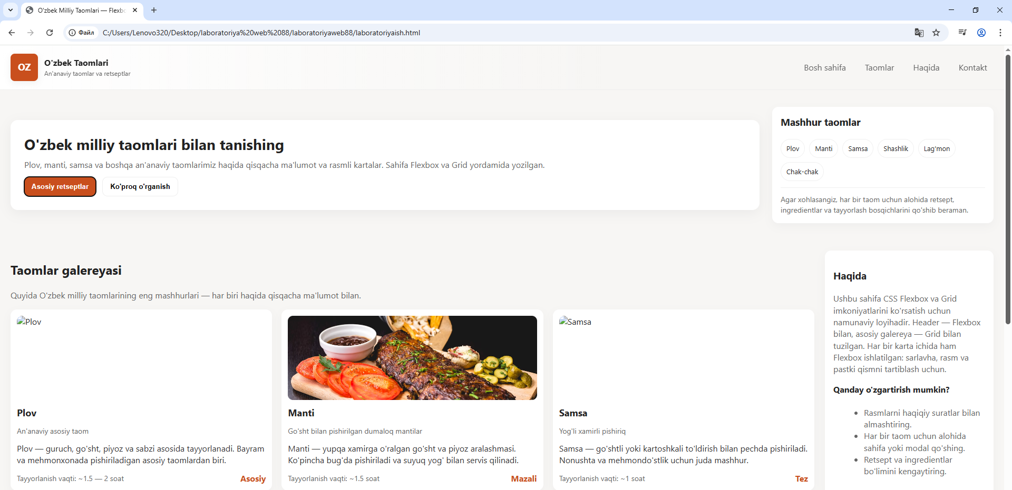
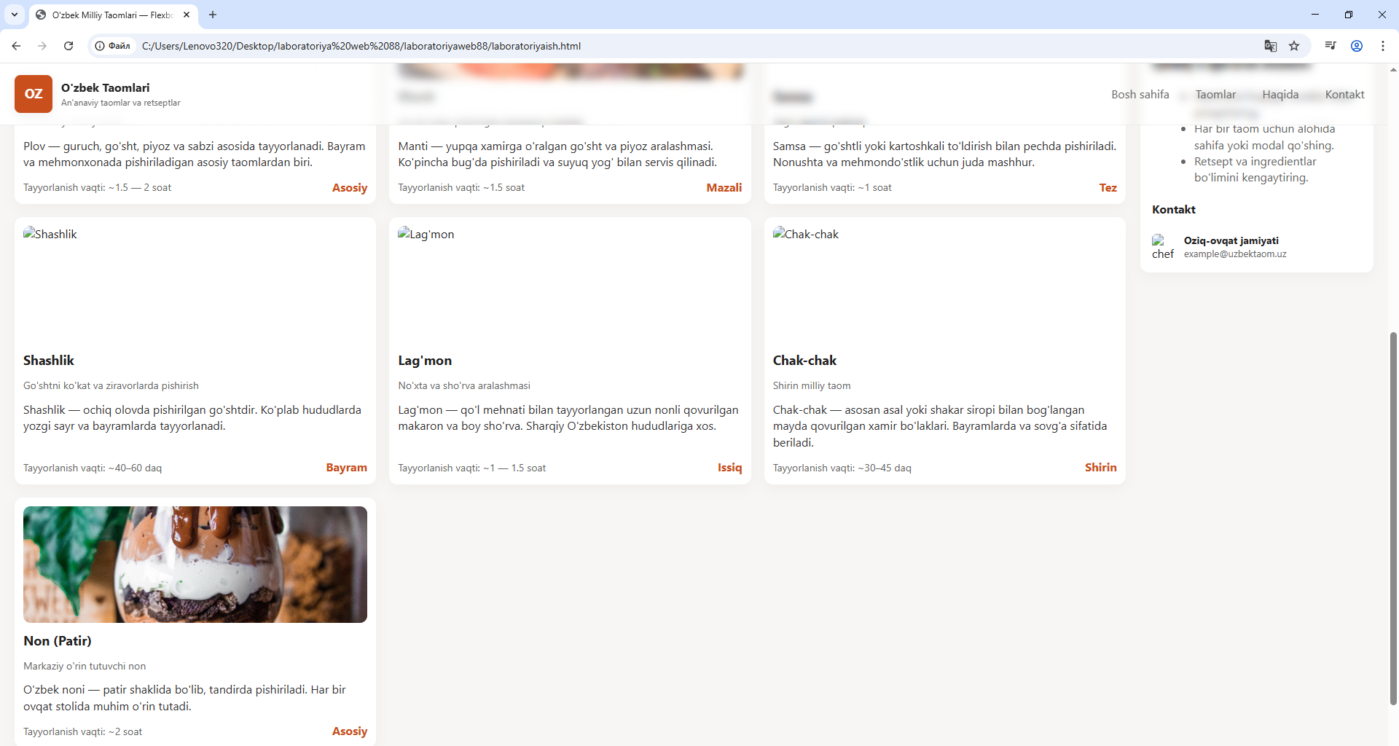

Xulosa
Xulosa qilib aytganda, CSS Flexbox va Grid — zamonaviy veb-dizaynning eng muhim vositalaridir. Ular yordamida sahifalarni moslashuvchan, chiroyli, va tartibli ko‘rinishda yaratish mumkin. Flexbox kichik element guruhlarini joylashtirish uchun qulay bo‘lsa, Grid esa butun sahifa tuzilmasini yaratishda afzal hisoblanadi.
Ushbu texnologiyalarni o‘zlashtirish veb-ishlab chiquvchiga moslashuvchan, responsiv va professional interfeyslar yaratish imkonini beradi. Ushbu amaliy ishda CSS Flexbox va Grid texnologiyalaridan foydalangan holda “O‘zbek milliy taomlari” mavzusida veb-sahifa yaratildi. Ish davomida sahifa tartibini zamonaviy va moslashuvchan qilish uchun Flexbox yordamida header (navigatsiya menyusi) tuzildi, Grid esa asosiy kontent qismi — taomlar galereyasini joylashtirishda ishlatildi.
Natijada, sahifa:
- Har xil ekran o‘lchamlariga (kompyuter, planshet, telefon) mos ravishda avtomatik joylashadi.
- Har bir taom uchun rasm, nomi va qisqacha tavsifi bilan chiroyli tartibda ko‘rsatiladi.
- Flexbox yordamida elementlar gorizontal va vertikal yo‘nalishda silliq tartibda joylashtirilgan.
- Grid tizimi orqali bloklar orasidagi bo‘shliqlar (gap) bir xil saqlanib, dizayn uyg‘unligi ta’minlangan.
Shunday qilib, ushbu ish orqali zamonaviy CSS texnologiyalari yordamida adaptiv (responsive) va vizual jihatdan jozibali veb-sahifa yaratish ko‘nikmasi mustahkamlandi.

