
Assignment Report
Gulshan Bauddh
Computer Software Application

(Supervisor by)
Sulbha P.A.
(Training officer)
Government of India
Ministry of Skill Development and Entrepreneurship, Directorate General of Training
National Skill Training Institute Mumbai, Maharashtra
Chunabhatti, Sion (400022)

Topic 5- Linear Search System

- What is a “Linear Search”?
Linear Search is a simple searching algorithm that checks every element in a list sequentially until a match is found or the end of the list is reached. It is the most basic way to find a specific value within an array, especially when the data is unsorted.

Fields (Inputs)
These are the variables used in your program:
Array Configuration
• Array Limit (n): The total number of elements the user wants to enter.
• Array Elements (arr): The actual numeric values stored in the list.
Search Parameters
• Search Key: The specific number the user is looking for.
• Flag: A variable used to track if the element was found (0 for No, 1 for Yes).
• Index (i): The position where the element is located.
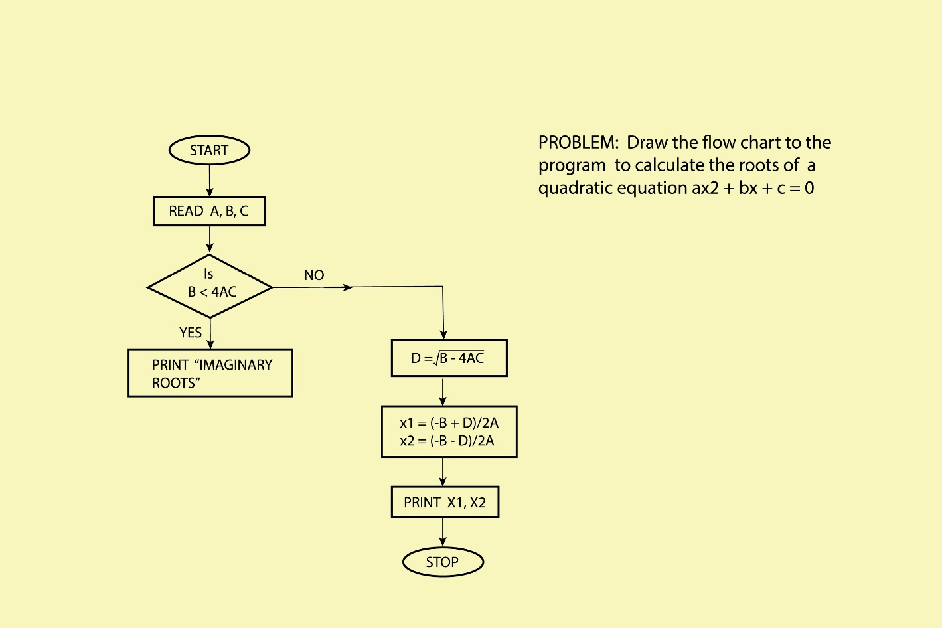
Shutterstock
Explore

Search Logic

Condition Action Result
arr[i] === searchKey Set flag = 1 and Break Element found
i < n (Loop continues) Check next index Searching...
Loop ends & flag == 0 Display "Not Found" Search failed

Algorithm (For Word File)
Algorithm for Linear Search System
- Start
- Input the array limit (n) from the user
- Input (n) number of elements and store them in an array
- Display the entered array elements
- Input the Search Key (the element to find)
- Start a loop from index 0 to n-1
- Compare each element with the Search Key; if they match, set flag = 1 and exit the loop
- If flag is 1, display "Element found" with its index; otherwise, display "Element not found" and Stop

Description
The Linear Search program is developed using JavaScript. The program allows users to define an array's size and content dynamically. It then performs a sequential scan to locate a specific "Search Key." This project is fundamental for understanding how to traverse arrays and use conditional flags to report results back to the user.
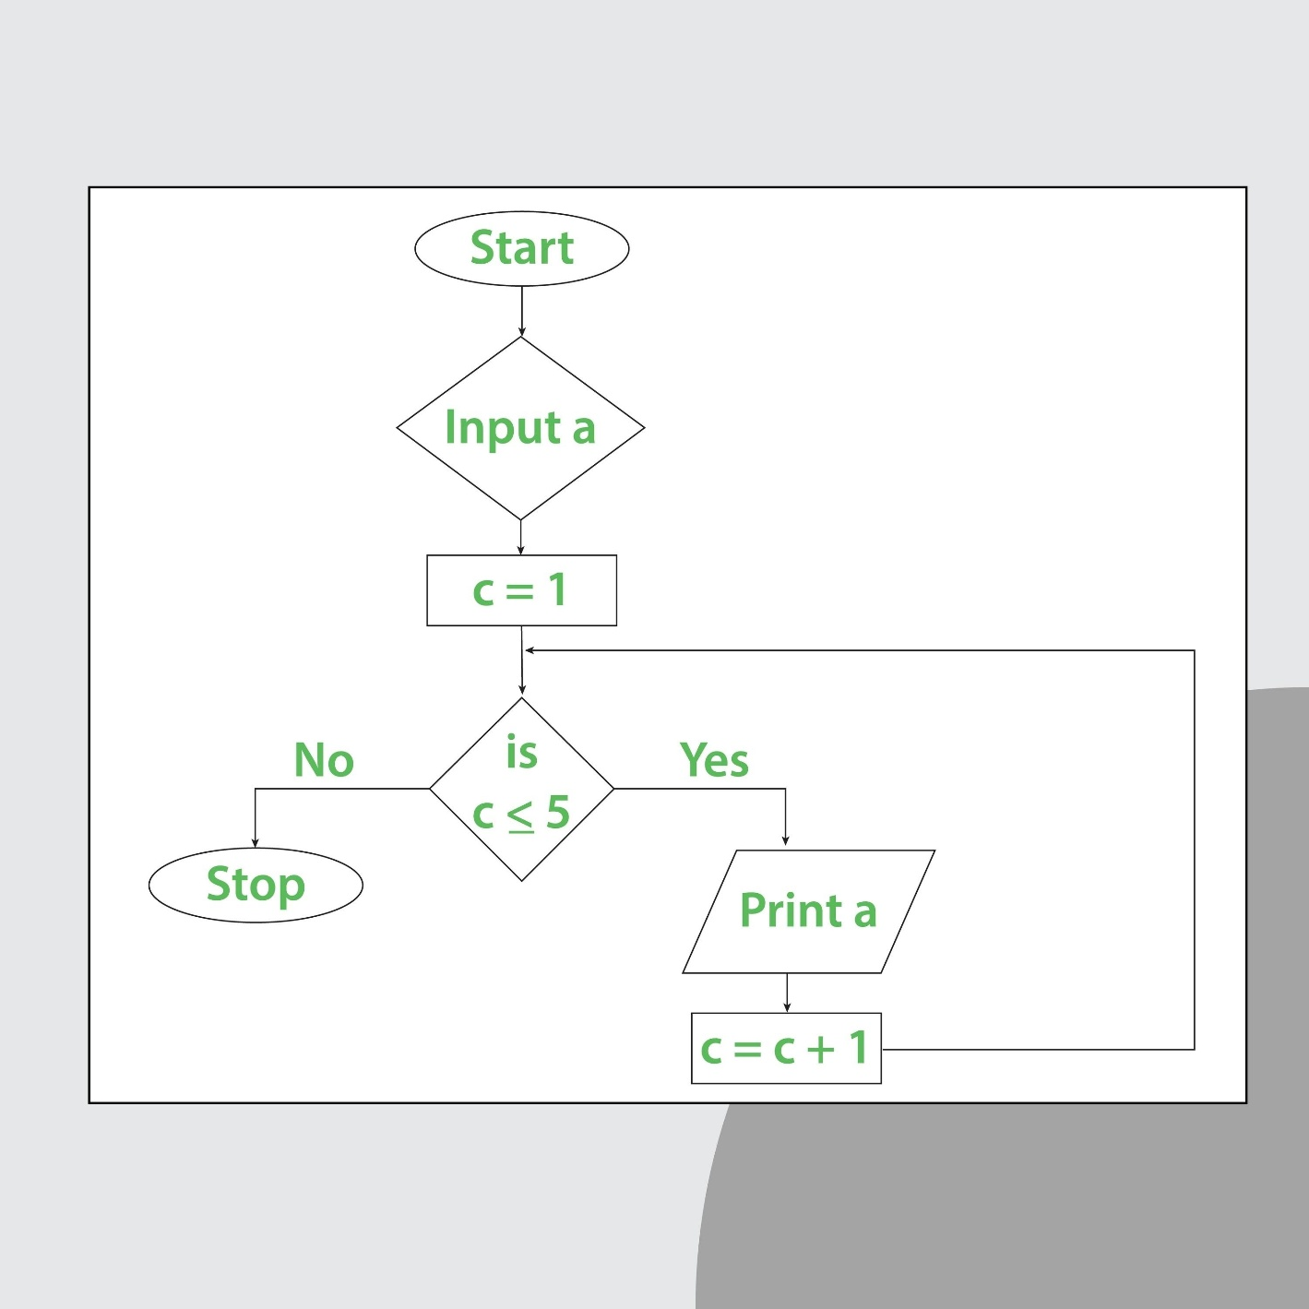
Shutterstock
Explore
Source Code
<html>
<head>
<title>Perform Linear Search:</title>
</head>
<body>
<h2>Perform Linear Search:</h2>
<script>
let n, arr;
n = parseInt(prompt("Enter Array limit."));
arr = new Array(n);
// Read Array
for (let i = 0; i < n; i++) {
arr[i] = parseInt(prompt("Enter Array elements."));
}

document.write("Array Elements are: ");
// Display Array
for (let i = 0; i < n; i++) {
document.write(arr[i] + " ");
}

let flag = 0;
let searchKey = parseInt(prompt("Enter your search key or searching Element:"));
let i; // Declare i outside to use it for index display

for (i = 0; i < n; i++) {
if (arr[i] === searchKey) {
flag = 1;
break;
}
}

if (flag) {
document.write("<br>Element found and your inser Element is : " + searchKey + " and at index : " + i);
} else {
document.write("<br>Element not found and your inser Element is : " + searchKey);
}
</script>
</body>
</html>

Output
Input: Limit: 3, Elements: 10, 20, 30, Search Key: 20
Result: Array Elements are: 10 20 30
Element found and your inser Element is : 20 and at index : 1

Conclusion
The Linear Search program successfully locates elements within a user-defined array using JavaScript. It highlights the importance of loops and break statements in optimizing search operations. This project provides a strong foundation for learning more complex data retrieval techniques.

Would you like me to create the next topic, such as Binary Search or Array Reversal, in this same format?

