Question1. Write a function that stutters a word as if someone is struggling to read it. The first two letters are repeated twice with an ellipsis ... and space after each, and then the word is pronounced with a question mark ?.

**Examples**

stutter("incredible") ➞ "in... in... incredible?"

stutter("enthusiastic") ➞ "en... en... enthusiastic?"

stutter("outstanding") ➞ "ou... ou... outstanding?"

Hint :- Assume all input is in lower case and at least two characters long.

word = input("Enter Stutter word: ")

print(f"{word[:2]}... {word[:2]}... {word}?")

word = input("Stutter word")

def stutter(word):

stuttered_word = word[:2] + " ... " + word[:2] + " ... " + word + "?"

return stuttered_word

stuttered_word = stutter(word)

print(stuttered_word)

Question 2.Create a function that takes an angle in radians and returns the corresponding angle in degrees rounded to one decimal place.

### Examples

radians_to_degrees(1) ➞ 57.3

radians_to_degrees(20) ➞ 1145.9

radians_to_degrees(50) ➞ 2864.8

def Convert(radian):

pi = 3.14159

degree = radian * (180/pi)

return degree

radian = int(input("Enter value of radisan : "))

print("degree =", round((Convert(radian)), 1))

Question 3. In this challenge, establish if a given integer num is a Curzon number. If 1 plus 2 elevated to num is exactly divisible by 1 plus 2 multiplied by num, then num is a Curzon number.

Given a non-negative integer num, implement a function that returns True if num is a Curzon number, or False otherwise.

### Examples

is_curzon(5) ➞ True

# 2 ** 5 + 1 = 33

# 2 * 5 + 1 = 11

# 33 is a multiple of 11

is_curzon(10) ➞ False

# 2 ** 10 + 1 = 1025

# 2 * 10 + 1 = 21

# 1025 is not a multiple of 21

is_curzon(14) ➞ True

# 2 ** 14 + 1 = 16385

# 2 * 14 + 1 = 29

# 16385 is a multiple of 29

def curzon_Num(num):

seq = 2 ** num + 1

add = 2 * num + 1

return seq % add == 0

num = int(input("Enter a number : "))

print(curzon_Num(num))

Question 4.Given the side length x find the area of a hexagon.

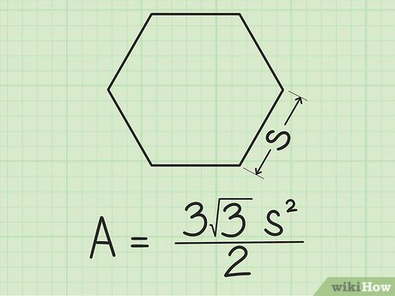

### Examples

area_of_hexagon(1) ➞ 2.6

area_of_hexagon(2) ➞ 10.4

area_of_hexagon(3) ➞ 23.4

import math as m

def hex_area(num):

return (((3 * m.sqrt(3)) * (num * num)) / 2 )

num = int(input("Enter number : "))

print("Area of hexagon : ", round((hex_area(num)),1))

Question 5. Create a function that returns a base-2 (binary) representation of a base-10 (decimal) string number. To convert is simple: ((2) means base-2 and (10) means base-10) 010101001(2) = 1 + 8 + 32 + 128.

Going from right to left, the value of the most right bit is 1, now from that every bit to the left will be x2 the value, value of an 8 bit binary numbers are (256, 128, 64, 32, 16, 8, 4, 2, 1).

### Examples

binary(1) ➞ "1"

# 1*1 = 1

binary(5) ➞ "101"

# 1*1 + 1*4 = 5

binary(10) ➞ "1010"

# 1*2 + 1*8 = 10

def decimal_to_binary(decimal_str):

# Convert the base-10 string to an integer

decimal_int = int(decimal_str)

# Initialize an empty list to store the binary digits

binary_digits = []

# Divide the integer by 2 and store the remainder as the least significant digit

while decimal_int > 0:

binary_digits.append(str(decimal_int % 2))

decimal_int //= 2

# Reverse the list and join the digits to create the binary string representation

binary_str = ''.join(reversed(binary_digits))

# Return the binary string representation

return binary_str

decimal_str = int(input("Enter integer : "))

print(decimal_to_binary(decimal_str))