
LAB 5
LAB 5: D3.JS FORCE-DIRECTED GRAPHS & GITHUB PAGES DEPLOYMENT
Date: 28-09-2026
PROBLEM STATEMENT
Static dashboards and charts show fixed snapshots of data, but they don't let users explore and interact. Interactive visualizations give users power-they can hover, drag, zoom, and discover patterns themselves. D3.js is the industry standard for building these interactive visualizations.
However, building in Jupyter notebooks keeps your work private. This lab teaches you to build an interactive force-directed graph using D3.js in Colab, then deploy it to GitHub Pages so you have a permanent, shareable public URL- a portfolio piece you can show employers and clients.
LEARNING OBJECTIVES
- To write D3.js code in a Colab %%html cell to create an interactive network visualization.
- To understand how D3 binds data to visual elements and responds to user interactions.
- To build a force-directed graph with draggable nodes.
- To build a Sankey diagram representing data flow between different stages.
- To build a hierarchical treemap using D3.js.
- To add interactive hover effects to visualizations.
- To export D3.js visualizations as standalone HTML files.
- To understand the Git workflow required for publishing visualizations.
- To prepare a visualization for deployment using GitHub Pages.
PROCEDURE
TASK 1: BUILD A FORCE-DIRECTED GRAPH
Description
A D3.js force-directed graph was created in a Google Colab %%html cell. The graph represents a data science pipeline consisting of seven major stages:
- Data Cleaning
- EDA
- Feature Engineering
- Model Training
- Evaluation
- Visualization
- Deployment
The nodes are represented using circles and the relationships between stages are represented using lines. The graph also supports interactive dragging of nodes.
Code Used
%%html
<div id="graph"></div>
<script src="https://cdn.jsdelivr.net/npm/d3@7/dist/d3.min.js"></script>
<script>
const width = 700, height = 450;
const nodes = [
{id: "Data Cleaning"},{id: "EDA"},{id: "Feature Engineering"},
{id: "Model Training"},{id: "Evaluation"},
{id: "Visualization"},{id:"Deployment"}];
const links = [
{source: "Data Cleaning", target: "EDA"},
{source: "EDA", target: "Feature Engineering"},
{source: "Feature Engineering", target: "Model Training"},
{source: "Model Training", target: "Evaluation"},
{source: "Evaluation", target: "Visualization"},
{source: "Visualization", target: "Deployment"},
{source: "EDA", target: "Visualization"},];
const svg = d3.select("#graph")
.append("svg")
.attr("width", width)
.attr("height", height)
.style("border", "1px solid #ccc");
const simulation = d3.forceSimulation(nodes)
.force("link", d3.forceLink(links).id(d => d.id).distance(110))
.force("charge", d3.forceManyBody().strength(-320))
.force("center", d3.forceCenter(width / 2, height / 2));
const link = svg.append("g")
.selectAll("line").data(links).join("line")
.attr("stroke", "#999").attr("stroke-width", 1.5);
const node = svg.append("g")
.selectAll("circle").data(nodes).join("circle")
.attr("r", 10).attr("fill", "#69b3a2")
.call(d3.drag()
.on("start", (event, d) => {
if (!event.active) simulation.alphaTarget(0.3).restart();
d.fx = d.x; d.fy = d.y; })
.on("drag", (event, d) => {
d.fx = event.x; d.fy = event.y })
.on("end", (event, d) => {
if (!event.active) simulation.alphaTarget(0);
d.fx = null; d.fy = null; }));
const label = svg.append("g")
.selectAll("text").data(nodes).join("text")
.text(d => d.id).attr("font-size", 11)
.attr("dx", 14).attr("dy", 4);
simulation.on("tick", () => {
link.attr("x1", d => d.source.x).attr("y1", d => d.source.y)
.attr("x2", d => d.target.x).attr("y2", d => d.target.y);
node.attr("cx", d => d.x).attr("cy", d => d.y);
label.attr("x", d => d.x).attr("y", d => d.y); });
</script>
Interpretation
- The D3.js version 7 library was loaded using the jsDelivr CDN.
- The nodes array defines the seven stages of the data science pipeline.
- The links array defines the relationships between the different stages.
- d3.forceSimulation() creates the force-directed layout.
- d3.forceLink() represents the relationships between connected nodes.
- d3.forceManyBody() applies a repulsive force between nodes.
- d3.forceCenter() keeps the graph positioned around the centre of the SVG.
- SVG circles represent the nodes.
- SVG lines represent the connections between nodes.
- Text elements display the names of the pipeline stages.
- d3.drag() provides interactive dragging functionality.
- The tick event continuously updates the positions of the nodes, links and labels.
Output
The force-directed graph was successfully rendered in Google Colab. The graph contains seven circular nodes connected through lines, with labels identifying each stage. The nodes can be dragged interactively.
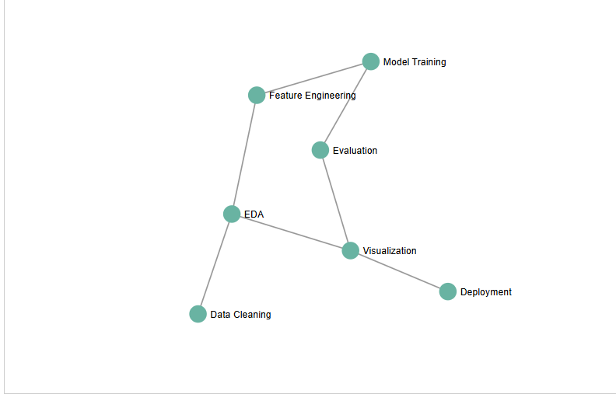

TASK 2: BUILD A SANKEY DIAGRAM
Description
A separate Sankey diagram was developed to represent the flow of data through different stages of a data pipeline.
The input sources were:
- Web Logs
- Mobile App
- CRM Export
The data then flows through processing stages such as Data Cleaning, EDA, Feature Engineering, Model Training and Evaluation. Visualization and Deployment were also included as final stages. A Rejected stage was used to represent data that did not continue after data cleaning.
The d3-sankey library was loaded using the required CDN source.
Data Used
Source / Stage | Target | Flow Value
Web Logs | Data Cleaning | 5000
Mobile App | Data Cleaning | 3000
CRM Export | Data Cleaning | 2000
Data Cleaning | EDA | 8500
Data Cleaning | Rejected | 1500
EDA | Feature Engineering | 6000
EDA | Visualization | 2500
Feature Engineering | Model Training | 4800
Feature Engineering | Evaluation | 1200
Model Training | Evaluation | 4800
Evaluation | Deployment | 5000
Evaluation | Visualization | 1000
Code Used
%%writefile index.html
<!DOCTYPE html>
<html lang="en">
<head>
<meta charset="utf-8">
<title>D3 Sankey – Data Pipeline</title>
</head>
<body>
<div id="graph"></div>
<script src="https://cdn.jsdelivr.net/npm/d3@7/dist/d3.min.js"></script>
<script src="https://cdn.jsdelivr.net/npm/d3-sankey@0.12/dist/d3-sankey.min.js"></script>
<script>
function draw() {
const width = 900, height = 450;
const nodes = [
{name: "Web Logs"},
{name: "Mobile App"},
{name: "CRM Export"},
{name: "Data Cleaning"},
{name: "Rejected"},
{name: "EDA"},
{name: "Feature Engineering"},
{name: "Model Training"},
{name: "Evaluation"},
{name: "Visualization"},
{name: "Deployment"}];
const links = [
{source: "Web Logs", target: "Data Cleaning", value: 5000},
{source: "Mobile App", target: "Data Cleaning", value: 3000},
{source: "CRM Export", target: "Data Cleaning", value: 2000},
{source: "Data Cleaning", target: "EDA", value: 8500},
{source: "Data Cleaning", target: "Rejected", value: 1500},
{source: "EDA", target: "Feature Engineering", value: 6000},
{source: "EDA", target: "Visualization", value: 2500},
{source: "Feature Engineering", target: "Model Training", value: 4800},
{source: "Feature Engineering", target: "Evaluation", value: 1200},
{source: "Model Training", target: "Evaluation", value: 4800},
{source: "Evaluation", target: "Deployment", value: 5000},
{source: "Evaluation", target: "Visualization", value: 1000} ];
const svg = d3.select("#graph")
.append("svg")
.attr("width", width)
.attr("height", height)
.style("border", "1px solid #ccc");
const graph = d3.sankey()
.nodeId(d => d.name)
.nodeWidth(16)
.nodePadding(20)
.extent([[10, 10], [width - 10, height - 10]])
({
nodes: nodes.map(d => ({...d})),
links: links.map(d => ({...d})) });
const color = d3.scaleOrdinal(d3.schemeTableau10);
svg.append("g")
.selectAll("path")
.data(graph.links)
.join("path")
.attr("d", d3.sankeyLinkHorizontal())
.attr("fill", "none")
.attr("stroke", d => color(d.source.name))
.attr("stroke-opacity", 0.4)
.attr("stroke-width", d => Math.max(1, d.width));
const node = svg.append("g")
.selectAll("rect")
.data(graph.nodes)
.join("rect")
.attr("x", d => d.x0)
.attr("y", d => d.y0)
.attr("width", d => d.x1 - d.x0)
.attr("height", d => d.y1 - d.y0)
.attr("fill", d => color(d.name))
.on("mouseover", function (event, d) {
d3.select(this).transition().duration(200)
.attr("fill", d3.color(color(d.name)).brighter(0.7)); })
.on("mouseout", function (event, d) {
d3.select(this).transition().duration(200)
.attr("fill", color(d.name)); });
svg.append("g")
.selectAll("text")
.data(graph.nodes)
.join("text")
.text(d => d.name)
.attr("font-size", 11)
.attr("x", d => d.x0 < width / 2 ? d.x1 + 6 : d.x0 - 6)
.attr("y", d => (d.y0 + d.y1) / 2)
.attr("dy", "0.35em")
.attr("text-anchor", d => d.x0 < width / 2 ? "start" : "end"); }
(function wait() {
if (window.d3 && window.d3.sankey) draw();
else setTimeout(wait, 50); })();
</script>
</body>
</html>
Interpretation
- D3.js and the d3-sankey library are loaded using CDN links.
- The nodes array contains the input sources, processing stages and final stages.
- The links array defines the source, target and value of each flow.
- d3.sankey() calculates the positions and dimensions of the Sankey nodes and links.
- The width of each flow represents its corresponding flow value.
- The rectangular nodes represent different stages of the pipeline.
- The connecting paths represent the movement of data between stages.
- The hover event smoothly changes the node colour when the mouse moves over a node.
- The mouseout event restores the original node colour.
- The final Sankey visualization was saved as a standalone index.html file.

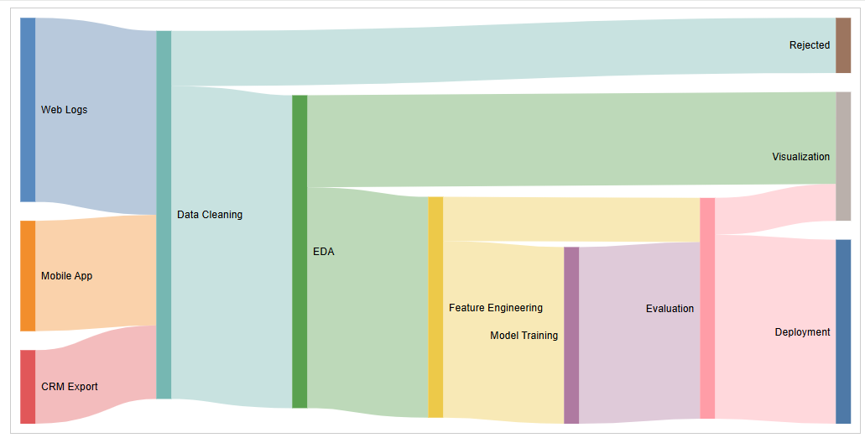
TASK 3: BUILD A TREEMAP (ALL LEVELS)
Description
An interactive treemap visualization was created using D3.js to represent hierarchical data.
The root category is Data Science, which contains four major categories:
- Data Sources
- Data Processing
- Machine Learning
- Visualization
Each category contains individual items with numerical values. The size of each rectangle represents its assigned value.
Hierarchical Data
Category | Item | Value
Data Sources | Web Logs | 5000
Data Sources | Mobile App | 3000
Data Sources | CRM Export | 2000
Data Processing | Data Cleaning | 4000
Data Processing | Data Transformation | 2500
Data Processing | Feature Engineering | 3000
Machine Learning | Model Training | 4500
Machine Learning | Evaluation | 2500
Machine Learning | Deployment | 2000
Visualization | EDA | 3000
Visualization | Dashboards | 2000
Code Used
%%writefile treemap.html
<!DOCTYPE html>
<html>
<head>
<meta charset="UTF-8">
<title>Treemap</title>
</head>
<body>
<div id="treemap"></div>
<script src="https://cdn.jsdelivr.net/npm/d3@7/dist/d3.min.js"></script>
<script>
const width = 900;
const height = 500;
const data = {
name: "Data Science",
children: [
{
name: "Data Sources",
children: [
{name: "Web Logs", value: 5000},
{name: "Mobile App", value: 3000},
{name: "CRM Export", value: 2000} ] },
{
name: "Data Processing",
children: [
{name: "Data Cleaning", value: 4000},
{name: "Data Transformation", value: 2500},
{name: "Feature Engineering", value: 3000} ] },
{
name: "Machine Learning",
children: [
{name: "Model Training", value: 4500},
{name: "Evaluation", value: 2500},
{name: "Deployment", value: 2000} ]},
{
name: "Visualization",
children: [
{name: "EDA", value: 3000},
{name: "Dashboards", value: 2000} ] ] };
const svg = d3.select("#treemap")
.append("svg")
.attr("width", width)
.attr("height", height)
.style("border", "1px solid #ccc");
const root = d3.hierarchy(data)
.sum(d => d.value)
.sort((a, b) => b.value - a.value);
d3.treemap()
.size([width, height])
.paddingOuter(5)
.paddingInner(3)
.paddingTop(25)
(root);
const color = d3.scaleOrdinal(d3.schemeTableau10);
const groups = svg.selectAll(".group")
.data(root.children)
.join("g")
.attr("class", "group");
groups.append("rect")
.attr("x", d => d.x0)
.attr("y", d => d.y0)
.attr("width", d => d.x1 - d.x0)
.attr("height", d => d.y1 - d.y0)
.attr("fill", d => color(d.data.name))
.attr("fill-opacity", 0.25)
.attr("stroke", d => color(d.data.name))
.attr("stroke-width", 2);
groups.append("text")
.attr("x", d => d.x0 + 6)
.attr("y", d => d.y0 + 18)
.text(d => d.data.name)
.attr("font-size", 14)
.attr("font-weight", "bold");
const leaves = svg.selectAll(".leaf")
.data(root.leaves())
.join("g")
.attr("class", "leaf");
leaves.append("rect")
.attr("x", d => d.x0)
.attr("y", d => d.y0)
.attr("width", d => d.x1 - d.x0)
.attr("height", d => d.y1 - d.y0)
.attr("fill", d => color(d.parent.data.name))
.attr("fill-opacity", 0.8)
.attr("stroke", "white")
.attr("stroke-width", 1)
.on("mouseover", function(event, d) {
d3.select(this).transition().duration(200)
.attr("fill-opacity", 1)
.attr("stroke", "black")
.attr("stroke-width", 2); })
.on("mouseout", function(event, d) {
d3.select(this).transition().duration(200)
.attr("fill-opacity", 0.8)
.attr("stroke", "white")
.attr("stroke-width", 1); });
leaves.append("text")
.attr("x", d => d.x0 + 5)
.attr("y", d => d.y0 + 18)
.text(d => d.data.name)
.attr("font-size", 11)
.attr("fill", "black");
leaves.append("text")
.attr("x", d => d.x0 + 5)
.attr("y", d => d.y0 + 33)
.text(d => d.value)
.attr("font-size", 10)
.attr("fill", "black");
</script>
</body>
</html>
Interpretation
- The hierarchical data is structured using d3.hierarchy().
- The .sum(d => d.value) function calculates the numerical value of each parent based on its children.
- d3.treemap() calculates the positions and sizes of the rectangles.
- The major categories are represented using larger background rectangles.
- Leaf nodes represent individual data items.
- The size of each leaf rectangle is proportional to its assigned value.
- Labels display the names of the individual items.
- Numerical values are also displayed inside the rectangles.
- Mouseover and mouseout transitions provide interactive visual feedback.
- The completed treemap visualization was saved as treemap.html.
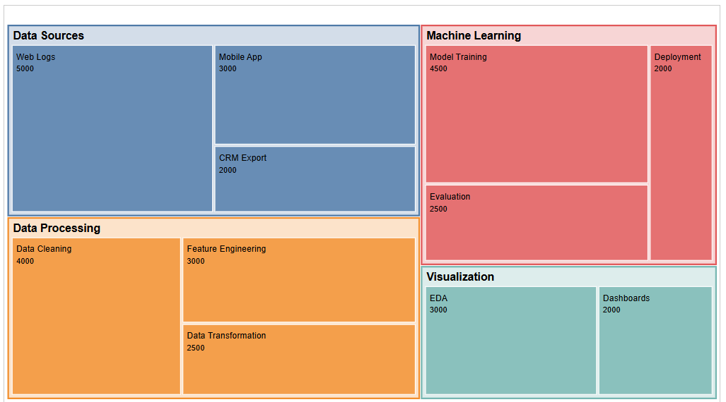
TASK 4: DEPLOY TO GITHUB PAGES
Description
The final task was to deploy one of the HTML visualizations through GitHub Pages. The Lab 5 instructions require an HTML visualization to be placed in a GitHub repository and GitHub Pages to be enabled from the main branch and root folder.
The notebook successfully created and verified the standalone index.html file. The actual GitHub repository and live GitHub Pages URL were not recorded in the notebook, so these details should be added after deployment.
Deployment Procedure
- Create a new GitHub repository, for example LAB_3.
- Add the index.html visualization to the repository.
- Commit the file to the repository.
- Push the file to the main branch.
- Open the repository on GitHub.
- Go to Settings → Pages.
- Under Source, select Deploy from a branch.
- Select the main branch.
- Select the /(root) folder.
- Click Save.
- Wait approximately 1–2 minutes for GitHub Pages deployment.
- Open the generated GitHub Pages URL and verify that the visualization is displayed correctly.
Verification Performed in Notebook
import os
print(os.path.exists("index.html"))
print(os.path.exists("index.html"))
print(os.path.getsize("index.html"))
with open("index.html", "r", encoding="utf-8") as f:
print(f.read()[:1000])
Interpretation
The notebook confirmed that index.html exists successfully. The file size was also checked and the beginning of the HTML source was displayed. This confirms that the visualization was successfully exported as a standalone HTML file.
GITHUB REPOSITORY LINK:
https://github.com/suresh1214/LAB_3 — NOT YET CREATED; repository creation is unavailable through the current GitHub actions.
LIVE GITHUB PAGES URL:
NOT DEPLOYED — repository creation and Pages deployment have not been verified.
GIT COMMIT HISTORY SCREENSHOT:
DATA INSIGHTS & FINDINGS
Key Findings
- The force-directed graph represents the relationships between the major stages of a data science pipeline.
- The graph contains seven pipeline stages and supports direct node dragging.
- The Sankey diagram represents the movement of data from Web Logs, Mobile App and CRM Export into different processing stages.
- The Sankey flow values allow the relative size of different data flows to be represented visually.
- The Data Cleaning stage sends 8,500 units to EDA and 1,500 units to Rejected.
- The EDA stage sends 6,000 units to Feature Engineering and 2,500 units to Visualization.
- The treemap organizes the Data Science hierarchy into Data Sources, Data Processing, Machine Learning and Visualization.
- The size of each treemap rectangle is determined by its assigned value.
- Hover transitions make the Sankey diagram and treemap more interactive.
- The standalone files index.html and treemap.html were successfully generated.
- The HTML file verification confirmed that the standalone visualization file could be loaded and inspected.
Overall Insight
This lab demonstrated how D3.js can transform structured data into interactive web-based visualizations.
The force-directed graph represents relationships, the Sankey diagram represents flow, and the treemap represents hierarchical data volume.
The lab also demonstrated how visualizations developed inside a Colab environment can be exported as standalone HTML files and prepared for deployment using GitHub Pages.
BUSINESS RECOMMENDATIONS / APPLICATIONS
1. Use Force-Directed Graphs for Relationship Analysis
Force-directed graphs can be used to represent relationships between systems, entities, teams or stages of a business process.
2. Use Sankey Diagrams for Flow Analysis
Sankey diagrams can be used to visualize the movement of customers, information, resources, energy, budget or data through different stages.
3. Use Treemaps for Hierarchical Data Analysis
Treemaps provide an efficient way to compare categories and subcategories when the data has a hierarchical structure.
4. Use Interactive Visualizations
Interactive visualizations allow users to explore data directly through features such as hovering, dragging and visual transitions.
5. Publish Standalone Visualizations
D3.js visualizations can be exported as standalone HTML files and shared through web hosting platforms such as GitHub Pages.
6. Maintain Version Control
GitHub can be used to maintain the source code, commit history and deployment version of interactive visualization projects.
CONCLUSION
The objective of this lab was to develop interactive D3.js visualizations and prepare them for web-based deployment.
A force-directed graph was created to represent a seven-stage data science pipeline, with draggable nodes and connected links. A Sankey diagram was developed to visualize data flow from Web Logs, Mobile App and CRM Export through different processing stages. An interactive treemap was also created to represent hierarchical data volumes across Data Sources, Data Processing, Machine Learning and Visualization.
The notebook successfully generated the standalone files index.html and treemap.html and verified the existence and size of index.html.
The final deployment step requires the selected HTML file to be committed to a GitHub repository and published through GitHub Pages.
Overall, this experiment demonstrated the use of D3.js for interactive visualization, data binding, layout generation, interaction handling and preparation of web-based visual analytics.

