AYDIN ADNAN MENDERES UNIVERSITY
CSE 431
NATURAL LANGUAGE PROCESSING WITH
MACHINE LEARNING TERM PROJECT

211805023 GÜLSÜM ÇETİNÖZLÜ
221805032 ZEYNEP SUDE ALTIN

Objective
This project develops a Turkish smart home voice command recognition system using Word2Vec embeddings. The system interprets user speech, understands semantic variations, and maps them to predefined commands. The goal is to compare different sentence embedding techniques to determine the most effective approach for command recognition.

Problem Statement:
Natural language understanding faces challenges when dealing with:
- Semantic variations: Users express the same intent differently ("ışığı yak" vs "lambayı aç")
- Unknown words: Slang or misspellings ("şavkı" for "ışığı")
- Out-of-vocabulary terms: Words not present in pre-trained models
Traditional word-independent approaches fail to capture phrase-level semantics, leading to false matches based on common verbs alone.
Data Set Creation and Model Training
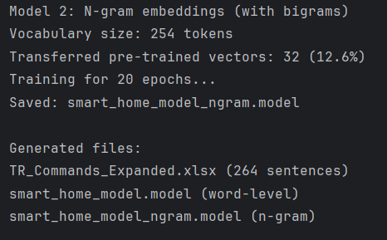
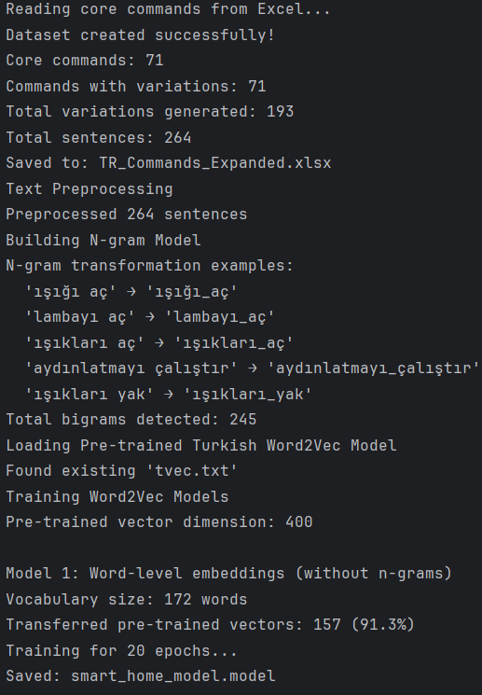

- For each core command, semantically similar phrases were generated
- Training Dataset:
- Core commands: 71
- Total variations: 193
- Total Training Sentences: 264
- Pre-trained model: Turkish Word2Vec
- Fine-tuning: 20 epochs on smart home corpus
- 2 models trained:
- Word-level model: Individual word embeddings
- N-gram model: Phrase-level embeddings
- Sentence Embedding Methods:
- Mean of Word Vectors
- TF-IDF Weighted Mean

Testing with Word Level Model
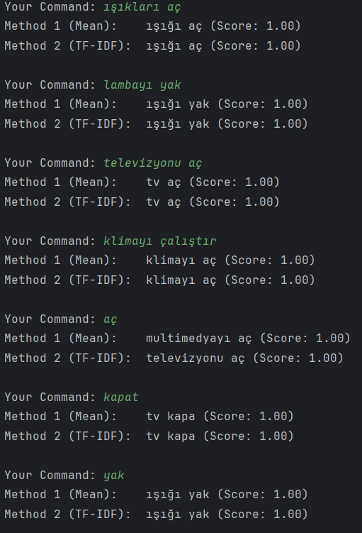
- Single verb "aç" matches different commands with perfect confidence depending on the method. System cannot determine which device the user wants to open.
- Isolated verbs match with 1.00 confidence. The system cannot distinguish between "tv'yi kapat", "ışığı kapat", or "klimayı kapat" when user only says "kapat".
- The word-level model treats words independently. When input contains only a verb, that single word's vector represents the entire command.

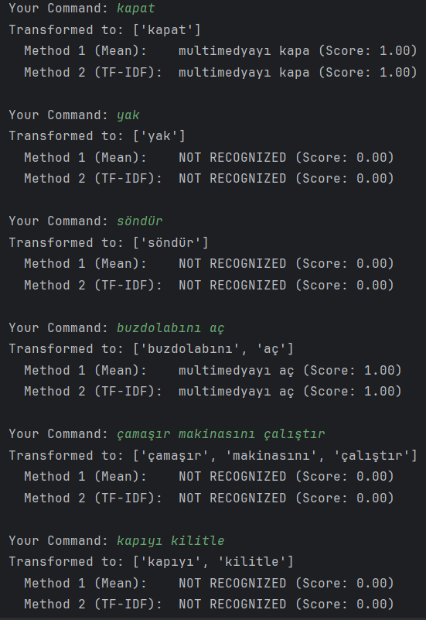
Testing with N-grams Model
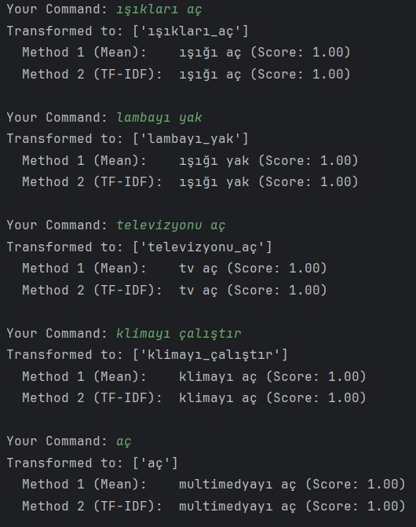

- The n-gram model still accepts isolated verbs with high confidence, similar to the word-level model. This occurs because single words like "aç" and "kapat" exist in the vocabulary as standalone tokens.
- “yak” and “söndür” isolated verbs are properly rejected. The difference in behavior suggests "yak" and "söndür" may not appear as standalone tokens in the training corpus, while "aç" and "kapat" do.
- Out-of-domain device "buzdolabını" is not in vocabulary. The model ignores the unknown word and matches based on "aç" alone, resulting in a false positive.
- Input: "çamaşır makinasını çalıştır"
- Transformed to: ['çamaşır', 'makinasını', 'çalıştır']
- Result: NOT RECOGNIZED (Score: 0.00)
- Input: "kapıyı kilitle"
- Transformed to: ['kapıyı', 'kilitle']
- Result: NOT RECOGNIZED (Score: 0.00)
- Out-of-domain phrases properly rejected.
- The n-gram model provides partial improvement over word-level embeddings. It successfully treats complete phrases as atomic units and rejects some isolated verbs ("yak", "söndür"). However, it still suffers from false positives when encountering common standalone verbs ("aç", "kapat") or when unknown words are paired with known verbs. The model's effectiveness depends heavily on how the training corpus structures individual words versus phrase units.

Evaluation Models
Test Dataset:
- 19 correct commands (variations of training data)
- 20 incorrect commands (out-of-domain phrases)
- Total: 39 test cases
Metrics:
- Precision: Of accepted commands, how many were correct?
- Recall: Of valid commands, how many did we catch?
- F1-Score: Harmonic mean balancing both metrics

METHOD 1 (Mean of Vectors - No N-grams) :
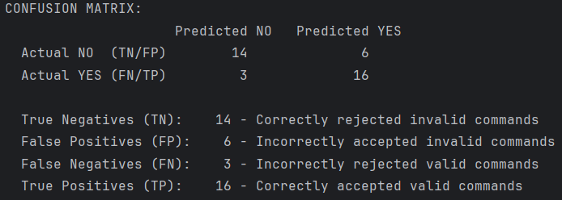
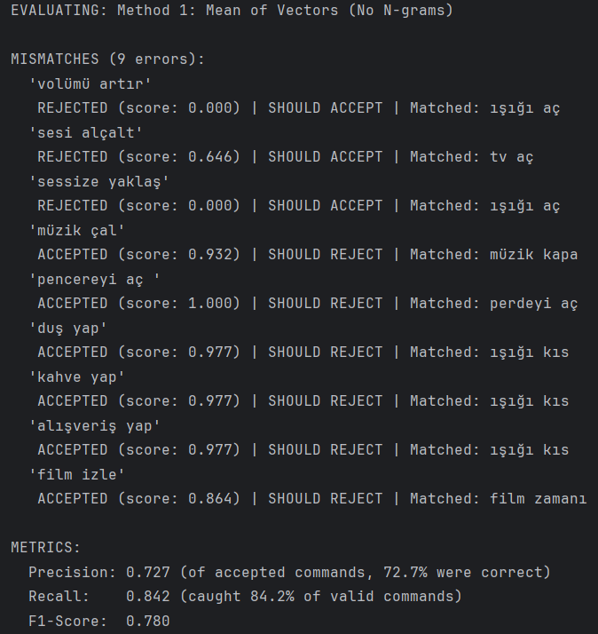
- High recall (84.2%) - catches most valid commands despite vocabulary gaps
- Accepts semantically similar but incorrect commands

METHOD 2 (Mean of Vectors With N-grams) :
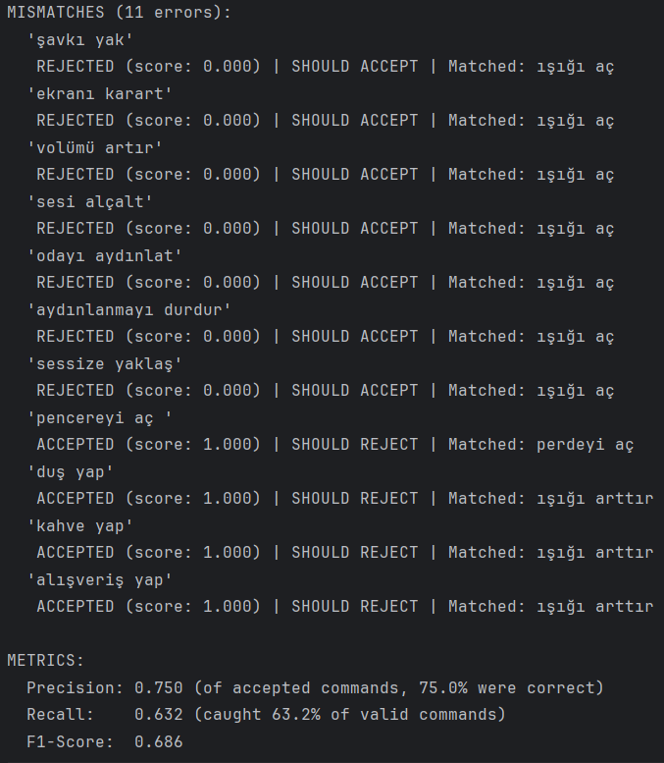
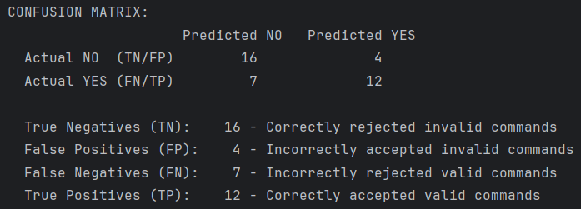
- Higher precision (75.0%) - more conservative, fewer false positives
- Lower recall (63.2%) - rejects valid variations not in training bigrams

METHOD 3 (TF-IDF Weighted - No N-grams) :
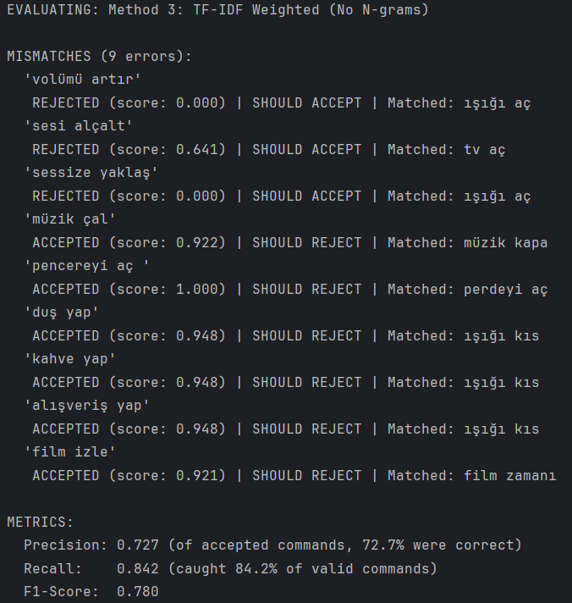
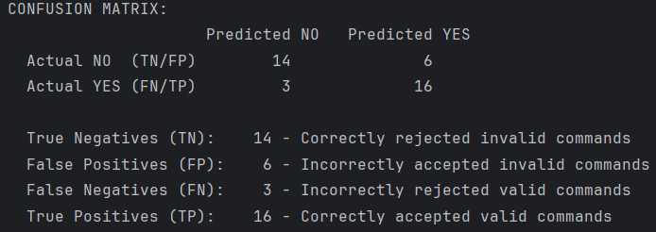
- TF-IDF weighting provides minimal benefit at word level. Common verbs ("aç", "kapat", "yap") get lower weights, distinctive words ("volümü", "pencereyi") get higher weights, but overall performance is unchanged.

METHOD 4 (TF-IDF Weighted With N-grams) :
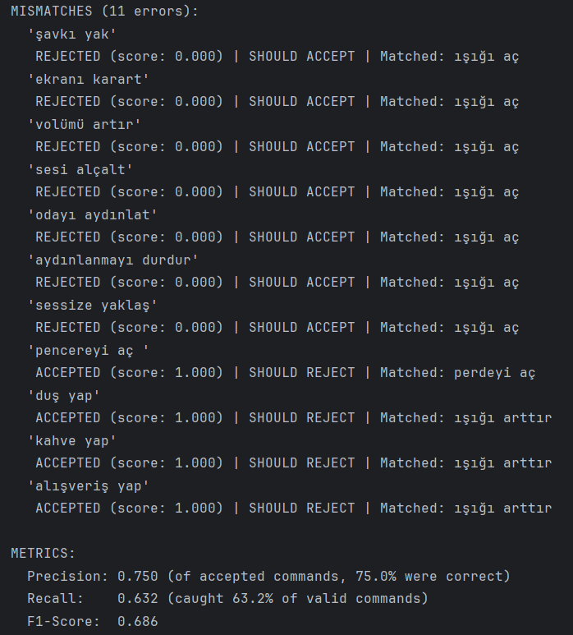
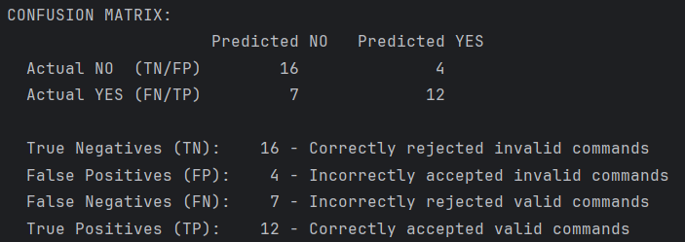
- TF-IDF provides no additional benefit when using n-grams. Since bigrams are already atomic semantic units ("ışığı_aç", "lambayı_yak"), weighting individual n-grams doesn't improve discrimination.

COMPARATIVE ANALYSIS
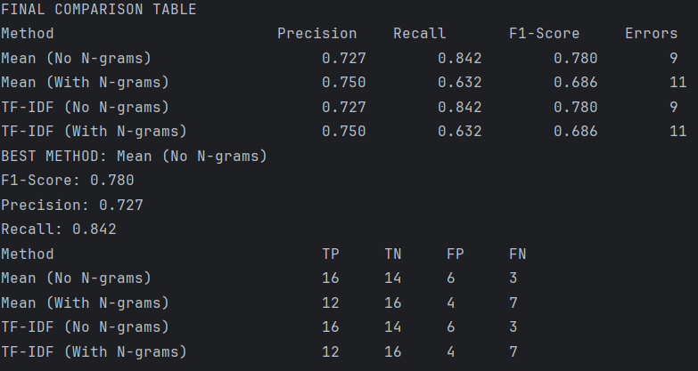
Best Method: Method 1 & 3 (Word-Level approaches) with F1: 0.780
- Word-level embeddings outperform n-gram embeddings in overall F1-score
- N-grams improve precision (+2.3%) but significantly reduce recall (-21.0%)
- TF-IDF weighting shows no measurable improvement over simple mean vectors
- Word-level accepts more commands (good recall) but less selective (lower precision)
For production systems, choose based on use case:
- High recall needed (minimize user frustration): Use Method 1 (Mean, Word-Level)
- High precision needed (minimize wrong activations): Use Method 2 (Mean, N-grams)

Technical Methodology
Word Embeddings (400 Dimensions)
- Word2Vec represents each word as a 400-dimensional vector in mathematical space. Each dimension captures different semantic features of the word. For example, dimensions might encode properties like "is it an action?", "related to light?", "related to sound?". The 400-dimensional space allows the model to capture rich semantic relationships between words. Words with similar meanings (like "ışık" and "lamba") will have vectors pointing in similar directions in this high-dimensional space.
Sentence Embeddings
- To represent entire commands, we aggregate word vectors using two approaches:
- Mean Vector: Arithmetic average of all word vectors in the command
- TF-IDF Weighted: Weighted average where important words (high TF-IDF) contribute more to the final vector
Cosine Similarity
- Cosine similarity measures how similar two vectors are by calculating the cosine of the angle between them. The result ranges from -1 to 1:
- 1.0 = identical meaning (vectors point in same direction)
- 0.0 = unrelated (vectors are perpendicular)
- -1.0 = opposite meaning (vectors point in opposite directions)
- We use cosine similarity because it focuses on the direction of vectors rather than their magnitude, making it ideal for comparing semantic meaning. Even if one sentence is longer than another, cosine similarity captures whether they express similar concepts.
Confidence Threshold (0.75)
- The threshold of 0.75 acts as a decision boundary:
- If similarity ≥ 0.75 → Accept as valid command
- If similarity < 0.75 → Reject as unrecognized
- This threshold was chosen to balance two competing goals:
- Higher threshold : Fewer false positives but misses valid variations
- Lower threshold : Catches more variations but accepts wrong commands
- A threshold of 0.75 provides optimal balance, accepting semantic variations while rejecting unrelated phrases.
- Example:
- "ışığı aç" vs "lambayı aç" → similarity: 0.87 (ACCEPTED)
- "ışığı aç" vs "müzik çal" → similarity: 0.42 (REJECTED)
N-gram Phrase Detection
The n-gram model uses Gensim's Phrases and Phraser to detect and combine frequently co-occurring words into single tokens (e.g., "ışığı" + "aç" → "ışığı_aç"). This treats complete commands as atomic semantic units, preventing false matches based on shared verbs alone.
Limitations:
- Out-of-vocabulary words cause zero vectors, leading to false negatives
- Semantic similarity causes false positives (e.g., "pencereyi aç" matches "perdeyi aç")
- N-grams require exact phrase structure, reducing flexibility
- Performance depends on pre-trained Turkish model quality
- Threshold tuning needed for different domains
- Turkish-specific challenges (agglutination, vowel harmony)

CONCLUSION
- Word-level embeddings (Methods 1 & 3) achieved the best overall performance with F1-Score of 0.780, demonstrating strong recall (84.2%) while maintaining acceptable precision (72.7%).
- TF-IDF weighting provided no measurable improvement over simple mean vectors in our domain, likely because smart home commands are short and have similar term distributions.
- N-gram phrase detection (Methods 2 & 4) improved precision to 75.0% by treating commands as atomic units, but significantly reduced recall to 63.2% due to strict matching requirements.
- The trade-off between precision and recall is clear: word-level models accept more user variations (better user experience) while n-gram models are more conservative (fewer false activations).
REFERENCES
- Turkish Word2Vec: https://github.com/akoksal/Turkish-Word2Vec
- Gensim Documentation: https://radimrehurek.com/gensim/
- Mikolov et al. (2013). "Efficient Estimation of Word Representations"

