**Exercise**

* Solve the following linear program:

maximise 5x1 + 6x2

* subject to

x1 + x2 <= 10

x1 - x2 >= 3

5x1 + 4x2 <= 35

x1 >= 0

x2 >= 0

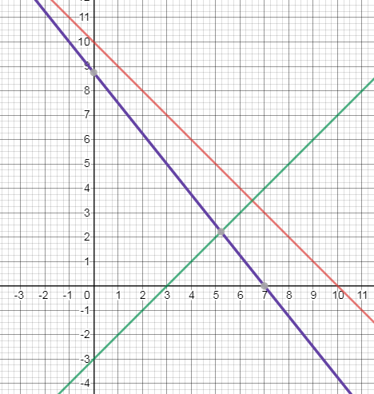

Max(3,0) = 5(3) +6(0) = 15

Max(7,0) = 5(7) + 6(0)

Max(47/9, 20/9) = 5(47/9) + 3(20/9)

= 295/9

= 32.78

5x1 + 4x1 – 12 = 35

9x1 = 47

x1 = 47/9

x2 = 20/9