**WQD 7011 – Numerical Optimization**

**Exercise 4 – Trust Region**

Name : Aswadi Abdul Rahman

Matrix No : WQD180082

Read and try to understand the code, then answer the following questions:

1. Use one sentence to describe the purpose of each function in file (b), (c), and (d).

* Trust_region.py – Define main function to calculate step length in trust region with selected step finder.
* Step_finder.py – Define 2 types of step finders used in trust region (e.g Cauchy point calculation and Dogleg method)
* Linalg_utils.py – Define some self-defined numpy functions such as is_psd, repair_psd and matrix inversion function.
* Psd (positive semidefinite) matrix defined as a symmetric matrix with non-negative eigenvalues

1. Modify the code to display 𝜌 for each iteration.

* Add a line in trust_region.py to achieve that:

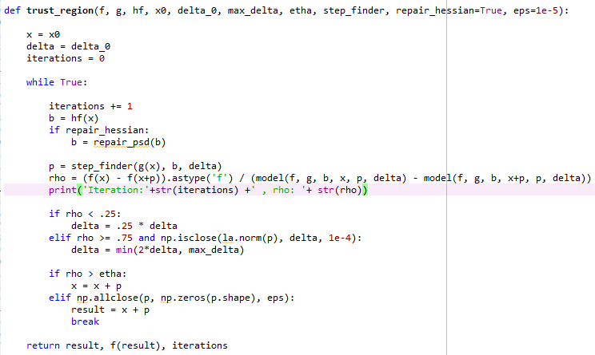

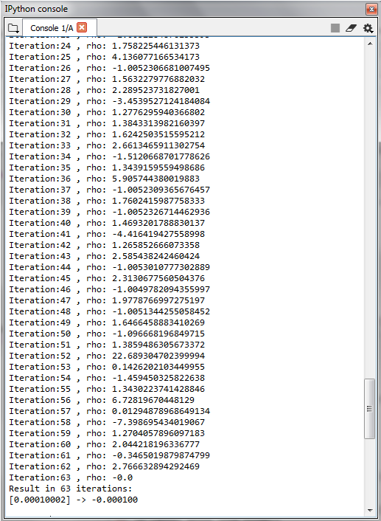

1. What is(are) the convergence criteria(s) for the trust region method?

* The iterations stop when step size found any step finder is equal or close to 0 (~10e-5)

1. Modify the code the use different step finder, and record the 𝜌.

* Change to dogleg_step_finder in main.py

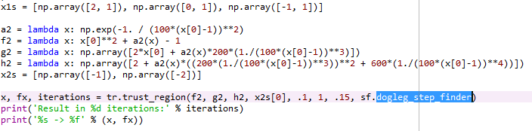

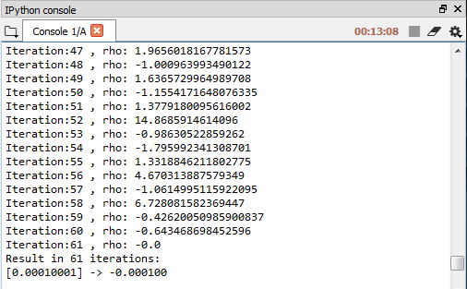

1. From the answers in Q4, compare the recorded results, and state your observation(s).

* The result obtained from both Couchy point method and dogleg method does not show much different (Both get x = 1e-4)
* Couchy point method spend 63iterations to reach convergence and Dogleg method spend 61 iterations to reach convergence.
* Both methods do not show significant difference to find solution but in terms of function complexity Cauchy point calculation is simpler than Dogleg method.