Bilkent University

Computer Engineering

CS 224 – Computer Organization

**Lab Report**

**Lab 5**

**Section 3**

**Gülsüm Güdükbay (21401148)**

**Date Of Lab: 12 April 2016**

**Program Code**

## lab5.asm is a program that reads a text file as a matrix and adds matrices

##

#########################################

# text segment #

#########################################

.text

.globl main

main: #execution starts here

li $v0, 30

syscall

move $s5, $a0

la $t0, size

lw $s0, 0($t0) # $s0 = N

mul $a0, $s0, $s0 # N^2

sll $a0, $a0, 2 # 4xN^2

li $v0, 9 #HEAP

syscall

move $s2, $v0 #store the address of resulting matrix

# Store the matrices read from the files

li $v0, 13

la $a0, mat1

li $a1, 0

li $a2, 0

syscall

move $t1, $v0

#read

li $v0, 14

move $a0, $t1

la $a1, stringBuff

li $a2, 160000000

syscall

move $s1, $v0 #$s1 = no of read chars

#close

li $v0, 16

move $a0, $t1 #restore file desc

syscall

#read buffer for mat1

la $a0, stringBuff

move $a1, $s1

move $a2, $s0

jal read_buffer

move $s3, $v0 #get the adress of the matrix1

# Store the matrix2 read from the file

li $v0, 13

la $a0, mat2

li $a1, 0

li $a2, 0

syscall

move $t1, $v0

#read

li $v0, 14

move $a0, $t1

la $a1, stringBuff

li $a2, 160000000

syscall

move $s1, $v0 #$s1 = no of read chars

#close

li $v0, 16

move $a0, $t1 #restore file desc

syscall

#read buffer for mat2

la $a0, stringBuff

move $a1, $s1

move $a2, $s0

jal read_buffer

move $s4, $v0 #get the adress of the matrix2

li $v0, 30

syscall

move $s6, $a0

sub $a0, $s6, $s5

li $v0, 1

syscall

li $v0, 4

la $a0, spce

syscall

#matrix addition

move $a0, $s3## $a0 = base address of matrix B

move $a1, $s4## $a1 = base address of matrix C

move $a2, $s2## $a2 = base address of matrix A

move $a3, $s0## $a3 = N

jal matrix_addition_intr

li $v0, 30

syscall

sub $a0, $a0, $s6

li $v0, 1

syscall

li $v0, 10

syscall # bye bye

########## READ BUFFER ##########

## $a0 = string buffer address

## $a1 = no of chars

## $a2 = N

## $v0 = adress of matrix

read_buffer:

addi $sp, $sp, -32

sw $ra, 0($sp)

sw $s0, 4($sp)

sw $s1, 8($sp)

sw $s2, 12($sp)

sw $s3, 16($sp)

sw $s4, 20($sp)

sw $s7, 24($sp)

sw $t9, 28($sp)

move $t9, $a0

move $t0, $a0 #index1

move $s1, $a2 # $s1 = N

move $s7, $a1

add $s7, $s7, $a0

## allocate heap space

la $t3, size

lw $t4, 0($t3) # $s0 = N

mul $a0, $t4, $t4 # N^2

sll $a0, $a0, 2 # 4xN^2

li $v0, 9 #HEAP

syscall

move $s0, $v0 #store the address of matrix

move $s4, $s0

j test_rb

read_loop:

lb $t3, 0($t0)

sle $t4, $t3, 57

sge $t5, $t3, 48

and $t4, $t5, $t4

beq $t4, $0, increment

inner_loop:

addi $t1, $t0,1 #index2 = index1+1

j inner_test

increment_i2:

addi $t1, $t1, 1

inner_test:

lb $t6, 0($t1)

sle $t7, $t6, 57

sge $t8, $t6, 48

and $t7, $t8, $t7

bne $t7, $0, increment_i2

addi $a1, $t0,0

addi $a2, $t1,-1

jal string_to_int

move $s3, $v0

sw $s3, 0($s4) # matrix[i] = converted int

addi $t0, $t1,0 #index1 = index2 + 1 %%%%%

addi $s4, $s4, 4

increment:

addi $t0, $t0, 1

test_rb: bne $t0, $s7, read_loop

move $v0, $s0 #return base adress of created matrix

lw $t9, 28($sp)

lw $s7, 24($sp)

lw $s4, 20($sp)

lw $s3, 16($sp)

lw $s2, 12($sp)

lw $s1, 8($sp)

lw $s0, 4($sp)

lw $ra, 0($sp)

addi $sp, $sp, 32

jr $ra

######### STRING TO INT #########

## $a1 = string index1

## $a2 = string index2

## $v0 = converted integer

string_to_int:

addi $sp, $sp, -16

sw $t1, 12($sp)

sw $t2, 8($sp)

sw $t3, 4($sp)

sw $t0, 0($sp)

move $v0, $0

addi $t1, $a2, 0 # i = index2

addi $t2, $0, 1 # times 10^n register

j test

loopConvert:

lb $t3, 0($t1)

subi $t3, $t3, 48 # char to int in ascii values

mul $t3, $t2, $t3 # decimal conversion for the digit

add $v0, $v0, $t3

mul $t2, $t2, 10

addi $t1, $t1, -1

test: bge $t1, $a1, loopConvert

end:

lw $t1, 12($sp)

lw $t2, 8($sp)

lw $t3, 4($sp)

lw $t0, 0($sp)

addi $sp, $sp, 16

jr $ra

######## MATRIX ADDITION ########

## $a0 = base address of matrix B

## $a1 = base address of matrix C

## $a2 = base address of matrix A

## $a3 = N

matrix_addition:

addi $t0, $0, 0 #i = 0

for_out_add:

beq $t0, $a3, for_out_end_add #i! = N

addi $t1, $0, 0 #j = 0

for_in_add:

beq $t1, $a3, for_in_end_add #j! = N

#calculate addresses

mul $t7, $t0, $a3 #i*N

add $t7, $t7, $t1 #i*N+j

sll $t7, $t7, 2 #(i*N+j)*4

add $t3, $t7, $a0 #(base address of matrix B) + offset

add $t4, $t7, $a1 #(base address of matrix C) + offset

add $t5, $t7, $a2 #(base address of resultant matrix A) + offset

#sum

lw $t9, ($t5) #load matrix A

lw $t8, ($t3) #load matrix B

lw $t6, ($t4) #load matrix C

add $t9, $t8, $t6 #add

sw $t9, ($t5)

addi $t1, $t1, 1

j for_in_add

for_in_end_add:

addi $t0, $t0, 1

j for_out_add

for_out_end_add:

jr $ra

######## MATRIX ADDITION LOOP INDTERCHANGE ########

## $a0 = base address of matrix B

## $a1 = base address of matrix C

## $a2 = base address of matrix A

## $a3 = N

matrix_addition_intr:

addi $t1, $0, 0 #j = 0

for_out_add_intr:

beq $t1, $a3, for_out_end_add_intr #j! = N

addi $t0, $0, 0 #i = 0

for_in_add_intr:

beq $t0, $a3, for_in_end_add_intr #i! = N

#calculate addresses

mul $t7, $t1, $a3 #i*N

add $t7, $t7, $t0 #i*N+j

sll $t7, $t7, 2 #(i*N+j)*4

add $t3, $t7, $a0 #(base address of matrix B) + offset

add $t4, $t7, $a1 #(base address of matrix C) + offset

add $t5, $t7, $a2 #(base address of resultant matrix A) + offset

#sum

lw $t9, ($t5) #load matrix A

lw $t8, ($t3) #load matrix B

lw $t6, ($t4) #load matrix C

add $t9, $t8, $t6 #add

sw $t9, ($t5)

addi $t0, $t0, 1

j for_in_add_intr

for_in_end_add_intr:

addi $t1, $t1, 1

j for_out_add_intr

for_out_end_add_intr:

jr $ra

######## MATRIX ADDITION LOOP UNROLLED########

## $a0 = base address of matrix B

## $a1 = base address of matrix C

## $a2 = base address of matrix A

## $a3 = N

matrix_addition_unr:

addi $t0, $0, 0 #i = 0

for_out_add_unr:

beq $t0, $a3, for_out_end_add_unr #i! = N

addi $t1, $0, 0 #j = 0

for_in_add_unr:

beq $t1, $a3, for_in_end_add_unr #j! = N

#calculate addresses

mul $t7, $t0, $a3 #i*N

add $t7, $t7, $t1 #i*N+j

sll $t7, $t7, 2 #(i*N+j)*4

add $t3, $t7, $a0 #(base address of matrix B) + offset

add $t4, $t7, $a1 #(base address of matrix C) + offset

add $t5, $t7, $a2 #(base address of resultant matrix A) + offset

#sum

lw $t9, ($t5) #load matrix A

lw $t8, ($t3) #load matrix B

lw $t6, ($t4) #load matrix C

add $t9, $t8, $t6 #add

sw $t9, ($t5)

addi $t1, $t1, 1

#calculate addresses

mul $t7, $t0, $a3 #i*N

add $t7, $t7, $t1 #i*N+j

sll $t7, $t7, 2 #(i*N+j)*4

add $t3, $t7, $a0 #(base address of matrix B) + offset

add $t4, $t7, $a1 #(base address of matrix C) + offset

add $t5, $t7, $a2 #(base address of resultant matrix A) + offset

#sum

lw $t9, ($t5) #load matrix A

lw $t8, ($t3) #load matrix B

lw $t6, ($t4) #load matrix C

add $t9, $t8, $t6 #add

sw $t9, ($t5)

addi $t1, $t1, 1

j for_in_add_unr

for_in_end_add_unr:

addi $t0, $t0, 1

j for_out_add_unr

for_out_end_add_unr:

jr $ra

#########################################

# data segment #

#########################################

.data

mat1: .asciiz "matrix1_400.txt" # filename for matrix B

mat2: .asciiz "matrix2_400.txt" # filename for matrix C

endl: .asciiz "\n"

spce: .asciiz " "

tabb: .asciiz "\t"

size: .word 400

stringBuff: .space 160000000

**Part 1**

**Program Analysis**

i) Without Cache Simulation Tool

|  |  |  |
| --- | --- | --- |
| n (=size) | Fill time (in seconds) | Addition time (in seconds) |
| 50 | 0.309 | 0.029 |
| 100 | 1.238 | 0.105 |
| 200 | 5.472 | 0.406 |
| 400 | 19.585 | 1.385 |

j) With Cache Simulation Tool

|  |  |  |
| --- | --- | --- |
| n (=size) | Fill time (in seconds) | Addition time (in seconds) |
| 50 | 1.829 | 0.198 |
| 100 | 7.095 | 0.787 |
| 200 | 29.257 | 3.060 |
| 400 | 164.542 | 24.432 |

Connecting with cache simulation tool slowed down the fill time approximately 85% and the matrix addition time approximately 87%.

**Part 2**

**A. Loop Interchange**

i) Without Cache Simulation Tool

|  |  |  |
| --- | --- | --- |
| n (=size) | Fill time (in seconds) | Addition time (in seconds) |
| 50 | 0.434 | 0.020 |
| 100 | 1.163 | 0.098 |
| 200 | 5.284 | 0.413 |
| 400 | 21.386 | 1.674 |

j) With Cache Simulation Tool

|  |  |  |
| --- | --- | --- |
| n (=size) | Fill time (in seconds) | Addition time (in seconds) |
| 50 | 2.512 | 0.308 |
| 100 | 6.891 | 0.774 |
| 200 | 32.580 | 3.762 |
| 400 | 165.218 | 19.321 |

Connecting with cache simulation tool slowed down the fill time approximately 85% and the matrix addition time approximately 87%.

Cache hit rate decreased from 81% to 77% when the loops were interchanged. Also, the addition time for the 400 by 400 matrix decreased significantly.

**B. Data Cache Parameters**

Matrix size of 100x100 is used for the below tables.

a) Direct Mapped Caches

|  |  |  |  |  |
| --- | --- | --- | --- | --- |
| Cache Size | Block Size | Hit Rate | Miss Rate | Number Of Misses |
| 512 | 16 | 95 | 5 | 19514 |
| 512 | 32 | 92 | 8 | 28211 |
| 512 | 64 | 88 | 12 | 45511 |
| 1024 | 16 | 96 | 4 | 14421 |
| 1024 | 32 | 96 | 4 | 14635 |
| 1024 | 64 | 94 | 6 | 23948 |
| 2048 | 16 | 97 | 3 | 12057 |
| 2048 | 32 | 97 | 3 | 9727 |
| 2048 | 64 | 97 | 3 | 12299 |

Green: Maximum hit rate

Yellow: Medium hit rate

Red: Minimum hit rate

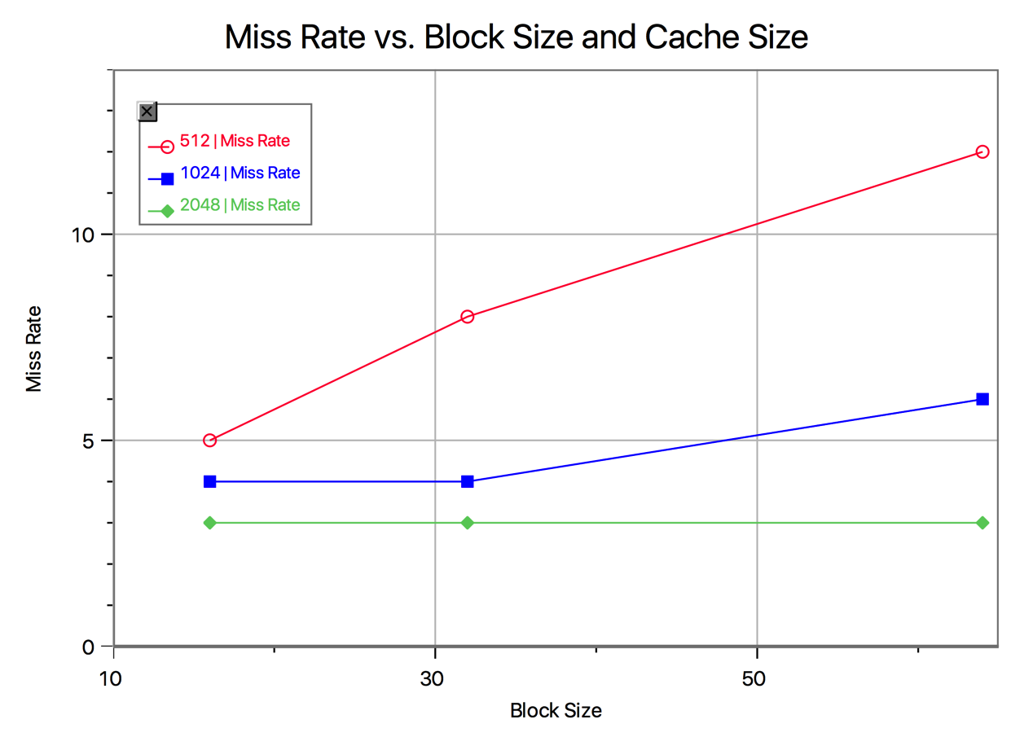

b) Fully Associative Caches

*LRU:*

|  |  |  |  |  |
| --- | --- | --- | --- | --- |
| Cache Size | Block Size | Hit Rate | Miss Rate | Number Of Misses |
| 512 | 64 | 89 | 11 | 39625 |
| 512 | 32 | 95 | 5 | 19817 |
| 2048 | 32 | 99 | 1 | 4956 |

The hıt rates increased significantly in fully associative cache selection compared to the direct mapped cache performance.

*Random:*

|  |  |  |  |  |
| --- | --- | --- | --- | --- |
| Cache Size | Block Size | Hit Rate | Miss Rate | Number Of Misses |
| 512 | 64 | 80 | 20 | 75769 |
| 512 | 32 | 99 | 1 | 4485 |
| 2048 | 32 | 99 | 1 | 2760 |

When the random block replacement policy was selected, for the same cache size but increased block size, the number of misses, therefore the miss rate increased drastically. As the cache size increased as block size remained the same, the number of misses dropped to half.

c) N – way Set Associative Caches

Medium Hit Rate:

|  |  |  |  |  |  |
| --- | --- | --- | --- | --- | --- |
| Cache Size | Block Size | Set Size | Hit Rate | Miss Rate | Number Of Misses |
| 512 | 32 | 1 | 84 | 16 | 58298 |
| 512 | 32 | 2 | 95 | 5 | 17716 |
| 512 | 32 | 4 | 99 | 1 | 2484 |
| 1024 | 32 | 4 | 99 | 1 | 2484 |

As the set size increased, the number of misses decreased significantly, so increasing the set size increases the hit rate significantly. However, increasing the cache size didn’t do any difference.

Poor Hit Rate:

|  |  |  |  |  |  |
| --- | --- | --- | --- | --- | --- |
| Cache Size | Block Size | Set Size | Hit Rate | Miss Rate | Number Of Misses |
| 512 | 64 | 1 | 76 | 24 | 90962 |
| 512 | 64 | 2 | 76 | 24 | 90781 |
| 1024 | 64 | 2 | 92 | 8 | 31411 |

Increasing the set size didn’t do any difference in the miss rate. However increasing the cache size as the block and set sizes remained the same increased the hit rate significantly.

Maximum Hit Rate:

|  |  |  |  |  |  |
| --- | --- | --- | --- | --- | --- |
| Cache Size | Block Size | Set Size | Hit Rate | Miss Rate | Number Of Misses |
| 2048 | 32 | 1 | 97 | 3 | 12057 |
| 2048 | 32 | 2 | 99 | 1 | 3712 |
| 2048 | 32 | 4 | 99 | 1 | 2484 |
| 4096 | 32 | 4 | 99 | 1 | 2484 |

As the set size increased, number of misses decreased drastically and therefore the hit rate increased. However, changing the cache size didn’t do any difference as the block size and set size remained the same.