**CS 484, Fall 2017**

**Homework Assignment 3: Image Segmentation (Report)**

**Spectral Mean Shift**

(i)(iii) Different Parameter Values and Statistics

41004

|  |  |  |
| --- | --- | --- |
| LUV Window Size | Precision | Recall |
| 0.03 | 0.124061 | 0.23866 |
| 0.032 | 0.122416 | 0.241435 |
| 0.034 | 0.1494 | 0.252536 |
| 0.036 | 0.111856 | 0.231483 |
| 0.038 | 0.139846 | 0.238756 |

124084

|  |  |  |
| --- | --- | --- |
| LUV Window Size | Precision | Recall |
| 0.03 | 0.146561 | 0.254171 |
| 0.032 | 0.16747 | 0.252002 |
| 0.034 | 0.158474 | 0.273774 |
| 0.036 | 0.135716 | 0.275609 |
| 0.038 | 0.142781 | 0.267518 |

35070

|  |  |  |
| --- | --- | --- |
| LUV Window Size | Precision | Recall |
| 0.03 | 0.124377 | 0.232604 |
| 0.032 | 0.119512 | 0.219183 |
| 0.034 | 0.120414 | 0.231493 |
| 0.036 | 0.138731 | 0.245939 |
| 0.038 | 0.128479 | 0.247393 |

299091

|  |  |  |
| --- | --- | --- |
| LUV Window Size | Precision | Recall |
| 0.03 | 0.052506 | 0.238918 |
| 0.032 | 0.05378 | 0.204162 |
| 0.034 | 0.052647 | 0.218939 |
| 0.036 | 0.054389 | 0.227471 |
| 0.038 | 0.247393 | 0.202081 |

135069

|  |  |  |
| --- | --- | --- |
| LUV Window Size | Precision | Recall |
| 0.03 | 0.087321 | 0.328618 |
| 0.032 | 0.118552 | 0.314472 |
| 0.034 | 0.108793 | 0.290805 |
| 0.036 | 0.110826 | 0.305495 |
| 0.038 | 0.10891 | 0.282644 |

(ii) Segmentation Results For the Final Parameter Value for 5 Images

LUV Window Size: 0.035

|  |  |  |
| --- | --- | --- |
| Image | Precision | Recall |
| 41004 | 0.137975 | 0.249569 |
| 299091 | 0.156817 | 0.279780 |
| 124084 | 0.126734 | 0.246025 |
| 135069 | 0.051488 | 0.218939 |
| 35070 | 0.108662 | 0.289717 |

(iv) Illustration of Performance Statistics

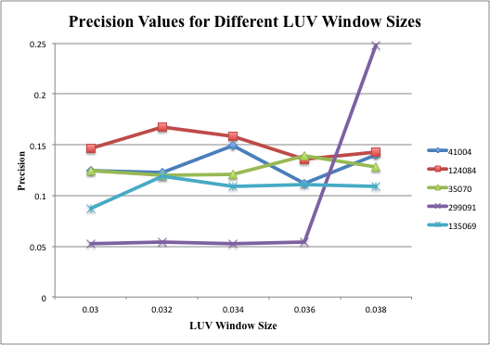

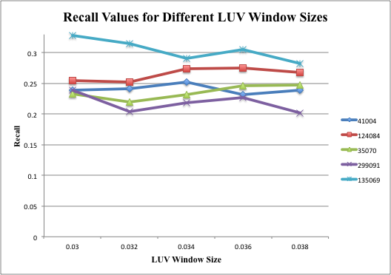

(vi) Discussion

1. What effect does varying r seem to have on the resulting segmentations?

If we increase the LUV window size, the precision values increased till a point (0.032). For one image, as the window size increased, precision increased significantly. Recall generally decreased for all images when window size increased.

1. What effect does adding position information as spatial features to color features have on the resulting segmentations?

The feature vector containing only LUV information gave false positives, therefore increased recall. Also, the precision values were so very less than the segmentations with spatial information added.

1. What are the advantages and disadvantages of using each type of feature vector?

Advantages of using only LUV feature vector: Faster than the other one. Increased recall.

Disadvantage: A lot of false positives were detected.

Spectral + Spatial Mean Shift

(i)(iii) Different Parameter Values and Statistics

**Varying LUV Window Size (xy_window = 0.13)**

41004

|  |  |  |
| --- | --- | --- |
| **LUV Window Size** | **Precision** | **Recall** |
| 0.031 | 0.186022 | 0.22134 |
| 0.033 | 0.146101 | 0.251196 |
| 0.035 | 0.176975 | 0.243158 |
| 0.037 | 0.168478 | 0.252153 |
| 0.039 | 0.088491 | 0.134641 |

124084

|  |  |  |
| --- | --- | --- |
| **LUV Window Size** | **Precision** | **Recall** |
| 0.031 | 0.21771 | 0.269686 |
| 0.033 | 0.201386 | 0.286036 |
| 0.035 | 0.206592 | 0.289122 |
| 0.037 | 0.196479 | 0.291375 |
| 0.039 | 0.212407 | 0.265349 |

35070

|  |  |  |
| --- | --- | --- |
| **LUV Window Size** | **Precision** | **Recall** |
| 0.031 | 0.352522 | 0.241323 |
| 0.033 | 0.325564 | 0.255514 |
| 0.035 | 0.265262 | 0.219525 |
| 0.037 | 0.136803 | 0.111216 |
| 0.039 | 0.143742 | 0.136946 |

299091

|  |  |  |
| --- | --- | --- |
| **LUV Window Size** | **Precision** | **Recall** |
| 0.031 | 0.112553 | 0.227471 |
| 0.033 | 0.098886 | 0.132986 |
| 0.035 | 0.199179 | 0.131322 |
| 0.037 | 0.15124 | 0.208117 |
| 0.039 | 0.078781 | 0.175858 |

135069

|  |  |  |
| --- | --- | --- |
| **LUV Window Size** | **Precision** | **Recall** |
| 0.031 | 0.539101 | 0.176279 |
| 0.033 | 0.438467 | 0.161861 |
| 0.035 | 0.476684 | 0.150163 |
| 0.037 | 0.49255 | 0.152884 |
| 0.039 | 0.485264 | 0.192601 |

(ii) Segmentation Results For the Final Parameter Values for 5 Images

LUV Window Size: 0.035

|  |  |  |
| --- | --- | --- |
| Image | Precision | Recall |
| 41004 | 0.137975 | 0.249569 |
| 299091 | 0.156817 | 0.279780 |
| 124084 | 0.126734 | 0.246025 |
| 135069 | 0.051488 | 0.218939 |
| 35070 | 0.108662 | 0.289717 |

**Varying XY Window Size (luv_window = 0.035)**

41004

|  |  |  |
| --- | --- | --- |
| **XY Window Size** | **Precision** | **Recall** |
| 0.11 | 0.197714 | 0.182105 |
| 0.12 | 0.176975 | 0.243158 |
| 0.13 | 0.176975 | 0.243158 |
| 0.14 | 0.176975 | 0.243158 |
| 0.15 | 0.176975 | 0.243158 |

124084

|  |  |  |
| --- | --- | --- |
| **XY Window Size** | **Precision** | **Recall** |
| 0.11 | 0.228314 | 0.238655 |
| 0.12 | 0.253698 | 0.237487 |
| 0.13 | 0.206592 | 0.289122 |
| 0.14 | 0.232176 | 0.329246 |
| 0.15 | 0.232176 | 0.329246 |

35070

|  |  |  |
| --- | --- | --- |
| **XY Window Size** | **Precision** | **Recall** |
| 0.11 | 0.350301 | 0.154129 |
| 0.12 | 0.138068 | 0.032741 |
| 0.13 | 0.265262 | 0.219525 |
| 0.14 | 0.265262 | 0.219525 |
| 0.15 | 0.265262 | 0.219525 |

299091

|  |  |  |
| --- | --- | --- |
| **XY Window Size** | **Precision** | **Recall** |
| 0.11 | 0.181897 | 0.131322 |
| 0.12 | 0.191735 | 0.131322 |
| 0.13 | 0.199179 | 0.131322 |
| 0.14 | 0.19962 | 0.131322 |
| 0.15 | 0.19962 | 0.131322 |

135069

|  |  |  |
| --- | --- | --- |
| **XY Window Size** | **Precision** | **Recall** |
| 0.11 | 0.476684 | 0.150163 |
| 0.12 | 0.476684 | 0.150163 |
| 0.13 | 0.476684 | 0.150163 |
| 0.14 | 0.476684 | 0.150163 |
| 0.15 | 0.476684 | 0.150163 |

(iv) Illustration of Performance Statistics

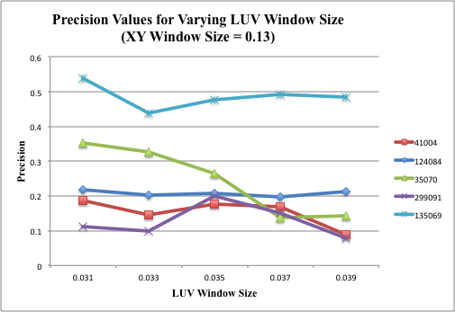

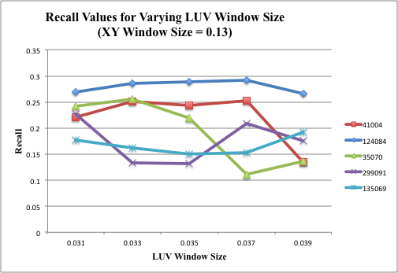

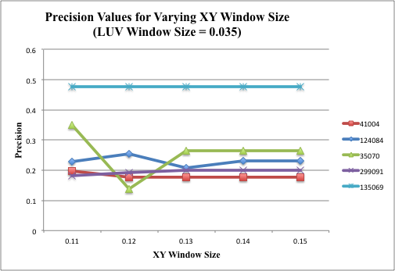

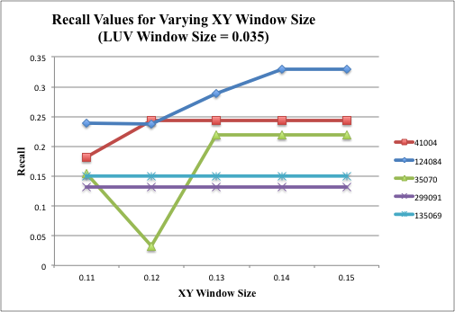

(vi) Discussion

1. What effect does varying r seem to have on the resulting segmentations?

If we increase the LUV window size, the precision values decreased generally (or increased till a point (0.035). Recall generally decreased for all images when window size increased.

If we increase the XY window size, the precision values stayed constant generally (or decreased till a point (0.12). Recall generally increased or stayed constant for all images when window size increased.

1. What effect does adding position information as spatial features to color features have on the resulting segmentations?

The feature vector containing only LUV information gave false positives, therefore increased recall. Also, the precision values were so very less than the segmentations with spatial information added.

1. What are the advantages and disadvantages of using each type of feature vector?

Advantages of using only LUV feature vector: Faster than the other one. Increased recall.

Disadvantage: A lot of false positives were detected.

Advantages of using only LUVXY feature vector: Increased precision, less false positives.

Disadvantage: Much slower than the first one, since it is a 5 dimensional space.