Basics of PYTHON lab 4 task

1. Write a Python program which accepts the radius of a circle from the user and compute the area.

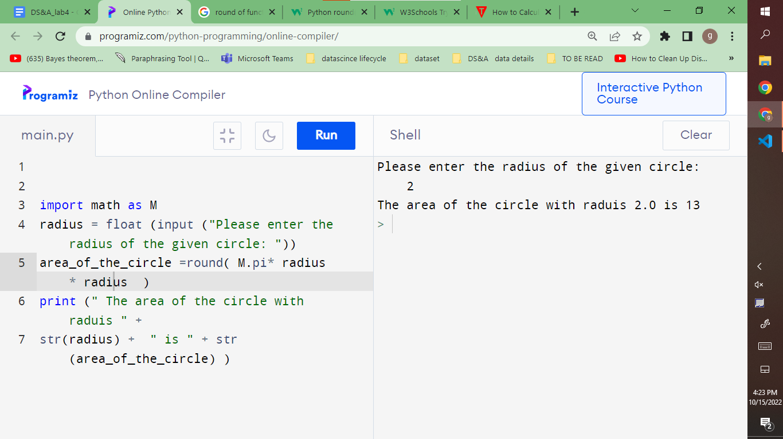

2. Write a Python program to guess a number between 1 to 9. Hint(use radom method to randomly generate numbers).

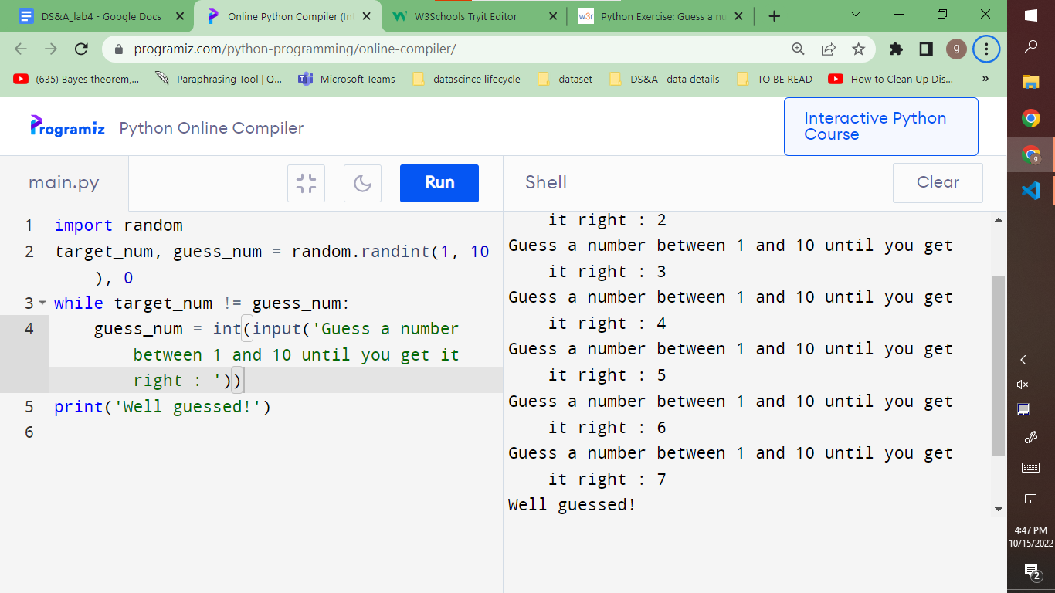

3. Write a Python program that accepts a word from the user and reverse it.

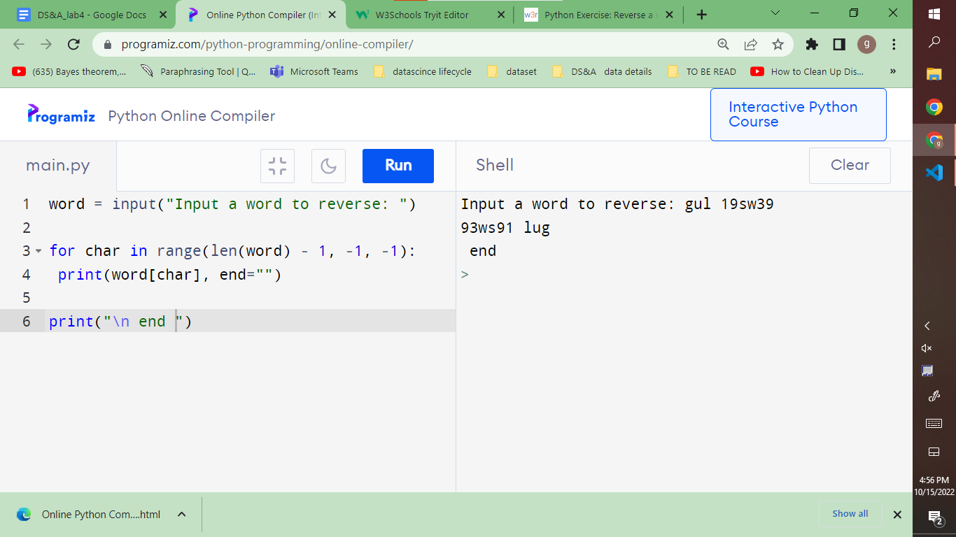

4. Write a Python program that prints all the numbers from 0 to 6 except 3 and 6. Note : Use 'continue' statement.

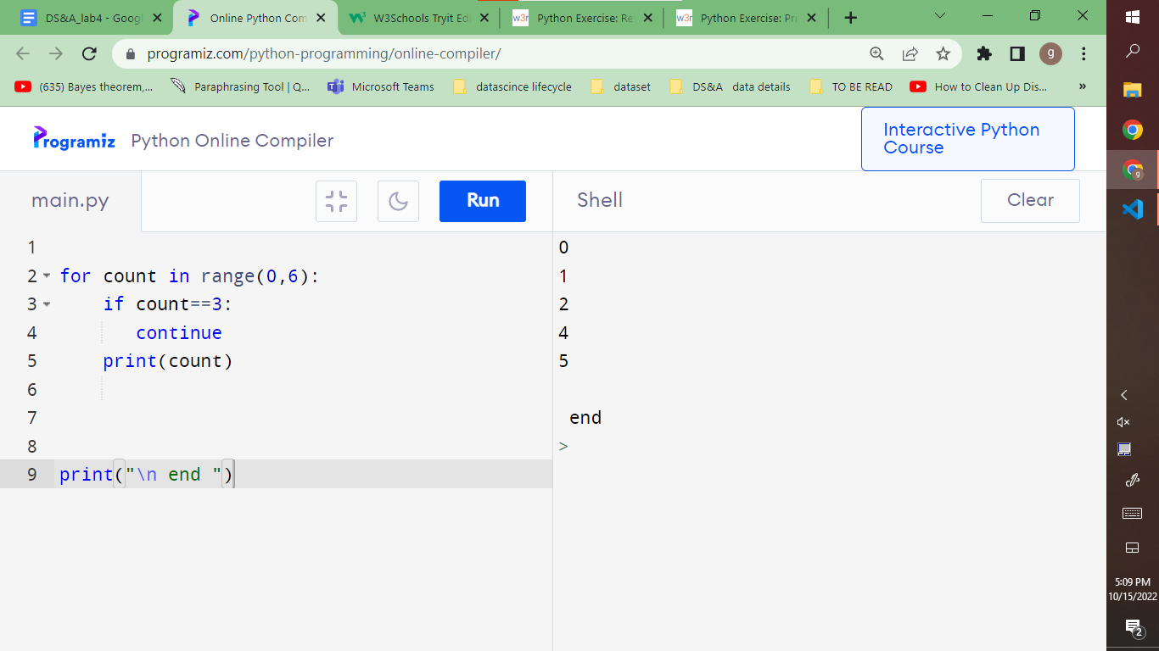

5. Write a Python program which iterates the integers from 1 to 50. For multiples of three print “Multiple of 3" instead of the number and for the multiples of five print “Multiple of 5". For numbers which are multiples of both three and five print “Multiple of both 3 & 5".

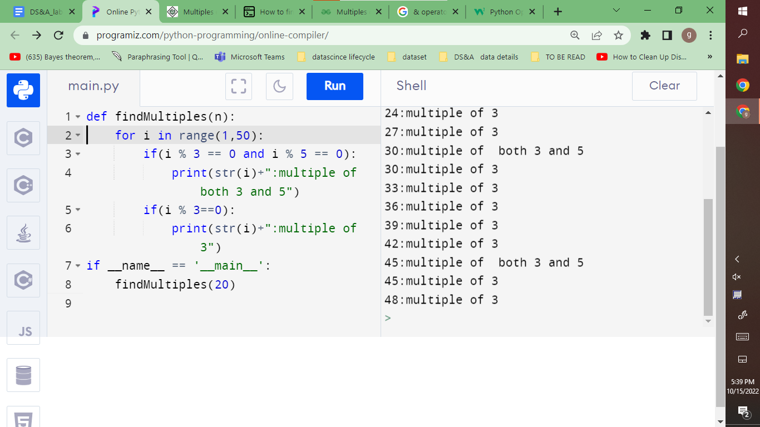

6. Write a Python program to check whether an alphabet is a vowel or consonant.

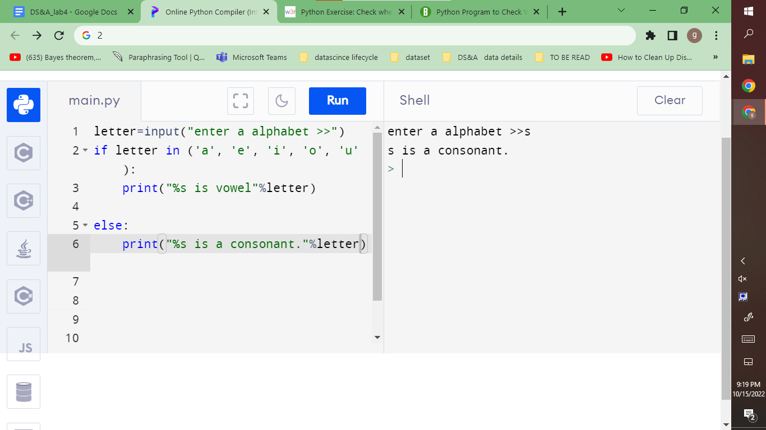

7. Write a Python program to convert temperatures to and from Celsius, Fahrenheit.

