**LAB 10 : R language, Data Structures, Manipulation, Plotting.**

**LAB TASKS:**

* **Perform the examples provided in Lab manual for practice**

**VECTOR**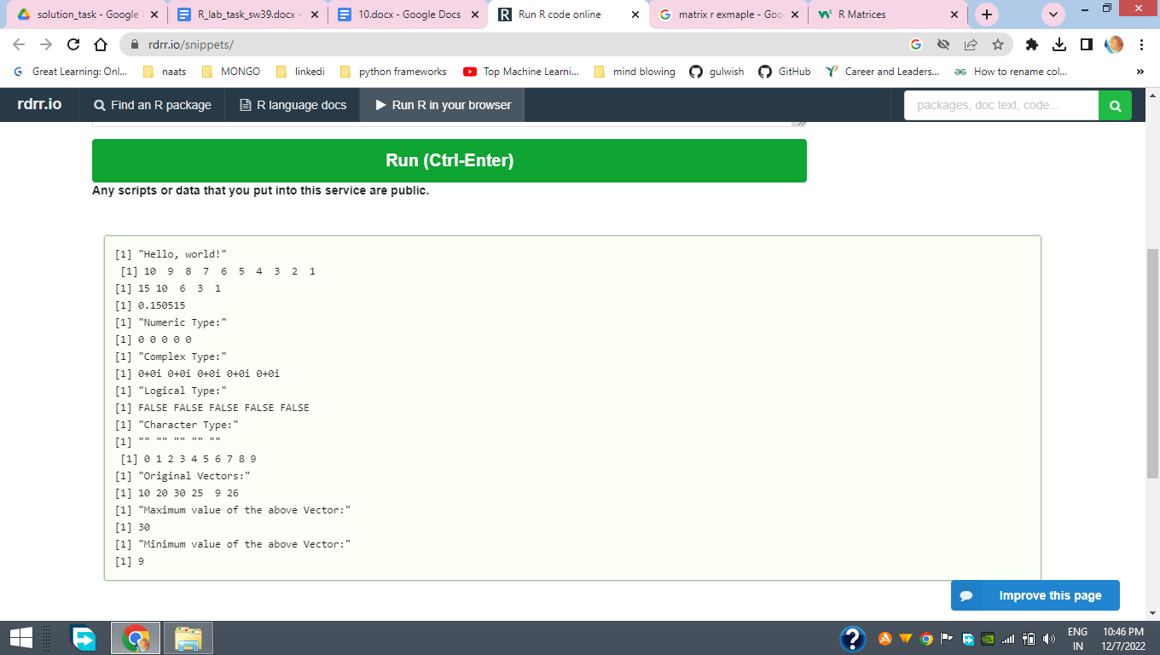

| rev(1:10)  rev(cumsum(1:5))  log10(sqrt(2))  #vector of a specified type and length.  x = vector("numeric", 5)  print("Numeric Type:")  print(x)  c = vector("complex", 5)  print("Complex Type:")  print(c)  l = vector("logical", 5)  print("Logical Type:")  print(l)  chr = vector("character", 5)  print("Character Type:")  print(chr)  #append  vector = c()  values = c(0,1,2,3,4,5,6,7,8,9)  for (i in 1:length(values))  vector[i] <- values[i]  print(vector)  #max & min value  x = c(10, 20, 30, 25, 9, 26)  print("Original Vectors:")  print(x)  print("Maximum value of the above Vector:")  print(max(x))  print("Minimum value of the above Vector:")  print(min(x)) |
| --- |

**MATRIces**

**DATA FRAMES** 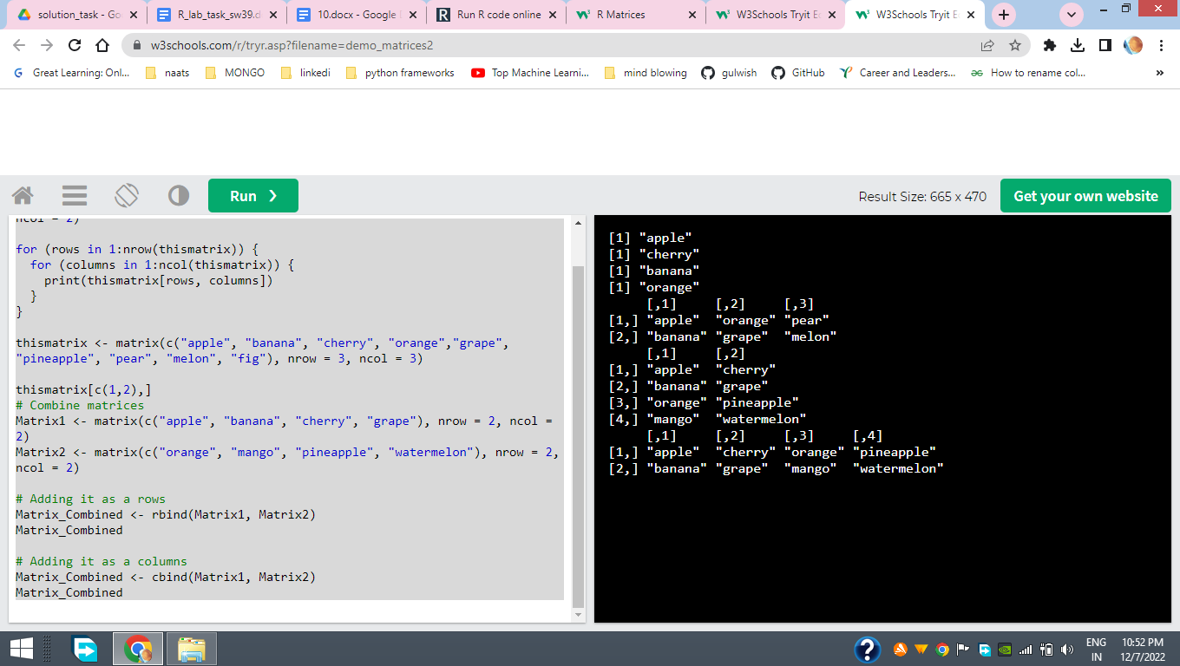

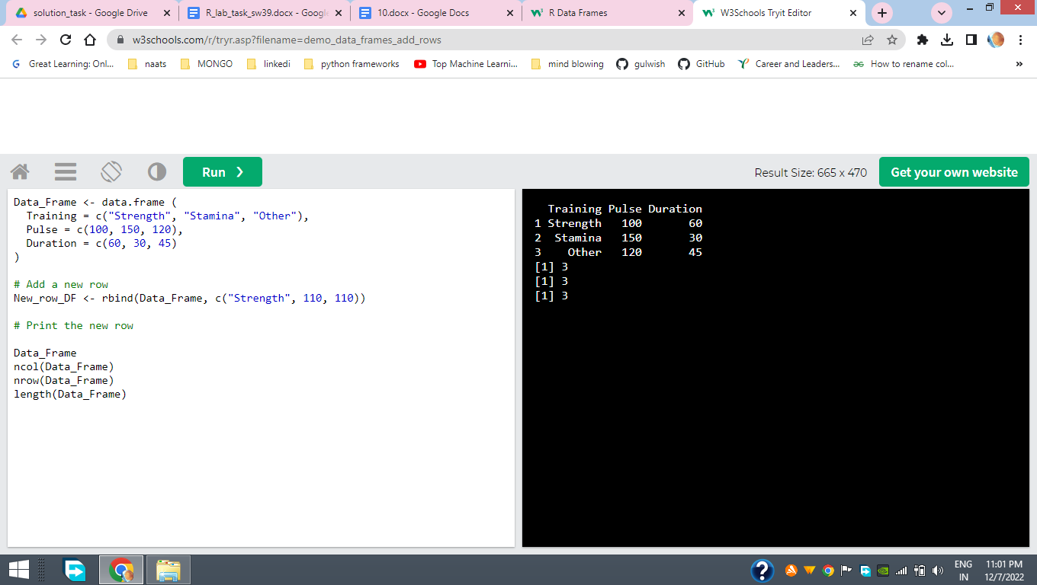

**List (loop join ,create)**

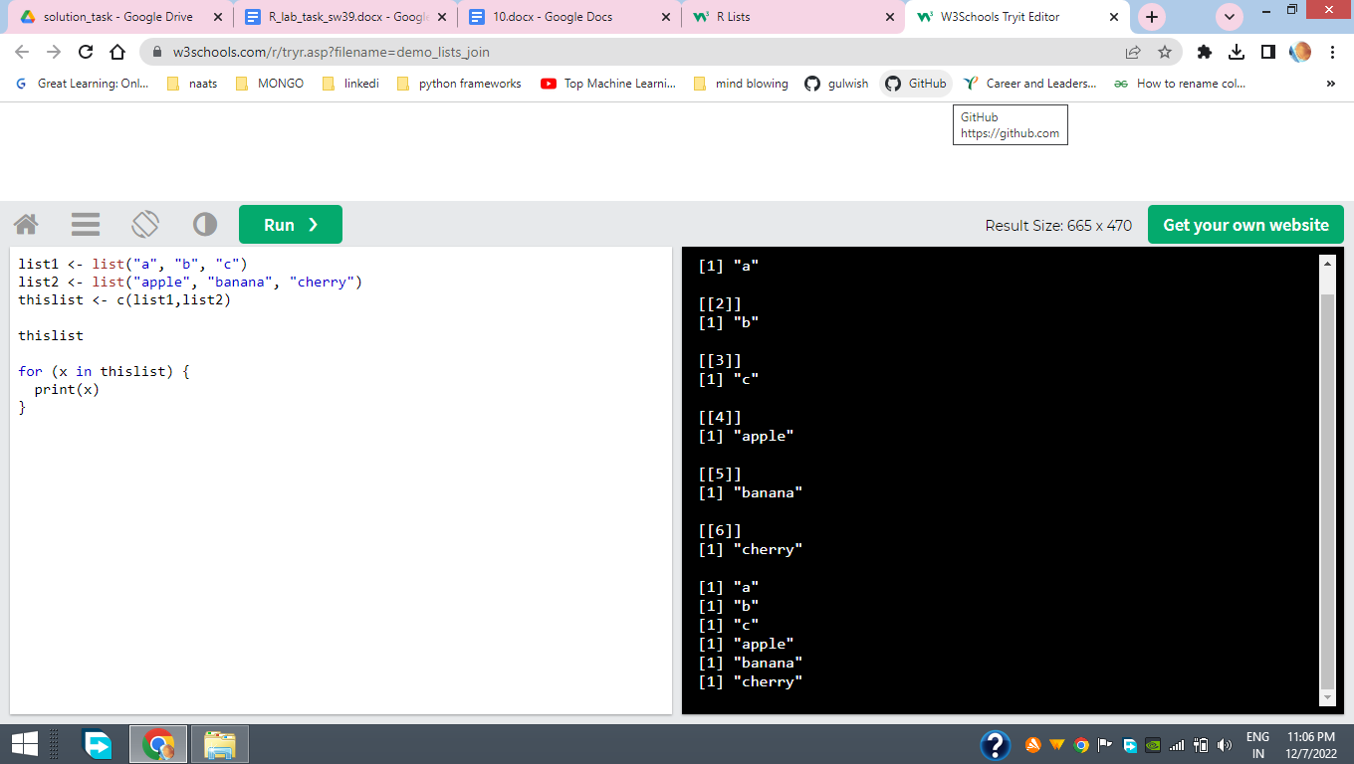

| list1 <- list("a", "b", "c")  list2 <- list("apple", "banana", "cherry")  thislist <- c(list1,list2)  thislist  for (x in thislist) {  print(x)  } |
| --- |

**Plot the following graphs and plots**

* **Box Plot**
* **Line Plot**
* **Scatter plot**

**REFERECEs: https://statisticsglobe.com**

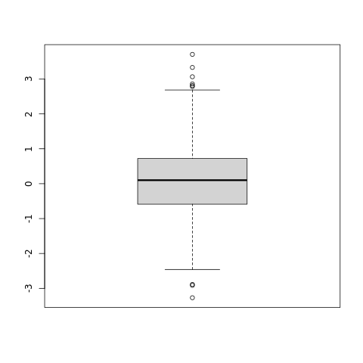

**BOX PLOT**

| **set.seed(8642) # Create random data**  **x <- rnorm(1000)** |
| --- |

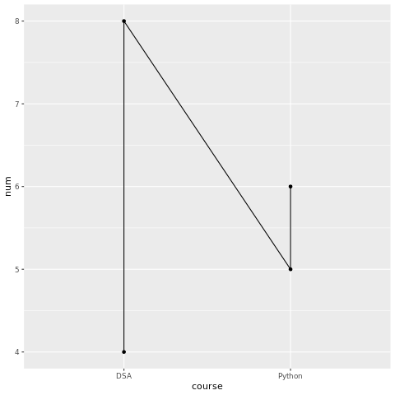

| **LINE PLOT :# Basic Line**  **ggplot(data=val, aes(x=course, y=num, group=1)) +**  **geom_line()+**  **geom_point()** |
| --- |

**Scatterplot Example**

| **attach(mtcars)**  **plot(wt, mpg, main="Scatterplot Example",**  **xlab="Car Weight ", ylab="Miles Per Gallon ", pch=5)** |
| --- |

